Publication 23-07-011 - April 2023
Prepared for the Washington Department of Ecology
Part 1 - Recycling Companies and Revenue
Report on Washington State Recycling
By Ellie Potts
and Tony Peterson
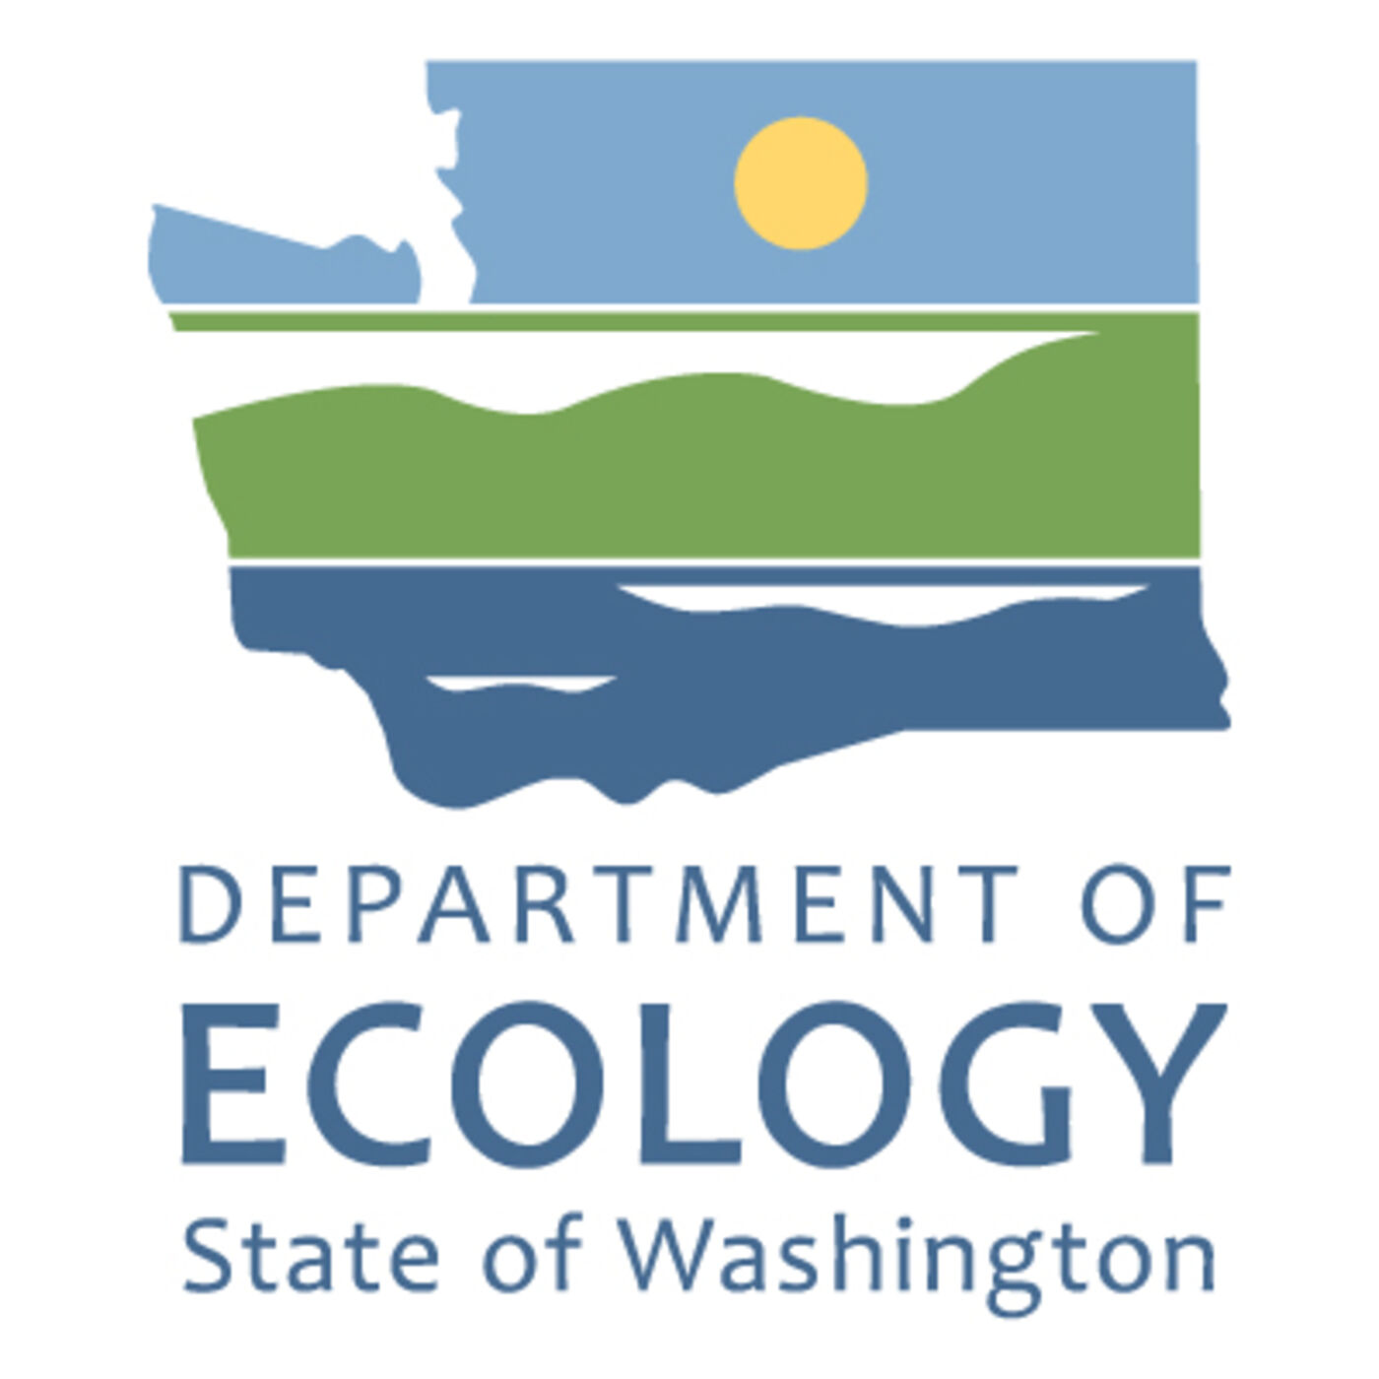

Publication Information
This document is available on the Department of Ecology’s website at: https://apps.ecology.wa.gov/publications/summarypages/2307011.html

Related Information
Publication 23-07-012: Part 2 - Economic Impact of Recycling
Publication 23-07-013: Part 3 - Equity and Environmental Justice

Contact Information
Solid Waste Management Program
Statewide Resource Services
P.O. Box 47600
Olympia, WA 98504-7600
Phone: 360-407-6000
Website: Washington State Department of Ecology

ADA Accessibility
The Department of Ecology is committed to providing people with disabilities access to information and services by meeting or exceeding the requirements of the Americans with Disabilities Act (ADA), Section 504 and 508 of the Rehabilitation Act, and Washington State Policy #188.
To request an ADA accommodation, contact Ecology by phone at 360-407-6000 or email at mark.hayes@ecy.wa.gov. For Washington Relay Service or TTY call 711 or 877-833-6341. Visit Ecology's website for more information.

Department of Ecology’s Regional Offices

Map of Counties Served
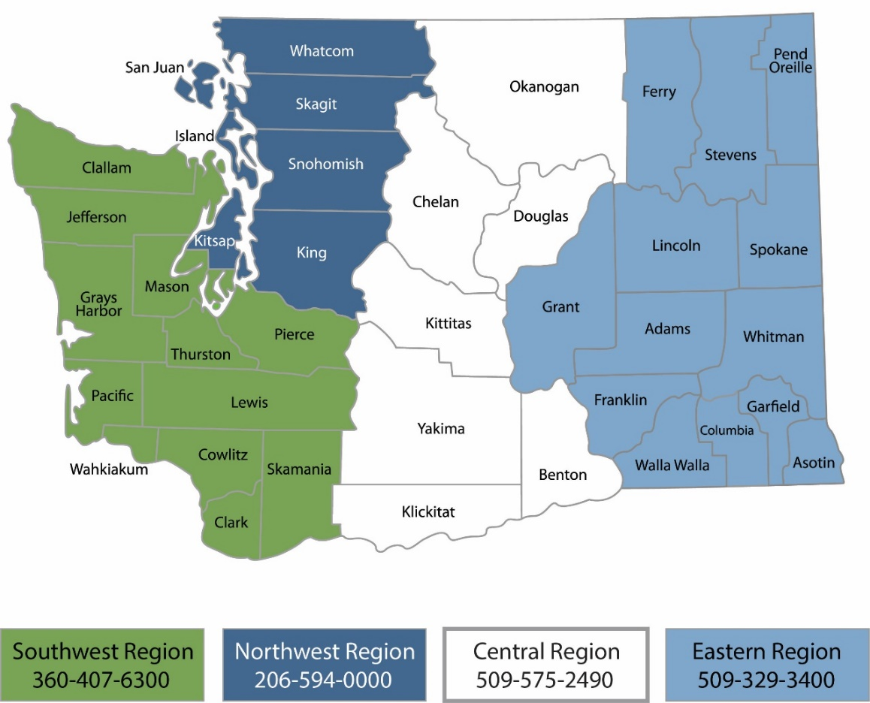
Region | Counties served | Mailing Address | Phone
Southwest | Clallam, Clark, Cowlitz, Grays Harbor, Jefferson, Mason, Lewis, Pacific, Pierce, Skamania, Thurston, Wahkiakum | P.O. Box 47775  Olympia, WA 98504 | 360-407-6300
Northwest | Island, King, Kitsap, San Juan, Skagit, Snohomish, Whatcom | P.O. Box 330316 Shoreline, WA 98133 | 206-594-0000
Central | Benton, Chelan, Douglas, Kittitas, Klickitat, Okanogan, Yakima | 1250 West Alder Street  Union Gap, WA 98903 | 509-575-2490
Eastern | Adams, Asotin, Columbia, Ferry, Franklin, Garfield, Grant, Lincoln, Pend Oreille, Spokane, Stevens, Walla Walla, Whitman | 4601 North Monroe  Spokane, WA 99205 | 509-329-3400
Headquarters | Statewide | P.O. Box 46700  Olympia, WA 98504 | 360-407-6000

Table of Contents
Publication Information 2
Related Information 2
Contact Information 2
ADA Accessibility 2
Department of Ecology’s Regional Offices 3
Map of Counties Served 3
About the Authors 4
Introduction 5
Executive Summary 5
Part one: Recycling Companies and Revenue 5
Data Classification 5
Industry Descriptions 7
Industry Size Summary 8
Sources and Data Limitations 9
The Waste Management and Remediation Services Sector 10
Employment and Salaries 10
Gross Business Income 13
Company Income 15
Revenue by region 17
The Recyclable Material Merchant Wholesalers Industry 21
Employment and Salaries 22
Gross Business Income 24
Company Income 25
Revenue by region 26
Survey Directory 29
Questions within Survey 1 29
Questions within Survey 2 31
Results 33
Limitations 33
Conclusion 34
Appendix A 35
Appendix B 37
Appendix C 38

About the Authors
The Center for Economic and Business Research is an outreach center at Western Washington University located within the College of Business and Economics. In addition to publishing the Puget Sound Economic Forecaster, the Center connects the resources found throughout the University to assist for-profit, non-profit, government agencies, quasi-government entities, and tribal communities in gathering and analyzing useful data to respond to specific questions. We use a number of collaborative approaches to help inform our clients so that they are better able to hold policy discussions and craft decisions.
The Center employs students, staff and faculty from across the University as well as outside resources to meet the individual needs of those we work with. Our work is based on academic approaches and rigor that not only provides a neutral analytical perspective but also provides applied learning opportunities. We focus on developing collaborative relationships with our clients and not simply delivering an end product.
The approaches we utilize are insightful, useful, and are all a part of the debate surrounding the topics we explore; however, none are absolutely fail-safe. Data, by nature, is challenged by how it is collected and how it is leveraged with other data sources. Following only one approach without deviation is ill-advised. We provide a variety of insights within our work – not only on the topic at hand but also the resources (data) that inform that topic.
We are always seeking opportunities to bring the strengths of Western Washington University to fruition within our region. If you have a need for analysis work or comments on this report, we encourage you to contact us at 360-650-3909 or by email at cebr@wwu.edu.
To learn more about CEBR visit us online at https://cebr.wwu.edu or follow us online through your favorite social media stream.
facebook.com/westerncebr
twitter.com/PugetSoundEF
linkedin.com/company/wwu-center-for-economic-and-business-research
instagram.com/wwucebr

The Center for Economic and Business Research is directed by Hart Hodges, Ph.D. and James McCafferty.

Introduction
This three-part comprehensive report is a search and analysis of the businesses that sort and refine Washington’s recyclable materials into sellable commodities, and the intermediate and end-users that use recyclable materials in manufacturing. Using existing databases and survey data, this report examines main processors in the supply chain, locations of generation and remediation, economic impacts, and equity concerns in Washington state. The goals of the three-part comprehensive report include a qualitative and quantitative baseline report of Washington state’s recycling industry to identify opportunities, existing benefits, potential benefits, and conduct an environmental justice and equity analysis. The three parts of this Recycling Baseline Report include policy recommendations based on capacities, needs, gaps, barriers and opportunities identified within the state:
- Part one: Recycling Companies and Revenue, provides economic data related to management of recyclable materials in Washington state and their principal processors.
- Part two: Economic Impact of Recycling, examines economic contribution of the recycling industry, identifying direct, indirect, and induced economic impacts of potential expansion within the recycling industry.
- Part three: Equity Analysis of Recycling, examines environmental justice and equity concerns within the solid waste and recycling system, mapping health and environmental hazard variables to facility locations.

Executive Summary

Part one: Recycling Companies and Revenue
This report provides reported income, employment, and size information of the largest companies in Washington state within selected sector and industry classifications. Survey data is also collected from some companies. A separate directory of survey information is provided including company name, general business information, material output, and location for survey respondents.

Data Classification
The North American Industry Classification System (NAICS) classifies business establishments for statistical data usage. For this baseline report, the industries of Waste Collection (NAICS 562) and Recycling Material Merchant Wholesalers (423930) are investigated to understand recycling in Washington state. The more numbers within the NAICS code, the more specific the sector. The Bureau of Economic Analysis describes the digits as so: the first two digits of the NAICS code designate the sector, the third designates the subsector, the fourth designates the industry group, the fifth digit designates the NAICS industry, and the sixth designates the national industry (the 6-digit US NAICS code ends in zero). Therefore, Waste Collection, a 3-digit code, is split into a total of three different industry groups examined in this report: Waste Collection, Waste Treatment and Disposal, and Remediation and Other Waste Management Services. These industry groups are all examined to understand the size of industries engaged in both waste streams and recycling, material recovery and disposal. Of the three industry groups in Waste Management (562), the Remediation and Other Waste Management Services subsector (5629) is further examined into three 6-digit categories that are directly engaged in recycling. This includes Remediation Services, Material Recovery Facilities, and All other Waste Management Services.
The number of establishments, employment, and salary data is examined for the following codes (with 3-digits or more) for all Waste Collection industry groups referenced in this report. This report also examines gross business income for Remediation and Other Waste Management Services (5629).
- Administrative and Support and Waste Management and Remediation Services – Code 56
  - Waste Management and Remediation Services 562.
    - Waste Collection – Code 5621
    - Waste Treatment and Disposal – Code 5622
    - Remediation and Other Waste Management Services – Code 5629
      - Remediation Services – Code 562910
      - Material Recovery Facilities – Code 562920
      - All other Waste Management Services – Code 562990

The number of establishments, employment, salary data, and gross business income is examined for Recyclable Material Merchant Wholesalers (423930). This industry group is within the following sector:
- Wholesale Trade – Code 42
  - Merchant Wholesalers, Durable Goods – Code 423
    - Miscellaneous Durable Goods Merchant Wholesalers – Code 4239
      - Recycling Material Merchant Wholesalers – Code 423930

Additional information on the NAICS code system and industry descriptions can be found at NAICS Association¹ site and the Bureau of Economic Analysis².

Industry Descriptions
This report identifies the principal processors and manufacturers of recyclable materials, using publicly available databases, supplemented with survey information. Two main groups are examined within this report, including Waste Management and Remediation Services sector (NAICS 562), and Recyclable Material Merchant Wholesalers industry (NAICS 423930).
The industries of Material Recovery Facilities (NAICS 562920) and Remediation Services (NAICS 562910) are also examined in detail within this report. According to the Bureau of Economic Analysis², Material Recovery Facilities (MRF) industry includes some waste recovery facilities and companies involved in the removal of recyclable materials from waste streams. This industry is directly involved with nearly all materials in the recycling sector (except soil, see Remediation Services) and is highly relevant to the recycling focus of this report.
According to the Bureau of Economic Analysis, the Remediation Services (NACIS 562910) industry includes companies that manage asbestos, lead, and toxic material abatement, lead abatement, biohazard cleanup services, environmental remediation, hazardous material removal and disposal, mine reclamation services, soil remediation, and revegetation. This industry’s involvement with mine sites, building remediation, soil and environmental remediation has a less direct but still important relation to the recycling sector. Organic material recovery (such as soil), and other recycled materials can be involved within the material stream of this sector, and according to this report’s survey data, some companies are involved in both remediation and material recovery or repurpose. While included in Waste Management sector, this industry is not a focus of this report, but rather is to give greater context of the industry and survey results.
Recyclable Material Merchant Wholesalers (NAICS 423930) include companies involved in reclamation and merchant wholesale of numerous materials. This includes bags, bottles, boxes, electronic parts, industrial waste, metal, oil, paper, plastic, rags, rubber, textile, and other scrap materials. The companies within this industry are primarily engaged in the wholesale and distribution of these recyclable materials, acting as the middle role between collection of used materials and recovery and repurpose of these new materials.

Industry Size Summary
Within Washington state, as of 2019, there are 214 establishments in the NAICS code 5621 category of Waste Collection, 35 in Waste Treatment and Disposal (NAICS 5622), and 336 in Remediation and Other Waste Management (NAICS 5629). This comprises 585 total establishments and a count of 15,632 employees in the Waste Management and Remediation Services sector (NAICS 562).
Drilling deeper into Remediation and Other Waste Management Services industry group (NAICS 5629), which includes 154 establishments in Remediation Services (NAICS 562910) and 32 in Material Recovery Facilities (NAICS 562920). Remediation and Other Waste Management Services industry group (NAICS 5629) had a gross business income of nearly $456 million in quarter 1 of 2022, including Material Recovery Facilities (NAICS 562920) gross business income of over $21 million.
Selected companies with top income values in Waste Management and Remediation Services (NAICS 562) includes Waste Management of Washington, Global Diving & Salvage Inc., and Emerald Services. The top three Material Recovery Facilities (562920) in Washington by reported income are Cedar Grove Composting Inc., Seattle, Columbia Resource Corporation in Vancouver, and Pacific Topsoils Inc. in Snohomish.
There are a total of 143 establishments and 2,412 employees in Washington’s Recyclable Material Merchant Wholesalers industry (NAICS 423930). The gross business income within the industry was over $470 million in quarter 1 of 2022. The top three companies by reported income include Seattle Iron & Metals Corporation in Seattle, employing 125 workers, followed by Tacoma’s Schnitzer Steel Industries Inc. employing 117 workers, and Simon Metals LLC, also in Tacoma and employing 70 workers.

Sources and Data Limitations
A wide range of public and proprietary data is used within this report. The information within this report is gathered from a variety of databases, including JobsEQ, Dun & Bradstreet, the US Census, and Washington state Department of Revenue. JobsEQ of Chmura Economics & Analytics collects information quarterly from an amalgamation of sources, including Bureau of Labor Statistics, Bureau of Economic Analysis, Census Bureau, and compiles historical data to create economic forecasts. All forecasts within this report are future predictions based on historical data, and reliance on forecasts should be accompanied with caution due to possible error. Dun & Bradstreet collects primary data and estimations based on other data streams available. Dun & Bradstreet data owns the Mergent Intellect source, which is collected on a rolling basis through questionnaires and surveys. This data source is used for identifying the companies involved in recycling, and the source’s reported income and locations are also provided within this report. The Department of Revenue’s regional gross business income is a more accurate source for identifying recycling company income, and data is organized by Workforce Development region.

The Waste Management and Remediation Services Sector
The Waste Management and Remediation Services (NAICS 562) sector is engaged in the collection, treatment, and disposal of waste materials. According to the United States Census Bureau, this includes haulers of waste materials, material recovery facilities (MRFs, which sort recyclable materials from the trash stream), remediation services (cleanup of contaminated buildings, mine sites, soil, or ground water), and septic pumping and other miscellaneous waste management services. Within this sector, there are three industry groups; separated by waste collection (NAICS 5621), waste treatment and disposal (NAICS 5622), and remediation and other waste management (NAICS 5629).
As of the first quarter of 2022, the Waste Management and Remediation Services sector (NAICS 562) in Washington state employs 17,921 employees, the 52nd largest sector of 103 3-digit sectors. The average annual wage in this sector is $86,214. This sector in Washington is forecasted to have a growth rate of 1.8% within the next year, 0.3% greater than the 1.5% annual growth of all sectors. Employees are expected to increase by 992 within the next three years, 1,684 within the next five years, and 3,526 within the next ten years.

Employment and Salaries
In 2019, Washington state held 585 establishments within the Waste Management and Remediation Services sector. The following table displays the number of establishments, employment counts, and average salaries for all the 4-digit NAICS code industry groups relevant to recycling within the Waste Management and Remediation Services sector in Washington state in 2019. The industries Remediation Services (NAICS 562910) and Material Recover Facilities (NAICS 562920) are within the Remediation and Other Waste Management Services industry group (NAICS 5629).
Table 1: Number of Establishments, Employment, and Average Salary for Sector NAICS 562, Washington state, 2019
Waste Management and Remediation Services Industry (NAICS 562)
Industry groups | Number of Establishments | Employment | Average Salary
Waste Collection (5621) | 214 | 5,045 | $68,757
Waste Treatment and Disposal (5622) | 35 | 2,886 | $101,607
Remediation and Other Waste Management Services (5629) | 336 | 7,701 | $77,431
Total in  Waste Management and Remediation Services sector (562) | 585 | 15,632 | $77,095
Source: United States Census Bureau
Under the umbrella of this sector includes Remediation and Other Waste Management Services industry group (NAICS 5629), capturing all Remediation Services, Materials Recovery Facilities, Septic Tank and Related Services, and All Other Miscellaneous Waste Management Services. The following table displays the number of establishments, employment counts, and average 2019 salaries of Washington’s industries within the Remediation and Other Waste Management Services industry groups that are relevant to recycling. This includes Remediation Services (562910) and Materials Recover Facilities (562920).
Table 2: Number of Establishments, Employment, and Average Salary for Industry group NAICS 5629, Washington state, 2019
Remediation and Other Waste Management Services Industry group (NAICS 5629)
Industries | Number of Establishments | Employment | Average Salary
Remediation Services (562910) | 154 | 5,468 | $86,942
Materials Recovery Facilities (562920) | 32 | 963 | $56,649
All other Waste Management Services (562990) | 150 | 1,270 | $52,240
Total of all industry groups in the Remediation and Other Waste Management Services Sector (5629) | 336 | 7701 | $77,431
Source: United States Census Bureau
For the tables above, data is gathered from 2019 United States Census Bureau County Business Patterns dataset. The number of establishments differs from company count within this data set. An establishment is a single physical location at which business is conducted or services or industrial operations are performed. It is not necessarily identical with a company or enterprise, which may consist of one or more establishments. Average salaries are found from dividing annual payroll by employee count.
The United States Census Bureau defines employment and establishment as the following:
Employment
Paid employment consists of full- and part-time employees, including salaried officers and executives of corporations, who are on the payroll in the pay period including March 12. Included are employees on paid sick leave, holidays, and vacations; not included are sole proprietors and partners of unincorporated businesses.
Establishment
An establishment is a single physical location at which business is conducted or services or industrial operations are performed. It is not necessarily identical with a company or enterprise, which may consist of one or more establishments. When two or more activities are carried on at a single location under a single ownership, all activities generally are grouped together as a single establishment. The entire establishment is classified on the basis of its major activity and all data are included in that classification. Establishment counts represent the number of locations with paid employees any time during the year.

Gross Business Income
The following chart illustrates a graph of Gross Business Income of the Remediation and Other Waste Management Services industry group (NAICS 5629) in Washington state from 2018 to 2022 quarterly. It shows the income in millions of dollars up until the first quarter of 2022, the most recent data posted from the Department of Revenue. In the first quarter of 2018, gross revenue was over $287 million dollars, with a general upward trend, peaking at $626,128,917 in the third quarter of 2021. The most recent amount from the first quarter of 2022 has total income at $455,904,552.
Figure 1: Gross Business Income of Remediation and Other Waste Management Services (NAICS 5629), Washington state, 2018-2022
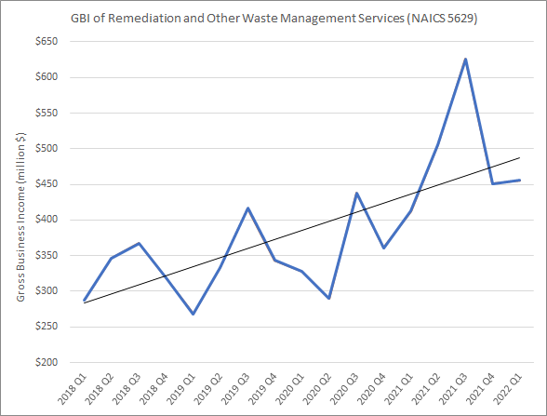
Source: Department of Revenue
See Appendix A for graphs for the other indirectly related industry groups: Waste Collection (NAICS 5621) and Waste Treatment and Disposal (NAICS 5622).

The following chart illustrates a graph of Gross Business Income of the Material Recovery Facilities industry (NAICS 562920) in Washington state from 2018 to 2022 quarterly. It shows the income in millions of dollars up until the first quarter of 2022, the most recent data posted from the Department of Revenue. In the first quarter of 2018, gross revenue was over $17 million dollars, with steep downturn at the end of 2019 and start to 2018, as in the first quarter of 2019 GBI was at $14 million. The industry in Washington state made a comeback in quarter 1 of 2019, spiking from $17 million to $21 million. The 2022 year began with $21,591,770 in GBI.
Figure 2: Gross Business Income of Material Recovery Facilities (NAICS 562920), Washington state, 2018-2022
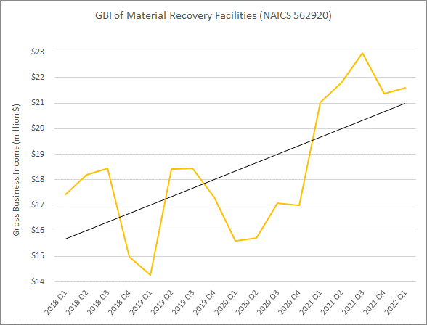
Source: Department of Revenue

Company Income
Below is a table of select companies leading by reported income in Washington state within the Waste Management and Remediation Services sector (NAICS 562). Waste Management of Washington leads in recycling income at $110 million, followed by Emerald Services Inc., at $84 million, and then Harold Lemay Enterprises Inc. at $52 million.
Table 3: Selected Companies in Waste Management and Remediation Services (NAICS 562) by Top Reported Income Values, Washington state
Company Name | Reported Income | Location | Employment
Waste Management of Washington, Inc. | $110,424,643 | Seattle | 329
Emerald Services, Inc. | $84,552,041 | Seattle | 260
Harold Lemay Enterprises, Inc. | $52,133,382 | Parkland | 568
Cedar Grove Composting, Inc. | $45,390,730 | Seattle | 198
Rabanco Companies | $24,375,099 | Seattle | 100
Columbia Resource Corporation | $20,294,153 | Vancouver | 85
Pacific Topsoils Inc. | $18,966,833 | Snohomish | 90
Source: Dun & Bradstreet

Within the industry group of Remediation and Other Waste Management Services, six of the top ten companies by reported income are within the Material Recovery Facilities industry (562920). This includes Cedar Grove Composting Inc., Columbia Resource Corporation, Pacific Topsoils Inc., Murrey’s Disposal Company Inc., Waste Management of Washington Inc., and Skagit River Steel & Recycling Inc. Below is a graph of this industry, with material recovery facilities all over the state. Cedar Grove Composting in Seattle leads at $45,390,730 in reported income, followed by Columbia Resource Corporation of Vancouver and Pacific Topsoils Inc. of Snohomish.

Table 4: Selected Companies Material Recovery Facilities (NAICS 562920) Services by Top Reported Income Values, Washington state
Company Name | Reported Income | Location | Employment
Cedar Grove Composting, Inc. | $45,390,730 | Seattle | 198
Columbia Resource Corporation | $20,294,153 | Vancouver | 85
Pacific Topsoils Inc. | $18,966,833 | Snohomish | 90
Murrey’s Disposal Company, Inc. | $14,685,405 | Tacoma | 66
Waste Management of Washington, Inc. | $13,772,886 | Seattle | 99
Skagit River Steel & Recycling, Inc. | $12,012,672 | Anacortes | 44
Lautenbach Recycling | $10,672,739 | Mount Vernon | 68
Waste Control Recycling Inc. | $8,201,080 | Longview | 70
Green Power Washington Corporation | $6,667,399 | Seattle | 125
Sunshine Disposal & Recycling | $6,418,198 | Spokane | 15
Source: Dun & Bradstreet
Dun & Bradstreet is a business directory source used in this report for identifying recycling companies. Dun & Bradstreet data owns the Mergent Intellect directory of business information, which is collected on a rolling basis through questionnaires and surveys. This data source is utilized to display the companies involved in recycling, but the reported income is an estimation gathered from surveys and collection bias. A more accurate representation of income is organized by region using data from the Department of Revenue in the Revenue by Region section.

Revenue by region
The Gross Business Income Data on Waste Management taxpayers and Recyclable Material Merchant Wholesale taxpayers is organized by workforce development area. A map of the Workforce Development areas and a list of which counties are in each region is in Appendix B of this report. Workforce areas are defined by the Department of Commerce. The Gross Business Income data from the Department of Revenue is organized by the mailing address of the company’s filed income and tax returns. The mailing address may be the taxpayer’s primary physical location, or it may be another address, such as their headquarters, accountant or other preferred address (which may be out of state).
Within 2021, the in-state average total gross business income (GBI) of the Waste Management Industry (NAICS 5629) was $4,030,664. In 2019 and 2020 it was $3,020,492 and $3,068,741, respectively. The Seattle-King Workforce Development area had the highest total GBI of $145,347,827 and highest count of taxpayers at 82, with an average GBI per taxpayer of $1,772,534. The highest average GBI per taxpayer was $3,014,091 from the 39 taxpayers in the Northwest Workforce Development area, totaling GBI at $117,549,541. Snohomish has the third highest GBI total of $91, 602,155, with an average GBI of $1,552,579 from 59 taxpayers. The Southwest, Pierce, and Spokane Workforce Development areas followed in highest total GBI. The regions that experienced the most growth include the North-Central, Eastern, and Benton-Franklin Workforce Development areas, which grew at rates of 50%, 40%, and 37% from 2019 to 2021. Out-of-state growth was also high within this time frame, at 58%. GBI out of state growth values are companies with a return mailing address (headquartered or branches) out of state but a physical address in state for paying Washington taxes. The Southwest region was the only workforce development area that had a decline in total GBI from 2019 to 2021 of 6%. These values are calculated by taking the difference between 2021 and 2019 total GBI values and dividing by the 2019 total GBI.

Figure 3: Waste Management and Remediation Services (NAICS 5629) Taxpayer Count and Average GBI per Taxpayer (2021) by Workforce Development Area [Patterned areas represent higher average GBI per taxpayer]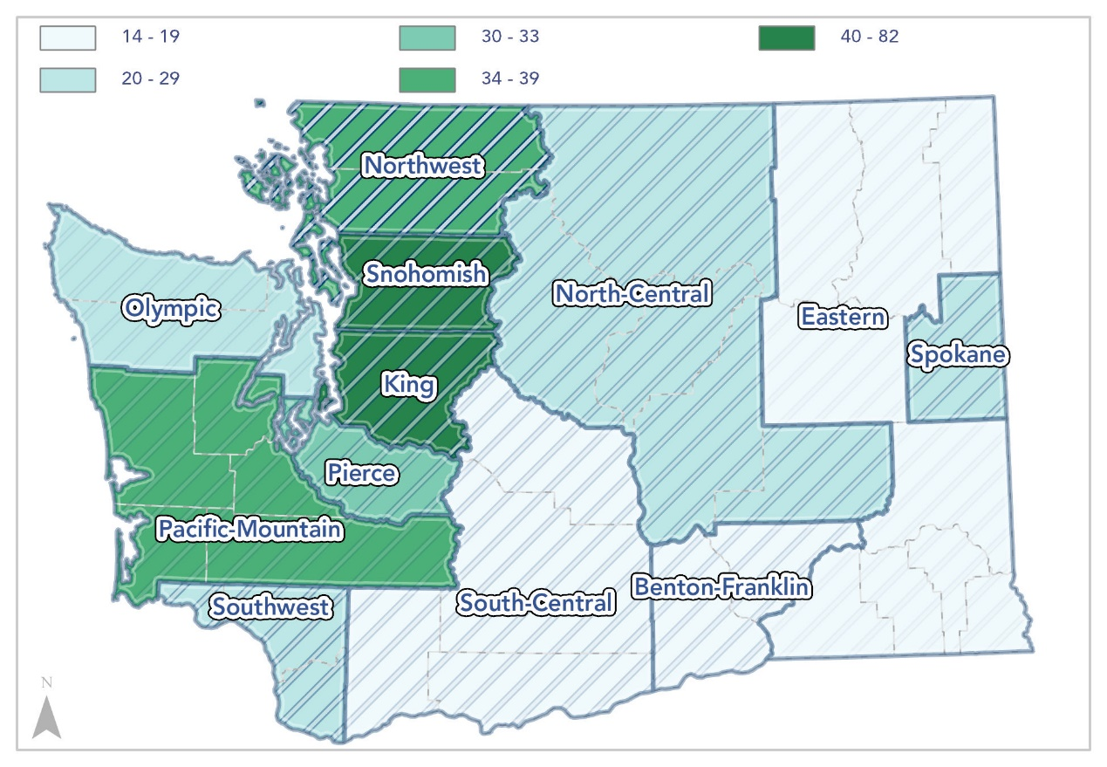

Figure 4: Waste Management and Remediation Services (NAICS 5629) Gross Business Income (2021) by Workforce Development Area [Percentages represent change in GBI between 2019 and 2021]
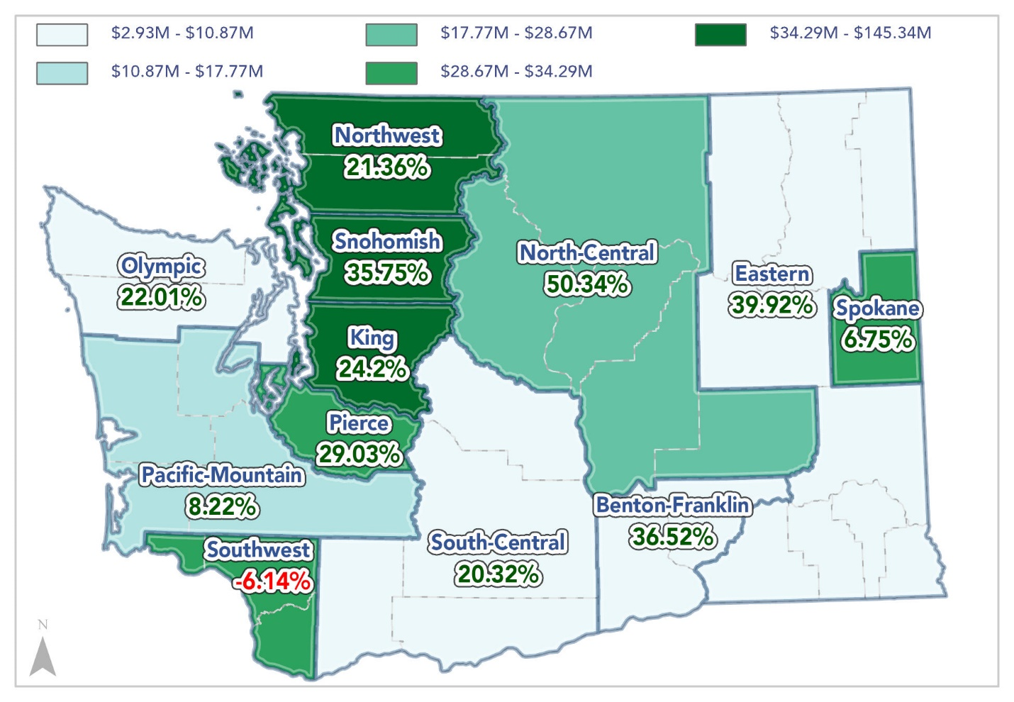

Below is a table displaying Washington state Department of Revenue’s regional gross business income within the Remediation and other Waste Management Services industry. GBI from 2019 to 2021 collected by the Department of Revenue organized by the 12 workforce development regions.
Table 5: Gross Business Income for Remediation and Other Waste Management Services (NAICS 5629) by Workforce Development Region, 2019-2021
Workforce Development Area | 2019 | 2020 | 2021
Benton Franklin | $7,962,900 | $8,625,506 | $10,871,248
Eastern | $2,095,691 | $2,363,613 | $2,932,318
King | $117,025,943 | $122,062,820 | $145,347,827
North-Central | $19,073,197 | $21,386,341 | $28,673,777
Northwest | $96,864,011 | $98,027,095 | $117,549,541
Olympic | $6,752,672 | $7,613,499 | $8,238,855
Pacific Mountain | $16,426,958 | $16,425,039 | $17,776,537
Pierce | $24,950,037 | $29,601,107 | $32,192,945
South Central | $8,207,905 | $9,962,180 | $9,875,960
Snohomish | $67,476,625 | $72,938,321 | $91,602,155
Southwest | $36,536,390 | $33,438,228 | $34,291,270
Spokane | $29,550,993 | $29,044,081 | $31,545,480
Out of State | $926,298,254 | $963,201,713 | $1,464,281,003
Total (in state) | $432,923,322 | $451,487,830 | $530,897,913
Total | $1,359,221,576 | $1,414,689,543 | $1,995,178,916

Source: Department of Revenue

The Recyclable Material Merchant Wholesalers Industry
Recyclable Material Merchant Wholesalers deal with materials ranging from bags, bottles, boxes, electronic parts, industrial waste, metal, oil, paper, plastic, rags, rubber, textile, and other scrap materials. This means that a portion of the income within this industry’s analysis, such as oil and electronic parts, do not directly affect the materials examined in this report (paper, glass, plastic, organics, metal and textiles) but are still relevant to material recovery and the overall industry.
As of the first quarter of 2022, the Recyclable Material Merchant Wholesalers industry (NAICS 423930) in Washington state employs 1,548 employees. Of the 37 Merchant Wholesalers Industry types, Recyclable Materials ranks 18th in employment. Other related Merchant Wholesaler Industries that may influence recycling include Metal Service Centers and Other Metal Merchant Wholesalers (NAICS 423510), employing 2,563 in Washington state, and Construction and Mining (except Oil Well) Machinery and Equipment Merchant Wholesalers (NACIS 423810) employing 1,616 employees. Merchant Wholesalers of Durable Goods industry (NAICS 423) consists of 69,780 employees in Washington’s workforce, with average annual wages of $101,623. The Recycling Material Merchant Wholesalers industry (NAICS 423930) has an average annual wage of $62,824, the third lowest within the Merchant Wholesale industry. This industry in Washington is forecasted to have a growth rate of 0.9% within the next year, which is identical to the average of the Merchant Wholesale industry rate, but 0.6% below the industry average of 1.5% growth. At a 0.9% growth rate, employees are expected to increase by 44 within the next three years, 73 within the next five years, and 150 within the next ten years.

Employment and Salaries
The following table displays the number of establishments, employment count, and average 2019 salaries of Washington’s Recyclable Material Merchant Wholesalers (NAICS 423930) split by employment size. The highest earning salaries are for companies that employ 100-499 employees, at $69,428 average 2019 salary. There are a total of 143 establishments for Recyclable Material Merchant Wholesalers in Washington state, with the average employee earning a salary of $53,981.
Table 6: Number of Establishments, Employment, and Average Salary of Recyclable Material Merchant Wholesalers in Washington state, 2019
Recyclable Material Merchant Wholesalers
Employment Size | Number of Establishments | Employment | Average Salary
Less than 5 employees | 55 | 98 | $36,918
5-9 employees | 16 | 95 | $46,295
10-19 employees | 28 | 326 | $49,344
20-99 employees | 19 | 643 | $48,005
100-499 employees | 11 | 540 | $69,428
More than 500 employees | 14 | 440 | $52,652
Total in  Recyclable Material Merchant Wholesalers | 143 | 2,412 | $53,981
Source: United States Census Bureau
For the tables above, data is gathered from 2019 United States Census Bureau County Business Patterns dataset. The number of establishments differs from firm count within this data set. Average salaries were found from dividing annual payroll by employee count.
The United States Census Bureau defines employment and establishment as the following:
Employment
Paid employment consists of full- and part-time employees, including salaried officers and executives of corporations, who are on the payroll in the pay period including March 12. Included are employees on paid sick leave, holidays, and vacations; not included are sole proprietors and partners of unincorporated businesses.
Establishment
An establishment is a single physical location at which business is conducted or services or industrial operations are performed. It is not necessarily identical with a company or enterprise, which may consist of one or more establishments. When two or more activities are carried on at a single location under a single ownership, all activities generally are grouped together as a single establishment. The entire establishment is classified on the basis of its major activity and all data are included in that classification. Establishment counts represent the number of locations with paid employees any time during the year.

Gross Business Income
The following chart illustrates a graph of Gross Business Income of the Recyclable Material Merchant Wholesalers in Washington state from 2018 to 2022 quarterly. It shows the income in millions of dollars up until the first quarter of 2022, the most recent data posted from the Department of Revenue. In the first quarter of 2018, gross revenue was nearly $265 million dollars, with a downward trend throughout the rest of the year and into 2019. In quarter 2 of 2020, GBI dropped to $205 million, before beginning a strong upward trend, peaking at $447,385,667 in the second quarter of 2021. The most recent amount from the first quarter of 2022 has total income at $470,859,901.

Figure 5: Gross Business Income of Recyclable Material Merchant Wholesalers in Washington state, 2018-2022
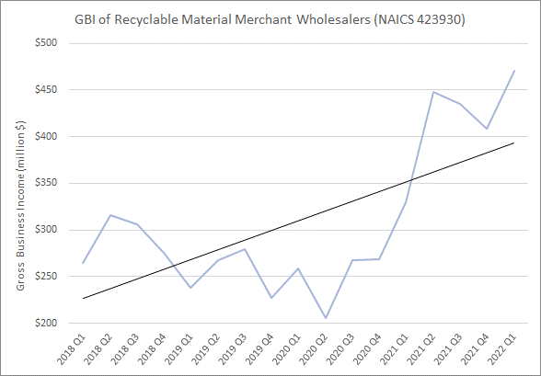
Source: Department of Revenue

Company Income
Below is a table of the top 10 companies by reported income in Washington state within Recyclable Material Merchant Wholesalers. Seattle Iron & Metals Corporation located in Seattle has annual income of $35 million. Schnitzer Steel Industries is headquartered in Portland, Oregon, but has its largest Washington location by reported income in Tacoma. Other locations in Washington include Arlington, Lynwood, Woodinville, Pasco, Tumwater, and Vancouver. Their annual income is around $28 million, followed by Simon Metals at $19 million, also located in Tacoma.
Table 5: Top 10 Companies by Reported Income in the Recyclable Material Merchant Wholesalers (NAICS 423930) industry, Washington state
Company Name | Reported Income | Location | Employment
Seattle Iron & Metals Corp | $34,946,116 | Seattle | 125
Schnitzer Steel Industries, Inc. | $28,035,391 | Tacoma | 117
Simon Metals, LLC | $19,380,043 | Tacoma | 70
Buffalo Industries LLC | $10,859,054 | Kent | 27
General Metals of Tacoma, Inc. | $9,000,000 | Tacoma | 110
American Recycling Corp | $7,205,498 | Spokane | 25
Pacific Coast Shredding LLC | $7,096,025 | Vancouver | 242
Spokane Recycling Products, LLC | $6,712,744 | Spokane | 20
Ecolights Northwest, LLC | $5,482,364 | Seattle | 26
Global Fiberglass Solutions of Texas, LLC | $4,993,662 | Bothell | 30
Source: Dun & Bradstreet
Dun & Bradstreet is a business directory source used in this report for identifying recycling companies. Dun & Bradstreet data owns the Mergent Intellect directory of business information, which is collected on a rolling basis through questionnaires and surveys. This data source is utilized to display the companies involved in recycling, but the reported income is an estimation gathered from surveys and collection bias. A more accurate representation of income is organized by region using data from the Department of Revenue in the Revenue by Region section.

Revenue by region
The Gross Business Income Data on Waste Management taxpayers and Recyclable Material Merchant Wholesale taxpayers is organized by workforce development area. A map of the Workforce Development¹¹ areas and a list of which counties are in each region is in Appendix B of this report.
Within 2021, the in-state average total GBI of the Recyclable Material Merchant Industry (NAICS 423930) was 9,137,344. This is a sizeable increase of GBI, as it is 1.7 times greater than the previous year’s average total GBI. The 2019 and 2020 average GBI totals were 5,050,114 and 5,386,065, respectively. Seattle-King has the highest count of taxpayers at 44, greatest total GBI of $362,308,205, and highest average per taxpayer at $8,234,277. Pierce county followed with 23 taxpayers and a total GBI of $104,976,783, followed by the Pacific-Mountain region with 13 taxpayers collecting $88,249,101 in total GBI. From 2019 to 2021, several workforce development areas in Washington had sizeable increases in Total GBI. Pacific-Mountain experienced a large increase in total GBI of 190% from two years prior, with Olympic and North-Central following at 96% and 87%, respectively. Pierce County is the only county that experienced a decline in GBI from the two years by 4%. These values are calculated by taking the difference between 2021 and 2019 total GBI values and dividing by the 2019 total GBI.

Figure 6: Recyclable Material Merchant Wholesaler (NAICS 423930) Taxpayer Count and Average GBI per Taxpayer (2021) by Workforce Development Area [Patterned areas represent higher average GBI per taxpayer] 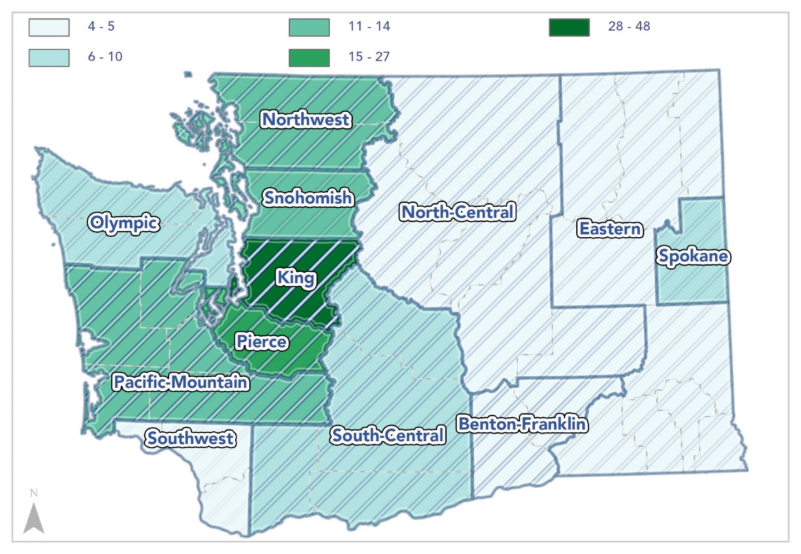

Figure 7: Recyclable Material Merchant Wholesaler (NAICS:423930) Gross Business Income (2021) by Workforce Development Area [Percentages represent change in GBI between 2019 and 2021] 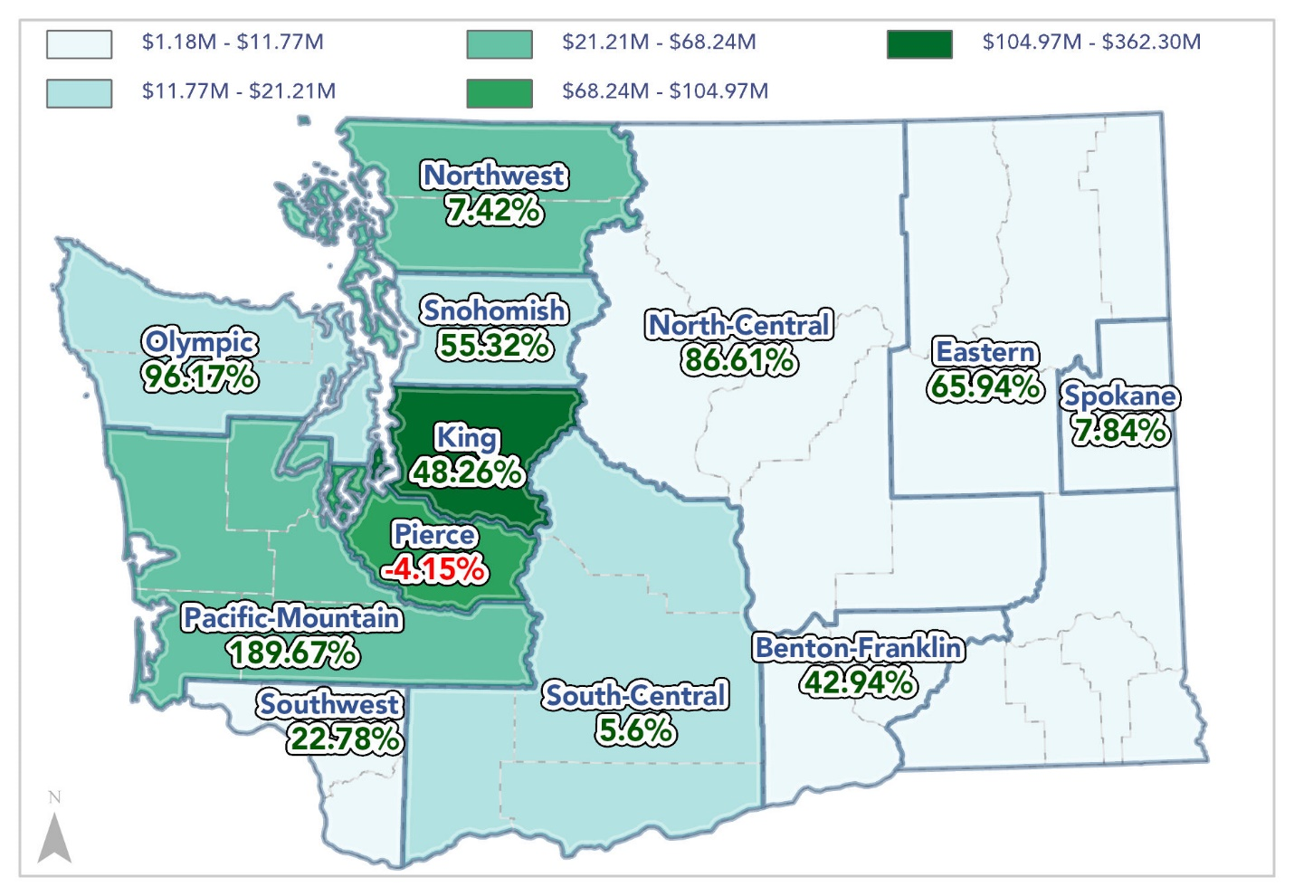

Below is a table displaying Washington state Department of Revenue’s regional gross business income within the Recyclable Material Merchant Wholesale industry. GBI from 2019 to 2021 collected by the Department of Revenue organized by the 12 workforce development regions.
Table 7: Gross Business Income Recyclable Material Merchant Industry, Washington state WFDR, 2019-2021
Workforce Development Area | 2019 | 2020 | 2021
Benton Franklin | $6,149,172 | $5,256,379 | $8,789,499
Eastern | $2,760,102 | $2,876,638 | $4,580,199
King | $244,366,740 | $222,239,502 | $362,308,205
North-Central | $6,308,341 | $5,643,261 | $11,772,010
Northwest | $39,474,350 | $37,447,741 | $42,404,575
Olympic | $7,124,985 | $8,395,103 | $13,977,307
Pacific Mountain | $23,560,640 | $29,055,775 | $68,249,101
Pierce | $109,518,055 | $81,180,842 | $104,976,783
South Central | $20,086,406 | $17,728,340 | $21,210,453
Snohomish | $13,046,706 | $16,857,338 | $20,263,971
Southwest | $962,724 | $525,742 | $1,181,987
Spokane | $7,527,235 | $5,327,505 | $8,117,738
Out of state | $524,087,260 | $563,887,847 | $949,478,139
Total (in state) | $480,885,456 | $432,534,166 | $667,831,828
Total | $1,004,972,716 | $996,422,013 | $1,617,309,967

Source: Department of Revenue

Survey Directory
CEBR developed and conducted two surveys using Qualtrics, which were sent to manufacturers, processors, and collectors of recycled materials within Washington state, using contacts provided by the Department of Ecology. Responses were intended to identify capacities, needs, gaps, barriers, supply chains, and opportunities for use of recyclable materials within Washington state. Questions were developed by CEBR staff based on Department of Ecology needs. Results utilized within this document only. This baseline survey report can serve as a reference point for future progress, and to help identify existing and potential benefits of recycling. The “n=” number refers to the number of responses to the associated question.
Contacts provided within Appendix D

Questions within Survey 1
The questions and number of responses from the first survey are outlined below. Development of this survey began April 18, 2022, and the survey was published on June 20, 2022. These questions focused on identifying types of recycled materials and other corresponding business information. Within Appendix C, all facilities contacted, and their business’ activity type are mapped within the six Waste Generation Regions. This survey was sent to 1153 emails provided by the Department of Ecology.
(Total Respondents: 44) (Completion Rate: 70%)
- What is the name of your business? (n=38)
- Where is your business located? (n=38)
- What type of business or facility type would best describe your business? (select all that apply) (n=38)
  - Hauler (n=9)
  - Material Recovery Facility (n=17)
  - Broker (n=1)
  - Manufacturer (n=6)
  - Curbside Pickup (n=3)
  - Other (n=15)
  - My business does not process recyclables (if selected, end of survey) (n=9)
- How many employees does your company have? (n=29)
- How many full-time equivalent employees does your company have? Full-time equivalent employees are your total number of weekly scheduled employee hours divided by a 40-hour full-time workweek. (n=29)
- What are the total annual wages paid out by your company? (n=27)
  - Below $500,000 (please specify) (n=10)
  - $500,000 - $750,000 (n=4)
  - $750,000 - $1,000,000 (n=2)
  - $1,000,000 - $1,250,000 (n=0)
  - $1,250,000 - $1,500,000 (n=4)
  - $1,500,000 - $1,750,000 (n=1)
  - $1,750,000 - $2,000,000 (n=3)
  - More than $2,000,000 (please specify) (n=3)
- What types of recyclables does your business process? (select all that apply) (n=27)
  - Paper (Go to Q8) (n=9)
  - Glass (Go to Q9) (n=5)
  - Plastic (Go to Q10) (n=6)
  - Organics (Go to Q11) (n=6)
  - Metals (Go to Q12) (n=12)
  - Textiles (Go to Q13) (n=3)
  - Other (Go to Q14) (n=14)
- What type of paper recycling do you do? (n=4)
  - Paper mill [annual amount processed/capture-ratio/% shipped out of state] (n=3)
  - Paperboard mill [annual amount processed/capture-ratio/% shipped out of state] (n=3)
  - All other converted paper product manufacturing [annual amount processed/capture-ratio/% shipped out of state] (n=1)
  - Something unlisted: [fill in here] [annual amount processed/capture-ratio/% shipped out of state] (n=1)
- What type of glass recycling do you do? (n=0)
  - Other pressed and blown glass and glassware manufacturing [annual amount processed/capture-ratio/% shipped out of state] (n=0)
  - Glass product manufacturing made of purchased glass [annual amount processed/capture-ratio/% shipped out of state] (n=)0
  - Something unlisted: [fill in here] [annual amount processed/capture-ratio/% shipped out of state] (n=3)
- What type of plastic recycling do you do? (n=5)
  - Plastic material and resin manufacturing [annual amount processed/capture-ratio/% shipped out of state] (n=1)
  - Something unlisted: [fill in here] [annual amount processed/capture-ratio/% shipped out of state] (n=4)
- What type of organics does your business process? (n=4)
  - Supermarkets and other grocery (except convenience) store [annual amount processed/capture-ratio/% shipped out of state] (n=0)
  - Solid waste collections and materials recovery facility [annual amount processed/capture-ratio/% shipped out of state] (n=1)
  - Organics, food recovery, waste diversion, composting [annual amount processed/capture-ratio/% shipped out of state] (n=4)
  - Something unlisted: [fill in here] [annual amount processed/capture-ratio/% shipped out of state] (n=2)
- What type of metal recycling do you do? (n=5)
  - Steel product manufacturing and nonferrous metal smelting [annual amount processed/capture-ratio/% shipped out of state] (n=2)
  - Iron foundries and Steel investment foundries [annual amount processed/% shipped out of state] (n=0)
  - Nonferrous and aluminum metal foundries and die-casting foundries [annual amount processed/capture-ratio/% shipped out of state] (n=3)
  - Other commercial equipment merchant wholesalers [annual amount processed/capture-ratio/% shipped out of state] (n=2)
  - Something unlisted: [fill in here] [annual amount processed/capture-ratio/% shipped out of state] (n=4)
- What type of textile recycling do you do? (n=2)
  - Recyclable material merchant wholesalers [annual amount processed/capture-ratio/% shipped out of state] (n=1)
  - Something unlisted: [fill in here] [annual amount processed/capture-ratio/% shipped out of state] (n=1)
- What type of other recycling do you do? (n=6)
  - Recyclable material merchant wholesalers [annual amount processed/capture-ratio/% shipped out of state] (n=0)
  - Something unlisted: [fill in here] [annual amount processed/capture-ratio/% shipped out of state] (n=6)

Questions within Survey 2
The questions and number of responses from the second survey are outlined below. Development of this survey began September 14, 2022 and was published on October 6, 2022. A second survey was created to better understand material movement throughout the state after expressing the potential issues from the first survey to the Department of Ecology project managers. CEBR paired with Impact WA to help with the distribution and targeting of relevant companies. This survey was sent to 616 emails.
(Total Respondents: 50) (Completion Rate: 36%)
- What is the name of your business? (n=38)
- Where is your business located? (n=30)
- What type of business or facility type would best describe your business? (select all that apply) (n=32)
  - Hauler (n=3)
  - Material Recovery Facility (n=11)
  - Broker (n=1)
  - Manufacturer (n=6)
  - Curbside Pickup (n=5)
  - Other [if selected, fill in the blank] (n=18)
- Regarding your business, what types of materials does your business process? (select all that apply) (n=31)
  - Paper (n=7)
  - Glass (n=4)
  - Plastic (n=5)
  - Organics (n=9)
  - Metals (n=7)
  - Textiles (n=4)
  - Not listed (n=10)
- (For every box checked above (a-g), the following questions will be asked:)
- Where do you get your materials from?
  - Hauler (n=18)
    - [If selected] How much annually (in tonnage): (n=15)
  - Material Recovery Facility (n=12)
    - [If selected] How much annually (in tonnage): (n=3)
  - Broker (n=4)
    - [If selected] How much annually (in tonnage): (n=3)
  - Manufacturer (n=5)
    - [If selected] How much annually (in tonnage): (n=2)
  - Curbside Pickup (n=22)
    - [If selected] How much annually (in tonnage): (n=9)
- Next, where does this material go after leaving your facility? (Please answer how much annually in tonnage) (n=46)
  - In state [check boxes for which Washington counties] (n=35)
  - Out of state [check boxes for which US states] (n=9)
  - Out of the country [check boxes for world region and text box for listing countries] (n=2)
- [Optional] Anything else you would like to share about this material or your answers above? (n=4)
- How many full-time equivalent employees do you have? (Full-time equivalent employees are your total number of weekly scheduled employee hours divided by a 40-hour full-time workweek.) (n=18)
- In your best estimate, what are the total annual wages paid out by your company? (Wage bands) (n=18)
  - Below $500,000 (please specify) (n=10)
  - $500,000-$750,000 (n=1)
  - $750,000-$1,000,000 (n=2)
  - $1,000,000-$1,250,000 (n=0)
  - $1,250,000-$1,500,000 (n=0)
  - $1,500,000-$1,750,000 (n=0)
  - $1,750,000-$2,000,000 (n=1)
  - More than $2,000,000 (please specify) (n=4)
[Optional] Would you like to share anything you are doing to reduce your environmental impact or emissions? (n=7)

Results
For the detailed report, please see separate PDF attachment.
- First Survey
  - By facility/business type: 29% MRF, 15% Haulers, 2% Broker, 10% Manufacturer, 5% Curbside Pickup, 25% Other, and 16% did not process recyclables
  - By material processed: 16% paper, 9% glass, 11% plastic, 11% organics, 21% metals, 7% textiles
  - By wage band: [36% <$500,000] [18% $500,000 - $750,000] [7% $750,000 - $1,000,000] [14% $1,250,000 - $1,500,000] [4% 1,500,000 - $1,750,000] [11% $1,750,000 - $2,000,000] [11% >$2,000,000]
- Second Survey
  - By facility/business type: 25% MRF, 7% Hauler, 2% Broker 14% Manufacturer, 11% Curbside Pickup, 41% other
  - By material processed: 14% paper, 8% glass, 12% plastic, 20% organics, 15% metals, 8% textiles, 25% not listed
  - Most respondents report sending materials to locations within WA (78% report materials stay in state, 18% out of state, and only 4% out of country)
    - The county respondents reported sending materials to the most often was Pierce, followed by King and San Juan (even though it is not a recycling hub)
    - The majority of out of state locations reported were Oregon and Idaho
    - The only reports of materials leaving the country were to Canada and Pakistan
  - By wage band: [10% <$500,000] [6% $500,000 - $750,000] [11% $750,000 - $1,000,000] [6% $1,750,000 - $2,000,000] [22% >$2,000,000]
  - Wage and FTE data suggest a gap in business sizes: 56% report less than $500,000 in yearly wages with an average of 4.7 FTE, 28% report more than $1,750,000 in yearly wages with an average of 101 FTE, the other 16% falls in between.

Limitations
Regarding the first survey, of the 38 who answered question 3, 9 (15%) indicated that they did not process recyclables.
Preliminary results indicate that “Capture-ratio” was a potentially confusing term and may have been clearer as “Diversion Rate.” No respondents answered questions related to where they procure their materials.
The second survey had a lower completion rate despite our best efforts to distribute and follow up with phone calls. A more targeted approach using activity types exclusive to recycling may yield better results for future surveys but would fail to capture potential gaps. Feedback collected while making follow-up phone calls with survey contacts implies that some of the data collected in our survey is data that is already reported to the state government, yet our attempts to source it were unsuccessful. Survey questions require refinement and should be easily deployable and transferable between future reports. Additional collaboration between Dept. Of Ecology and survey writers would maximize future survey success.
Additional limitations within this survey include the defining factors of “recycling” are not identical across the industry. Certain industries that specialize in a material not recyclable may have a byproduct used in the recycling industry. This was discovered within the results of our survey as some construction and concrete facilities that took the survey but did not disclose their business as a “recycler,” even if their byproducts are carried throughout the recycling industry. This was apparent in both surveys’ results and is due to classifications defined by WA solid waste handling standards (Chapter 173-350 WAC).

Conclusion
- Survey results are inconclusive in terms of detailed movement of materials and estimates of total quantities, but are useful in terms of generalized movement
  - In many cases, responses with detailed quantities come from only one source, making it impossible to average
  - Reported amounts only account for a small number of businesses based on the NAICS codes
  - Businesses did report the type of facility they receive materials from, as well as where they send them to within the second survey, which begins to build the data needed for establishing a material chain
- Most respondents who reported materials they process stay within Washington stay in Washington, top counties being Pierce and King County
- Most respondents reporting that they send materials out of state indicate they end up in Idaho or Oregon
- One respondent reported sending materials to Pakistan
- A next step recommended from this survey includes further investigation into top businesses within associated NAICS codes to ascertain estimates of material quantities though surveys or direct interviews

Appendix A

Figure 8: Gross Business Income of Waste Collection in Washington state, 2018-2022

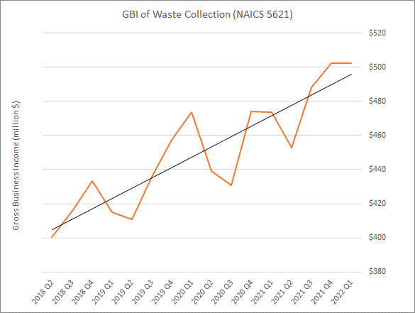
Source: Department of Revenue

Figure 9: Gross Business Income of Waste Treatment and Disposal in Washington state, 2018-2022

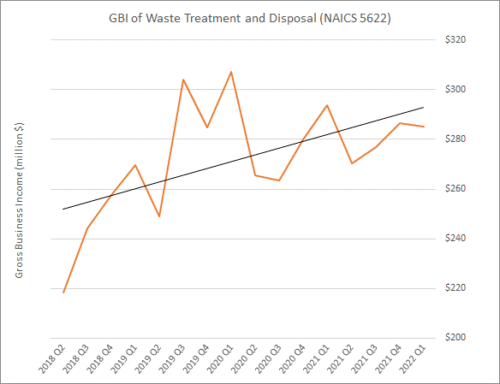
Source: Department of Revenue

Appendix B
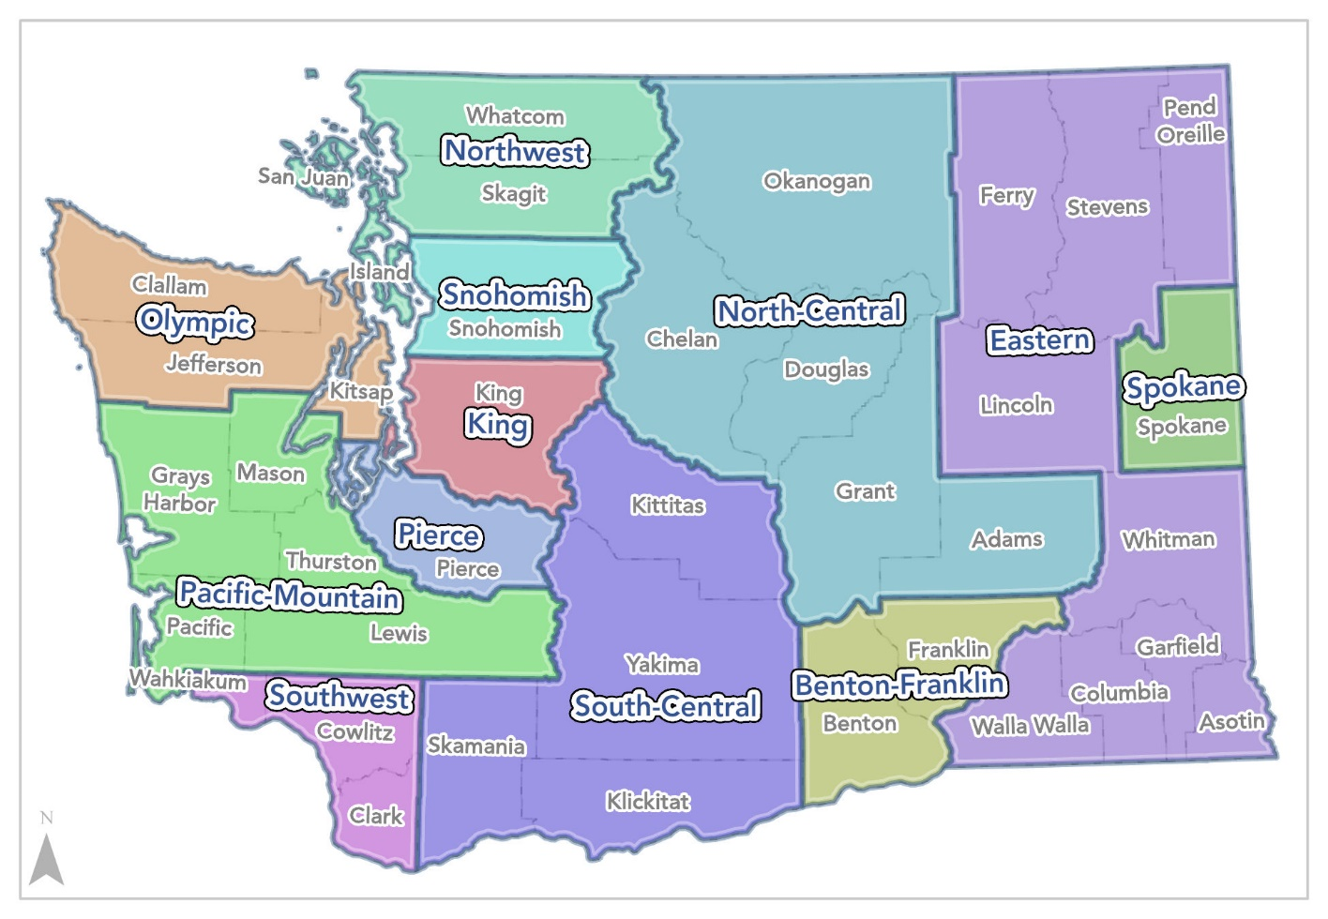
Source: Workforce Development Council
Above is a map of Washington’s workforce development areas from the Regional Workforce Plan website. Each workforce area is overseen by the Workforce Development Councils and creates a four-year workforce plan that offers a vision for their local workforce development system¹¹. The Northwest region includes Island, San Juan, Skagit, and Whatcom counties. Olympic region includes Clallam, Jefferson, and Kitsap counties. The Pacific Mountain region includes Grays Harbor, Mason, Thurston, Lewis, and Pacific counties. The Southwest region includes Wahkiakum, Cowlitz, and Clark counties. The North Central region includes Adams, Chelan, Douglas, Grant, and Okanogan counties. The South-Central region includes Kittitas, Klickitat, Skamania, and Yakima counties. The Benton-Franklin region includes Benton and Franklin counties. The Snohomish, Seattle-King, Tacoma-Pierce, and Spokane counties all have their own region. The Eastern region encompasses all other counties such as Asotin, Columbia, Ferry, Garfield, Lincoln, Pend Oreille, Stevens, Walla Walla, and Whitman counties.

Appendix C
Below are seven maps displaying WA state and six Waste Generation Regions provided by the Department of Ecology’s Waste Characterization Study: Central, East, Northwest, Puget Sound, Southwest, and West. These maps are symbolized based on “Activity Type” and represent the businesses that CEBR attempted to contact as part of the survey process. Non-operational businesses were excluded.

Figure 10: Activity Type of Facilities Involved in Recycling – Washington state Overview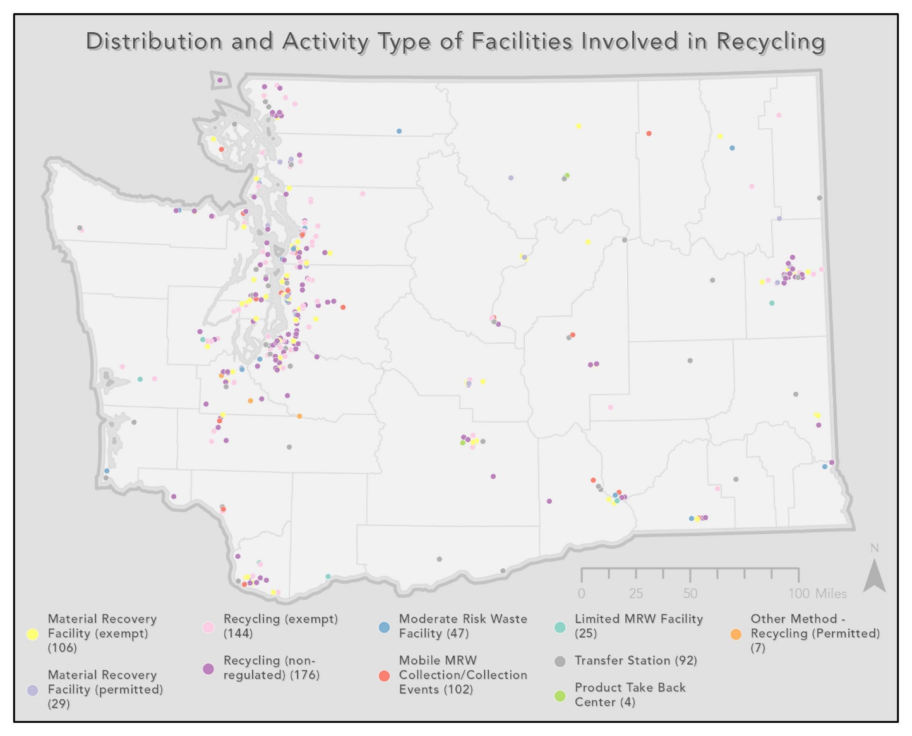

Figure 11: Activity Type of Facilities Involved in Recycling – Central Waste Generation Region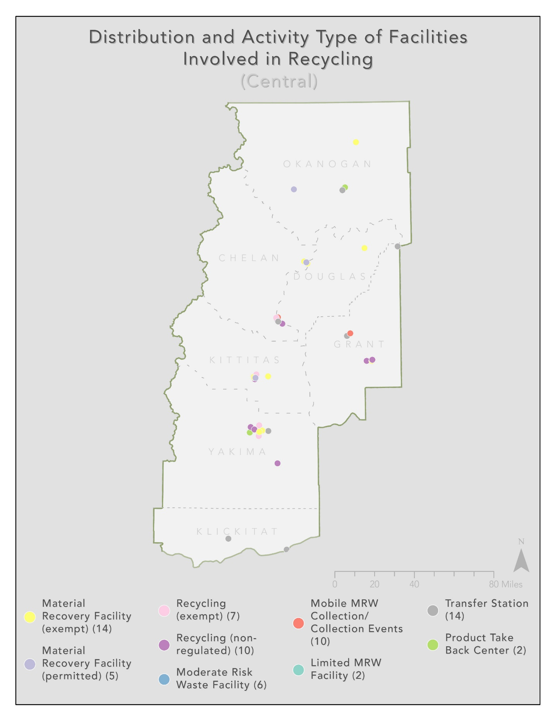
Figure 12: Activity Type of Facilities Involved in Recycling – West Waste Generation Region 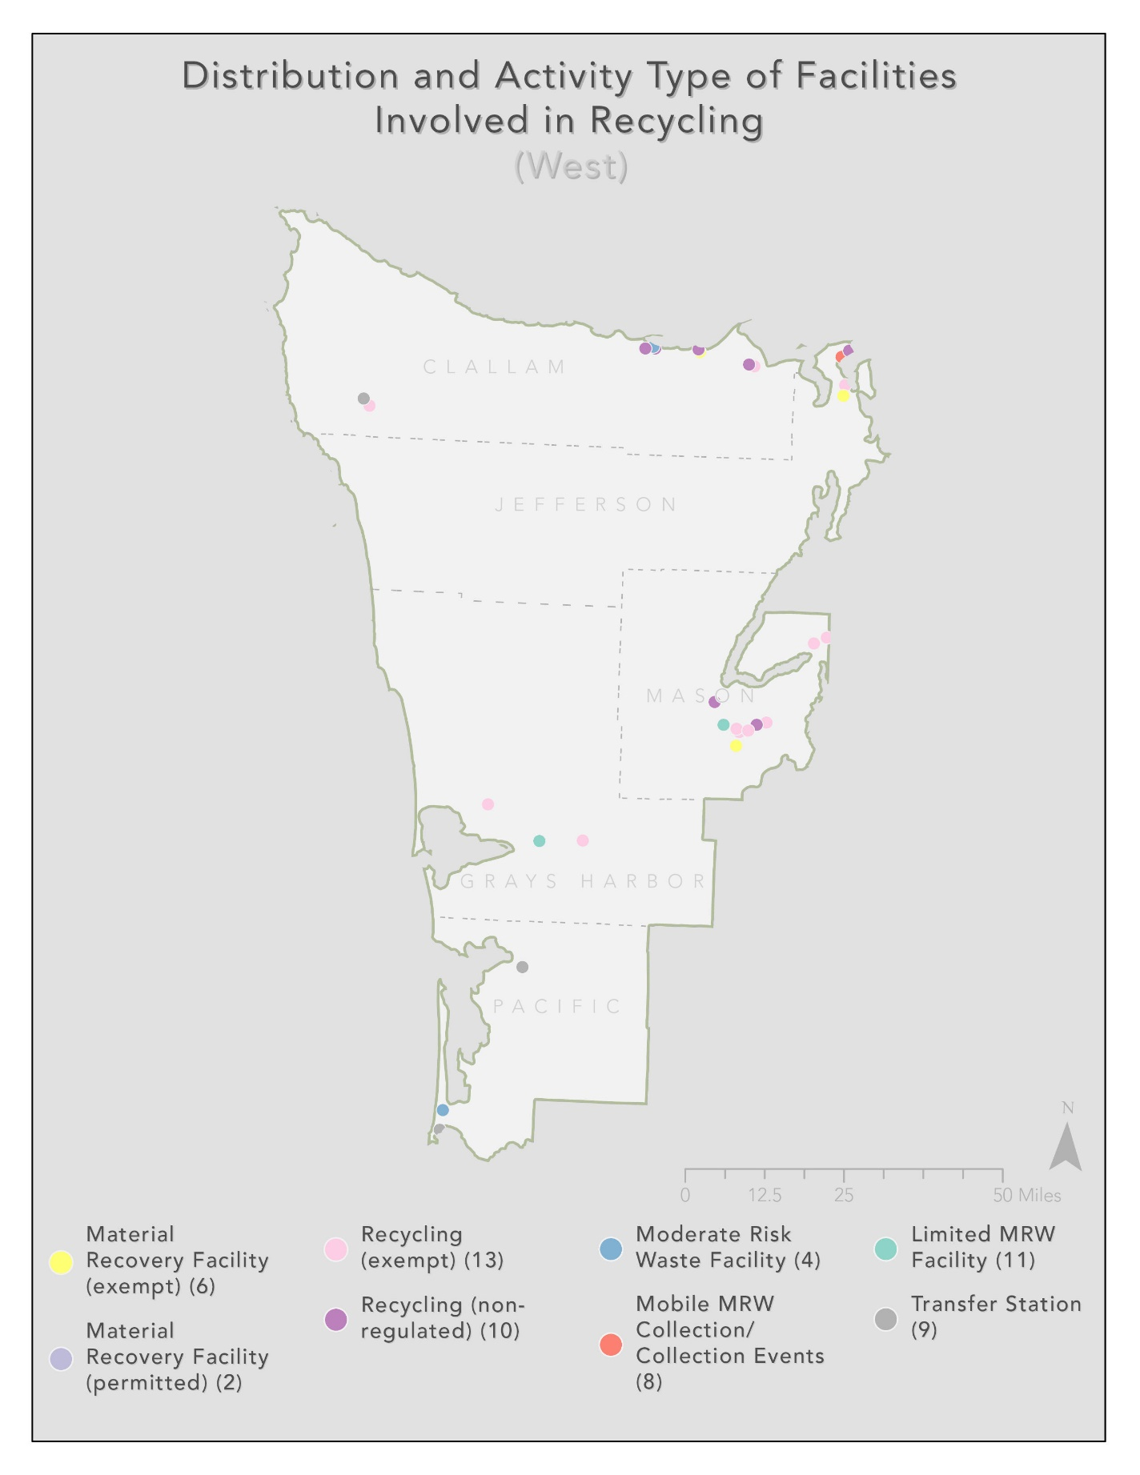
Figure 13: Activity Type of Facilities Involved in Recycling – Southwest Waste Generation Region 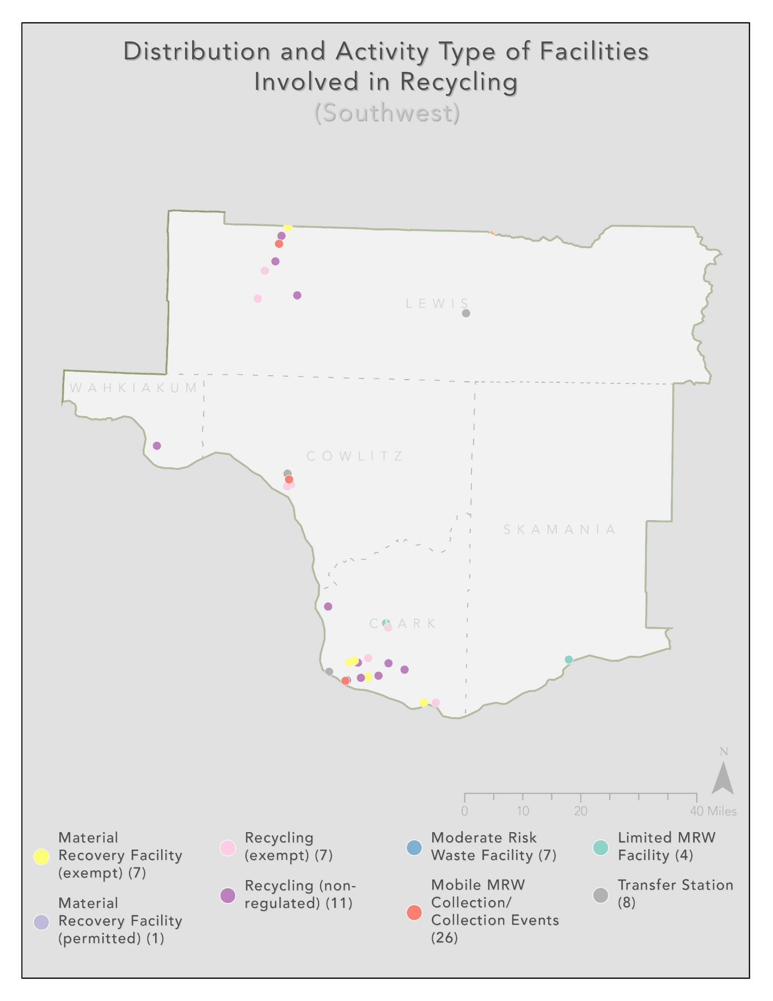
Figure 14: Activity Type of Facilities Involved in Recycling – Puget Sound Waste Generation Region 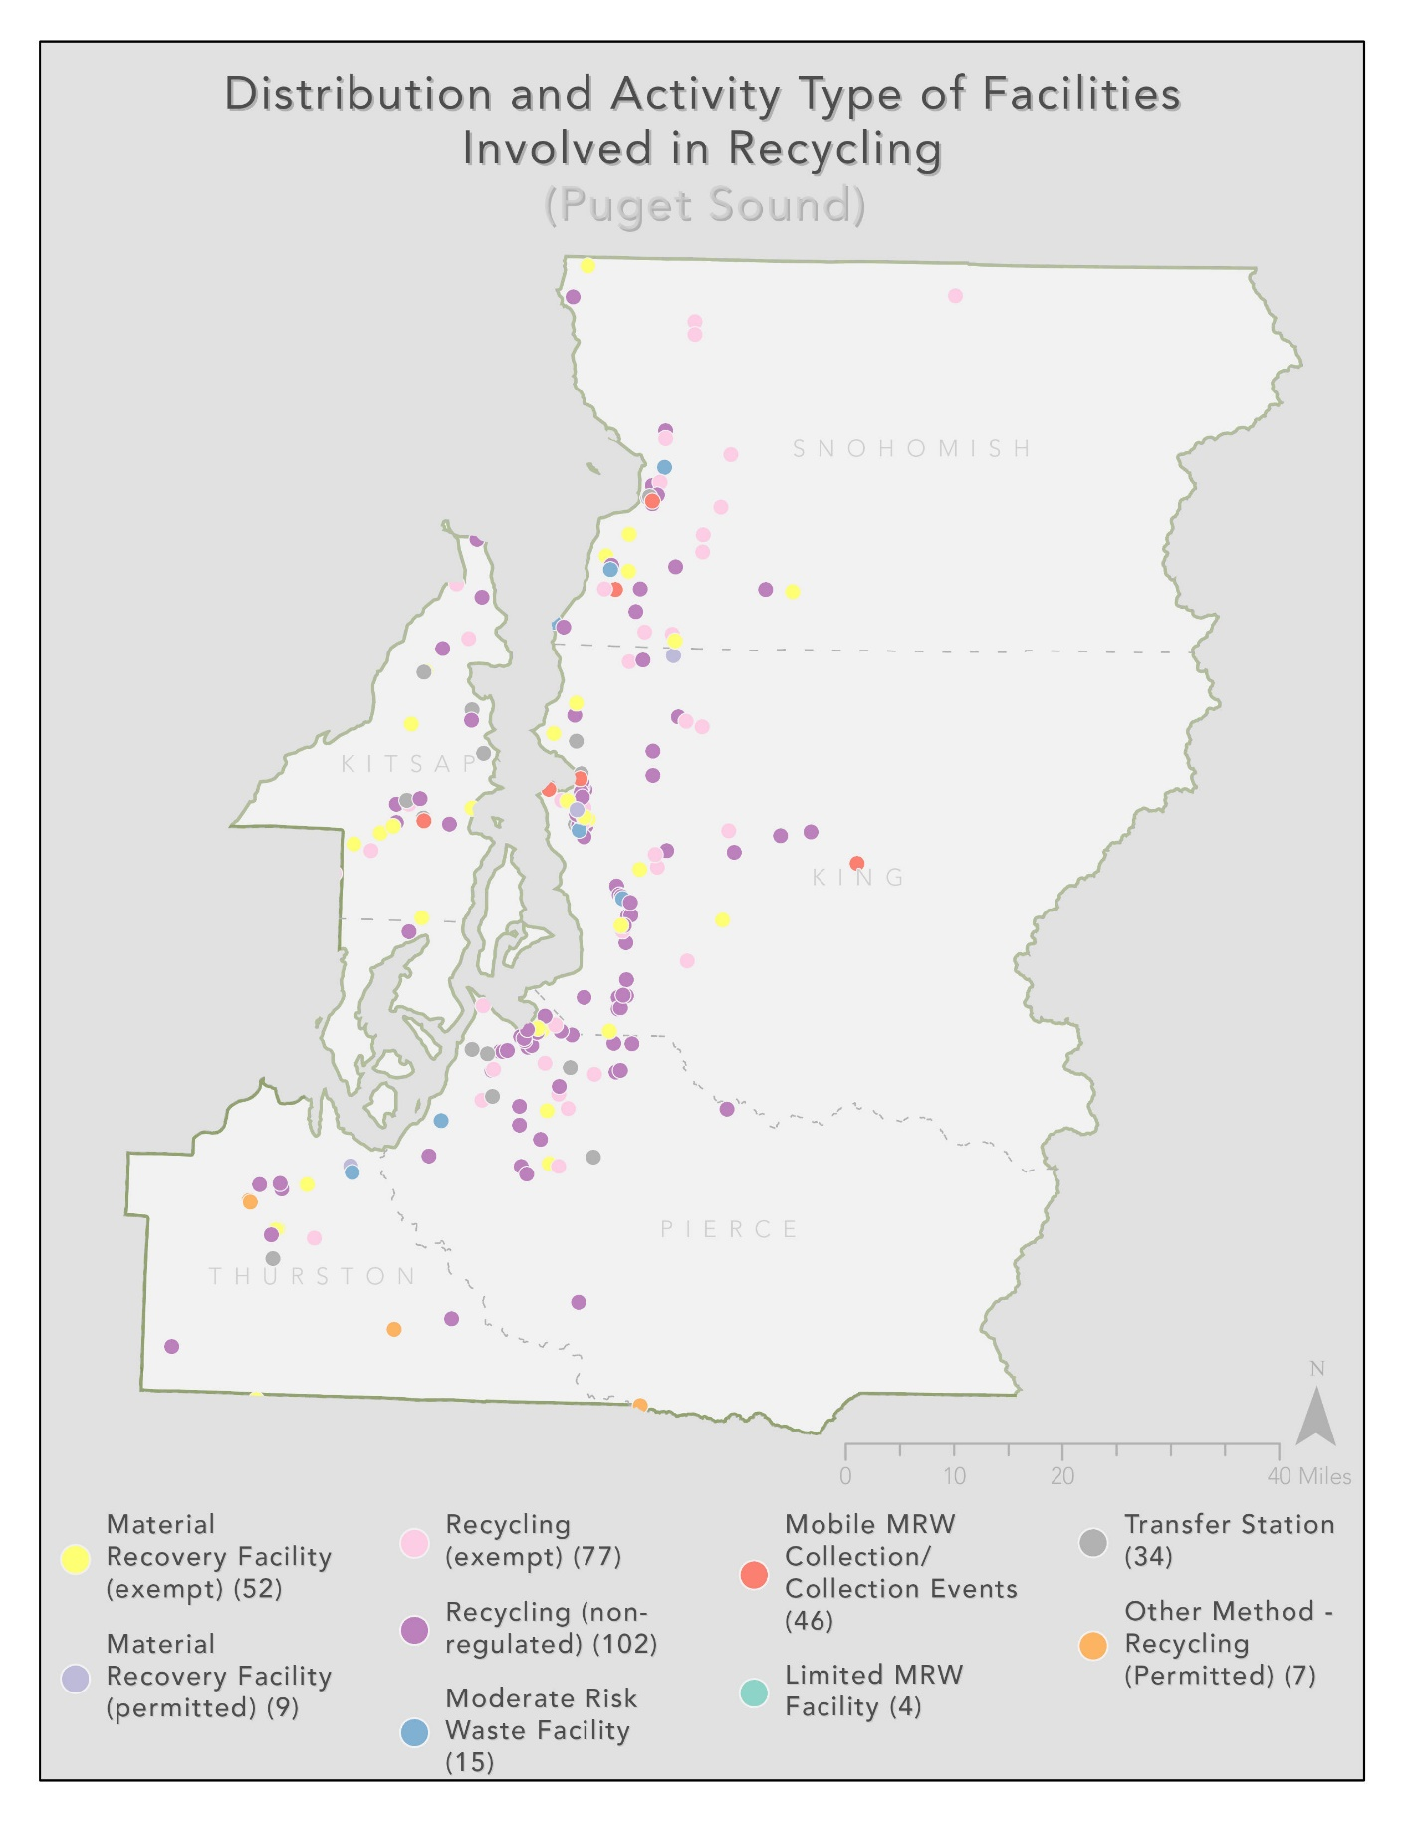
Figure 15: Activity Type of Facilities Involved in Recycling – Northwest Waste Generation Region 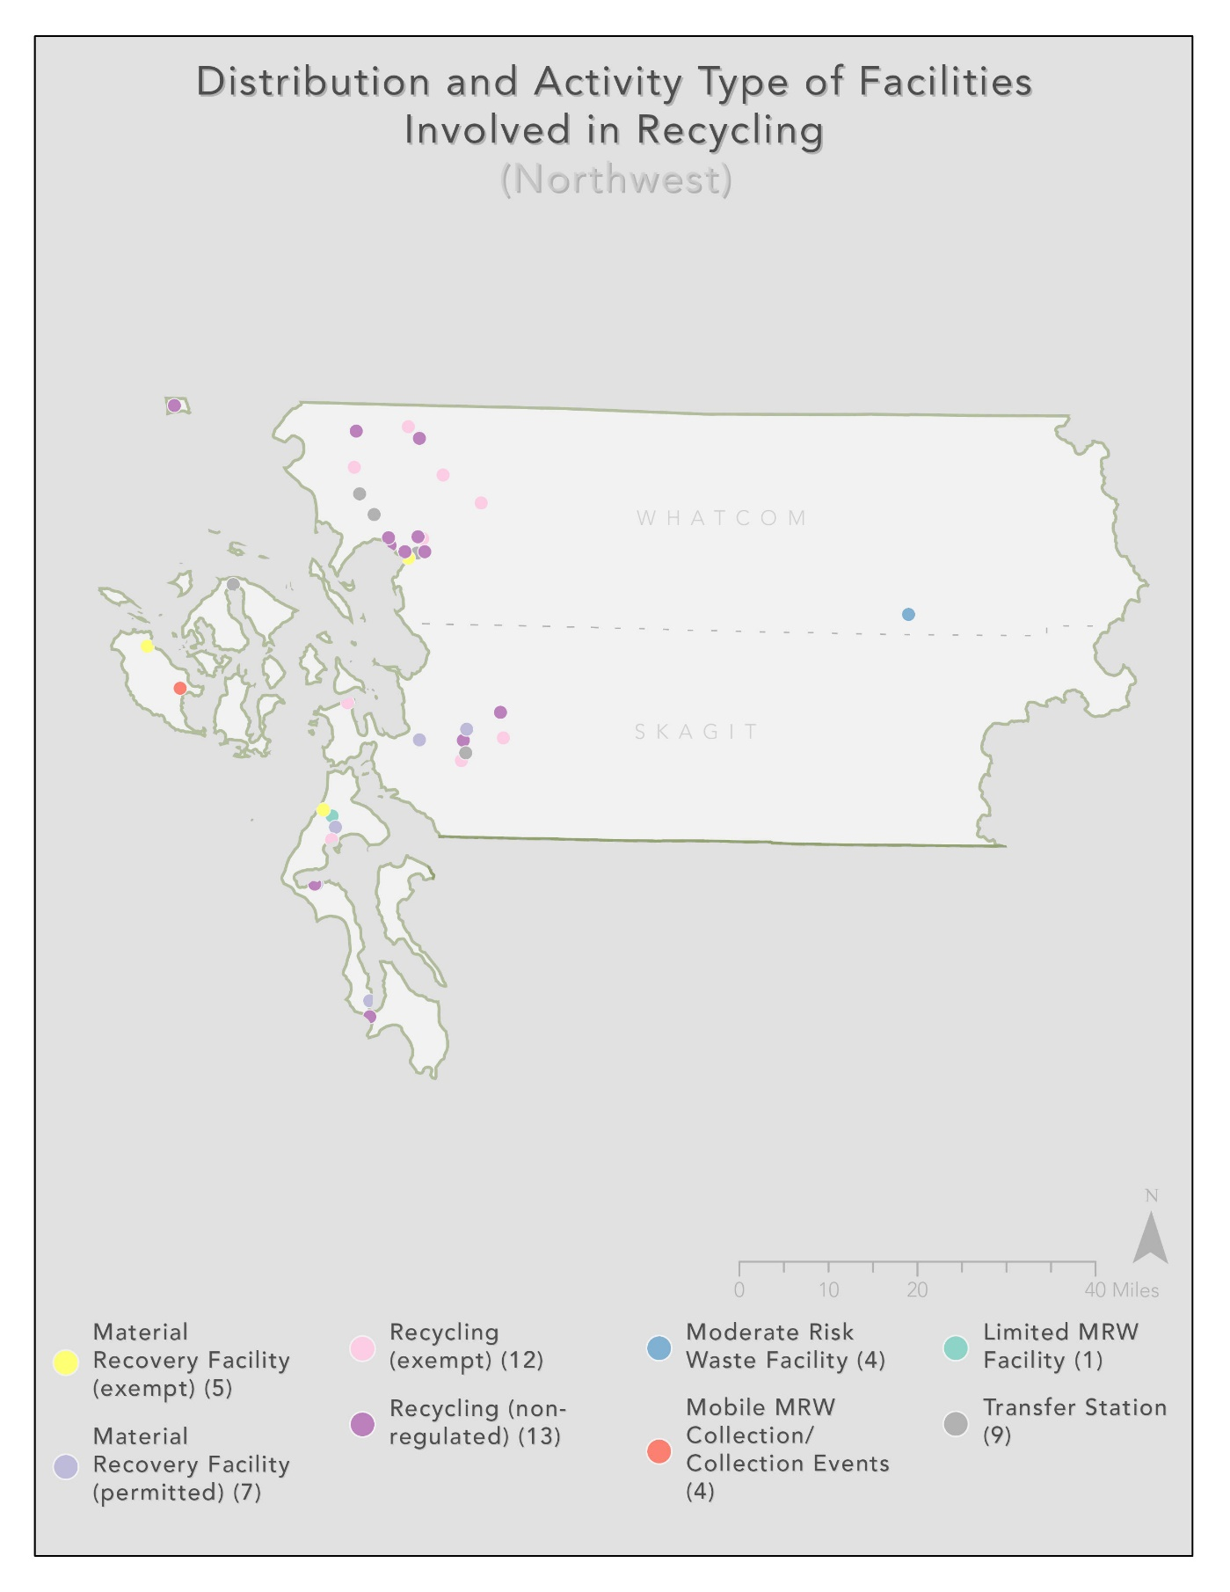
Figure 16: Activity Type of Facilities Involved in Recycling – East Waste Generation Region
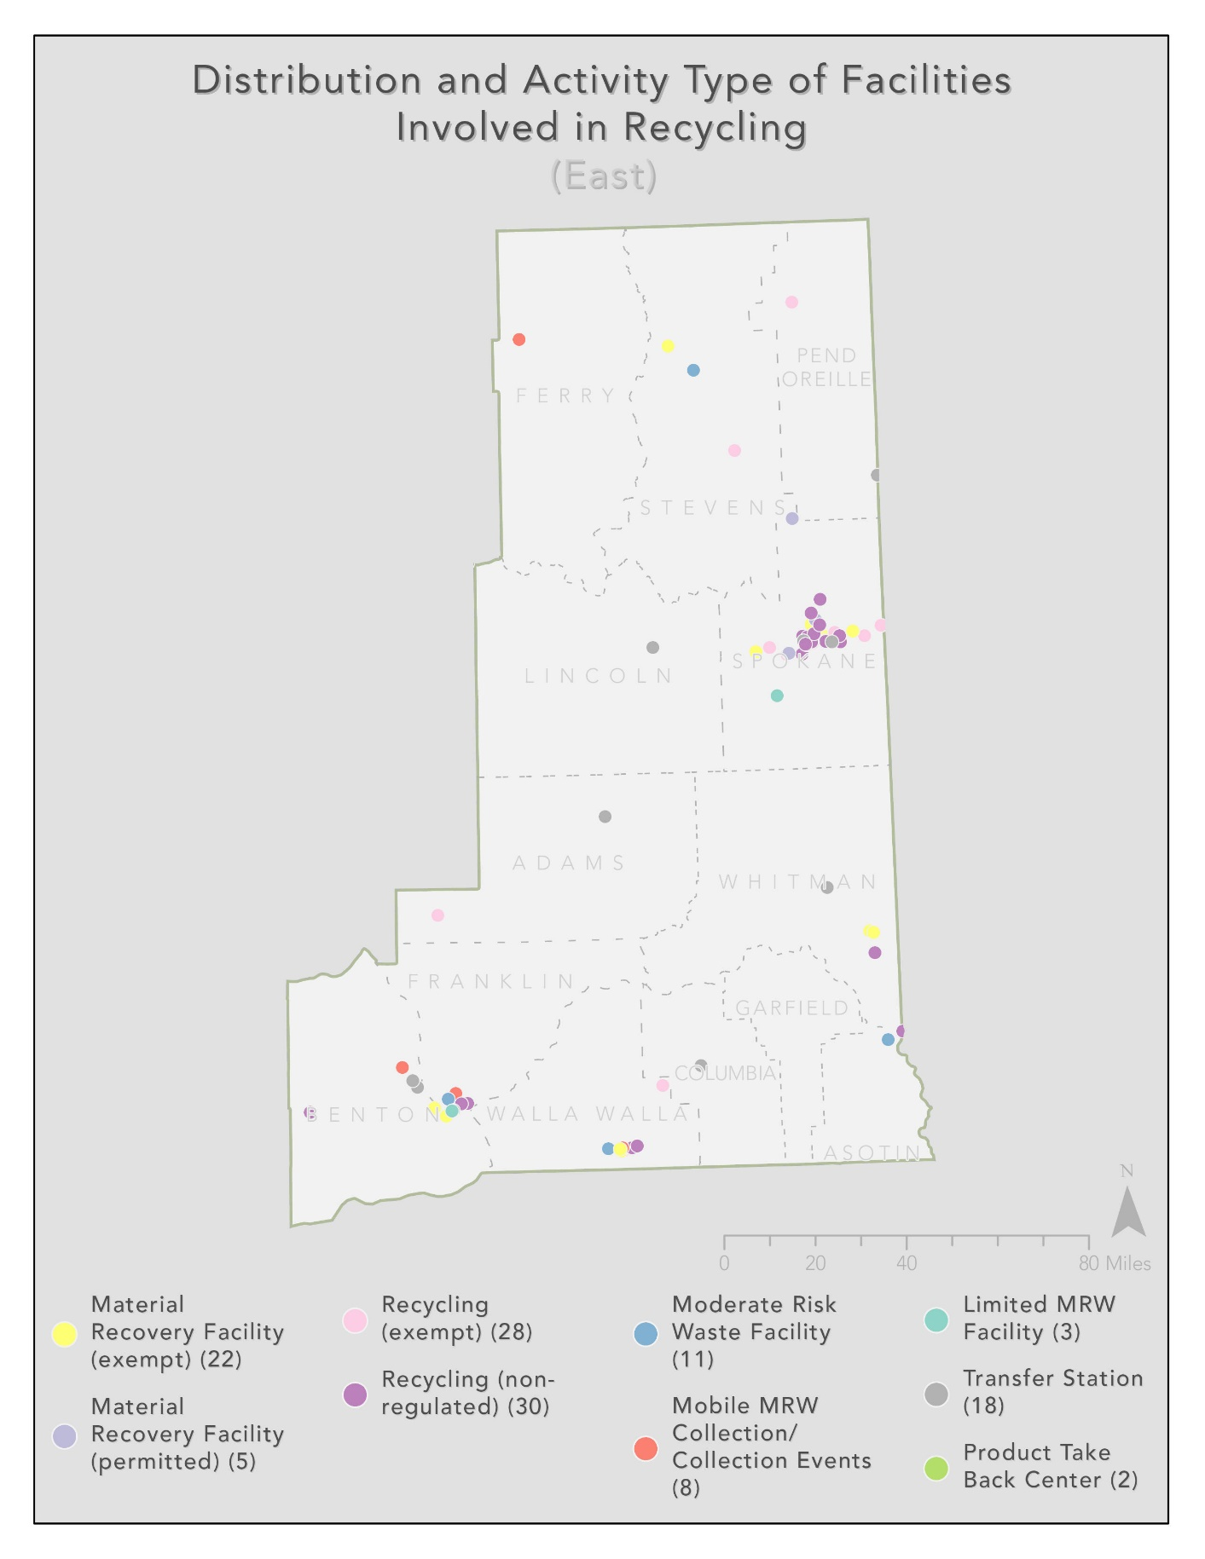

https://apps.ecology.wa.gov/publications/summarypages/2307012.html
https://apps.ecology.wa.gov/publications/summarypages/2307013.html
www.ecology.wa.gov/contact
https://www.naics.com/search/
https://www.bea.gov/help/faq/19
https://www.naics.com/naics-code-description/?code=562920&v=2022
https://www.naics.com/naics-code-description/?code=562910&v=2022
https://www.naics.com/naics-code-description/?code=423930
https://www.census.gov/naics/?input=562&year=2022&details=562
https://www.chmura.com
https://www.census.gov/programs-surveys/cbp/data/datasets.html
https://www.census.gov/programs-surveys/cbp/data/datasets.html
https://dor.wa.gov/about/statistics-reports, https://apps.dor.wa.gov/ResearchStats/Content/GrossBusinessIncome/Report.aspx
https://dor.wa.gov/about/statistics-reports, https://apps.dor.wa.gov/ResearchStats/Content/GrossBusinessIncome/Report.asp
Dun & Bradstreet, Mergent Intellect, https://www.mergentintellect.com/index.php/search/index
https://www.mergentintellect.com/index.php/search/index
https://wtb.wa.gov/planning-programs/regional-workforce-plans/
https://wtb.wa.gov/planning-programs/regional-workforce-plans/
https://wtb.wa.gov/planning-programs/regional-workforce-plans/
https://dor.wa.gov/about/statistics-reports, https://apps.dor.wa.gov/ResearchStats/Content/GrossBusinessIncome/Report.aspx
https://www.naics.com/naics-code-description/?code=423930
Data Collected from Bureau of Labor Statistics.
https://www.census.gov/programs-surveys/cbp/data/datasets.html
https://dor.wa.gov/about/statistics-reports, https://apps.dor.wa.gov/ResearchStats/Content/GrossBusinessIncome/Report.aspx
https://www.mergentintellect.com/index.php/search/index
https://dor.wa.gov/about/statistics-reports, https://apps.dor.wa.gov/ResearchStats/Content/GrossBusinessIncome/Report.aspx
https://dor.wa.gov/about/statistics-reports, https://apps.dor.wa.gov/ResearchStats/Content/GrossBusinessIncome/Report.aspx
https://dor.wa.gov/about/statistics-reports, https://apps.dor.wa.gov/ResearchStats/Content/GrossBusinessIncome/Report.asp
https://wtb.wa.gov/planning-programs/regional-workforce-plans/

