Table 13
Prepared for the Washington Department of Ecology
Part 2 - Economic Impact of Recycling
Publiation 23-07-012 - March 2023
Report on Washington State Recycling
By Ellie Potts
Michael Rodriguez
Lino Marioni
Tai Starchman
and Sarah Frahm

Publication Information
This document is available on the Department of Ecology’s website at: https://apps.ecology.wa.gov/publications/summarypages/2307012.html

Related Information
Publication 23-07-012: Part 1 - Recycling Companies and Revenue
Publication 23-07-013: Part 3 - Equity and Environmental Justice

Contact Information
Solid Waste Management Program
Statewide Resource Services
P.O. Box 47600
Olympia, WA 98504-7600
Phone: 360-407-6000
Website: Washington State Department of Ecology

ADA Accessibility
The Department of Ecology is committed to providing people with disabilities access to information and services by meeting or exceeding the requirements of the Americans with Disabilities Act (ADA), Section 504 and 508 of the Rehabilitation Act, and Washington State Policy #188.
To request an ADA accommodation, contact Ecology by phone at 360-407-6000 or email at mark.hayes@ecy.wa.gov. For Washington Relay Service or TTY call 711 or 877-833-6341. Visit Ecology's website for more information.

Department of Ecology’s Regional Offices

Map of Counties Served
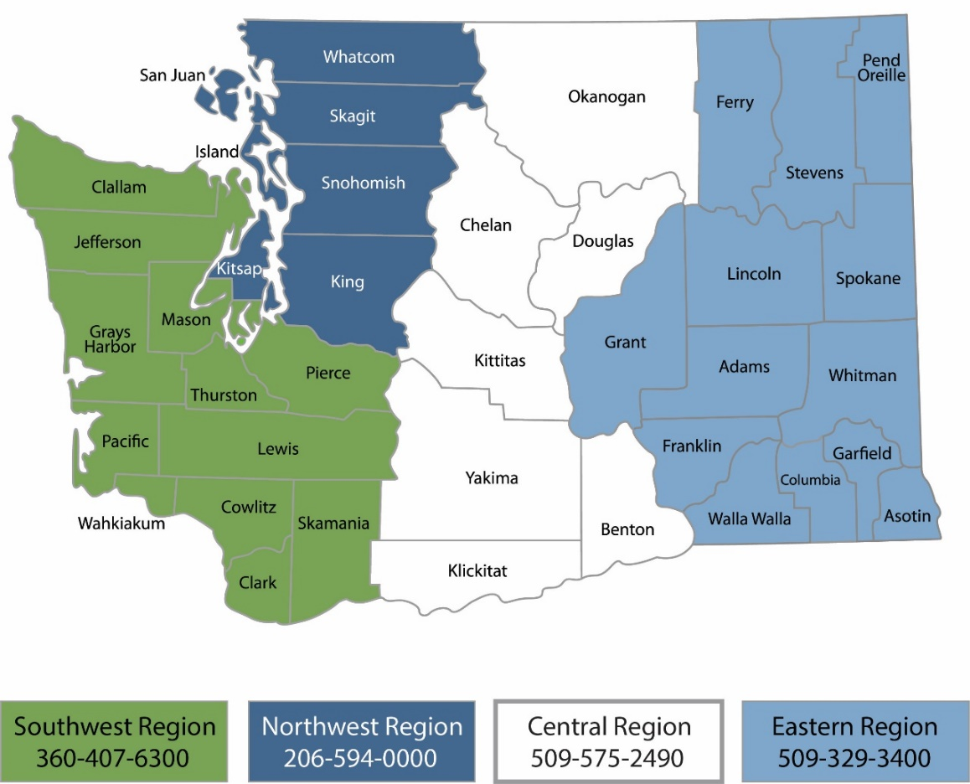
Region | Counties served | Mailing Address | Phone
Southwest | Clallam, Clark, Cowlitz, Grays Harbor, Jefferson, Mason, Lewis, Pacific, Pierce, Skamania, Thurston, Wahkiakum | P.O. Box 47775  Olympia, WA 98504 | 360-407-6300
Northwest | Island, King, Kitsap, San Juan, Skagit, Snohomish, Whatcom | P.O. Box 330316 Shoreline, WA 98133 | 206-594-0000
Central | Benton, Chelan, Douglas, Kittitas, Klickitat, Okanogan, Yakima | 1250 West Alder Street  Union Gap, WA 98903 | 509-575-2490
Eastern | Adams, Asotin, Columbia, Ferry, Franklin, Garfield, Grant, Lincoln, Pend Oreille, Spokane, Stevens, Walla Walla, Whitman | 4601 North Monroe  Spokane, WA 99205 | 509-329-3400
Headquarters | Statewide | P.O. Box 46700  Olympia, WA 98504 | 360-407-6000

Table of Contents
Publication Information 2
Related Information 2
Contact Information 2
ADA Accessibility 2
Department of Ecology’s Regional Offices 3
Map of Counties Served 3
About the Authors 6
Introduction 7
Executive Summary 7
Part two: Economic Impact of Recycling: 7
Literature and Landscape Overview 8
Key points within this report 8
Policy Recommendations 8
Circular Economy 9
Criterion for a Circular Economy 9
Next Steps for Washington 10
Residential 11
Curbside Collection of Recyclables 11
Life Cycle Assessment 14
Commercial 15
Institutional 16
Industrial 17
Does automation help expand the recycling business bottom line or the circular economy? 19
Effects of Automation on Labor Market 21
Policy and Regulation 24
Domestic Purchases and Supply Chain Analysis 26
Domestic Purchases 26
Plastic 31
Glass 35
Paper 38
Metals 41
Organics 44
Company Trends 45
Economic Impact 47
Model Limitations 49
Changes to the Industry: Material Recovery Facilities (NAICS 562920) 50
Changes to the Industry: Recyclable Material Merchant Wholesalers (NAICS 423930) 51
International Supply Chain 52
International Supply Chain Within Washington State 53
Appendix A 54
Harmonized Tariff Schedule Definitions 54
Appendix B 58
Appendix C 62
Appendix D 63
Life-Cycle Assessment of Residential Curbside Pickup Case Study 65
Appendix E 66
Bibliography 67
Annotated Bibliography 71
Data Sourcing 71
Literature Review 71

About the Authors
The Center for Economic and Business Research is an outreach center at Western Washington University located within the College of Business and Economics. In addition to publishing the Puget Sound Economic Forecaster, the Center connects the resources found throughout the University to assist for-profit, non-profit, government agencies, quasi-government entities, and tribal communities in gathering and analyzing useful data to respond to specific questions. We use a number of collaborative approaches to help inform our clients so that they are better able to hold policy discussions and craft decisions.
The Center employs students, staff and faculty from across the University as well as outside resources to meet the individual needs of those we work with. Our work is based on academic approaches and rigor that not only provides a neutral analytical perspective but also provides applied learning opportunities. We focus on developing collaborative relationships with our clients and not simply delivering an end product.
The approaches we utilize are insightful, useful, and are all a part of the debate surrounding the topics we explore; however, none are absolutely fail-safe. Data, by nature, is challenged by how it is collected and how it is leveraged with other data sources. Following only one approach without deviation is ill-advised. We provide a variety of insights within our work – not only on the topic at hand but also the resources (data) that inform that topic.
We are always seeking opportunities to bring the strengths of Western Washington University to fruition within our region. If you have a need for analysis work or comments on this report, we encourage you to contact us at 360-650-3909 or by email at cebr@wwu.edu.
To learn more about CEBR visit us online at https://cebr.wwu.edu or follow us online through your favorite social media stream.
facebook.com/westerncebr
twitter.com/PugetSoundEF
linkedin.com/company/wwu-center-for-economic-and-business-research
instagram.com/wwucebr

The Center for Economic and Business Research is directed by Hart Hodges, Ph.D. and James McCafferty.

Introduction
This three-part comprehensive report is a search and analysis of the businesses that sort and refine Washington’s recyclable materials into sellable commodities, and the intermediate and end-users that use recyclable materials in manufacturing. Using existing databases and survey data collected from businesses that process recyclables, this report examines main processors in the supply chain, locations of generation and remediation, economic impacts, and equity concerns in Washington State. The goals of the three-part comprehensive report include a qualitative and quantitative baseline report of Washington State’s recycling industry to identify opportunities, existing benefits, potential benefits, and conduct an environmental justice and equity analysis. The three parts of this Recycling Baseline Report include policy recommendations based on capacities, needs, gaps, barriers and opportunities identified within the state:
- Part one: Recycling Companies and Revenue, provides economic data related to management of recyclable materials in Washington State and their principal processors.
- Part two: Economic Impact of Recycling, examines economic contribution of the recycling industry, identifying direct, indirect, and induced economic impacts of potential expansion within the recycling industry.
- Part three: Equity Analysis of Recycling, examines environmental justice and equity concerns within the solid waste and recycling system, mapping health and environmental hazard variables to facility locations.

Executive Summary

Part two: Economic Impact of Recycling:
This report contains a Literature and Landscape Overview analyzing management of recyclable materials in the residential, commercial, institutional, and industrial sectors within Washington State. Management processes used in areas outside of Washington are also discussed. The end of this report contains an annotated bibliography on the additional information and background sources on this topic.

Literature and Landscape Overview
At the core of the recycling landscape is the economic viability of market participation. In our review of the current recycling environment in Washington State and at large, the factors that increase recycling are those that modify incentives for the public, companies, and consumers. Tracing the factors behind these incentives and the associated costs involves the identification of vulnerable points as materials change hands. Capacities, needs, gaps, barriers, and opportunities for principal processors and end-users of Washington’s recyclable materials are examined in residential, commercial, institutional, and industrial sectors. Our next-step recommendations for improvement of recycling in Washington State include: automating the processing of recyclables, reducing contamination in residential and commercial recyclables, and evaluating material flows and using life-cycle assessments to tighten circular economy attributes in Washington State.

Key points within this report
- The economic impact of expanding employment by 100 workers in the Material Recovery Facility Industry has an indirect impact on employment of 23 jobs and an induced impact of 26 jobs. This represents the positive ripple effect of employment gains in the Material Recovery Facility industry across the Washington State economy.
- The economic impact of expanding employment by 100 workers in the Recyclable Material Merchant Industry results in an indirect 28 jobs and an induced 36 jobs.
- The total material amount collected for recycling in the year 2018 was 8.34 million tons.
- Tariffs do not have a big impact on how countries recycle because they provide insight on how materials may reach a certain country, but processing and markets for processed materials are domestically influenced. The Harmonized Tariff Schedule shows just how many materials exist and how documentation creates clear trade agreements to avoid cheap imports.
- Circular economies require being more efficient with materials through better recycling processes. The level of efficiency with regards to materials in Washington could be improved, however, some progress has been made through program initiatives.
- In 2021, the port in Kalama, WA was the second largest exporter of recyclables of the state’s ports. This port is recommended for its proximity to the Pacific Ocean and for its access to the Columbia River which stretches across southern Washington.

Policy Recommendations
- Effective strategies for curbside and residential recycling primarily concerned efforts to stem the contamination of recyclable materials in the collection process. Promising efforts in this regard have included increasing public outreach and education on recycling practices and introduction of fines to discourage improper sorting. We have also explored the potential impact of greater automation and streamlining materials sorting, however this too can be limited by contamination.
- Washington can move closer to having more of a circular economy by following practices developed in other jurisdictions, like the blueprint created by the report ‘Circular Charlotte’. This report suggests that creating a circular economy will take a combination of short term and long-term action plans that primarily focus on the development of a buy in from city residents through communication campaigns and increasing producer responsibility.

Circular Economy
What is a Circular Economy?
Our current economy is mostly linear. Resources are extracted, turned into materials and then made into products. Once the product has ended its useful life from the owner’s perspective, it is commonly disposed of either by going into landfills or incinerated. Each raw material requires energy to be made, along with time to produce it and money to fund the production. An economy that is constantly having to remake these raw materials instead of circulating them, is one that is very inefficient and wasteful with regards to time, money, and energy spent.
This leads to the emergence of a new concept: a circular economy, in which materials and waste are recaptured in order to reproduce new goods or products, replacing the ‘end of life’ concept, and supporting sustainable development through being more efficient with materials. This economic system is designed to be regenerative and reduce waste. It has many benefits such as: job creation, reducing CO2 emissions, less consumption of virgin materials, reduction in waste, and providing more opportunities for skills development.
A significant complexity in describing a circular economy is the lack of an agreement related to whether materials recaptured are part of it or not based on their eventual next use. Transformation is a key issue of disagreement within this space. When paper is recaptured and recycled into another form of paper it is clearly circular but when plastic is recaptured and infused with road base, for example, some assume this terminal transformation excludes it from being considered circular. Being an emerging space there is no clear definition.

Criterion for a Circular Economy
As a disclaimer, it is difficult to quantitively determine whether an economy is circular or not. Many of the components are hard to precisely measure, and to attribute directly to the change in economy style. The most attainable measurement would be determining if the economy is manufacturing less materials. Assuming a constant amount of demand for material goods, this would demonstrate more reusing of materials and better efficiency. An increase in jobs could be used as a measure, however it is hard to directly attribute that increase to a change in the economic structure. A decrease in CO2 emissions could also be an indicator, however once again, there are many other factors that could attribute to a decrease in CO2 emissions.
While it is difficult to attain a clear definition of what entails a circular economy, these statistics have the best potential to measure Washingtons progress towards one. The first statistic that can be measured is an increase in recovery rate percentage. If we observe an increase in the ratio between annual total waste recycled and annual total recyclable waste generation, that will indicate that a higher percentage of recyclable materials are in fact being recycled. If we look at the percentage in which recyclable materials are recycled instead of merely the quantity of recycled materials, we can get a better sense of the improvements that are being made within the state with regards to the efficiency in which materials are being recycled.
A second statistic that could be measured is examining the number of imported materials Washington is receiving. If Washington is importing fewer virgin materials, then assuming a constant or increasing amount of demand, this would demonstrate that the state is relying less on them and instead reusing the ones that they already have circulating through the economy. A final statistic would be examining the number of materials that the state is exporting. An increase in exports would demonstrate that Washington has a surplus of materials, which may indicate that we are more efficiently recapturing materials destined for later reuse or transformation.
In terms of the first measurement, recovery rate, this can be translated into company success, such as sales of material recovery facilities or gross business income of workforce development regions within this industry. Existing data was used to describe the baseline of the recycling industry within Washington State in Part one - Recycling Companies and Revenue report, part 1 of 3 of the compiled report. In Part two - Economic Impact of Recycling, the economic benefits of industry expansion are described in terms of direct, indirect, and induced effects of industry growth. Increased job creation and company sales improve Washington’s status as a circular economy if it is inferenced that recovery rates are increasing with industry expansion.

Next Steps for Washington
The steps to transforming into a circular economy are complex. There is considerable debate on what constitutes a circular economy, along with what metrics should be used to demonstrate this kind of transition. Furthermore, the steps taken to achieve a circular economy are not set in stone. There are many methods that may vary city by city. The following recommendations for the state of Washington are based on a 2018 report, titled ‘Circular Charlotte’, in which a blueprint for the steps a city needs to take to achieve a circular economy is detailed. The plan covers 30 years in route to achieving a fully waste free city by 2050.
The blueprint recommends establishing a public sector commitment to the transition. This includes a rebranding of the state and creating a communications campaign. The most important goal of the short term is to provide information needed to the public to gain strong commitments to the circular economy. Once this is established, long-term steps can begin to take place.
With regards to longer term steps, the report recommends transitioning to alternative business models and purchasing models that better support the reuse of materials. The main goal in these long-term steps is to increase producer responsibility, extending it to after the product is used. If Washington wants to improve their circular economy, some action to increase producer responsibility and to incentivize businesses to reuse materials is needed based on the report. This can be accomplished through creating alternative business models and systems that make producer manufacturers responsible for what they create and sell, even after the products are sold.
These are just some of the recommendations from the ‘Circular Charlotte’ report. These recommendations are very broad, and not specific to Washington. However, the main takeaways from the blueprint are presented as a starting point to navigate a very complex issue.

Residential

Curbside Collection of Recyclables
In examining the effectiveness of recyclable material sourcing in Washington, we examine consumer behavior and its relationship with surrounding conditions such as institutional, industrial and government practices. We look here for the rate of landfill diversion for recyclable materials. A question in examining this piece of the chain is whether individuals are effectively participating in landfill diverting practices. Aside from the direct benefit of diverting materials from landfills, the degree to which individuals are separating their recyclables for collection is critical in expanding the supply of materials available to recovery facilities. Most common strategies in improving the material yield from individuals and households include community outreach and education. The aim of these strategies focuses upon education and generating awareness of local recycling practices. This has proven to be effective in this respect, though the cost of outreach and education needs to be considered, especially as the markets for a wider variety of recyclable materials appear and expand.

Figure 1: Solid Waste Recovered from Residential and Commercial Sectors
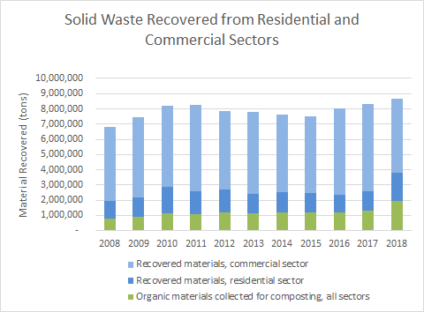
Source: Washington State Department of Ecology
The figure on page 10 distinguishes between the proportions originating from commercial sources, residential sources, and organic waste materials. The overall 10-year trend depicts a local peak in 2011 followed by a period of decline until 2015. Most recent data from the years 2016 to 2018 depicts a positive trend in total solid waste recovery with 2018 representing a 10-year high. Over this 10-year period, the majority of recovered materials originated from the commercial sector, followed by residential sources and organic materials. The proportion of residential and organic sources has seen more growth than the commercial sector in recent years, contributing to this 10-year high.
Figure 2: Total Recoverable Solid Waste Generation; Recovered vs Landfill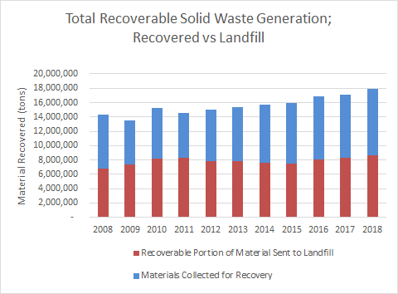
Source: Washington State Department of Ecology
The figure above shows both the recovered material (detailed in Figure 1) along with the material landfilled that could have been recovered. The trend depicted here shows a steady increase in overall waste generation, reaching a 10-year high in 2018 at approximately 18 million tons of material. Accompanying this recent trend of growth in total recoverable solid waste generation, the proportion of recoverable material sent to landfill compared to the proportion of material recovered remained mostly stable between 2012 and 2018.

 | Total Material Recovered for Recycling (tons) | 8,344,398

The total materials recovered from residential recycling amounted to 8,344,398 tons in 2018. The table in Appendix E describes the total recovery of materials from the municipal waste stream in Washington State from 2008 to 2018.

Life Cycle Assessment
A Life Cycle Assessment (LCA) is typically used to quantify environmental consequences and connect material information to economic metrics. Evaluating the sustainability of a waste material is more complex than ensuring more tonnage is diverted from the landfill, and an LCA can track the efficacy and sustainability of certain manufacturing or discard practices. An LCA can compare waste collection practices in terms of efficiency, landfill diversion and level of greenhouse gas emissions.
Findings in this report found a decline in GHG emissions from a two-bin collection configuration (for landfill and recyclables). However, the inclusion of a third bin for organic waste was found to negate this change, increasing net GHG emissions through the need for increased collection and separation. This is not only a matter of negating emissions but outlines the tradeoff between a more complex collection system and increased expenditure in terms of fuel, labor and capital. Additional review of the role of residential recycling in Washington State including Material Recovery Facility contamination, King County Materials Recovery Facility Assessment report, and Life Cycle Assessment projects are located in the Appendix D.
In considering the holistic goals of residential based services consideration may be appropriate of examining all residential streams in relationship to each other to negate the impacts of population change and other factors that change the volumes captured. A ratio of total waste to the streams may provide a clearer measurement of long-term shifts and support goal setting.

Commercial
Commercial recycling refers to the collection and recovery of scrap or used materials from businesses, and some industries. It is distinct from industrial recycling as it does not include materials from industrial manufacturing or construction (such as coal combustion products, scrap tires, or demolition/construction materials). Within this context, commercial recycling does not refer to the commercial collection of materials, as done so by private firms, but instead simply the collection of materials from commercial businesses. The commercial sector in Washington represents a significant share of the total flow of materials into the state's MRF’s.
Within garbage collection, according to Seattle Public Utilities, in many cases recyclable materials from multi-family residences, such as apartment complexes, are commingled with commercial pickups. Many collection routes are “mixed”, stopping at both commercial businesses and multifamily residences. This can make it difficult to parse the composition of materials being recovered specifically from commercial sources.
In King County, commercial businesses generated 112,855 tons of recyclable materials in 2020. The tonnage collected from King County residences during the same period was 121,179 tons. King County estimated 200,000 tons of potentially recyclable materials were landfilled in 2021, highlighting the fact that there still exists a considerable quantity of unrecovered materials.
The rate of contamination in collected commercial recyclables is like that of residential areas, at 12%. Again, as in the residential sector, this represents an opportunity for considerable improvements, as reducing the quantity of contaminant material being collected will help reduce processing costs and the efficiency of pickups. Contaminants from commercial sources are also more likely to contain hazardous compounds, such as those found in medical and laboratory waste. Not only does this complicate the collection and recovery process but also increases the risk of accidental human exposure. Education on proper sorting techniques, and outreach to commercial businesses, can help reduce the rate of contamination and improve efficiency.
Strategies that may be highly effective in the residential sector for improving collection rates may not be as effective within the commercial domain. Evaluating the current scope and scale of commercial recycling in the state will be of great value in the development of best practices for maximizing the efficiency and effectiveness of the state's material recovery efforts.

Institutional
This table provides a count of institutional locations within Washington state. Within this data, we account for each location from each category, meaning that many of these locations are separate branches of the same institution.
Table 1: Number of institutional locations in Washington State
Institutional Locations Washington State
Location Type | Number of Locations
Schools and Educational Services | 14,976
Churches and Religious Institutions | 12,590
Nursing Homes/Care Facilities | 3,268
Hospitals | 1,239
Prisons | 80
Source: Dun & Bradstreet
Looking at these institutions at the state level, many of the internal recycling practices vary by the discretion of each individual organization within the bounds of greater waste disposal regulations. In the case of schools and educational institutions, Washington State has seen local, city level and school district level efforts to improve recycling, composting and waste diversion rates. One case of this comes from the efforts of the city of Seattle, where Seattle Public Utilities and local school districts have introduced mandatory recycling and composting programs. Another avenue for improving recycling practices in these institutions have come at the state level, through grants like WRRED grants. WRRED grants provide funding for public schools and nonprofit organizations for development of recycling and waste reduction.

Industrial
The state of Washington is one of the wealthiest states in the country and has a large industrial section. The figure below breaks down the top 10 manufacturing sectors, with regards to output, in the state of Washington.
Figure 3: Top 10 Washington Manufacturing Sectors
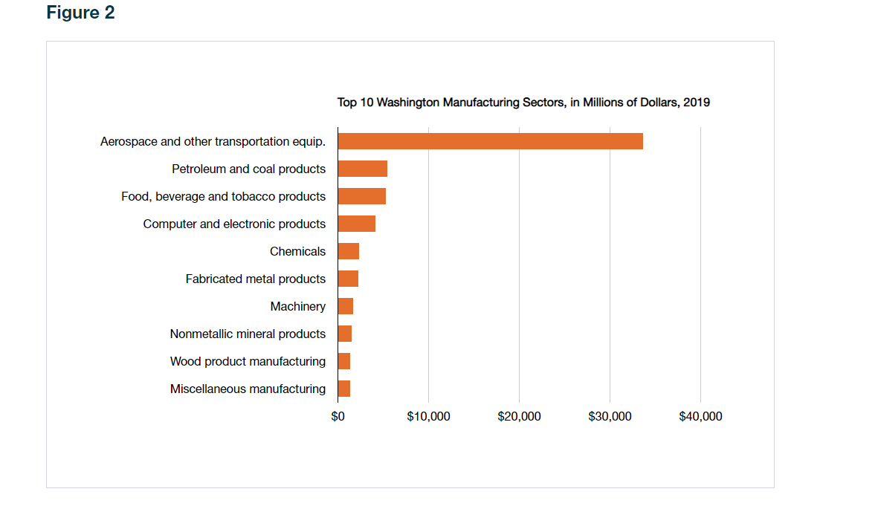
Source: National Association of Manufacturers
The data was taken from the National Association of Manufacturers 2021 report. By far the largest sector in Washington is Aerospace and other transportation equipment, which produced around $32 billion dollars’ worth of output in 2019. This is because of Boeing Inc., which is the largest aerospace company in the world, and has firms located in Renton and Everett. Petroleum and coal products come in a distant second, with around $5 billion dollars.
Manufacturers account for 10.64% of total output in the state, and 8.04% of employment. $65.2 billion worth of output came from the industrial sector in 2019.
In total there are 7,300 industrial companies in Washington state. Industrial companies can be defined as businesses dealing with manufacturing goods, while commercial companies refer to any businesses done with the sole motive of gaining a profit.
The figure below looks at the breakdown of the top 10 manufacturing companies, providing information on their location, and number of employees.

Table 2: Top 10 Washington State Manufacturing Companies
Company | Employees | City
Boeing Commercial Airplane Co. | 18,560 | Everett
The Boeing Co. | 4,900 | Kent
I.S.S.C., inc. | 2,820 | Airway Heights
Terex Aerial Work Platforms | 2,500 | Redmond
Schweitzer Engineering Laboratories, Inc. | 2,350 | Pullman
Phillips Oral Healthcare, LLC | 1,800 | Bothell
Borton & Sons, Inc. | 1,500 | Yakima
Tyson Fresh Meats, Inc. | 1,400 | Wallula
HP, Inc. | 1,100 | Vancouver
Physio-Control | 1,100 | Redmond
Source: Dun & Bradstreet
Boeing is by far the largest company with four times more employees than the next largest company. Geographically, the largest manufacturers are scattered all over the state, with some in eastern Washington, some in the King County area, and some in southern Washington.
These large manufacturing companies produce a lot of waste, some of which is recyclable. The most recycled materials include scrap metals (such as copper, iron, aluminum), paper and cardboard, glass, plastics, textiles, scrap tires, chemicals, and digital waste.
The importance of recycling industrial waste is twofold. First, sustainability is crucial for the future world. Increasing recycled waste lowers pollution rates and improves standards for human health. Second, industrial waste has the potential to be dangerous. If a company violates waste regulations, they can be hit with heavy fines, hurting their business bottom line.
The recycling collection process for industrial companies appears to be the same as commercial, and institutional.
7.6 billion tons of industrial waste was produced in the U.S. in 2017. This creates a large potential for recovering recyclable materials and reducing the amount of waste that ends up in landfills.

Does automation help expand the recycling business bottom line or the circular economy?
The sorting process of the recycling industry needs improvement. The inefficiency of human labor with regards to sorting through recyclable material can be greatly improved through automation, the process of using artificial intelligence (AI) technology to sort through incoming materials on the conveyor belt, rather than human workers. This transition could lead to vast improvements for the recycling industries’ bottom line, along with the circular economy.
The gaps in the current process of material sorting are oftentimes due to issues surrounding human labor. The labor is very difficult, and the working conditions are tough, which leads to a high turnover rate and a lack of experience at the position. Furthermore, the ability to properly sort and correctly identify recyclable materials is a process that leaves lots of room for human error, as it can be difficult to determine which materials can be recycled without the aid of technology. Both the accuracy and the speed in which these workers sort are concerns for the industry.
If human workers are unable to recover recyclable materials at a high rate, they are hurting themselves by losing out on these opportunities to sell their remade materials for a profit. Recycled materials can be extremely valuable, and incorrectly placing them in landfills loses money. The following charts offer the $/ton value for some recyclable materials in the PNW.
Figure 4: Recycled Fiber Prices ($/ton), Pacific Northwest, 2015-2022

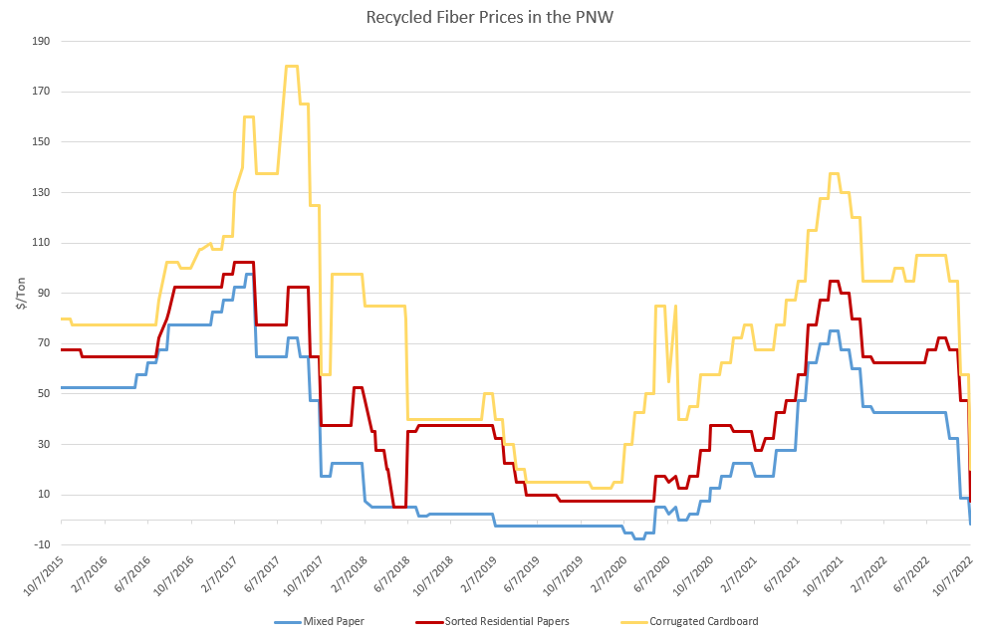 Source: Recyclingmarkets.net
Figure 5: Recycled Plastic Prices (cents/pound), Pacific Northwest, 2015-2022
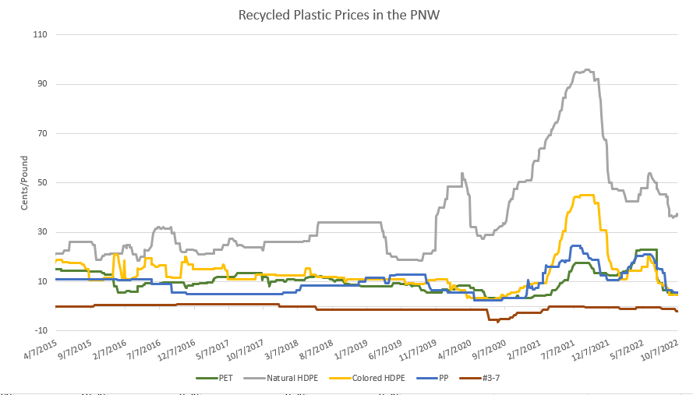
Source: Recyclingmarkets.net
In addition to accuracy, the speed at which human workers can sort through materials can be improved upon. The numbers vary, but most sources cite that AI can sort through recyclable materials about twice as fast as human workers, with more precision. AMP Robotics has achieved speeds up to 140 picks per minute, while being able to sustain at least 120 picks per minute. Their most recently available object recognition rate is 10 billion annually.
This could increase the quantities of waste sorted daily, and possibly increase the number of materials heading to processors, and in turn decrease the amount of recycling residuals ending up in landfills.
While automation still has a way to go in its development before being able to be more regularly implemented in MRF facilities, this would be a beneficial direction for the recycling industry to improve the circular economy and the industry’s bottom line. Too many tons of recyclable materials go into landfill, wasting precious materials that can be reused. The recycling industry has an opportunity to save money and help boost the circular economy. Investing in automation could assist with these improvements.

Effects of Automation on Labor Market
While growing automation in the recycling industry has its many benefits, it also may have negative effects on the labor market. Waste Management, one of the largest waste management companies in North America, is potentially phasing out 7,000 roles in the next couple of years. The company projects that between 5,000-7,000 jobs will be eliminated by 2026. CEO of WM, Jim Fish, believes it is a great opportunity to use technology to reduce their dependence on high turnover jobs.
When analyzing careers in recycling through the US Bureau of Labor Statistics website, the primary jobs that will be replaced with automation are sorters, who are responsible for sorting recyclable materials from the recyclable collection on the conveyor belts at MRF’s. This specific role is seen as one of the highest turnover positions in the recycling industry. This is primarily due to both the mental and physical challenges associated with the job. Those who work on the conveyor belt are expected to be on their feet their entire shift, constantly bending over to reach items on the conveyor belt, placing strain on their backs and shoulders. The job is high paced with minimal time to rest. In addition, it takes constant concentration to properly sort recyclable materials. These positions are also typically seen as some of the lower skilled ones with minimal requirements for the job.
AMP Robotics, based in Colorado, has seen 230 deployments in more than 80 different MRF facilities across the world. However, the implementation of automation in a MRF facility does not necessarily mean a complete phasing out of human employees who previously held those positions. Workers are still needed to be there to assist the technology, pulling out potentially harmful items, such as garden hoses, from the recycling stream, along with making sure that no stray recyclables fall into the wrong group. Technology and human labor go hand in hand within this role at MRF’s.
An article by Ashley Nunes from the Harvard Business Review argues that the recycling industry does not look to technology to completely transform the existing labor force. Instead, they see technology as an opportunity to upskill or to reskill employees to higher up positions and decrease employment attrition by about half. The idea proposed is to have technology do much of the tedious manual labor, and then fill job positions with better skills to handle more difficult situations.
Financially, automation might make sense financially for some businesses. While upfront investments can be large, it is believed that automation can cut labor costs by 30%. Looking specifically at high turnover jobs, where it costs money to constantly hire and train new employees, automation can save companies a large amount of money in the long run. Their overall quality of service can improve as well by having more reliable work.
While some jobs may decrease in the industry, it is believed that overall wages could increase. Laborers who work alongside automation command a 10-15% premium for their computer literacy. In addition, when jobs require a specialized skill, wages go up due to the scarcity of people being able to fill that position.
Furthermore, while automation may slightly decrease the number of jobs in the recycling industry, it can increase jobs in the overall economy. This is because automation can increase the number of recyclable materials recovered, improving the circular economy, which leads to more job creation.
Increased implementation of automation at MRF facilities will increase the efficiency of recovering recyclable materials while decreasing labor costs for the recycling industry. While a percentage of jobs will be lost, automation is seen as an opportunity to realign job opportunities that currently lead to large amounts of attrition.

Policy and Regulation
Apart from collection from institutions, the behavior and policies of Washington State’s policies government institutions play an important role in forming the economic environment surrounding recycling. This can occur when taxes are levied on the recycler itself, increasing the cost of operation as well as when taxes are levied elsewhere along the supply chain. Through this lens, we examine how policy, regulation, and taxation interact with operation and modify consumption within the recycling supply chain (I.e., do they promote, incentivize, or discourage consumption).
- Business and Occupation Taxes
  - Manufacturing
  - Wholesaling
  - Retail
  - Service and other activities
- Motor Transportation or Urban Transportation public utility tax
- Use tax
Given the degree to which recyclable materials must be transported and change hands, it is particularly vulnerable to accumulating the cost of these taxes and carrying them to end-product prices, impacting the competition of recycled products with nonrecycled counterparts. In other words, if we are seeking to increase consumption of recycled goods and thereby increase revenue for recyclers, it is worth evaluating the impact of these accumulated tax points. Alleviating the tax burden on the producers of recycled products may help them better compete in their respective markets.
In contrast, generating demand and subsequently expanding market capacity for recycled materials could involve discouraging or disincentivizing of non-recycled products with recyclable alternatives. For instance, in 2020 the EU implemented a levy or “plastic tax” on non-recyclable plastics or plastics not containing a sufficient level of recycled material. This may prove to be an attractive approach in that it not only generates additional state revenue but by increasing the price of these products, recycled substitutes become more competitive.
Policies such as Extended Producer Responsibility programs are an avenue of increasing capture rate (or the ratio between the weight of materials collected for recycling and the total weight of all recyclables in the waste stream) and expanding capacity through a mandate that producers fund the recovery of their product or packaging. Legislative actions such as the 2006 Electronic Product Recycling Law have implemented this type of regulation by allocating costs and operations to the manufacturers themselves. Covered businesses under this program are required to participate in the recovery of electronic products for recycling. For this program, a separate entity was established to develop and operate the statewide collection of electronic products, funded by manufacturers. This type of regulation requires manufacturers to work with local governments, non-profits, and recycling operations to expand collection, capacity, and education.
Policies that require consumer deposits on recyclable products or packaging or buyback programs at collection of these recyclable products can impact recovery of these materials. This type of deposit return program is most applied to beverage containers, called “bottle bill” programs. Deposit programs operate in ten states, including Oregon, California and Hawaii. Depending on how the law is written, money generated from unredeemed deposits can be returned to the state, kept by the manufacturer or distributor, or directed to be used to fund administration of the program itself.

Domestic Purchases and Supply Chain Analysis

Domestic Purchases
To develop a preliminary picture of supply chain conditions surrounding Washington State’s recyclables market we examine several metrics. In this section we compare the purchasing relationships between material recovery facilities, recyclable material merchant wholesalers and industries linked by a high share of annual purchases. Within these industrial relationships we examine the regional behavior of selected industries or the rate at which these industries are utilizing Washington State based firms.
One such metric we use to illustrate these relationships is Supplier Location Quotient. Location quotient (LQ) is a statistical measure representing the concentration of an industry within a specific economic zone relative to the national average. A LQ score of 1 would indicate the prevalence of a given activity within the region is exactly equal to the national average, whereas an LQ score of 2 indicates double the concentration of said activity in that location. For example, in the table below we see that the LQ score for Waste Collection is 0.80, meaning the study region had only 80% of the waste collection activity relative to the national average.
This metric is helpful for our analysis as it provides insight into the prevalence of industries related to material recovery (whether they be suppliers or buyers) within the state of Washington. When this information is coupled with regional data (such as for Idaho, Oregon, or California) we can garner a better understanding of where material from outside Washington is coming from, in addition to where exported materials may be headed.
Within the context of the data in this section, notable findings can be identified when a low LQ score is present alongside a low percentage of in region purchases. This can provide valuable information regarding not only processing, but also the flow of materials and waste between locations. As previously stated, coupled with additional metrics, such as the rate of purchases originating from within the region, we can identify specific industries that may rely more heavily on products originating from outside the state.

Table 4: Top Suppliers for WA Material Recovery Facilities
Top Suppliers for Material Recovery Facilities
 | Purchases from US Firms | Purchases from in-region US Firms | Purchases from Out-of-Region Firms | Percentage of Total Domestic Purchases | Supplier Location Quotient (In-Region) | % In-Region Purchases
Waste Collection | $3,047,000 | $2,212,000 | $835,000 | 4.59% | 0.80 | 73%
Petroleum and Coal Products Manufacturing | $2,435,000 | $1,900,000 | $535,000 | 3.67% | 1.15 | 78%
Remediation and Other Waste Management Services | $2,431,000 | $2,431,000 | $0 | 3.66% | 2.35 | 100%
Waste Treatment and Disposal | $1,903,000 | $1,815,000 | $88,000 | 2.86% | 1.86 | 95%
Total Domestic Purchases | $66,436,000 | $32,051,000 | $34,385,000
Source: JobsEQ
Industry Descriptions:
- Waste Collection: This U.S. industry comprises establishments primarily engaged in one or more of the following: (1) collecting and/or hauling nonhazardous solid waste (i.e., garbage) within a local area; (2) operating nonhazardous solid waste transfer stations; and (3) collecting and/or hauling mixed recyclable materials within a local area.
- Petroleum and Coal Products Manufacturing: The Petroleum and Coal Products Manufacturing subsector is based on the transformation of crude petroleum and coal into usable products. The dominant process is petroleum refining that involves the separation of crude petroleum into component products through such techniques as cracking and distillation. In addition, this subsector includes establishments that primarily further process refined petroleum and coal products and produce products, such as asphalt coatings and petroleum lubricating oils.
- Remediation and Other Waste Management Services: Industries in the Waste Management and Remediation Services subsector group establishments engaged in the collection, treatment, and disposal of waste materials. This includes establishments engaged in local hauling of waste materials; operating materials recovery facilities (i.e., those that sort recyclable materials from the trash stream); providing remediation services (i.e., those that provide for the cleanup of contaminated buildings, mine sites, soil, or ground water); and providing septic pumping and other miscellaneous waste management services. There are three industry groups within the subsector that separate these activities into waste collection, waste treatment and disposal, and remediation and other waste management.
- Waste Treatment and Disposal: This industry comprises establishments primarily engaged in operating land fill sites, incinerators, or other treatment or disposal facilities for non-hazardous or hazardous waste. Establishments that integrate the collection, treatment and disposal of waste are also included.
In this analysis, we examine the supply chain in terms of the key suppliers of and key buyers to Washington State material recovery facilities. Above we have included the four top supplying industries, the total purchases that MRFs make to firms from these industries and the percentage of in-region (in-state) vs out-of-region purchases in terms of US dollars. What this first dataset represents is the relationship between MRFs and these key industries in order to identify adjacent industries that have significant economic bearing on the performance and economic efficacy of material recovery facilities. Second, we examine the primary buyers of the services of MRFs, which in plain terms, represents the industries that make up the MRFs primary sources of revenue in Washington state.
Represented above is an overview of four top domestic supplying industries for materials recovery facilities. Waste Collection holds the largest share of MRF purchases in Washington State, wherein state MRFs collectively purchase over 3 million dollars in goods and services from US waste collection firms alone. This consists of 2.2 million in regional purchases and 835,000 dollars in out of region (out of state) purchases from waste collection firms alone. This finding coincides with our expectations given the available sources of recyclable materials and their collection. However, what is notable is the 73 percent rate of purchases in the region. Additional information on Waste Collection and MRF companies is in part one of this three-part recycling report.
In contrast, data from Remediation and Other Waste Management Services (remediation meaning services relating to the reversal or mitigation of environmental damage) as well as Waste Treatment and Disposal industries (including hazardous waste management/disposal) are more consistent with expectations and fair better in employment compared to the national average. Additionally, Petroleum and Coal Products Manufacturing industries placed second in their individual share of purchases. This could be attributed to activities such as oil recycling or combustion energy recovery.
Table 5 Top Buyers from WA Material Recovery Facilities
Top Buyers from Material Recovery Facilities
 | In-Region Purchases Value | Percentage of Total Domestic Purchases | Buyer Location Quotient
Activities Related to Real Estate | $14,024,000 | 14.17% | 1.12
Offices of Real Estate Agents and Brokers | $10,073,000 | 10.18% | 0.96
Executive, Legislative, and Other General Government Support | $4,309,000 | 4.35% | 1.13
Remediation and Other Waste Management Services | $3,603,000 | 3.64% | 2.35
Total Domestic Purchases | $98,990,000
Source: JobsEQ
Examining purchases from MRFs yields a significant gap between top purchasing industries. The top two real estate-based industries together constitute nearly a quarter of all purchases from MRFs. This concentration is likely due to recycling services and waste disposal contracts with commercial housing and property management firms. Additionally, these top four purchasing industries appear to be comprised of industries purchasing the services of MRFs or, in the case of the government support source, directly funding these facilities.
Table 6: Top 10 Remediation Services, Material Recovery Facilities, and Recyclable Material Merchant Wholesale companies in Washington State by sales
Company Name | Sales | Location | NAICS Code | Materials Recycled
Cedar Grove Composting Inc. | $45,390,730 | Seattle | 526920 | Organics
Seattle Iron and Metals Corp | $34,946,116 | Seattle | 423930 | Metals
Schnitzer Steel Industries | $28,035,391 | Tacoma | 423930 | Metals
Metro Metals Northwest Inc. | $19,380,084 | Tacoma | 423930 | Metals
TopSoils Inc. | $18,996,833 | Snohomish | 562920 | Organics
Murrey's Disposal Company Inc. | $14,685,405 | Tacoma | 562920 | Paper, Plastic, Glass, Metal
Cedar Grove Organics Inc. | $14,414,644 | Seattle | 562920 | Organics
Waste Management of Washington | $13,772,886 | Seattle | 562920 | Paper, Plastic, Glass, Metal
NorthStar Federal Services | $13,653,244 | Issaquah | 562910 | Metals, Textiles
Skagit River Steel & Recycling | $12,012,672 | Anacortes | 562920 | Plastic, Glass, Metals
Source: Dun & Bradstreet

This table shows the top 10 remediation services, MRFs, and recyclable material merchant wholesalers' companies by sales. These facility types are comprised within 3 different sectors, the NAICS codes 56291, 56292, and 423930, respectively. Additional information about industry characteristics and company information is in part one of this three-part recycling report.
These sales range from $12 million to $45 million. Many of the top companies are classified as MRFs, with 7 of them being MRFs and the other three being recyclable material merchant wholesalers. Three of the top four selling companies recycle only metals, and all three of those are recyclable material merchant wholesalers. Three of the top six companies recycle only organics, all of which are MRFs, with Cedar Grove Composting Inc. obtaining sales that are $10 million more than the next best at over $45 million. As far as location, most of the companies are in Seattle or Tacoma in higher density areas in the state. All the companies are in western Washington, ranging from Anacortes to Seattle.

Plastic
Figure 6: Plastic Recycling Supply Chain
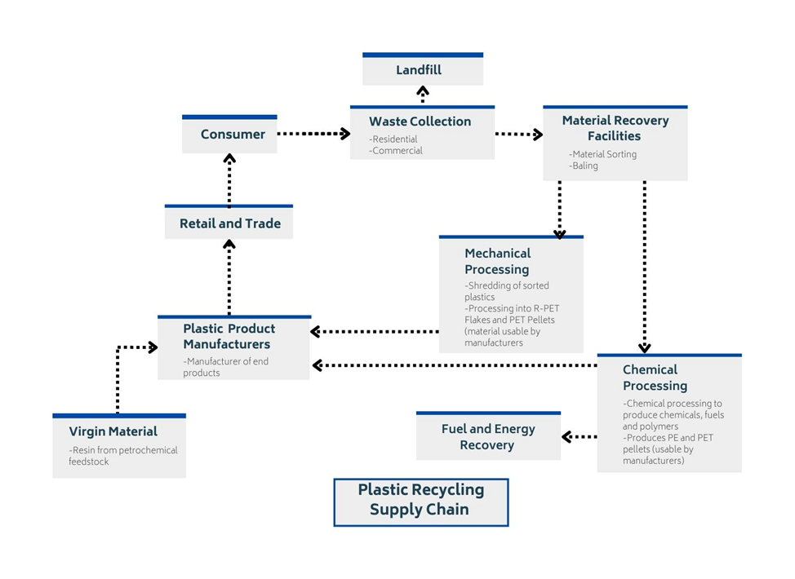
Plastics are collected and transported to Material Recovery Facilities. Solid plastics are shredded, and plastic chemical compounds can be broken down into other chemicals, fuels, and polymers. PET pellets are produced from both processes and are then redistributed to retailers from manufacturers who generate a final reusable product; fuel from the chemical processing is transferred to energy specific manufacturers. If not sent to retail and trade companies, reusable chemicals are also held in petrochemical feedstocks. Plastics will reach the landfill at the point of collection when they are disposed of with other trash and when their final use is for nonrecycled items like carpets.

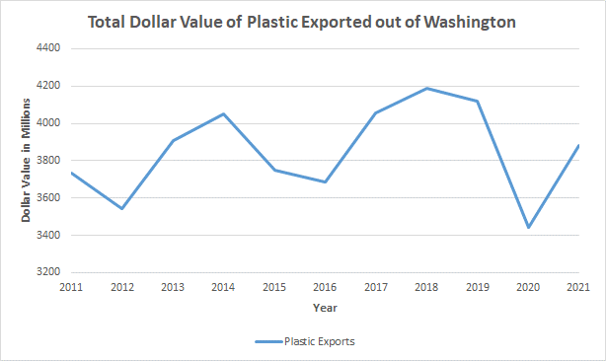Figure 7: Plastic Exports out of Washington State, 2011-2021
Source: WISER trade
Materials are from the WISER Trade data base using industrial machinery (including computers), electric machinery, sound and TV equipment, miscellaneous chemical products, plastics and articles thereof, organic chemicals, pharmaceutical products, and footwear.

Plastic exports in Washington State increased from 2020 to 2021. In 2020 most plastic and rubber exports leaving the U.S. were sent to Latin America, the Caribbean, and China30. According to the WA State Commodities Dataset from WISER Trade, plastic exports were worth $3.9 billion in 2021; miscellaneous chemical products accounted for about two thirds of overall plastic production. Due to the Covid-19 pandemic, medicine was in high demand globally, and Washington state was a large supplier of pharmaceuticals because they were derived from these reusable chemical products. There is more information of these chemical derivatives in Appendix A Table 17. Additionally, Table 16 highlights the Agreement on Trade in Pharmaceutical Products, or Pharma Agreement, stating that pharmaceuticals are traded with zero tariffs in seven countries including the U.S. This agreement eliminates barriers in accessing medicine and increases innovation while nations are sharing products and ideas to provide relief among citizens with evolving medicine.
The countries that participate in the Pharma Agreement receive benefits of withholding investment ties and increasing workers’ rights and conditions that come with free-trade agreements. The table for plastics in Appendix A has additional plastic tariff information based on the Harmonized Tariff Schedule (HTS) which lists chemical compounds used in manufacturing processes. Canada, Central America, Sub-Saharan countries in Africa, Mexico, Bahrain, Australia, Morocco, Singapore, Oman, Israel, Jordan can all assist the U.S. reach more circular feedstocks by importing biodegradable or reusable chemical abstractions such as maleic anhydride, oxalic, sebacic, and fumaric acid while these chemicals are duty-free.
Within this supply chain, the top five companies by sales in Washington State that handle plastic include Skagit River Steel and Recycling of Anacortes, Lautenbach Recycling of Mount Vernon, Columbia Resource Corporation of Vancouver, Sunshine Disposal and Recycling of Spokane, and K&S Recycling of Vancouver.
Table 7: Top 5 companies in Washington that handle plastic
Company Name | Sales | Location | Employment
Skagit River Steel and Recycling* | $12,012,672 | Anacortes | 44
Lautenbach * | $10,672,739 | Mount Vernon | 68
Columbia Resource Corporation * | $9,995,169 | Vancouver | 20
Sunshine Disposal and Recycling * | $6,418,198 | Spokane | 15
K&S Recycling * | $4,000,000 | Vancouver | 12
Source: Dun & Bradstreet
* = The company manages other materials besides plastic, and sales are a cumulative amount for all materials.
The companies pulled from this list come from the Mergent intellect database. The companies eligible to meet this list fall under the following 3 NAICS codes: MRF’s, remediation services, and recyclable material merchant wholesalers in Washington state. For context, there are 600 listed MRFs, 176 remediation services, and 277 recyclable material merchant wholesalers in Washington. While the eligible companies for this list include these three kinds of companies, the top 5 with regards to sales, are MRFs.
Of the top five companies that process plastic, none of them specialize in only processing plastic, as indicated by the asterisk. Each one of them processes other materials. The top selling company that processes plastic, Skagit River Steel and Recycling, had over $12 million in sales. The locations of these facilities are scattered across the state with one as far east as Spokane and one as far south as Vancouver. The top five companies employ a total of 159 workers.
Skagit River Steel and Recycling has been in the recycling industry as a family-owned business since 1958 and specializes in scrap metals and steels but has their hand in the plastic market for recycling fishing nets and industrial and commercial grade plastics. Lautenbach Recycling is the largest family-owned recycler in Washington State. Columbia Resource Company provides waste disposal for residents, industrial, and construction industries. These items are typically on a smaller scale, including the recycling of plastic coat hangers, bags, lids, caps, jars, shipping envelopes, and film packaging. Sunshine Disposal and Recycling provides garbage and septic services in addition to recycling and provides services to residential and commercial customers. In addition to plastic, the company sorts and bales a variety of recyclables materials, but specializes in paper, cardboard, and metal. K&S Recycling, another family-owned recycler, also specializes in pulp and paper, manufacturing, and solid waste, primarily specializing in purchasing and reselling new and used cardboard boxes in bulk.

Glass

Figure 8: Glass Recycling Supply Chain
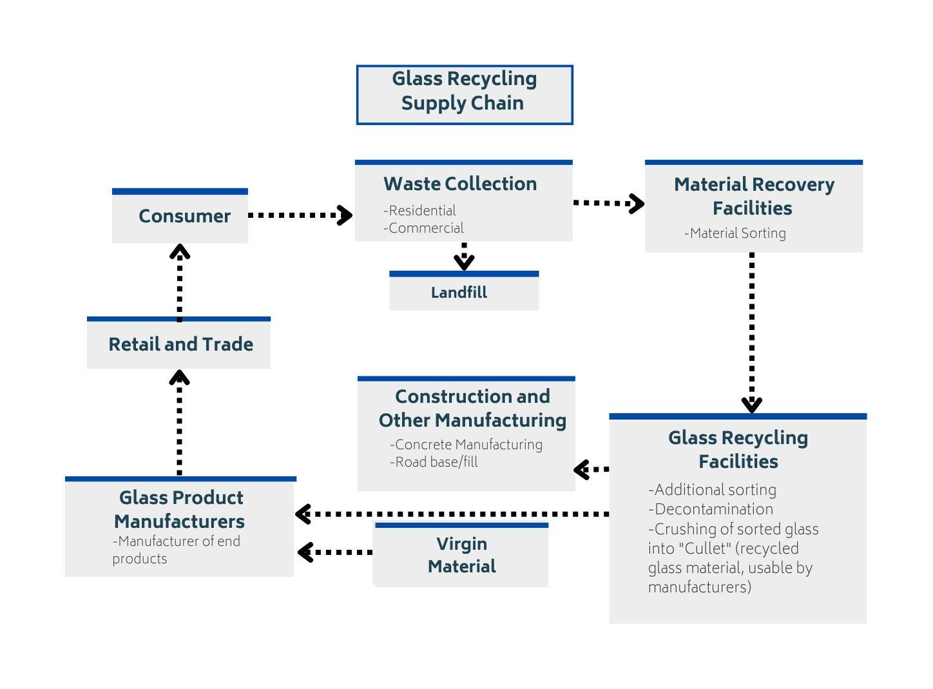
Residential and commercial waste collection is taken to the first of Material Recovery Facilities to be sorted. It moves to another recycling facility for more sorting and decontamination, and finally the glass is crushed into cullets, or smaller pieces. From here, product manufacturers can use the cullets for concrete manufacturing and road construction or offer it to retail and trade companies. This means glass is not indefinitely circular. The transformation is not from glass to glass but rather glass in concrete for landscaping and road base called fill. This alternative use is a diversion from landfills but is not technically recycling.

Figure 9: Glass Exports out of Washington State, 2011-2021
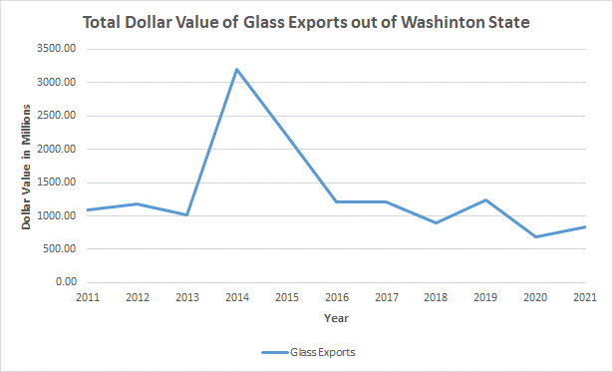
Materials are from the WISER Trade database using vehicles parts, glass and glassware, and ceramic products.

In Washington, glass exports were worth $840,801,423 in 2021. As of 2020 glass exports leaving the U.S. went to Europe and Central Asia. Vehicles generated $722,291,780 in exports, and looking at Table 19 in Appendix A, the general rates for windshields and mirrors are 4.9% and 3.9%. Because these rates are generally low, this means that countries are more willing to trade this glass and export to other countries, meaning the global glass market is not as competitive as other materials. See Appendix A Table 19 for glass bottle tariff information.

Table 8: Top 5 companies in Washington that handle glass
Company Name | Sales | Location | Employment
Murrey's Disposal Company Inc* | $14,685,405 | Tacoma | 42
Waste Management of Washington Inc* | $13,772,886 | Seattle | 99
Skagit River Steel and Recycling* | $12,012,672 | Anacortes | 44
Columbia Resource Corporation * | $9,995,169 | Vancouver | 20
Waste Control Recycling Inc* | $8,201,081 | Longview | 70
Source: Dun & Bradstreet
* = The company recycles other materials besides glass, and sales are a cumulative amount for all materials.
Murrey’s Disposal offers curbside garbage, recycling and yard waste collection in Pierce County, Washington. They recycle paper, plastic, glass, and metal. Waste Management of Washington provides recycling services all over the state, with more than 28 different locations. Waste Management specializes in residential/curbside recycling services. Besides glass they recycle paper, plastic, and metals. Skagit River Steel and Recycling also recycles plastic, and a brief description of the company is located above in that section. Columbia Resource corporation serves the residents and businesses of the Vancouver and Washougal areas. They recycle cardboard, office paper, plastic containers, oil, glass bottles, and ferrous and aluminum metals. Waste Control accepts recyclable materials, household hazardous waste, small quantity generator waste, and appliances from residences and businesses located in Cowlitz and Wahkiakum Counties. They specialize in both residential and business recycling.

Paper
Figure 10: Paper Recycling Supply Chain
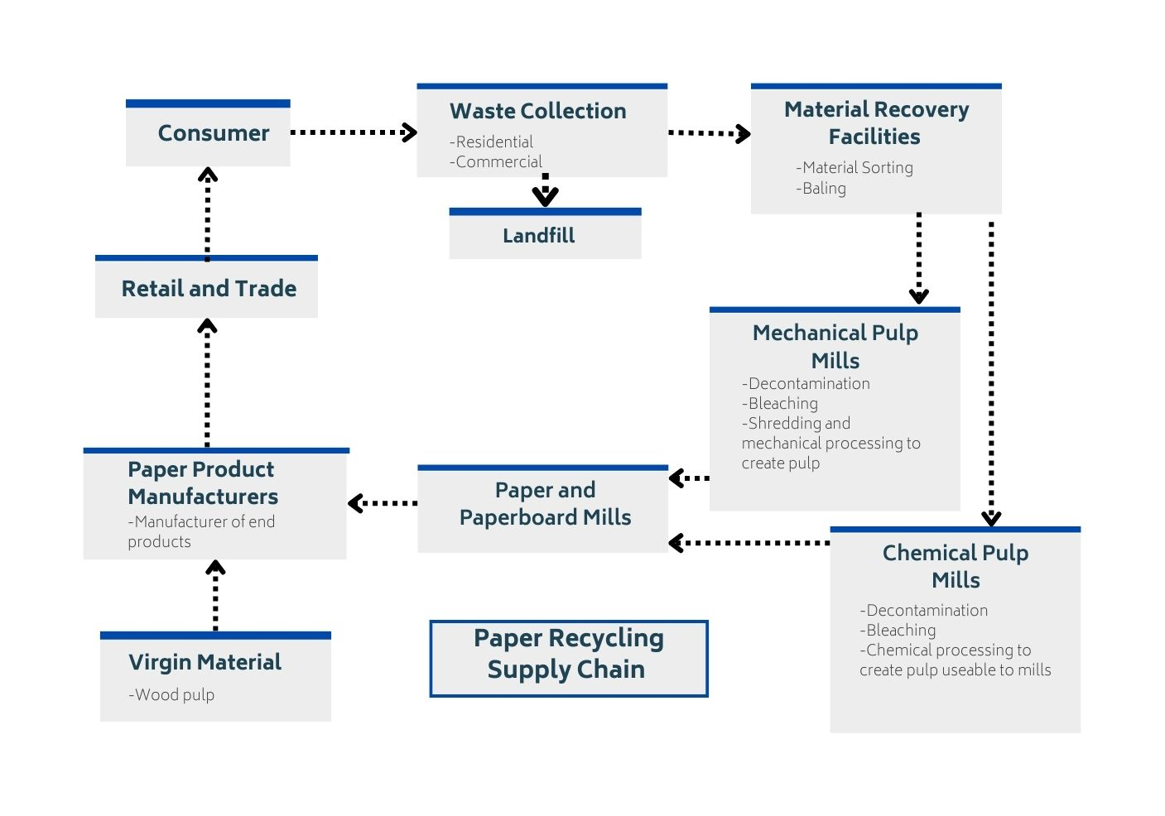
Paper is sent to Material Recovery Facilities and is only disposed in landfills at the point of collection if put with other trash materials. Paper then goes to either a Mechanical Pulp Mill or a Chemical Pulp Mill for decontamination, bleaching, shredding, or chemical processing to create pulp. The pulp from these two mills is sent to paper and paperboard mills, and the final step in this procedure is the manufacturers preparing the paper to be bought by retailers and consumers.

Figure 11: Paper Exports out of Washington State, 2011-2021 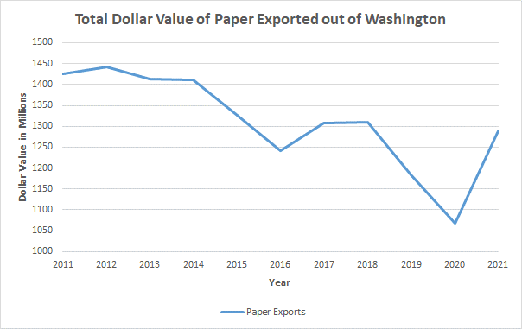
Materials are from the WISER Trade database recording printed books, newspapers, manuscripts, recovered waste and scraps, paper and paperboard articles, and photographic and cinematographic goods.
In 2021, $1.3 billion worth of paper were exported from Washington’s ports. Paper and Paperboard made up most of these exports accounting for $826 million, and in 2020 many of these products were exported throughout North America and Canada²⁶ and Malaysia30. From the figure above, paperboard and paper are the stage of paper product prior to manufacturing which makes it the ideal stage to transport. Additionally, all general tariff rates (refer to Table 18 Appendix A) for paper and paperboard are free which incentivizes trading of materials to countries who can benefit from processing more paper.

Table 9: Top 5 companies in Washington that recycle paper
Company Name | Sales | Location | Employment
Murrey's Disposal Company * | $14,685,405 | Tacoma | 42
Waste Management of Washington Inc.* | $13,772,886 | Seattle | 99
Lautenbach Recycling * | $10,672,739 | Mount Vernon | 68
Recycling & Disposal Services * | $3,724,126 | Ferndale | 31
DTG Recycling * | $3,629,956 | Tacoma | 20
Source: Dun & Bradstreet
* = The company manages other materials besides paper, and sales are a cumulative amount for all materials.
All the top selling paper recyclable material sorting companies also recycled other materials, as indicated by the asterisk. The highest company was Murrey's disposal company at over $14,685,405. The top three companies had sales over $10 million, but after that there is a significant drop off down to $3 million in sales. The companies are located all over the western side of the state, with locations in Seattle, Mount Vernon, Ferndale, and Tacoma. The total number of employees is 260.
Murrey’s disposal company also sorts plastic, glass, and metal, and a brief description of their company is mentioned above in the glass section. Waste Management of Washington and Lautenbach recycling also recycles plastic, glass, and metals and are mentioned in the glass and plastic sections respectively. Recycling & Disposal Services recycles all kinds of papers including cardboard, mixed paper, and newspaper. In addition to paper, they also recycle aluminum and tin cans, glass (in bottle form), and plastics. DTG recycle provides integrated recycling services for commercial, industrial, and construction clients. The main type of paper they recycle is cardboard, while also recycling a long list of other items, including plastic, concrete, metal, wood, and roofing.

Metals
Figure 12: Metal Recycling Supply Chain
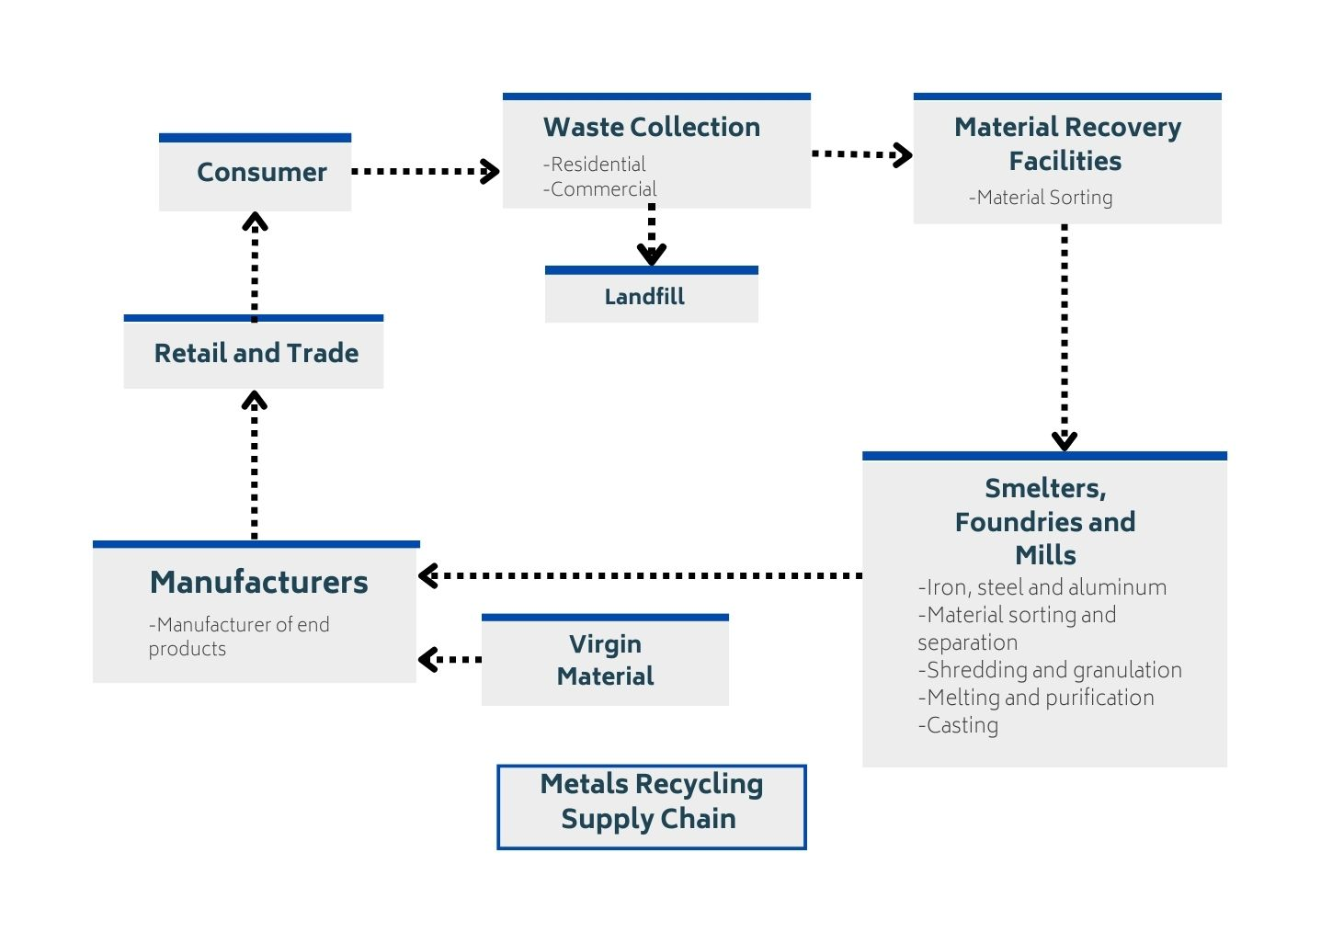
Metal is first sorted at Material Recovery Facilities. Next, smelters do a final round of sorting in preparation for melting, shredding, and casting. Materials that undergo this process are iron, steel, and aluminum. Zinc is used to galvanize iron and steel, so zinc would also be included in this process. Tin is not recycled but rather removed by the smelting process from steel cans.

Figure 13: Metal Exports out of Washington State, 2011-2021
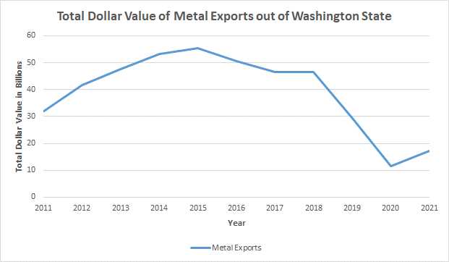
Materials considered in the graph are from the WISER Trade database: aircraft, spacecraft and parts thereof, iron and steel, aluminum and articles thereof, miscellaneous articles of base metal, arms and ammunition, railway or tramway stock, traffic signal equipment, tin and zinc.
Metal materials exported from Washington represent 24.5 percent of the total commodities exported from Washington in 2021. In 2020 metal was exported mostly to Latin America, the Caribbean, Thailand, and the Philippines from the U.S.²⁶ Airplane and spacecraft material tops the chart with $13 billion in value followed by electric machinery with an export value sum of $2 billion. Like paper, metal generally has no tariffs and supports the circular supply chain diagram because the smelting process is so efficient.

Table 10: Top 5 companies in Washington that handle metals
Company Name | Sales | Location | Employment
Seattle Iron and Metals Corp | $34,946,116 | Seattle | 100
Schnitzer Steel Industries, Inc. | $28,035,391 | Tacoma | 117
Metro Metals Northwest Inc. | $19,380,084 | Tacoma | 53
General Metals of Tacoma | $9,000,000 | Tacoma | 110
American Recycling Corp | $7,205,498 | Spokane | 25
Source: Dun & Bradstreet
The top companies that recycle metal all solely recycle metal and no other materials and are all recyclable material merchant wholesalers. The highest selling company, Seattle Iron and Metals Corp, had sales of over $34 million. Three of the top 5 companies had sales over $19 million. These companies are mostly located in Tacoma (3), with one in Seattle and the other in Spokane. The number of employees for the top 5 metal recycling companies is 405.
Seattle Iron and Metals Corp is the largest metal only recycling company in Washington, with regards to sales, and has been in business since 1922. They recycle both ferrous and nonferrous metals all throughout the Northwest, including Alaska and Canada. Schnitzer Steel Industries was founded in 1906 and is one of the global leaders in the metals recycling industry. They collect, process, and recycle raw scrap metal (ferrous and nonferrous) and provide processed scrap metal to mills and foundries. Metro Metals Northwest, formerly known as Simon Metals, focuses on the processing of precious metal recyclables generated in electronics, photographic, jewelry, aerospace, and e-waste companies. General metals of Tacoma were founded in 1965 and is solely focused on metal recycling. American Recycling Corp buys scrap metal from customers in almost any shape, size, form or mixture. This includes all ferrous and nonferrous metals.

Organics
Figure 14: Organics Recycling Supply Chain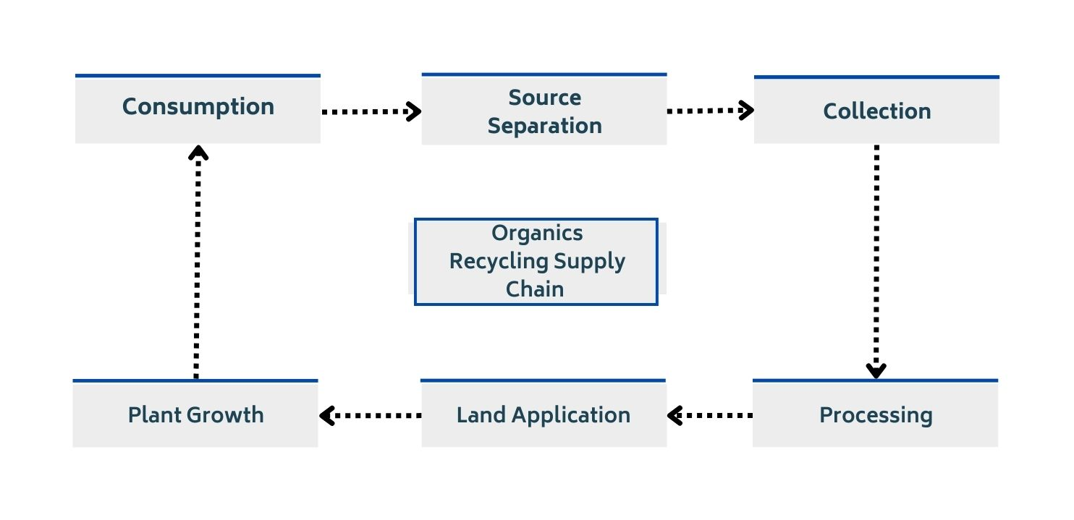
The economic overview for organic recycling in Washington is limited. Organic material does not get exported; it stays in Washington to be used as fertilizer. Therefore, a graph of exported organic material was not obtainable. (View Table 20 in Appendix A for tariff information on specific whole foods.) It is also important to note that organic materials only go to the landfill if they are disposed of with other trash at the point of collection.
Just like other recyclable materials, processing and markets for processed materials are the key to success for increasing organics recycling and recyclability and allows a source for measuring the number of organics being recycled (versus tracking residential recycling, especially on a statewide scale.) However, there are only a few anerobic digestion facilities in Washington other than for dairy and meat products, which makes it difficult to measure the progress of organic recycling in Washington.

Table 11: Top 5 companies in Washington that handle organics
Company Name | Sales | Location | Employment
Cedar Grove Composting Inc. | $45,390,730 | Seattle | 22
Pacific Topsoil’s Inc. | $18,996,833 | Snohomish | 90
Cedar Grove Organics Inc. | $14,414,644 | Seattle | 40
Lautenbach Recycling * | $10,672,739 | Mount Vernon | 68
Recycling & Disposal Services Inc. * | $3,724,126 | Ferndale | 32
Source: Dun & Bradstreet
* = The company manages other materials besides organics, and sales are a cumulative amount for all materials.
Four of the top five companies that recycle organics only recycle organics, with the one exception being Lautenbach Recycling. Four of the top five companies had sales of over $10 million. Three of the companies are in Seattle, with the other two located in Mount Vernon and Ferndale. The top company, Cedar Grove Composting, had the highest number of sales for an MRF. The total number of employees for these top five organics recycling companies is 238.
Cedar Grove Composting Inc. recorded the highest sales for any organic recycling company. They harness the vitality of organic waste by recycling it into compost. They compost 350,000 tons of residential and commercial yard and food waste annually. Pacific Topsoil’s is the next leading organic recycling company. They accept brush, grass clippings, sod, and dirt. Lautenbach recycling also recycles paper, metals, plastic, and glass and a description of the company is mentioned in the plastic section. In addition to organics, Recycling & Disposal Services recycles all kinds of papers including cardboard, mixed paper, and newspaper. In addition to paper, they also recycle aluminum and tin cans, glass (in bottle form), and plastics.

Company Trends

- The top companies, with regards to sales, exclusively recycle one kind of material, either organics or metals. In addition, these companies in general seem to have the highest sales.
- Very few of the top companies, with regards to sales, sell exclusively paper, plastic, glass or textiles
- Companies that recycle paper and plastic have the lowest sales out of the top selling ones
- Most of the top selling companies are in either Seattle or Tacoma, with the vast majority being in western Washington. This is expected because of the access to ports, and any potential expansion of facilities in eastern Washington would be limited in the outsourcing of exports or sale of recovered materials to domestic facilities or overcome a transportation cost.
- With regards to plastic, glass, paper, and organics, the top 5 companies for each are all MRFs. Meanwhile, the top 5 companies with regards to recycling metal are all recyclable material merchant wholesalers. No remediation services company made any of the lists.

Economic Impact
Economic impact analyses are an important tool used to make decisions. However, they are often misused, overestimated, or generally misunderstood. An economic impact analysis measures the ripple effects of an action taken by a government, industry, household, or other entity. The impacts include output (production), employment, labor income, and can also include state, local, and federal taxes.
The initial spending is the direct effect. So, if the government spends $1 million on a new road, $1 million is the direct effect. The impact of that spending ripples into other parts of the economy as the road builders purchase asphalt, the asphalt company itself may purchase more goods, these are called indirect effects. Finally, induced effects are the increases in spending that result when households have more income for their labor. In the road example, the induced effects would count the meals purchased at a restaurant because a laborer switched from part-time to full time because of the government spending.
- Direct – Initial change in demand (spending and jobs supported)
  - Money spent directly on a new recycling facility or the new employees hired
- Indirect – Changes in spending throughout the supply chain due to a change in demand
  - Increased demand for inputs in recycling industry which ripples through the supply chain
- Induced – Changes in spending that result when households see a change in their income
  - If increased demand for outdoor education led to programs hiring more people or promoting them from part-time to full-time positions, induced effects could include the increased spending of the staff on meals at restaurants, as well as other goods and services
Each industry has a different impact on the economy. Economic multipliers measure how broadly an industry impacts the economy. If the road project spends $1 million in the construction sector and it produces $2 million in output from direct, indirect and induced effects, then the multiplier for the construction industry is 2. However, multipliers are just one measure of the benefits to an economy. It wouldn’t make sense for a city to pay for a new road simply because the multiplier is higher if there was a different project of a higher need.
Economic impact analyses ignore opportunity costs. So, if there is a plot of land that the city wants to turn into a library, but a private developer wants to turn into an apartment building, the economic impact analysis would only measure the value to the community for turning the plot into a library. It would not consider the potential impacts of another—possibly better—use of the same amount of spending. Similarly, economic impact analyses do not consider environmental or other social costs. While there may be significant economic benefit to developing the vacant land into the library, the analysis does not consider the harm to the environment from the construction or the environmental benefits that the land had while vacant.
Another commonly ignored issue with economic impact analyses is crowding out. For example, if the city hires an accountant from somewhere else within the region, the economic impact analysis does not consider that the accountant was already employed elsewhere in the region doing another meaningful job. This can lead to overcounting an economic impact.
Economic impact analysis is a helpful tool, but it is important to keep in mind its limitations. The analysis is highly dependent on the quality of the data and its user. The impact analysis does not account for all possible outcomes and should be considered a maximum of the possible economic benefits to the region.
Economic impact analysis is particularly complicated in the context of recycling. Comparing aluminum recycling to mining new aluminum, the recycling is less expensive, requires less labor, and is generally less impactful on the economy. However, this does not mean that it is better to mine new aluminum than to recycle because the economic impact analysis ignores the environmental and social benefits of recycling.
The tables below show the economic impact of adding 100 new employees to the material recovery facilities industry. There are currently 963 employees in this industry in Washington.
Table 12: Economic Impact of Material Recovery Facilities
Material Recovery Facilities
Economic Impact | Direct | Indirect | Induced | Total
Employment | 100 | 23 | 26 | 149
Sales/Output | $19,667,916 | $5,819,427 | $5,440,549 | $30,927,892
Compensation | $5,315,925 | $1,921,411 | $1,841,733 | $9,079,069
Source: JobsEQ
In this example, the material recovery facilities hire 100 new employees at a total salary of $5.3 million. The new employees generate $19.7 million in additional output. The additional production ripples through the supply chain, contributing to 23 new jobs who are hired at a total salary of $1.9 million. These new employees generate $5.8 million to the economy. The initial 100 new employees increase their household spending because of their additional labor income. This new spending contributes to 26 new jobs which earn $1.8 million in earnings and product $5.4 million in new economic activity. In total, the new 100 jobs generate 49 additional jobs, a multiplier of 1.49.

The tables below show the economic impact of adding 100 new employees to the recyclable material merchant wholesaler’s industry. There are currently 2,412 employees in this industry in Washington.

Table 13: Economic Impact of Recyclable Material Merchant Wholesalers
Recyclable Material Merchant Wholesalers
Economic Impact | Direct | Indirect | Induced | Total
Employment | 100 | 28 | 36 | 164
Sales/Output | $25,072,941 | $6,439,508 | $7,392,203 | $38,904,652
Compensation | $6,288,540 | $2,533,492 | $2,502,407 | $11,324,439
Source: JobsEQ

In this example, the recyclable material merchant wholesale company hires 100 new employees at a total salary of $6.3 million. The new employees generate $25.1 million in additional output. The additional production ripples through the supply chain, contributing to 28 new jobs who are hired at a total salary of $2.5 million. These new employees generate $6.4 million to the economy. The initial 100 new employees increase their household spending because of their additional labor income. This new spending contributes to 36 new jobs which earn $2.5 million in earnings and product $7.4 million in new economic activity. In total, the new 100 jobs generate 64 additional jobs, a multiplier of 1.64.
Current industry information and employment for both Material Recovery Facilities and Recyclable Material Merchant Wholesaler sectors is in part one of this three-part recycling report.

Model Limitations
While economic impact analysis is a great starting tool it is important to note that it does have limitations. This type of analysis does not take into consideration opportunity costs, environmental costs/benefits, or societal costs/benefits. It is a very straightforward assessment that is much more likely to overestimate the effects than to underestimate them. This is due to crowding out, which occurs when additional sources of employment, sales/output, compensation, etc., come from within the region, creating a redistribution of resources instead of an addition of resources. For example, if a city hires an economist from within the region, the economic impact analysis considers that to be an additional employee, when the number of employees within the region stays the same.
The economic impact analysis is also very reliant on the quality of data and its user. It is limited in the number of outcomes it considers and should be used as the maximum number of economic benefits brought to a region. This tool still provides a great baseline to display the potential economic benefits for a region despite some of its shortcomings. However, it is important to keep in mind some of the limitations it does have.

Changes to the Industry: Material Recovery Facilities (NAICS 562920)

Table 14: Economic Impact of changes to the MRF Industry in Washington State
5% | Direct | Indirect | Induced | Total
Employment | 5 | 1 | 1 | 8
Sales/Output | $1,136,000 | $329,830 | $394,796 | $1,860,626
Compensation | $315,765 | $112,518 | $117,274 | $545,557
25% | Direct | Indirect | Induced | Total
Employment | 25 | 6 | 7 | 38
Sales/Output | $5,680,000 | $1,649,150 | $1,973,979 | $9,303,129
Compensation | $1,578,823 | $562,592 | $586,372 | $2,727,787
50% | Direct | Indirect | Induced | Total
Employment | 50 | 11 | 15 | 76
Sales/Output | $11,360,000 | $3,298,299 | $3,947,958 | $18,606,257
Compensation | $3,157,646 | $1,125,185 | $1,172,743 | $5,455,574
75% | Direct | Indirect | Induced | Total
Employment | 75 | 17 | 22 | 114
Sales/Output | $17,040,000 | $4,947,449 | $5,921,937 | $27,909,386
Compensation | $4,736,468 | $1,687,777 | $1,759,115 | $8,183,361
Source: JobsEQ
Economic Impact has been projected given total industry sales/output from each industry. We project growth at 5%, 25%, 50% and 75% and model the indirect, induced and total impact on employment and compensation at each level. Sales/output (industry GDP) data used in this model can be found in Appendix C. At 25% growth to industry GDP we anticipate a total of 38 added jobs, 2.7 million in compensation and an increase of 9.3 million in GDP. At the higher end, 75% growth would correspond to 114 jobs, 8.2 million in compensation and 27.9 in GDP. It is important to note that this should not be used as an illustration of net job/GDP growth in the Washington economy, as these changes could represent other factors. These changes may represent shifts in employment from other industries to Material Recovery Facilities or similar shifts in GDP.

Changes to the Industry: Recyclable Material Merchant Wholesalers (NAICS 423930)

Table 15: Economic Impact of changes to the Recyclable Material Merchant Wholesalers Industry, Washington State
5% | Direct | Indirect | Induced | Total
Employment | 5 | 3 | 3 | 10
Sales/Output | $1,786,000 | $721,060 | $702,903 | $3,209,962
Compensation | $360,880 | $260,792 | $208,798 | $830,469
25% | Direct | Indirect | Induced | Total
Employment | 25 | 13 | 13 | 51
Sales/Output | $8,930,000 | $3,605,299 | $3,514,513 | $16,049,812
Compensation | $1,804,399 | $1,303,960 | $1,043,988 | $4,152,347
50% | Direct | Indirect | Induced | Total
Employment | 50 | 26 | 26 | 103
Sales/Output | $17,860,000 | $7,210,598 | $7,029,026 | $32,099,625
Compensation | $3,608,799 | $2,607,920 | $2,087,977 | $8,304,695
75% | Direct | Indirect | Induced | Total
Employment | 75 | 40 | 39 | 154
Sales/Output | $26,790,000 | $10,815,898 | $10,543,539 | $48,149,437
Compensation | $5,413,198 | $3,911,880 | $3,131,965 | $12,457,042
Source: JobsEQ
The Recyclable Material Merchant Wholesale industry constitutes a larger proportion of total GDP than Material Recovery facilities which corresponds to its larger anticipated indirect and induced impact multipliers. At 25% industry GDP growth, we anticipate a total impact of 51 jobs, 4.2 million in compensation and 16 million in GDP contribution. At 75%, 154 total jobs, 12.5 million in compensation and 48.1 million in GPD contribution.

International Supply Chain
The Oregon Department of Environmental Quality’s Materials Management program examined the environmental impact of materials. This included the full-life impact of a material, starting with resource extraction, then the design and production, use, end-of-life management, and disposal and recovery. Findings from this report include ways to improve recovery rates and reduce waste generation, and year-to-year changes on waste generation, disposal and recovery within the state. Within Washington State, recycling aims of reduced global waste can be achieved with material life-cycle assessments and improvements of domestic and international transfer of material recovery facilities. Identifying the baseline supply chain characteristics in Washington can help formulate policy improvements for the stakeholders and facilities involved in the related industries.
Figure 15: Materials Life Cycle
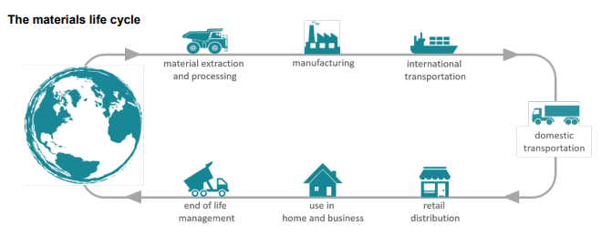
Source: 2020 Oregon Material Recovery and Waste Generation Rates Report
Investigation of the recycling supply chain faces notable limitations, especially at the international level. While imports and exports of recycled and recyclable materials are present in Washington’s recycling supply chain there are certain barriers to effectively isolating and identifying their effects on the local industries and state economy. The primary limitation faced here lies in cargo and shipping tracking practices. First, tracking practices in international shipping are limited by cargo weight and weight value. This poses an issue for the accuracy of shipping data and for the reliability of data comparison to material volumes reported by surveyed recycling facilities.
The limitations on data of imported and exported recyclable goods moving in and out of Washington ports is that the additional domestic movement and other points of entry and exit for these goods. For instance, port data does not account for movement of material prior to export for a material that could originate from out-of-state sources. These factors make it difficult to identify the true impact of materials, such as carbon footprint, on the state level.

International Supply Chain Within Washington State

This section will analyze plastic, paper, glass, metal, and organics imported into the U.S. and how Washington state ports are interacting in the international supply chain. To understand the bigger picture of the circular economy outside of Washington state, it is important to look at the Harmonized Tariff Schedule (HTS) to see the tariff information on recyclable materials imported into the U.S. and which materials are duty-free according to Free-Trade Agreements. The HTS is a resource provided by the U.S. International Trade Commission which lists schedule B codes. The HTS in this report is a condensed replica of the official HTS with an added notes section; there is more information about the make-up of the HTS in Appendix A. Additionally, Appendix A contains a list of the Free-Trade Agreements.
There are ports in 28 cities in Washington state. Seattle is the leader in exports for Washington shipping $5.77 billion worth of products in 2021. As a state, Washington plastic exports are worth $2.3 billion, paper exports are worth $467 million, metal exports are worth $71 billion, glass exports are worth $559 million, and organics are worth $5 billion. (These numbers paint a general picture of export statistics because of limited commodities listed in WISER Trade35). These different types of materials have their own HTS tables located in Appendix A. International tariff information explains how each country chooses to prioritize their own domestic industries through tariffs, keeping foreign prices higher than domestic goods prices, and protecting worker’s rights and conditions under free-trade agreements.

Duty-Free International Trade Rewards
- Strengthens worker’s rights and conditions
- Reduces accessibility barriers
- Innovation (pharmaceuticals)
- Decreases the need to raise the prices of imported goods

Tariff Protections
- Decreases domestic industry competition
- National Security
- Protects domestic employment
- Increases a country’s agency or control of imports

Appendix A
Table 16: Free-Trade Agreement Provisions
Harmonized Tariff Schedule Provisions
D- The African Growth Opportunity Act (AGOA) | This act was established in 2000 and “promotes economic growth through good governance and free markets” allowing textile and non-textile goods to be imported into Sub-Saharan countries (SSA) with duty free treatment.
E – The Caribbean Basin Initiative (CBI) | This initiative was created in 1983 by the Caribbean Basin Economic Recovery Act (CBERA). The United States Trade Representative (USTR) is responsible for constructing a report every other year to evaluate if countries are increasing production of textiles with “duty-free access to the U.S. market.”
K - Agreement on Trade in Pharmaceuticals Products | The “Pharma Agreement” was designed under the World Trade Organization (WTO) and has made over 10,000 pharmaceutical products duty-free.
S - The United States-Mexico-Canada Agreement (USMCA) | This North American agreement was created in 2020. It replaced the North American Free Trade Agreement (NAFTA), which was an agreement among these three nations to cut import taxes to zero.
P - The Dominican Republic-Central America FTA (CAFTA-DR) | This act began in 2011. This provision emphasizes labor protections across all regions and has helped strengthen worker’s rights and conditions in Guatemala.

Harmonized Tariff Schedule Definitions
Rate: the price increase credited to the domestic country based on the price of the foreign good
Schedule B code: A 4-to-8-digit number assigned to each type of recyclable material in order to find its corresponding tariff information for materials imported into the U.S.
General Rate of Duty: The general rate of duty represents the normal trade relations (NTR) rates applicable for each product across the globe
Special Rate of Duty: Special rates refer to the customized rates from specific countries
Duty-free Rate: “Duty” refers to taxes. If products are eligible for duty-free rates, then there are no tariffs or costs required by the importing or exporting country. An asterisk (*) will represent duty-free rate agreements with Australia, Bahrain, South Korea, Morocco, Singapore, Oman, Israel, Panama, Jordan, Columbia, Chili, and Peru
Table 17: CEBR Harmonized Tariff Schedule for Plastic
International Supply Chain of Plastic
Material/Purpose | Code(s) | General and Special Rates of Duty | North Korea and Cuba Special Rates
Mainly covered in paper | 4202.99.1000 | The general rate of duty is 3.4% for plastics mainly covered in paper. *Special rates apply and provisions include D, E, P, and S | 80%
Acyclic polycarboxylic acids | 2917.11 (Oxalic acid) | The general rate of duty is 3.4% for this chemical compound and *special free rates apply. Provisions include D, E, P, and S | 34.5%
Chemical engineering | 2917.13 (Adipic and sebacic acid) | The general rate of duty is 4.8% for these compounds with *special free rates including provisions D, E, P and S | 25%
Biodegradable | 2917.19.15 (Fumaric Acid) | The general rate of duty is 6.5% for this compound, found in food and pharmaceuticals, with *special rates and provisions include D, E, P and S | 15.4¢/kg + 87%
Biodegradable | 2917.19.23 (Maleic anhydride) | The general rate of duty is 6.5%. This chemical is used in the manufacturing process. *Special free rates apply and provisions include D, E, K, P, and S | 15.4¢/kg + 53.5%
Plasticizer, used to make more flexible material | 2919.90 (Triphenyl phosphate) | Free | 15.4¢/kg + 57%
Acrylic polymers in primary forms | 3906  3906.90.2 & 3906.90.5 | Elastomeric material is generally free.  (Not classified) have an average general rate of 5.25% | 20%  At least 25%
Cellulose and its chemical derivatives | 3912.11 (Non plasticized)  3912.12 (Plasticized)  3912.31 | *Special Rates apply to all.  Cellulose acetates have the same general rate of 5.6%  Cellulose esters have a general rate of 6.4% | 73.5%  73.5%  66%
Waste, parings and scarp, of plastic | 3915 | Free | 10%
Plastic bottles | 3923.30 | The general rate is 3% and *special rates apply | 80%
Table 18: CEBR Harmonized Tariff Schedule for Paper
International Supply Chain of Paper
Material | Schedule B Code(s) | General and Duty-Free Rates | North Korea and Cuba Special Rates
Uncoated paper and paperboard | 4801-4823 | Free | Avg. Of %27.3
Photographic films | 3702 | The general rate of duty for instant print film, x-rays, polychrome, and microfilm are 3.7%. *Special free rates apply, and provisions include D, E, P, and S | 38¢/$m^{2}$
Photographic paper | 3703 | General rate for all codes is 2.8-3.7% and provisions include D, E, P, and S
Newspaper | 4707 | Free | Free

Table 19: CEBR Harmonized Tariff Schedule for Glass
International Supply Chain of Glass
Material | Schedule B Code(s) | General and Duty-Free Rates | North Korea and Cuba Special Rates
Airtight containers of glass or metal | 2005.70 | The general return rate to the imported countries sales is 9.9¢/kg on drained weight. *Special rates and provisions D, E, P and S apply | 11.6¢/kg on drained weight
Glass bottles | 2207.10.30 (For beverages)  2207.10.60 (Non beverage purposes) | The general return rate for glass bottle beverages is 18.9¢/pf.liter and 2.5% for non-beverage bottles. *Special free rates are offered for both types (Panama included only for 2207.10.30) | 1.32¢/pf.liter  20%
Cullet and other waste and scrap | 7001.00 | The general rate for broken down glass is 3%. *Special free rates are included, and D, E, P and S are applicable | 50%
Windshields | 7007.21 | The general rate for windshields is the highest of the glasses at 4.9%. *Special free rates are included, and D, E, P and S are applicable | 60%
Mirrors (including vehicles) | 7009.10 | The general rate for rearview mirrors is 3.9%. *Special free rates are included, and D, P and S are applicable | 50%
Drained weight: the weight of the solid portion of the product with the liquid drained after thermal processing

Table 20: International Supply Chain of Metal
International Supply Chain of Metal
Material | Schedule B Code(s) | General and Duty-Free Rates | North Korea and Cuba Special Rates
Aluminum | 7602 (Scrap)  7612.90 (Cans)  7616 (Nails, tacks, staples, screws, etc.) | Scrap aluminum is free. Cans have a general rate of 2.7% with provisions D, E, P, and S, and aluminum articles have a general rate of 5.4% with the same provisions | Free  45%  45%
Tin ores (mined) | 2609 | Free | Free
Iron and Steel | 2619  2620.19 (Zinc slag, ash, and residue) | Free  Free | Varies depending on zinc, lead, and copper content

Table 21: International Supply Chain of Organics
International Supply Chain of Organics
Material | Schedule B Code(s) | General and Duty-Free Rates | North Korea and Cuba Special Rates
Eggs | 0407 | The general rate for all forms of egg is 2.8¢/dozen with *special rates and provisions D, E, P, and S offered | 10¢/dozen
Vegetables | 0709-0712 | Rates vary for all vegetables and are generally not free. | Rates vary
Coffee and Tea | 0901 (Coffee)  0902 (Tea) | Free  Green tea has a general rate of 6.4% and all black tea is free. | Free  20%
Spices | 0904-0910  0904.22 (Paprika)  0910.99.06 (Thyme)  0910.99.07 (Bay leaves) | There are only three spices with general rates: paprika is 3¢/kg, thyme is 4.8%, and bay leaf is 3.2%. Pepper, vanilla, cinnamon, cloves, nutmeg, dill, curry, turmeric, and cumin are all free | 11¢/kg  25%  25%
Vegetable waste, residues, byproducts, and animal waste | 2308 | The general rate is 1.4% | Avg. of 17.5%

Appendix B
“University of Maine researchers: Circular economy concepts may be overlooking environmental justice”
Quinn, Megan. “University of Maine Researchers: Circular Economy Concepts May Be Overlooking Environmental Justice.” Waste Dive, 21 June 2022.
While on the surface the concept of a circular economy has many positives, there are concerns that the initial reports on this topic may be overlooking environmental and social justice issues. Researchers from the University of Maine conducted a study “Just by Design'', where they documented language used in 24 different circular economy reports between 2018-2020. In these reports they examined how the plans either discussed or omitted concepts of justice. Many of the reports contained broad claims about job creation but lacked the critical details on how they would be able to equally distribute them to those overburdened communities. Many of them did not acknowledge the many long-standing structural inequalities that exist in this country with regards to racial, economic and social status, but the inequality issues cannot be fixed with words and deeds. While these policies may have the best intentions, without adequate attention being paid to these inequalities, they will be swept under the rug and ignored. Instead, technological innovation continues to be the dominant approach and the main area of focus.
Many of the reports contained a neoliberal frame of justice, which is the assumption that free markets institutionally are the best way to address social inequalities. It follows the idea that giving everybody access to the market will resolve these inequalities. Michael Haedicke, one of the researchers on this study, believes there is a better approach. He believes the best way to incorporate justice is to give everyone who has a stake in the outcome's representation, rather than a ‘free for all’ approach, because many times in these situations those in the minority are overlooked and left out.
Examining the language that is used in creating these frameworks is critical because it helps shape the form that the circular economy takes. When organizations, especially nonprofit ones, adopt language that promotes neo liberal frames of justice, there is a lack of awareness and detail for how inequality concerns will be addressed. When conducting focus groups with stakeholders, there was some discussion on the order of building the circular economy. Some believe you implement the circular economy, and then issues of equality will emerge. Others believed you must intentionally design these systems with equality and justice in mind from the beginning.
The researchers concurred with the latter and concluded that minority groups need to be more included in the conversation for greater equality and justice to be achieved from the start. Going out of the way to include provisions for these equities is a necessary step to achieve these goals.
“Politicizing Circular Economy: what can we learn from Responsible Innovation?”
Pansera, Mario, et al. “Politicising Circular Economy: What Can We Learn from Responsible Innovation?” Politicising Circular Economy: What Can We Learn from Responsible Innovation? Responsible Innovation, 26 Apr. 2021.
An article from the Journal of Responsible Innovation agrees with many of the ideas presented in the ‘Just by Design' study, sharing similar worries about neoliberal framing. The authors of this study are concerned that this method of framing is only focused on the technological endeavor side and is not considering systemic socio-ecological implications, which has the potential to create a ‘sophisticated form of greenwashing’, if the implementation continues to be apolitical. Too many political, social, and equity concerns are either ignored or not incorporated. Pansera et al, calls for a much broader analytical lens to be deployed, in order to properly connect the required innovations for a circular economy with the social and political aspects that are entangled with it.
Luckily, with the support of the European Union, a new project has been launched called, ‘A Just Transition to a Circular Economy’, also known as JUST2CE. The project aims to develop a multi-layered conceptual framework for a just and responsible transition to a circular economy, while addressing some of the previously neglected equality factors. Their goal is to broaden societal and community-based goals, resulting in better outreach to local communities. The article concludes with the idea that transitioning to a circular economy goes beyond depending on the development of new technologies. It also requires governance processes that require the socio-political nature of technological innovation.
Both articles come to the same conclusion that while most of the focus thus far in the transition to a circular economy is centered around technological innovation, there are many other factors that need to be considered. The socio-political aspects are intertwined with the technological innovation we need to achieve a circular economy.
“Circular Charlotte: Towards a zero waste and inclusive city”
Eva, et al. “Circular Charlotte: Towards a Zero Waste and Inclusive City.” City of Charlotte Government.
A report called ‘Circular Charlotte’ gave a blueprint for the steps a city needs to take to achieve a circular economy. It details the city's plans of action over the next 30 years to achieving a fully waste free city by 2050. It details some of the benefits, barriers, and improvements needed in accomplishing these goals.
Potential benefits include a 30X increase in the number of jobs created per 10,000 tons of goods disposed of, reduced strain on upstream producers, and the ability to meet increasing demand while dealing with the scarcity of critical resources. Further benefits include increases in opportunities across the community and decreases in the amount of poverty. Additional information on the Circular Charlotte report can be found in Appendix B.
While these benefits are great there are several barriers preventing this transition for the city of Charlotte. There are gaps in the physical and technological innovation needed, gaps in the skills needed by individuals along with the right mindset, and finally political and legal barriers. There are many obstacles to overcome in making this transition.
Some broader long-term solutions to these challenges are designing all products for easy repair, disassembly and full accessibility, creating business structures and incentives to get materials back into the economy at the highest possible value, and avoiding the use of toxic substances.
Looking more short term, establishing public sector commitment to the transition, completing baseline assessments, rebranding the city, and creating a communications campaign all are goals of the next 5 years for Charlotte. The focus of these goals is to engage with community members along with city representatives to provide the information needed to gain strong commitments to making this transition. From there more time-consuming changes can begin to take form.
‘Circular Charlotte’ envisioned to produce a waste free and inclusive city. The city, along with their stakeholders, present a vision of how this could look, along with roadmaps for the necessary actions to take to get there. While the previous two articles display some concerns for the future of circular economies, this report lays out a plan on how to address these concerns and builds a blueprint to demonstrate all the potential benefits that a circular economy can provide.
For starters, one of the most beneficial outcomes from the circular economy is the creation of new jobs. The U.S. EPA estimates that landfill and incineration processes result in between 1-6 jobs per 10,000 tons of goods disposed of. In contrast, recycling generates an estimated 36 jobs for the same amount of material. But what creates by far the greatest number of jobs is reuse and refurbishment, which creates 300 jobs per 10,000 tons disposed of, avoiding the landfill altogether. Furthermore, if all 144,403 tons of plastic could have been recycled instead of landfilled, $35 million dollars' worth of revenue could have been saved or created in Charlotte. Reusing materials also reduces strain on upstream producers who are continuously having to reproduce virgin materials.
In addition, the transition to a circular economy can greatly help with the problem of scarcity. Critical resources, such as the metals used in electronics, are becoming scarcer, and our current linear economy aids that issue by being wasteful and inefficient. Our economy will only continue to grow over time, which makes the transition to keeping materials in perpetual circulation the best way to manage this increasing demand.
Furthermore, the circular economy can help decrease poverty and increase opportunities for all within the community. The city of Charlotte plans to focus efforts on skill development, training, and inclusive programs designed to lift those who are economically disadvantaged. They also intend to encourage entrepreneurship, launching support services for these new entrepreneurs and local markets. The idea of circular housing is also planned to be implemented, by giving priority to developers who aim to provide different levels of pricing for housing within individual developments. This increases social cohesion, along with creating an equitable manner of providing low-income housing in prime locations in the city.
Currently there are several barriers standing in the way for this transition to happen. First, there are gaps in the physical and technological innovation needed. There is no current way for the city of Charlotte to recycle materials such as Styrofoam, plastic, plastic foils, etc. Most of the materials are not designed for high value reuse and recycling. From a social perspective, changing the mindset of individuals is a challenge. A circular economy will require a great deal of new skills and knowledge, along with a new, comparable workforce. Finally, there are political and legal barriers, such as existing rules and regulations that hamper how certain waste streams are used and where they can take place. A group of stakeholders listed many more barriers, categorized into 4 major categories: physical and technological, social and cultural, economic and financial, and political and legal.
The city of Charlotte has laid out some short term and long-term action plans to begin taking the necessary steps to make this transition to a circular economy. Some broader long-term solutions include designing all products for easy repair, disassembly and full accessibility, creating business structures and incentives to get materials back into the economy at the highest possible value, and avoiding the use of toxic substances.
Looking more short term, establishing public sector commitment to the transition, completing baseline assessments, rebranding the city, and creating a communications campaign all are goals of the next 5 years for Charlotte. The focus of these goals is to engage with community members along with city representatives to provide the information needed to gain strong commitments to making this transition. From there more time-consuming changes can begin to take form.
Some of these changes include transitioning to alternative business models and purchasing models that better support the reuse of materials. One approach to this is extending producer responsibility, keeping them responsible for the products they create even after the products are sold.
Many challenges exist for making such a widescale transition to a circular economy. However, this report from the city of Charlotte provides a blueprint for other cities to follow. There are many barriers that exist in all different areas, but with good planning and foresight these barriers can be broken down. The benefits of this transition are vast, and extremely rewarding. Tapping into these benefits can help propel our society into a much more successful and sustainable future.

Appendix C
Table 22: Industry growth for Material Recovery Facilities and Recyclable Material Merchant Wholesalers by percentage
Growth | Material Recovery Facilities (GDP) | Recyclable Material Merchant (GDP)
5% | $1,136,029 | $1,786,051
25% | $5,680,147 | $8,930,253
50% | $11,360,294 | $17,860,507
75% | $17,040,441 | $26,790,760

Source: Jobs EQ

Appendix D
While public education and participation in waste separation for recyclable materials can significantly improve efficiency and lower sorting costs for material recovery facilities, there is also a notable advantage, in terms of residential and curbside collection, to simplifying collection practices. Requiring residents to conduct additional sorting of recyclable materials may reduce overall participation or volume of materials collected. The alternative of simplifying collection offsets this risk and has been shown in some cases to increase the rate of landfill diversion. While simplifying collection, allowing multiple materials to be collected in one curbside bin, the levels of contamination increase as well as the need for sorting materials after collection.
Locally, a 2020 report from the King County Solid Waste Division program identified some of the core issues the region faces in the effectiveness of its curbside collection and recyclable materials processing. King County material recovery facilities, first and foremost, identified contamination in their collection stream as a pressing issue. This contamination takes the form of unusable materials, which either cannot be sorted (dead animals, small engine parts) or require additional labor and resources to sort into batches of material viable for baling, transportation and reprocessing into raw, usable material.
Furthermore, materials that cannot be sorted out in the MRF process can result in rejection of the entire bale of material, for example, a bale of paper that contains too much non-paper material). This occurs especially in cases of cross contamination from food products. Here, contamination of paper and some plastic products can result in the entire accompanying load of material being outright rejected, taking away from what otherwise would have been usable material and reducing supply. Similar rejection of material can occur with the presence of excessive moisture in a load of materials which has either made the material (like paper or cardboard) unable to be processed or sorted.

Figure 16: Overall Flow of King County Recyclable Materials
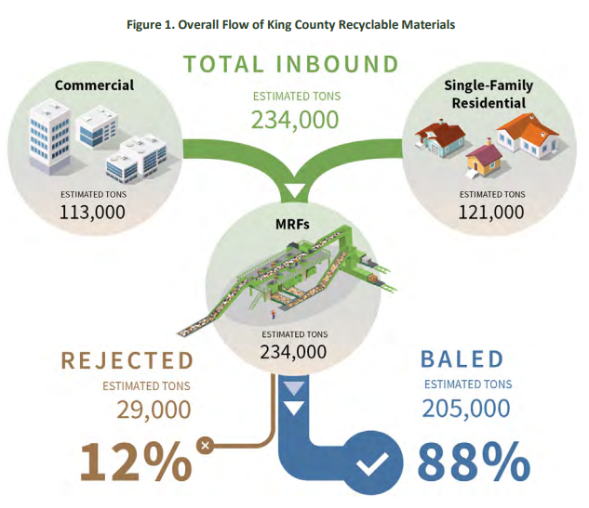
Beyond these issues, MRFs in King County also identified direct hazards to workers occurring through contamination in the stream of materials. Biohazards, hazardous chemicals, flammables and sharp objects have been present in the King County stream of collected materials. The presence of these materials not only poses a risk to workers at these facilities but by extension, can increase costs and slow work as additional measures need to be taken for safety and removing them from collected materials. Each of these factors begin at issues with initial material collection. This King County report identifies several potential options to address these issues.
One option that could be translated to Washington is expanding community outreach and education with complete lists of acceptable materials. Another option would be to introduce fines for contaminating materials found in residential recyclables. This would motivate informed participation in recycling collection and could potentially offset costs from rejected batches of material. Another option- included investment in MRF infrastructure like automated sorting to reduce the current labor cost from some of the contamination.

Life-Cycle Assessment of Residential Curbside Pickup Case Study

The Life-Cycle assessment (LCA) of residential curbside material collection provides some key insights into the economic and environmental outcomes associated with this sector of material recovery. The Environmental Research and Education Foundation conducted this LCA in 2022, and specifically looked to examine the greenhouse gas (GHG) emissions associated with different configurations of curbside collection, in addition to identifying crucial factors that impact curbside collection efficiency. Their model used Solid Waste Optimization Life-cycle Framework (SWOLF), consisting of “state-of-the-art life-cycle process models for solid waste collection, recycling, landfilling, composting, anaerobic digestion (AD), waste-to-energy (WTE), and gasification that uniquely facilitate integrated analyses of material recovery strategies.
Regarding collections efficiency, and improving capture rate for curbside residential recycling, the report identified 4 key factors. These being 1) the materials included in collections, 2) how effectively residents sort their recyclable materials, 3) single vs dual stream recycling programs, 4) the location and type of end-uses markets (e.g., bottle-to-bottle) for each recovered material. These factors played the most significant role in determining the effectiveness of curbside collection programs.
In terms of bin configuration, this LCA looked at 3 different options. These were one bin (landfill only), two bins (landfill, mixed recycling), and three bins (landfill, recycling, yard waste). Of these three choices, two bins were by far the most energy efficiency- with a 38% reduction in GHG emissions relative to one bin. These energy savings were rooted in reductions in manufacturing that could utilize recycled materials. This improvement, however, was entirely negated by the inclusion of the third yard waste bin. This third bin necessitated an additional weekly collection and pickup. In addition to these added fuel expenditures, in addition to other auxiliary factors included in the processing of organic waste (such as pile aeration).
Additionally, the LCA looked at which materials contributed to the GHG savings associated with recycling relative to landfill dumping. Aluminum cans, mixed metals, office and residential paper, and corrugated containers all ranked highest in their reduction to GHG emissions. Again, most of these savings resulted from the reduced consumption of virgin materials in manufacturing. The refinement and processing of virgin materials are more energy intensive than the reclamation and repurposing of recycled materials. The life cycle assessment process is important to ensure that recycling processes are useful in reducing emissions and properly handling materials. By looking at a single material’s environmental impact, it can be easier to compare alternative processing steps to reduce waste within material flows.

Appendix E
Table 23: Materials Collected for Recycling (tons), 2018
Materials Collected for Recycling (tons)
Asphalt & Concrete | 2,998,372 | Miscellaneous | 21,652
Other Ferrous Metal | 1,324,097 | PET Plastics | 21,439
Cardboard | 650,682 | LDPE Plastics | 20,802
Construction & Demolition Debris | 596,110 | Electronics | 17,813
Yard Debris | 561,869 | Auto Lead Acid Batteries | 15,960
Yard Debris & Food mixed | 394,527 | Steel Cans | 14,954
Mixed Paper | 222,117 | Other Recyclable Plastics | 14,861
Wood Waste | 169,607 | HDPE Plastics | 13,733
Land clearing Debris | 168,547 | Aluminum Cans | 13,329
Other Nonferrous Metal | 143,033 | Roofing Material | 11,817
Other Organics | 121,555 | Industrial Organics | 11,229
Newspaper | 103,867 | Other Glass | 9,388
Food Scraps | 103,105 | Antifreeze | 3,633
Meats, Fats & Oils | 99,502 | Oil Filters | 2,638
Container Glass | 84,163 | Carpet & Pad | 2,109
Appliances/White Goods | 80,006 | Light Bulbs | 989
Used Oil | 56,285 | Household Batteries | 907
Gypsum | 54,980 | Mixed Plastics | 831
High Grade Paper | 53,765 | Paint | 266
Food Processing Waste | 53,664 | Mattresses | 140
Textiles | 37,921 | Other Batteries | 86
Tires | 36,289 | Cartons | 64
Agricultural Organics | 31,660 | Photographic Films | 33
Source: Washington State Department of Ecology

 | Total Material Recovered for Recycling (tons) | 8,344,398

Bibliography

“Business & Commercial Collection,” Business & Commercial Collection – Seattle Utilities. Retrieved September 1, 2022, from https://www.seattle.gov/utilities/your-services/collection-and-disposal/garbage/business-and-commercial-collection
“Solid waste division,” King County Department of Natural Resources and Parks. King County Solid Waste Division, September 2020. Retrieved September 1, 2022, from https://kingcounty.gov/depts/dnrp/solid-waste.aspx
“2020 Recycling Economic Information Report - US EPA,” Environmental Protection Agency, November 2020. Retrieved September 1, 2022, from https://www.epa.gov/sites/default/files/2020-11/documents/rei_report_508_compliant.pdf
Dun & Bradstreet, Mergent Intellect, https://www.mergentintellect.com/index.php/search/index
“School Recycling & Waste Reduction Resources,” Seattle Public Utilities, 2022. Retrieved October 1, 2022, from https://www.seattle.gov/utilities/protecting-our-environment/education/school-recycling-and-waste-reduction
“Waste reduction and recycling education grants,” Department of Ecology, Retrieved October 1, 2022, from https://ecology.wa.gov/WRRED
National Association of Manufacturers, NAM. https://www.nam.org/
Lifset, Reid, et al. “Extended Producer Responsibility.” Journal of Industrial Ecology, vol. 17, no. 2, 2013, pp. 162–166., https://doi.org/10.1111/jiec.12022.
Top 10 Manufacturing Companies in Washington State,” Industry Select, February 14, 2022. Retrieved August 1, 2022, from https://www.industryselect.com/blog/top-10-manufacturing-companies-in-washington-state
AMP Robotics Marks Milestone in Data, Pick Rates for Automated Recycling,” Robotics 24/7, July 2, 2021. Retrieved August 10, 2022, from https://www.robotics247.com/article/amp_robotics_marks_data_pick_rate_milestones_automated_recycling
Maria Rachal, “WM explains plan to accelerate automation amid a ’war for talent’,” WasteDive, June 15, 2022. Retrieved September 15, 2022, from https://www.wastedive.com/news/wm-watson-automation-acceleration-collection-mrf-customer-service/624970/#:~:text=Energy-,WM%20explains%20plans%20to%20accelerate%20automation%20amid%20a%20'war%20for,in%20a%20tight%20labor%20market
Ashley Nunes, “Automation Doesn’t Just Create or Destroy Jobs- It Transforms Them,” Harvard Business Review, November 2, 2021. Retrieved August 1, 2022, from https://hbr.org/2021/11/automation-doesnt-just-create-or-destroy-jobs-it-transforms-them
“Introduction of plastic tax in EU from 2021 on,” Circular Plastics Alliance, July 10, 2020. Retrieved August 1, 2022, from https://circular-plastics-alliance.com/en/plastic-tax-in-eu-from-2021/
Chapter 173-900, Washington State Legislature, 2006. Retrieved August 1, 2022, from https://apps.leg.wa.gov/wac/default.aspx?cite=173-900
“Luyi Gui, et al. “Implementing Extended Producer Responsibility Legislation,” A Multi-stakeholder Case Analysis, Journal of Industrial Ecology, vol. 17, no. 2, 2013, Retrieved August 1, 2022.
National Conference of State Legislatures, Retrieved August 1, 2022.
JobsEQ, Chmura Economics & Analytics, Retrieved July 1, 2022, from https://jobseq.eqsuite.com/landing/economic-development
“Definition: potential chemicals such as fatty acids like vegetable oil, waste oil, or animal fat that can be converted into biodiesel or fuel,” Ballotopedia, Retrieved November 1, 2022, from https://ballotpedia.org/Feedstock
United States product exports and imports. United States Product Exports and Imports 2020 | WITS Data. (n.d.). Retrieved January 3, 2023, from https://wits.worldbank.org/CountryProfile/en/Country/USA/Year/2020/TradeFlow/EXPIMP/Partner/WLD/Product/All-Groups
World Institute for Strategic Economic Research. Retrieved August 3, 2022, https://www.wisertrade.org/home/portal/index.jsp
“European Polymer Journal,” Elsevier Copyright, ScienceDirect, 2019. Retrieved November 8, 2022, from https://www.sciencedirect.com/science/article/pii/S0014305719309164
Skagit River Steel & Recycling, Retrieved November 8, 2022, from https://www.skagitriversteel.com/recycling-services
Lautenbach Recycling, Retrieved November 8, 2022, from https://www.lautenbachrecycling.com/commercial-recycling-services/transportation//
Columbia Resource Company, Retrieved November 8, 2022, from https://www.columbiaresourcecompany.com/
Sunshine Disposal. Retrieved November 8, 2022, from https://sunshinedisposal.com/residential/residential-recycling/
K&S Recycling Inc. Retrieved November 8, 2022, from https://www.ksrecycling.net/plastics/
United States product exports and imports. United States Product Exports and Imports 2020 | WITS Data. (n.d.). Retrieved January 3, 2023, from https://wits.worldbank.org/CountryProfile/en/Country/USA/Year/2020/TradeFlow/EXPIMP/Partner/WLD/Product/All-Groups
“Zinc Metal and Its Uses in Multiple Industries,” Noah Chemicals, July 7, 2022. Retrieved November 1, 2022, from https://noahchemicals.com/blog/zinc-metal-and-its-uses-in-multiple-industries/#:~:text=Zinc%20is%20a%20slightly%20brittle,galvanize%20steel%20or%20iron%20parts
“How to Recycle Tin or Steel Cans,” Earth911, Retrieved November 1, 2022, from https://earth911.com/recycling-guide/how-to-recycle-tin-or-steel-cans/#:~:text=The%20cans%20are%20crushed%20and,a%20furnace%20into%20flat%20sheets
Joe Demski, “Understanding Implan: Direct, Indirect, and Induced Effects,” IMPLAN, June 18, 2020. Retrieved October 1, 2022, from https://blog.implan.com/understanding-implan-effects
“Glossary of economic impact terms,” Natural Resources Management Gateway – US Army Corps of Engineers, November 6, 2001. Retrieved August 1, 2022, from https://corpslakes.erdc.dren.mil/employees/economic/glossary.cfm
“2020 Oregon Material Recovery and Waste Generation Rates Report,” Oregon Department of Environmental Quality, June 2020. Retrieved March 1, 2022, from https://www.oregon.gov/deq/recycling/Documents/2020MRWGRatesReport.pdf
“Managing the Waste and Recycling Supply Chain,” Waste Advantage, October 2, 2014. Retrieved March 1, 2022 from https://wasteadvantagemag.com/managing-waste-recycling-supply-chain/
Harmonized Tariff Schedule, U.S. International Tarde Commission, Retrieved September 1, 2022, from https://hts.usitc.gov/
WISER Trade dataset, Washington State Commodities Dataset, provided by Washington State Department of Ecology on September 26, 2022.
U.S. Customs and Border Protection, Retrieved September 14, 2022 from https://www.cbp.gov/trade/priority-issues/trade-agreements/special-trade-legislation/african-growth-and-opportunity-act#:~:text=The%20African%20Growth%20and%20Opportunity,good%20governance%20and%20free%20markets.
Office of the U.S. Trade Representative, The Caribbean Basin Initiative, Retrieved November 1, 2022, from https://ustr.gov/issue-areas/trade-development/preference-programs/caribbean-basin-initiative-cbi
U.S. Customs and Border Protection, Retrieved September 14, 2022 from U.S. – Mexico – Canada Agreement (USMCA) Frequently Asked Questions | U.S. Customs and Border Protection (cbp.gov)
Office of the U.S. Trade Representative, Retrieved September 15, 2022, from CAFTA-DR (Dominican Republic-Central America FTA) | United States Trade Representative (ustr.gov)
ScienceDirect, Functional Foods and Nutraceuticals in Metabolic and Non-Communicable Diseases, 2022, Retrieved September 16, 2022, from https://www.sciencedirect.com/topics/agricultural-and-biological-sciences/fumaric-acid
ScienceDirect, Handbook of Biopolymers and Biodegradable Plastics, 201, Retrieved September 15, 2022, fromhttps://www.sciencedirect.com/topics/chemical-engineering/maleic-anhydride
ScienceDirect, Introduction to Aerospace materials, 2012, Retrieved September 15, 2022, from https://www.sciencedirect.com/topics/chemistry/plasticizer
Guide to Inspections of Low Acid Canned Food 8, U.S. Food and Drug Admin., 2015. Retrieved November 1, 2022, from https://www.fda.gov/inspections-compliance-enforcement-and-criminal-investigations/inspection-guides/guide-inspections-low-acid-canned-food-8-0#:~:text=Fill%20weight%2Fdrained%20weight%2D%20Fill,liquid%20drained%20after%20thermal%20processing
“King County Multi-Family Recycling Education Pilot Program,” King County Recycling Education Campaign, 2008. Retrieved March 1, 2022, from https://kingcounty.gov/~/media/depts/dnrp/solid-waste/garbage-recycling/documents/KingCountyMulti-familyReport.ashx?la=en
“Life-Cycle Assessment (LCA) of Curbside Material Recovery,” Environmental Research & Education Foundation, 2022. Retrieved July 19, 2022, from https://erefdn.org/product/life-cycle-assessment-lca-of-curbside-material-recovery-pdf/
Import Genius, Retrieved January 9, 2023, https://app.importgenius.com/

Annotated Bibliography

Data Sourcing
The data within this report is gathered from a variety of databases, including Chmura Economics & Analytics, Dun & Bradstreet, the US Census, and Washington State Department of Revenue. JobsEQ of Chmura Economics & Analytics collects information quarterly from an amalgamation of sources, including Bureau of Labor Statistics, Bureau of Economic Analysis, Census Bureau, and compiles historical data to create economic forecasts. All forecasts within this report are future predictions based on historical data, and reliance on forecasts should be accompanied with caution due to possible error. Dun & Bradstreet collects primary data and estimations based on other data streams available. Dun & Bradstreet data owns the Mergent Intellect source, which is collected every few years through questionnaires and surveys. This data source is used for much of the company sales and employment information within this report. The sales amounts may be overstated due to survey bias within data collection and should be used with caution for error. To identify any errors, the amounts claimed within this data can be compared the Department of Revenue’s regional gross business income to see the size of sales gaps or overstatements. The Department of Revenue data within this report is provided at 4-digit code level (NAICS 5629) for Waste Management and Remediation Services, where the data on Recyclable Material Merchant Wholesalers sector is provided on a 6-digit code level (NAICS 423930).

Literature Review
The Recycling Development Center’s Washington Recycling Infrastructure Map and Dashboard
This resource provides data, filterable by product, on 48 recycling facilities in the Pacific Northwest Region, including Washington, the greater Vancouver BC area, and the Willamette Valley. The implication of this international boundary is that these systems are not necessarily restricted by state or international borders. These facilities employ 3,500 workers, 3,300 of whom work in paper processing facilities. In terms of the facilities’ geographical distribution, 36 are in Washington, 7 in Oregon, and 5 in BC. Of note, the facilities in British Columbia deal only in plastic. Of the 2.7M tons of total material processed by these facilities, 65% is sourced from Washington State, and 62% originates from residential areas. The highest frequency inbound load for these facilities was cardboard, and the most frequent outbound loads were cardboard and HDPE plastic (high-density polyethylene).
Connecticut Residential Recycling Economic Study Final Report December 2020
This study examines the direct, indirect, and induced economic impacts of residential recycling in the state of Connecticut. It is referenced as an example on the reporting of the total economic impact of this process, including material sourcing and employee specialization (such as transportation, drop off, collection, and administrative). The specific economic impacts examined are employment, labor income, value added, output, and taxation.
Recycling Economic Information (REI) Report United States Environmental Protection Agency EPA November 2020.
This is a report on the economics of recycling in the United States on a national scale. Processing the 556 million metric tons of recycled goods produced each year employs 681,000 people, providing $37.8B in wages paid, and $5.5B in tax revenue. Wages increased $1.2B from 2007 to 2012, even as the industry lost 76,000 workers and $1.3B in revenue. Ferrous metals, construction and demolition, and non-ferrous metals represent the top three materials contributing to this impact in 2012. The report also includes valuable visual aids, such as a flow chart for the scope of the total indirect and direct economic impacts of recycling.
Recycling Market Development Plan Texas Commission on Environmental Quality Final Report prepared by Burns McDonnell August 2021.
This report covers current recycling efforts and discusses policy and infrastructural improvements to the recycling system that could induce increased economic activity (such as in the form of job creation). To calculate the recycling rate, the authors use the following equation: Total Recycled / (Total Recycled + Total Disposed) = Percent Recycling Rate. The study encourages promoting the categories of recyclable material that could yield the highest value or highest quantity, such as typical recyclables, organics, and construction and demolition. The study found that the largest cost associated with recycling was collection and transportation, processing, and public education/outreach. One issue noted is that the costs of recycling can exceed the value of the recyclable material itself, as recycled materials are commodities that are strongly impacted by market fluctuations.
Costs are offset through a combination of service fees, and the sale of recycled commodities. Collection frequency is the primary factor increasing recyclable material collection costs. The authors categorize each type of collected material (single stream, yard trimmings, food and beverage etc.) and discuss their respective collection costs. Other factors that impact collection costs include separation of materials, drive times, set-out limit size, and uncontainerized or unbundled set outs. A few additional factors that impact cost include the scope and age of the recycling program, and the number of renters occupied residences. The generation of lightweight, flexible, plastic, and multi-material packaging, and residential cardboard is increasing. Products such as newspapers and printed paper products, in contrast, are on the decline.
This change in product composition is increasing MRF costs, and decreasing revenues, impacting profitability of these facilities. The viability of traditional weight-based measurements and standards is also being jeopardized, as recycled products become lighter. Suggestions for increasing the rate of recycling include automating service, providing consistent information and messaging, collection carts, hub and spoke, and multi-family recycling. Also, organizing cooperative marketing campaigns to match locally produced recycled product producers with local consumers. For rural markets, it is suggested to encourage volunteer community groups, civic organizations, community service opportunities, and education groups. The authors also examine several federal and state grant programs, and the advantages and disadvantages of public-private partnerships.
Waste Management 2020 Report on Recycling
This report breaks down the costs of processing recycled plastic material by type, source, and amount. It shows that the PNW region is the closest to total possible capacity regarding plastic processing and reclamation of any region in the US. The primary uses for these reclaimed PET products are fiber, food and beverage bottles, sheet and film, non-food bottles, and other (engineered resin etc.).
The Economic Contributions of Recycling to the Pennsylvania Economy – A report of the Pennsylvania Recycling Markets Center June 2017.
This report looks at exploring methods to expand markets for recycled material. It does this by assessing the economic contributions to Pennsylvania (study location) from the recycling industry in the form of jobs added, wage income, tax revenue, and output revenues. It breaks down the kinds of recycled materials (and relevant laws associated with them). Three sectors are designated, core recycling, downstream manufacturing, and reuse/remanufacturing.
Waste Diversion Strategies; San Francisco
The city of San Francisco for instance, implements a simplified, single bin approach which accepts eight distinct categories of recyclable waste in the single container. As of 2019, the city has reported a landfill diversion rate of approximately 80%, higher than any other major city in the country. This increase represents an approximately 30% increase in waste diversion from the year 2000 when the rate was estimated to be 50%.
Another notable change in waste collection practices made by the city of San Francisco has been to reduce the size of their landfill collection bins. This was introduced as an additional approach to encouraging public recycling. Unlike education and awareness programs this practice passively discourages the overuse of landfill collection bins with the aim that the public will voluntarily sort out materials to account for reduced space.

https://apps.ecology.wa.gov/publications/summarypages/2307011.html
https://apps.ecology.wa.gov/publications/summarypages/2307013.html
www.ecology.wa.gov/contact
https://www.tceq.texas.gov/assets/public/assistance/P2Recycle/study/TheStudyontheEconomicImpactsofRecycling.pdf
b3ab45c4-6feb-4846-a08a-8c1d4bf08821.xlsx (live.com)
b3ab45c4-6feb-4846-a08a-8c1d4bf08821.xlsx (live.com)
https://www.seattle.gov/utilities/your-services/collection-and-disposal/garbage/business-and-commercial-collection
https://kingcounty.gov/depts/dnrp/solid-waste.aspx
https://www.epa.gov/sites/default/files/2020-11/documents/rei_report_508_compliant.pdf
https://www.mergentintellect.com/index.php/search/index
https://www.seattle.gov/utilities/protecting-our-environment/education/school-recycling-and-waste-reduction
https://ecology.wa.gov/WRRED
https://www.nam.org/
https://www.mergentintellect.com/index.php/search/index
https://www.industryselect.com/blog/top-10-manufacturing-companies-in-washington-state
About Us (recyclingmarkets.net)
About Us (recyclingmarkets.net)
https://www.robotics247.com/article/amp_robotics_marks_data_pick_rate_milestones_automated_recycling
https://www.wastedive.com/news/wm-watson-automation-acceleration-collection-mrf-customer-service/624970/
https://hbr.org/2021/11/automation-doesnt-just-create-or-destroy-jobs-it-transforms-them
https://circular-plastics-alliance.com/en/plastic-tax-in-eu-from-2021/
https://apps.leg.wa.gov/wac/default.aspx?cite=173-900
https://onlinelibrary.wiley.com/doi/10.1111/jiec.12022
State Beverage Container Deposit Laws (ncsl.org)
https://jobseq.eqsuite.com/landing/economic-development
https://www.bls.gov/iag/tgs/iag562.htm#:~:text=The%20waste%20management%20and%20remediation%20services%20subsector%20is%20part%20of,and%20disposal%20of%20waste%20materials
https://www.bls.gov/iag/tgs/iag562.htm#
https://www.bls.gov/iag/tgs/iag562.htm#:~:text=The%20waste%20management%20and%20remediation%20services%20subsector%20is%20part%20of,and%20disposal%20of%20waste%20materials
https://www.mergentintellect.com/index.php/search/index
https://ballotpedia.org/Feedstock Note: All Supply Chain Diagram charts were created by the Center of Business and Economic Research using the platform Canva.
WISERTrade | Online International Trade Data And Statistics Database
https://wits.worldbank.org/CountryProfile/en/Country/USA/Year/2020/TradeFlow/EXPIMP/Partner/WLD/Product/All-Groups
https://www.wisertrade.org/home/portal/index.jsp
https://www.sciencedirect.com/science/article/pii/S0014305719309164
https://www.mergentintellect.com/index.php/search/index
https://www.skagitriversteel.com/recycling-services
https://www.lautenbachrecycling.com/commercial-recycling-services/transportation//
https://www.columbiaresourcecompany.com/
https://sunshinedisposal.com/residential/residential-recycling/
https://www.ksrecycling.net/plastics/
WISERTrade | Online International Trade Data And Statistics Database
https://www.mergentintellect.com/index.php/search/index
WISERTrade | Online International Trade Data And Statistics Database
https://www.mergentintellect.com/index.php/search/index
https://noahchemicals.com/blog/zinc-metal-and-its-uses-in-multiple-industries/#:~:text=Zinc%20is%20a%20slightly%20brittle,galvanize%20steel%20or%20iron%20parts
https://earth911.com/recycling-guide/how-to-recycle-tin-or-steel-cans/#:~:text=The%20cans%20are%20crushed%20and,a%20furnace%20into%20flat%20sheets
WISERTrade | Online International Trade Data And Statistics Database
https://app.importgenius.com/
https://www.mergentintellect.com/index.php/search/index
https://www.mergentintellect.com/index.php/search/index
https://www.bls.gov/iag/tgs/iag562.htm#:~:text=The%20waste%20management%20and%20remediation%20services%20subsector%20is%20part%20of,and%20disposal%20of%20waste%20materials.
https://www.bls.gov/iag/tgs/iag562.htm#:~:text=The%20waste%20management%20and%20remediation%20services%20subsector%20is%20part%20of,and%20disposal%20of%20waste%20materials.
https://blog.implan.com/understanding-implan-effects
https://corpslakes.erdc.dren.mil/employees/economic/glossary.cfm
https://www.bls.gov/iag/tgs/iag562.htm#:~:text=The%20waste%20management%20and%20remediation%20services%20subsector%20is%20part%20of,and%20disposal%20of%20waste%20materials.
https://www.bls.gov/iag/tgs/iag562.htm#:~:text=The%20waste%20management%20and%20remediation%20services%20subsector%20is%20part%20of,and%20disposal%20of%20waste%20materials.
https://www.oregon.gov/deq/recycling/Documents/2020MRWGRatesReport.pdf
https://wasteadvantagemag.com/managing-waste-recycling-supply-chain/
https://www.oregon.gov/deq/recycling/Documents/2020MRWGRatesReport.pdf
https://hts.usitc.gov/
WISERTrade | Online International Trade Data And Statistics Database
https://www.cbp.gov/trade/priority-issues/trade-agreements/special-trade-legislation/african-growth-and-opportunity-act#:~:text=The%20African%20Growth%20and%20Opportunity,good%20governance%20and%20free%20markets.
https://ustr.gov/issue-areas/trade-development/preference-programs/caribbean-basin-initiative-cbi
https://www.cbp.gov/
https://ustr.gov/
https://www.sciencedirect.com/topics/agricultural-and-biological-sciences/fumaric-acid
https://www.sciencedirect.com/topics/chemical-engineering/maleic-anhydride
https://www.sciencedirect.com/topics/chemistry/plasticizer
Federal Register :: Harmonized Tariff Schedule Numbers for the Paper and Paper-Based Packaging Products
Harmonized System (HS) Codes (trade.gov)
https://www.fda.gov/inspections-compliance-enforcement-and-criminal-investigations/inspection-guides/guide-inspections-low-acid-canned-food-8-0#:~:text=Fill%20weight%2Fdrained%20weight%2D%20Fill,liquid%20drained%20after%20thermal%20processing.
https://www.wastedive.com/news/environmental-justice-umaine-circular-economy/625454/
https://www.tandfonline.com/doi/full/10.1080/23299460.2021.1923315
https://charlottenc.gov/sws/circularcharlotte/Pages/default.aspx
https://www.bls.gov/iag/tgs/iag562.htm#:~:text=The%20waste%20management%20and%20remediation%20services%20subsector%20is%20part%20of,and%20disposal%20of%20waste%20materials
https://kingcounty.gov/~/media/depts/dnrp/solid-waste/about/documents/MRF_assessment-2020.ashx?la=en
https://kingcounty.gov/~/media/depts/dnrp/solid-waste/garbage-recycling/documents/KingCountyMulti-familyReport.ashx?la=en
https://erefdn.org/product/life-cycle-assessment-lca-of-curbside-material-recovery-pdf/
b3ab45c4-6feb-4846-a08a-8c1d4bf08821.xlsx (live.com)
https://www.arcgis.com/apps/dashboards/5f3994e663bc464f905a1411968db6fb
Ipsaerio expedi re, occum is et quiat optatur audit elest (recyclect.com).
https://www.epa.gov/sites/default/files/2020-11/documents/rei_report_508_compliant.pdf
https://www.tceq.texas.gov/assets/public/assistance/P2Recycle/study/TheStudyontheEconomicImpactsofRecycling.pdf
https://sustainability.wm.com/downloads/WM_Report_on_Recycling.pdf
http://www.pennrmc.org/wp-content/uploads/2017/06/RMC_PARecyclingMarketplace_Analysis.pdf
https://sfenvironment.org/news/press-release/mayor-lee-announces-san-francisco-reaches-80-percent-landfill-waste-diversion-leads-all-cities-in-north-america

