Publication 23-07-013 - April 2023
Prepared for the Washington Department of Ecology
Part 3 - Equity Analysis of Recycling
Report on Washington State Recycling
By Ellie Potts
Michael Rodriguez
and Tony Peterson

Publication Information
This document is available on the Department of Ecology’s website at: https://apps.ecology.wa.gov/publications/summarypages/2307013.html

Related Information
Publication 23-07-012: Part 2 - Companies and Revenue
Publication 23-07-013: Part 3 - Economic Impact of Recycling

Contact Information
Solid Waste Management Program
Statewide Resource Services
P.O. Box 47600
Olympia, WA 98504-7600
Phone: 360-407-6000
Website: Washington State Department of Ecology

ADA Accessibility
The Department of Ecology is committed to providing people with disabilities access to information and services by meeting or exceeding the requirements of the Americans with Disabilities Act (ADA), Section 504 and 508 of the Rehabilitation Act, and Washington State Policy #188.
To request an ADA accommodation, contact Ecology by phone at 360-407-6000 or email at mark.hayes@ecy.wa.gov. For Washington Relay Service or TTY call 711 or 877-833-6341. Visit Ecology's website for more information.

Department of Ecology’s Regional Offices

Map of Counties Served
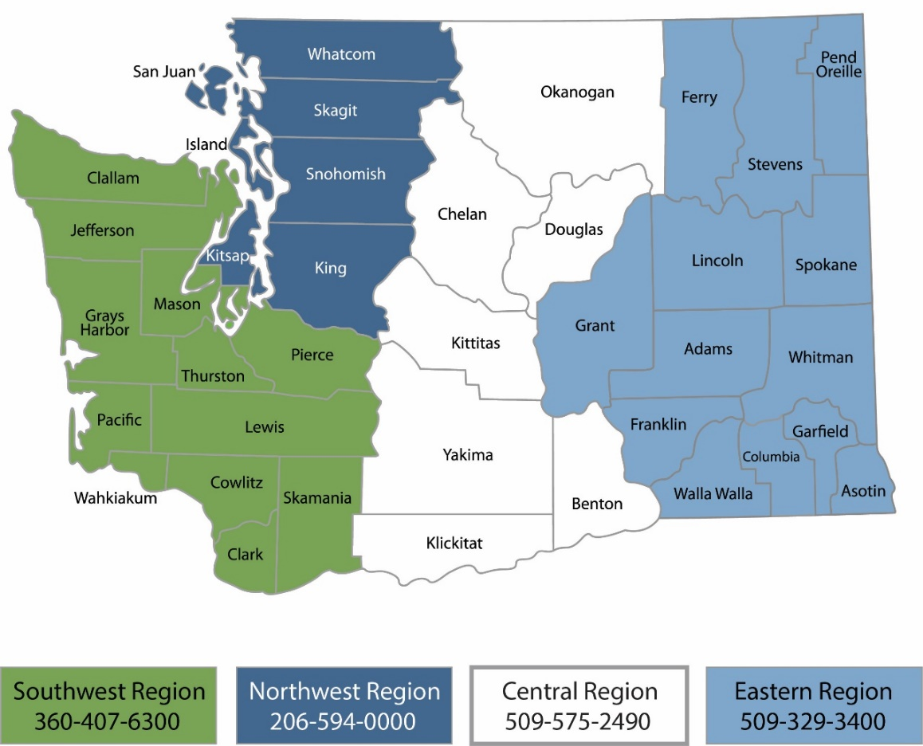
Region | Counties served | Mailing Address | Phone
Southwest | Clallam, Clark, Cowlitz, Grays Harbor, Jefferson, Mason, Lewis, Pacific, Pierce, Skamania, Thurston, Wahkiakum | P.O. Box 47775  Olympia, WA 98504 | 360-407-6300
Northwest | Island, King, Kitsap, San Juan, Skagit, Snohomish, Whatcom | P.O. Box 330316 Shoreline, WA 98133 | 206-594-0000
Central | Benton, Chelan, Douglas, Kittitas, Klickitat, Okanogan, Yakima | 1250 West Alder Street  Union Gap, WA 98903 | 509-575-2490
Eastern | Adams, Asotin, Columbia, Ferry, Franklin, Garfield, Grant, Lincoln, Pend Oreille, Spokane, Stevens, Walla Walla, Whitman | 4601 North Monroe  Spokane, WA 99205 | 509-329-3400
Headquarters | Statewide | P.O. Box 46700  Olympia, WA 98504 | 360-407-6000

Table of Contents
Publication Information 2
Related Information 2
Contact Information 2
ADA Accessibility 2
Department of Ecology’s Regional Offices 3
Map of Counties Served 3
About the Authors 5
Introduction 6
Part three: Equity Analysis of Recycling 6
Demographic Analysis 7
Demographic Analysis of Administrative Support, Waste Management and Remediation Services 7
By Business Owner 8
By Employee Demographics 12
Washington Environmental Health Disparity Index 15
Washington Wealth Disparities and Recycling Facilities 16
Population in Poverty and Proximity to Recycling Activities 17

About the Authors
The Center for Economic and Business Research is an outreach center at Western Washington University located within the College of Business and Economics. In addition to publishing the Puget Sound Economic Forecaster, the Center connects the resources found throughout the University to assist for-profit, non-profit, government agencies, quasi-government entities, and tribal communities in gathering and analyzing useful data to respond to specific questions. We use a number of collaborative approaches to help inform our clients so that they are better able to hold policy discussions and craft decisions.
The Center employs students, staff, and faculty from across the University as well as outside resources to meet the individual needs of those we work with. Our work is based on academic approaches and rigor that not only provides a neutral analytical perspective but also provides applied learning opportunities. We focus on developing collaborative relationships with our clients and not simply delivering an end product.
The approaches we utilize are insightful, useful, and are all a part of the debate surrounding the topics we explore; however, none are absolutely fail-safe. Data, by nature, is challenged by how it is collected and how it is leveraged with other data sources. Following only one approach without deviation is ill-advised. We provide a variety of insights within our work – not only on the topic at hand but also the resources (data) that inform that topic.
We are always seeking opportunities to bring the strengths of Western Washington University to fruition within our region. If you have a need for analysis work or comments on this report, we encourage you to contact us at 360-650-3909 or by email at cebr@wwu.edu.
To learn more about CEBR visit us online at https://cebr.wwu.edu or follow us online through your favorite social media stream.
facebook.com/westerncebr
twitter.com/PugetSoundEF
linkedin.com/company/wwu-center-for-economic-and-business-research
instagram.com/wwucebr

The Center for Economic and Business Research is directed by Hart Hodges, Ph.D. and James McCafferty.

Introduction
This three-part comprehensive report is a search and analysis of the businesses that sort and refine Washington’s recyclable materials into sellable commodities, and the intermediate and end-users that use recyclable materials in manufacturing. Using existing databases and survey data, this report examines main processors in the supply chain, locations of generation and remediation, economic impacts, and equity concerns in Washington State. The goals of the three-part comprehensive report are to provide a qualitative and quantitative baseline report of Washington State’s recycling industry to identify opportunities, existing benefits, potential benefits, and conduct an environmental justice and equity analysis. This recycling Baseline Report contains three parts:
- Part one: Recycling Companies and Revenue, estimates volumes of recyclable materials generated within Washington State and their principal processors.
- Part two: Economic Impact of Recycling, examines economic contribution of the recycling industry, identifying direct, indirect, and induced economic impacts of potential expansion within the recycling industry.
- Part three: Equity Analysis of Recycling, examines environmental justice and equity concerns within the solid waste and recycling system, mapping health and environmental hazard variables to facility locations.

Part three: Equity Analysis of Recycling
This report compiles demographic data of Washington State establishments in 2019 in the United States Waste Management and Remediation Services (NAICS 56) industry. Demographic data displays occurrences of demographic majority ethnic group, and veteran status among employees and by owner.
Plastic facility location data collected by the Department of Ecology are overlayed with Native Lands in Washington State, mapping the industry’s effects on culturally significant sites. Plastic facility locations are overlayed with poverty rates in Washington State to display any trends and equity concerns associated with environmental stressors. The variables of hazardous waste distance, toxic waste, cancer rates, wastewater discharge, and life expectancy rates with proximity to a facility are each mapped in order to analyze any systemic environmental health hazard patterns. In conclusion, the topic of redlining within Washington State is explored to better understand health risks and environmental hazards that create socioeconomic barriers, deepen inequality, and decrease economic mobility.
In examining environmental justice and equity in the solid waste and recycling system, we have found:
- On average, rates of individuals living in poverty are higher with increased proximity to facilities involved in recycling activities.
- Potential economic risk factors in living wage among workers in key recycling industries.
- Wage trends in key recycling industries were found to present risks to affordability for employees.
- Within the industries we examined, the average wage did not meet cost of living estimates for two-bedroom rents in the Seattle Metro area. Additionally, average wages within the Material Recovery Facility industry did not meet cost of living estimates for one-bedroom rents within this region.

Demographic Analysis

Demographic Analysis of Administrative Support, Waste Management and Remediation Services
Data for this section is sourced from the US Census Bureau 2020 Annual Business Survey (ABS). This survey uses data from the previous year (2019) and we are currently awaiting the 2021 ABS to provide more recent 2020 data. Additionally, this survey provides nationwide data collection which has a wider scope than Washington state businesses, this is intended as a baseline report for the demographic characteristics of the sector as a whole based upon available data.
Demographic information concerning both owner status and employee demographics is based upon NAICS code 56 which describes businesses relating to Waste Management, Remediation and Administrative Support. This survey draws from the establishment itself rather than from each individual owner or employee, quantifying the number of establishments that present a majority in each field.
This dataset was chosen as it was the most reliable available data at this scale of analysis (recycling industry demographics, limited to Washington State). The sector includes industries and businesses directly in the domain of this report’s scope such as material recovery facilities, waste management services as well as their associated administrative support services. Certain aspects of this Census Bureau survey present data limitations. First, this survey focuses on establishments rather than individuals in its collection which may not capture variation caused by different establishment sizes. However instead this represents the establishment/firm level demographic trends present in the industry as a whole. Second, terminology used by Census Bureau in conducting this survey may be outdated in terms of current practices in demographic analysis. This appears in their methodology in their survey of business demographics by “sex” rather than “gender.”
Data visualizations are constructed by calculating each demographic's percent share of either business ownership or employment. Total responses are based only on observations with classified demographics, unclassified observations have been omitted.

By Business Owner
The following visualizations describe the distribution of business ownership within administrative, support, waste management and remediation services sector.
Figure 1: Business Ownership: Administrative Support and Waste Management and Remediation Services
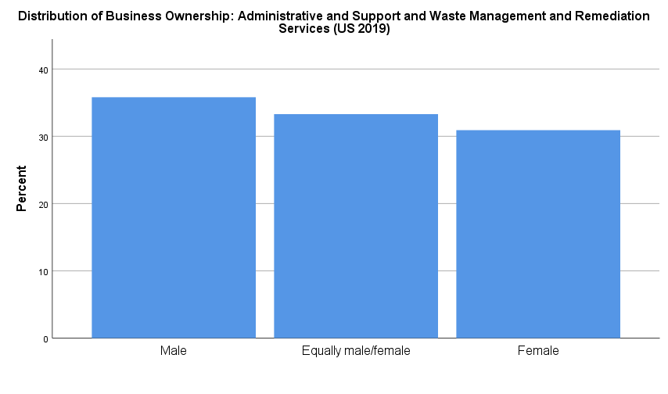
The distribution of business ownership within this sector is characterized by mostly male ownership with this demographic accounting for roughly 35% of cases. This group is followed by businesses owned equally male and female owned. This is followed by female owned businesses, making up roughly 31% of cases.

Figure 2: Business Ownership by Ethnic Group: Administrative Support and Waste Management and Remediation Services
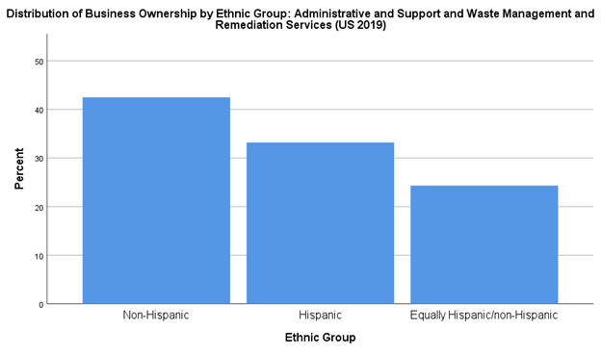

When divided by ethnic group, approximately 42% of businesses are non-Hispanic owned, 32% Hispanic owned and 25% equally Hispanic and Non-Hispanic.

Figure 3: Distribution of Business Ownership by Race Group: Administrative and Support and Waste Management and Remediation Services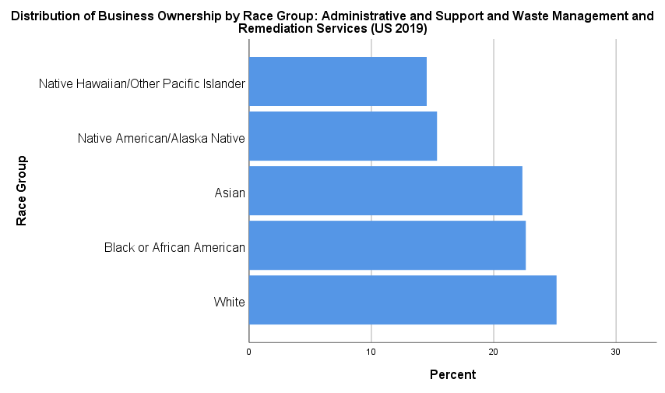
Establishment ownership within this industry is distributed with the majority of establishments presenting majority ownership by white individuals at roughly 25% of cases. This is followed by Black or African American ownership and then by Asian majority ownership with comparable levels of occurrence around 23%. Finally Native American/Alaska Native and Native Hawaiian and other Pacific Islander groups presented occurrences of majority ownership at 15% and 14% respectively.

Figure 4: Business Ownership by Veteran Status: Administrative Support and Waste Management and Remediation Services
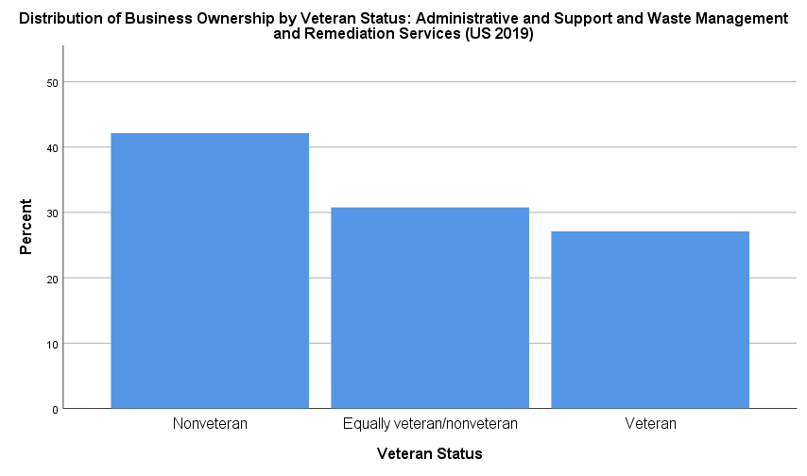
Ownership among non-Veterans leads business ownership in this sector with approximately 41% of cases. This is followed by equally distributed ownership and then by Veteran owned businesses with roughly 28% of cases.

By Employee Demographics
The following four visualizations describe the composition of employee demographics within administrative, support, waste management and remediation services sector.
Figure 5: Employee Demographics: Administrative Support and Waste Management and Remediation Services
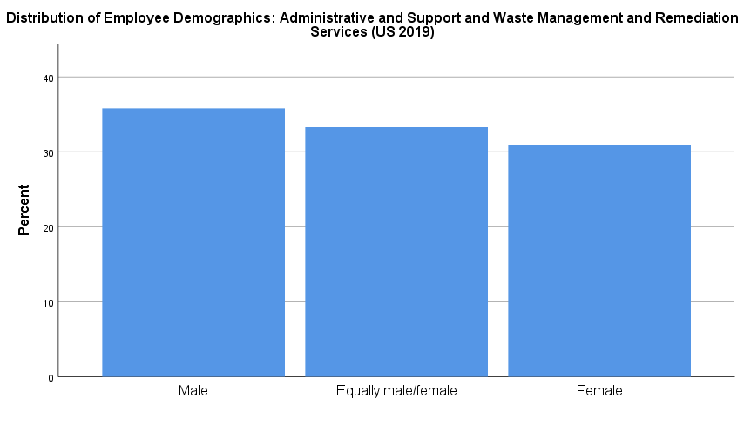
Businesses in this sector are mostly male majority with around 36% of cases, followed by equal male and female compositions and then female majority businesses at just over 30% of cases.
Figure 6: Employee Demographics by Ethnic Group: Administrative Support and Waste Management and Remediation Services
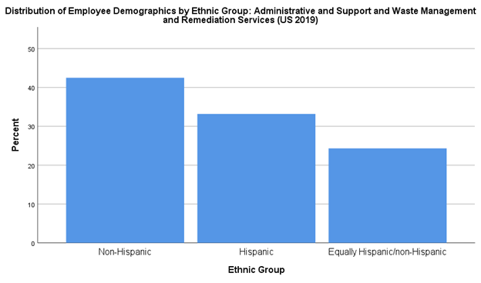
Most businesses are majority non-Hispanic at around 42% of cases. This is followed by Hispanic majority employment at 32% and then equally distributed cases at 24%.
Figure 7: Employee Demographics by Race Group: Administrative Support and Waste Management and Remediation Services
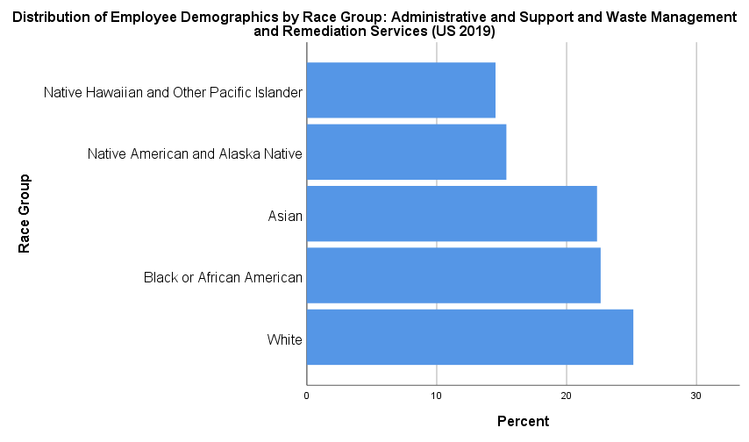
In employment by racial group, white employees make up around 25% of cases. This is followed by Black or African American employees at around 23% followed shortly by Asian employees at just under 23%. Native American and Alaskan Native employees represent about 15% of cases and Native Hawaiians/Other Pacific Islanders represent just under 15% of employees.
Figure 8: Employee Demographics by Veteran Status: Administrative Support and Waste Management and Remediation Services
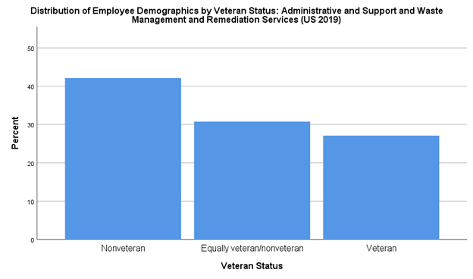
Finally, businesses in this sector have primarily non-veteran employee compositions at around 41% of cases. This is followed by businesses with equal distributions and then, with the smallest share, businesses with primarily veteran employment represent roughly 28% of cases.

Washington Environmental Health Disparity Index
The Washington State Health Disparity Index was first finalized in 2019 and is comprised of multiple environmental and demographic variables which are used to determine the relative environmental risk to the population. The number provided by the index (Figure 9) has a direct correlation to the average life expectancy of an individual within that area. Areas scoring 7 or higher are indicated as having negative impacts on life expectancy.
Figure 9: Environmental Health Disparity Index (WA Dept of Health, 2022)
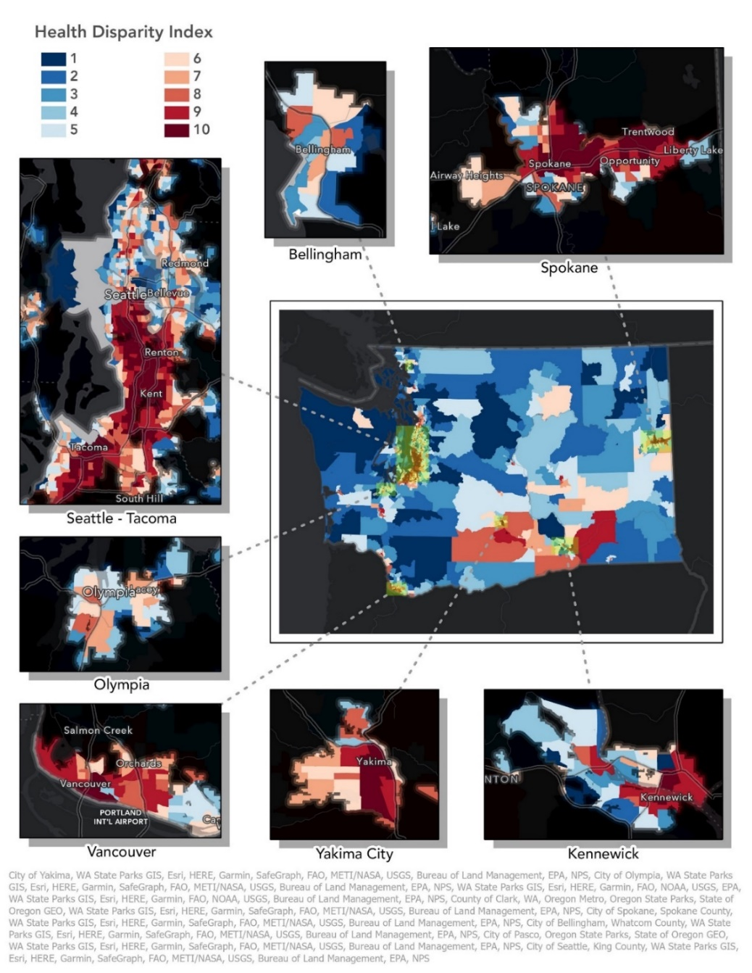

Washington Wealth Disparities and Recycling Facilities
One way in which we examine economic equity is by looking at the relationships between regional wages, housing, and the cost of living. This allows us to develop a sense for the conditions of workers within individual industries and any surpluses or deficits between their earnings and an estimated living wage. Below we compare average rents for one and two-bedroom apartments in the Seattle metro area and extrapolated a living wage assuming full-time employment and a target proportion of income dedicated to rent (33%).
Table 2: Seattle MSA Living Wage
Housing Type | Rate | Required household hourly wage
Rent: 1 bedroom | $1,739 | $30.10
Rent: 2 bedroom | $2,044 | $35.38

For instance, Material Recovery Facility (262920) workers in the Seattle metro area have an average annual wage of $58,032 (as of Q1 2022). This represents an hourly wage of approximately $27.9. Compared to average one- and two-bedroom apartment rentals in the Seattle area we find that these wages fall below required wage for the average cost of housing. One-bedroom rents in this region average an estimated $1,739 which would constitute approximately 39% of the average worker’s income (assuming full-time employment). This rate increases to 44% of average income to afford a 2-bedroom apartment in this area. In the case of MRFs in the Seattle area, rent is a significantly higher proportion of average income than the standard of 33%.
In looking at another industry we’ve examined throughout this report, Recyclable Material Merchant Wholesaler (23930) workers have been making more on average than MRF workers. Here, workers averaged at $63,240 in annual wages (as of Q1 2022). This represents a higher annual wage than both state and national averages for workers within the same industry at a wage of approximately $30.40 per hour. With this wage, workers are able to meet the expected living wage for one-bedroom apartments in the region. However, this wage still falls short of livable wage for two-bedroom rents. Here cost of housing for a two-bedroom rent would constitute nearly 39% of the workers income.
In addition to this, the Seattle area has a higher cost of living than the state or national rates with a cost-of-living index of 144.7. What this amounts to in our discussion of equity is that the average worker in these industries is faced with dedicating a greater proportion of income to housing. However, at a higher cost of living, flexibility in this regard can be limited, creating geographic barriers based upon wage and the cost of housing.

Population in Poverty and Proximity to Recycling Activities
Demographics are an important factor to consider when examining the impacts of industry. One demographic that is wide reaching and touches the lives of many different people is poverty. In order to understand the impacts that recycling may have on those who are part of this demographic group, an analysis of the spatial relationship between recycling facilities and populations in poverty was conducted.
Figure 10: Density of Population in Poverty by Distance from Facility (US Census, ACS, 2019)
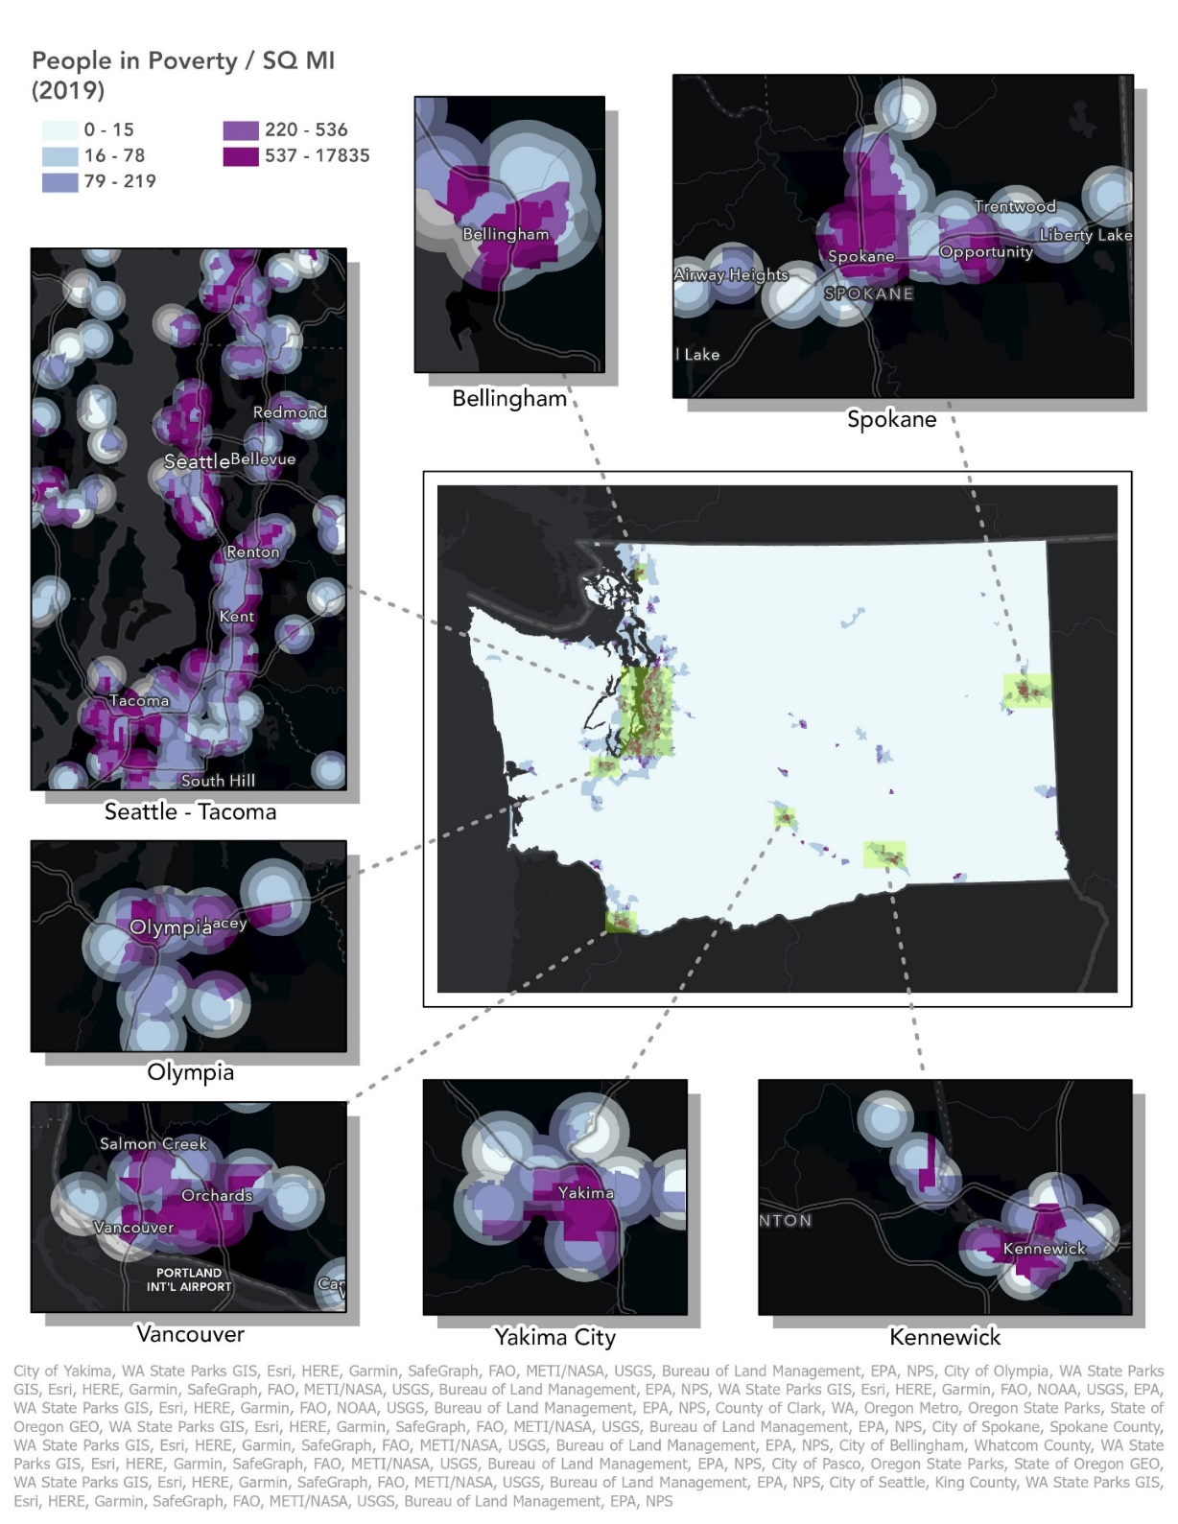
Figure 11: Density of Population in Poverty by Distance from Facility (US Census, ACS, 2021)
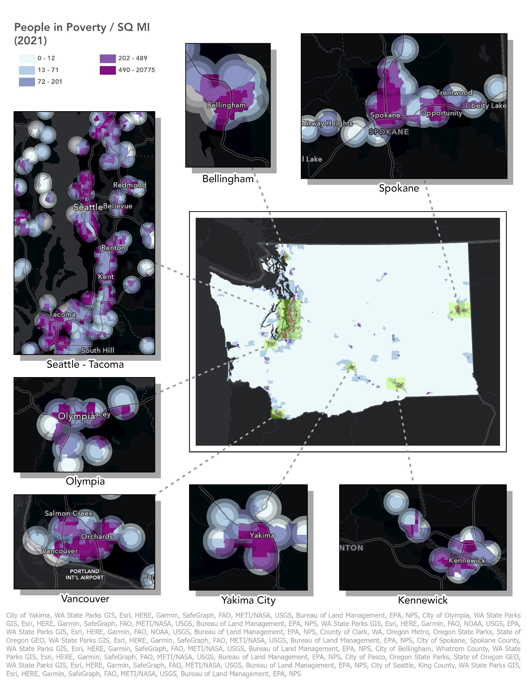
This first dataset (Figure 10) is from the American Community Survey (ACS) 2015-2019, using census tracts from before the 2020 redistricting. While the second (Figure 11) is from the ACS 2017-2021, using census tracts post 2020 redistricting. Determining exact changes between these datasets is difficult due to the change in census tracts, maps of both sets are provided to help illustrate these changes. Highlighted areas on the maps are within a 2-mile radius of facilities that take part in recycling activities.
Using ArcGIS Pro and a methodology called area-weighted interpolation, potential statistical relationships can be identified, though it should be strongly noted that correlation does not equal causation. The findings from this methodology (Figure 12) imply, however, that there is a spatial relationship between the rates of people in poverty and recycling facilities. In 2021, the average density of people in poverty within a 1-mile radius was 506 people per square mile, while the average within 1.5-2 miles was 353. Outside of the 2-mile radius, the average was only 212. This trend was also found in the 2019 dataset with a density of 477 people in poverty within a 1-mile radius, 343 within a 1.5-2-mile radius, and 222 outside of the 2-mile radius. This correlation is likely due to multiple factors such as the high number of facilities located within major metropolitan areas which generally have higher concentrations of overall populations and therefore poverty as well.
While this should not be expected to reliably express the relationship between recycling industry workers and poverty, it aims to reveal any notable relationship between recycling activity and the potential impact on the surrounding economic conditions. Namely asking; do recycling activities and facilities primarily occur within lower income areas? Do they occur mainly within densely populated areas? Are there any potential opportunities that could be provided to these communities that live in such proximity?
Figure 12: Average Population in Poverty (per SQ MI) in Relation to Recycling Facility Proximity
Distance from Recycling Facilities (Miles) | FREQUENCY | AVG Population in Poverty / SQ MI (2019) | FREQUENCY | AVG Population in Poverty / SQ MI (2021)
1 | 876 | 477.7078 | 1015 | 506.7547
1.5 | 996 | 441.4287 | 1165 | 475.2034
2 | 949 | 343.6986 | 1089 | 353.9706
Outside Radius | 1027 | 221.9903 | 1220 | 212.4098

https://apps.ecology.wa.gov/publications/summarypages/2307011.html
https://apps.ecology.wa.gov/publications/summarypages/2307012.html
www.ecology.wa.gov/contact
https://www.census.gov/programs-surveys/abs/technical-documentation/methodology.html.
https://doh.wa.gov/data-and-statistical-reports/washington-tracking-network-wtn/washington-environmental-health-disparities-map
https://data.census.gov/table?q=washington+census+tracts+poverty&g=0400000US53$1400000&tid=ACSST1Y2021.S1701

