EAGL Application Instructions for
2023-25 Local Solid Waste Financial Assistance

Solid Waste Management’s guidance for using Ecology’s Administration of Grants & Loans System (EAGL) to apply for Local Solid Waste Financial Assistance (LSWFA)
For the
Solid Waste Management Program

Washington State Department of Ecology Olympia, Washington

April 2023 - Publication 23-07-017

Publication Information
This document is available on the Department of Ecology’s website at: https://fortress.wa.gov/ecy/publications/summarypages/2307017.html

Related Information

Publication 23-07-018: Local Solid Waste Financial Assistance Funding Guidelines1

Contact Information
Solid Waste Management Program
Headquarters
P.O. Box 47600
Olympia, WA 98504-7600
Phone: 360-407-6105
Website: Washington State Department of Ecology

ADA Accessibility

The Department of Ecology is committed to providing people with disabilities access to information and services by meeting or exceeding the requirements of the Americans with Disabilities Act (ADA), Section 504 and 508 of the Rehabilitation Act, and Washington State Policy #188.

To request an ADA accommodation, contact Ecology by phone at 360-407-6000 or email at swmpublications@ecy.wa.gov. For Washington Relay Service or TTY call 711 or 877-833-6341. Visit Ecology's website for more information.

Department of Ecology’s Regional Offices

Map of Counties Served
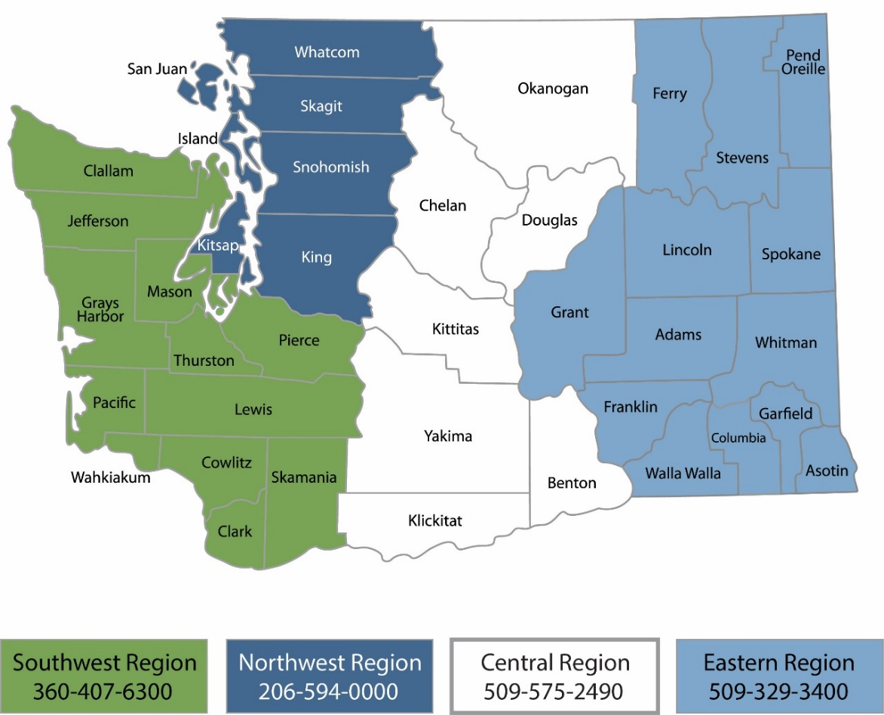

Region | Counties served | Mailing Address | Phone
Southwest | Clallam, Clark, Cowlitz, Grays Harbor, Jefferson, Mason, Lewis, Pacific, Pierce, Skamania, Thurston, Wahkiakum | PO Box 47775  Olympia, WA 98504 | 360-407-6300
Northwest | Island, King, Kitsap, San Juan, Skagit, Snohomish, Whatcom | PO Box 330316  Shoreline, WA 98133 | 206-594-0000
Central | Benton, Chelan, Douglas, Kittitas, Klickitat, Okanogan, Yakima | 1250 W Alder St Union Gap, WA 98903 | 509-575-2490
Eastern | Adams, Asotin, Columbia, Ferry, Franklin, Garfield, Grant, Lincoln, Pend Oreille,  Spokane, Stevens, Walla Walla, Whitman | 4601 N Monroe  Spokane, WA 99205 | 509-329-3400
Headquarters | Across Washington | PO Box 46700  Olympia, WA 98504 | 360-407-6000

EAGL Application Instructions for
2023-25 Local Solid Waste Financial Assistance

Solid Waste Management’s guidance for using Ecology’s Administration of Grants & Loans System (EAGL) to apply for Local Solid Waste Financial Assistance (LSWFA)

Solid Waste Management Program Washington State Department of Ecology
Olympia, WA

April 2023 | Publication 23-07-017

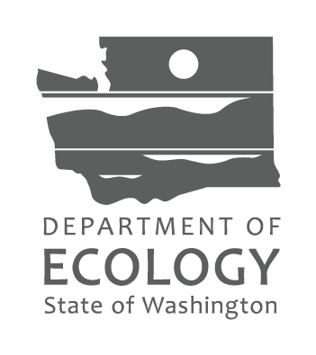
Table of Contents
EAGL Application Instructions for 2023-25 Local Solid Waste Financial Assistance 4
Introduction 7
Getting Started in EAGL 7
Accessing EAGL 7
Training materials and guidance documents 8
Important tips for navigating EAGL 8
Beginning an EAGL Application 10
Locating the LSWFA funding opportunity 10
Applying for LSWFA 11
Application menu 11
How to search for your application 13
Application Forms 15
General information form 15
Navigation links tool 16
Project characterization form 17
Mapping information form 17
Recipient contacts form 18
Additional Funds and Coordination form 18
Category specific task(s) form 20
Spending plan and outcomes data collection form 23
Uploads form 23
Submitting Your Application 24
Change the status and submit 24
Global Errors 25
Confirm your submission 26

EAGL Screenshots

Screenshot 1. Access My Training Materials for helpful EAGL resources 8
Screenshot 2. Check for Global Errors after completing a form 9
Screenshot 3. How to locate the LSWFA application 10
Screenshot 4.Quickly filter for the LSWFA application 11
Screenshot 5. How to initiate an LSWFA application 11
Screenshot 6. Remember your application number and continue to complete the application forms. 12
Screenshot 7. Application forms for LSWFA 12
Screenshot 8. Example of a page error message 13
Screenshot 9. Use the My Applications screen to search for your application 13
Screenshot 7. Use the My Applications screen to search for your application 13
Screenshot 8. Example of "Search Results" for previous instruction 14
Screenshot 9. Example of a document list under "My Tasks" 14
Screenshot 10. Example of LSWFA's naming convention and short description format 15
Screenshot 11. Select the correct Project Category related to the funds you are applying for 16
Screenshot 12. Use the navigation links at the bottom of each form to move to the next form on the list 16
Screenshot 13. Select the Forms Menu link at the top of each form to navigate to other application forms. 17
Screenshot 14. Above the Add/Modify Location(s) button will show if the map is checked out and to whom 17
Screenshot 15. Add people who need to sign the agreement beyond the Authorized Signatory to this table. 18
Screenshot 16. To add another task, select the Add button 20
Screenshot 17. List measurable outcome(s), enter the overall expected outcome and unit of measure for each 21
Screenshot 18. Grant Total should equal the Total Eligible Cost in red 23
Screenshot 19. The first step in submitting the application is to View Status Options 24
Screenshot 20. Under Application Submitted, select Apply Status 24
Screenshot 21. Attest to authority to submit the application 25
Screenshot 22. The Global Errors message indicates which form the error is located 25
Screenshot 23. Confirm the application is submitted 26

Introduction
The Local Solid Waste Financial Assistance (LSWFA) grant program, administered through the Washington State Department of Ecology, assists counties with the costs to maintain their local Solid and Hazardous Waste Management plans. Counties can use these funds to implement eligible activities identified in their plans and to enforce local and state solid waste rules and regulations.

Ecology designed these grant application instructions for those planning to submit a LSWFA application for the 2023-25 Biennium through Ecology’s Administration of Grants and Loans (EAGL) system. This document supplements Ecology’s broader guidance in the EAGL External Users’ Manual and the Administrative Requirements for Recipients of Ecology’s Grants and Loans (Yellow Book).

If you have questions about the grant program, see the 2023-25 Local Solid Waste Financial Assistance Funding Guidelines1 or visit Ecology’s webpage.

Please contact the grant manager assigned to your jurisdiction, or headquarters staff, if you have any questions about the application process. You can find their Contact Information in the accompanying 2021- 2023 LSWFA Guidelines.

Getting Started in EAGL

Accessing EAGL

Current EAGL users
Log in to your Secure Access Washington (SAW) account and the system will direct you to EAGL.

New SAW or EAGL users
If you do not already have one, you must create a Secure Access Washington (SAW) account. You may not “share” a SAW account with another person or organization. You also need to complete an EAGL registration form. Please see the detailed instructions, including a how-to video, for registering as a new SAW and/or EAGL user.
Once you have your SAW account and Ecology’s EAGL staff validates you as a new user, you will have access to EAGL. Please note that it may take up to three business days for Ecology to approve your user request.
EAGL assigns the first person to register for your Organization as the role of “Authorized Official”. For subsequent EAGL registrations, the system notifies the Authorized Official that you are a new user. The Authorized Official must assign your role in the EAGL system and add you to the appropriate Applications/Agreements and subdocuments before you can access them.

Training materials and guidance documents
Training materials, such as the EAGL External User’s Manual3, are in EAGL under the My Training Materials link at the top right of the My Home screen. You should familiarize yourself with this document. It has additional step-by-step instructions, important system requirements, and tips for navigating EAGL. Please be sure to read the 2023-2025 LSWFA funding guidelines1 and the Administrative Requirements for Recipients of Ecology’s Grants and Loans (Yellow Book4) before starting the application process.
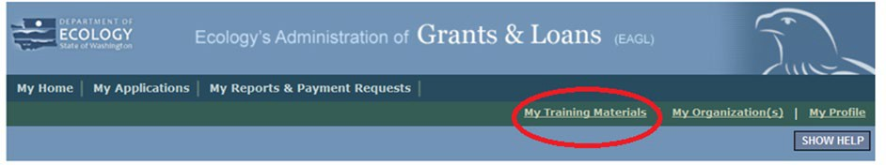
Screenshot 1. Access My Training Materials for helpful EAGL resources

Important tips for navigating EAGL
- Open EAGL using one of these web browsers: Google Chrome, Edge Chromium, Mozilla Firefox, or Safari. EAGL does not spell check. The web browsers listed have built-in spell check tools that should work in EAGL. We no longer recommend using Internet Explorer.
- EAGL is not available from 2:00 p.m. to 3:00 p.m. on Mondays. This is EAGL’s scheduled maintenance time. Make sure to save your work and exit the system prior to this time to avoid losing data.
- Save often! For network security purposes, both SAW and EAGL have timeout features based on inactivity.
  - When SAW times out after inactivity, data entered to that point should not be lost. The system will prompt you to re-enter your Username and Password.
  - When EAGL times out due to inactivity, unsaved data will be lost. Frequently save your work using the SAVE button. Once you save your work, you can exit EAGL. You can re-open your application and pick up where you left off.
- There is no logout feature in EAGL. If you are interrupted or need to leave in the middle of filling out your application, hit the save button located at the top right of the application form and then exit. Exit the system from the Menu bar by selecting the “File” drop-down menu and Exit, or simply click the “X” in the upper right corner of the screen.
- Write down your system generated Document Information number. You can use the last three digits to search for your Application/Agreement later.
- The back button ( ) does not work in EAGL. Using the back button in EAGL or your browser may result in losing information. Instead, select your Document Information number to return to the Application Menu screen.
- Remove formatting before copying and pasting text into EAGL. The EAGL system does not easily read formatted text or special characters. For best results, type directly into the textboxes or cut and paste your text from Notepad or a Word document (saved as plain text) into the application’s textboxes. Notepad is a Windows Accessory found in the “Start” button list.
- Check your spelling. EAGL is not a word processing application. Please be sure to check for typos and grammar before submitting your application. Pay particular attention to email addresses. Modern web browsers may have a spellcheck feature that can assist you with grammar and spelling.
- Red asterisk (*). This indicates that the field is required. The system will give you an error notice – at the top of the screen – if you try to submit an application with errors or missing information.
- Tool tip icon. This symbol indicates more information is available. Hovering over it displays instructions.
- Global errors icon. This symbol indicates an error. After you fill out your Application Form, you can run the Check Global Errors command. The button is located at the top right on each application form. See the screenshot below.
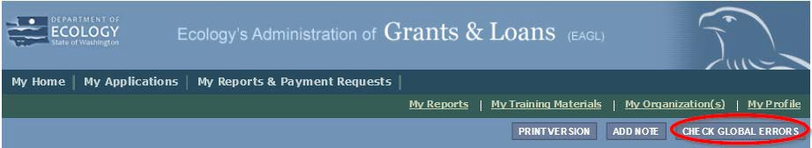
Screenshot 2. Check for Global Errors after completing a form
If you do get global errors, the message provides links to the forms that you need to fix. Go to the form in the error message, edit it, and re-save the form. Sometimes you simply need to visit a form to clear the error message.

Beginning an EAGL Application

Locating the LSWFA funding opportunity
On the My Home screen in EAGL, Authorized Officials can find grant opportunities by clicking on the View Opportunities button. See Screenshot 3.
If you do not see the View Available Opportunities section, you likely have a system role that does not allow you to start or submit applications. An Authorized Official in your organization is responsible for changing the roles for others within the organization. You can also contact your grant manager for help modifying your role.
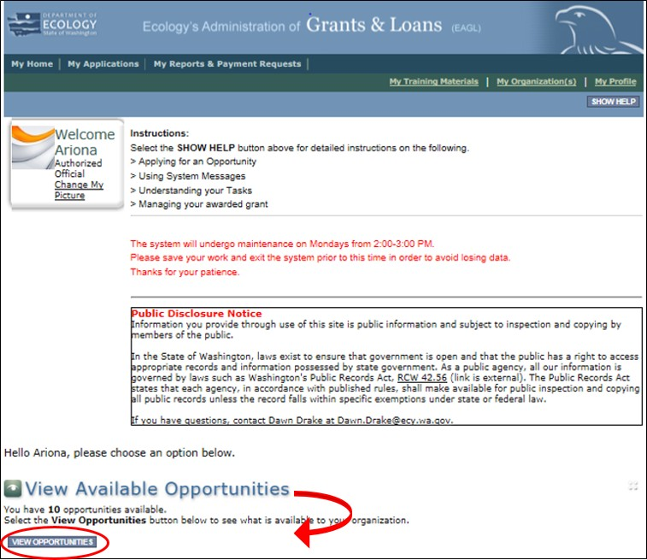
Screenshot 3. How to locate the LSWFA application

After selecting the View Opportunities button, the My Opportunities screen loads. This is where you can filter for the LSWFA funding opportunity. Simply enter “local” as the document instance and hit filter. Remember, do not use the back button in EAGL because it does not work.
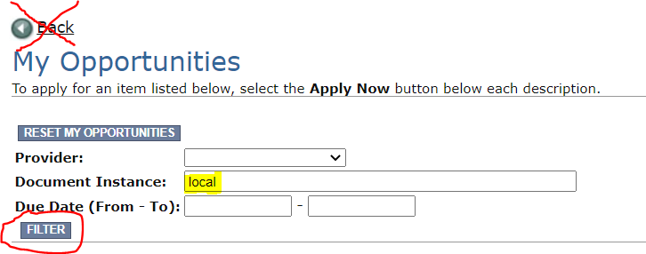
Screenshot 4.Quickly filter for the LSWFA application

Applying for LSWFA
Scroll down the list until you see Local Solid Waste Financial Assistance. Select Apply Now. Only click on Apply Now once to avoid unintentionally creating multiple applications.
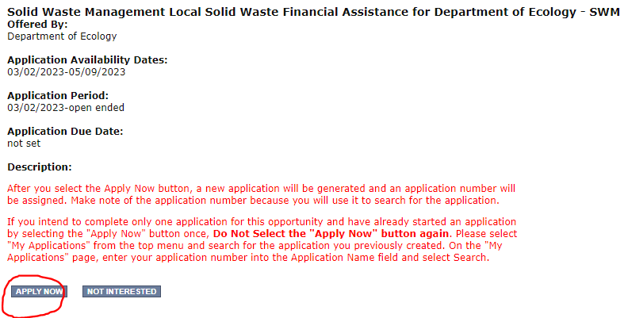
Screenshot 5. How to initiate an LSWFA application

Application menu
You are now in the application process. The system automatically assigned you a Document Information Number. In the screenshot below, you can see that number right under Application Menu at the top of the screen. It’s important to write this number down. It becomes your grant application number, and you can use the last three digits to search for it later.

From the Application Menu screen, you can view your role and the status of your application or grant.
To continue, select View Forms under View, Edit, and Complete Forms. You can return to the Application Menu from any screen by selecting your Document Information Number.
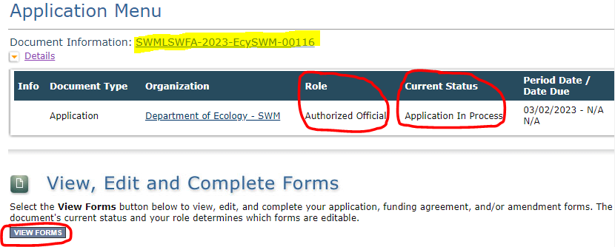
Screenshot 6. Remember your application number and continue to complete the application forms.
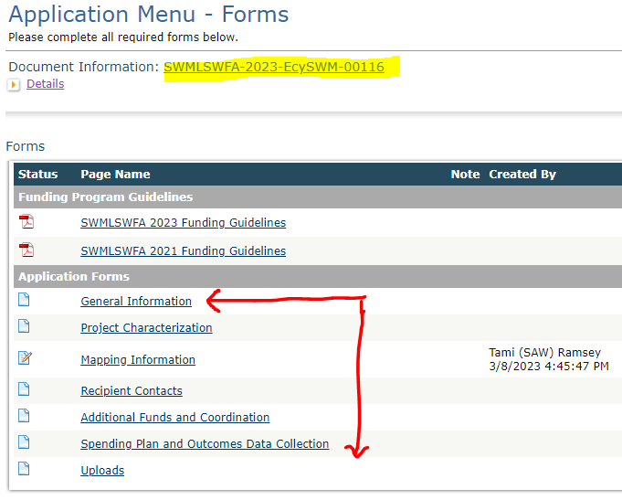
Screenshot 7. Application forms for LSWFA

If the form you’re working on is not complete when you select Save, you will receive a page error message. EAGL saves the work you already did. You can go back later to finish the form.
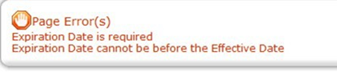
Screenshot 8. Example of a page error message

How to search for your application
If you don’t complete the application in one session, you can search for the application when you return to EAGL to access it again. Here are two search options:

“My Applications” Option
Select My Applications in the top menu to take you to the screen in Screenshot 9. The quickest way to search for your application is by clicking on the Search button with no criteria added. This gives you a list of applications associated with the organization name you applied under. From there, select your Document Information Number in the Name column.

If there are too many results, enter the last three digits of your Document Information Number in the
Application Name field and select Search again.
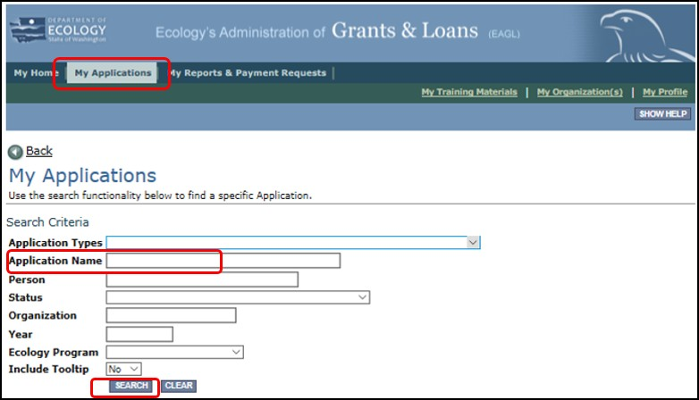
Screenshot 9. Use the My Applications screen to search for your application
Screenshot 7. Use the My Applications screen to search for your application
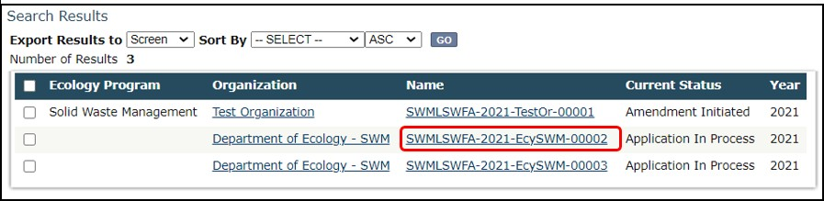
Screenshot 8. Example of "Search Results" for previous instruction

“My Tasks” Option
If you are the Authorized Official and your application is still in process, you can also access the application through My Tasks on your EAGL homepage. Open your tasks list and select your application number under the Name column.
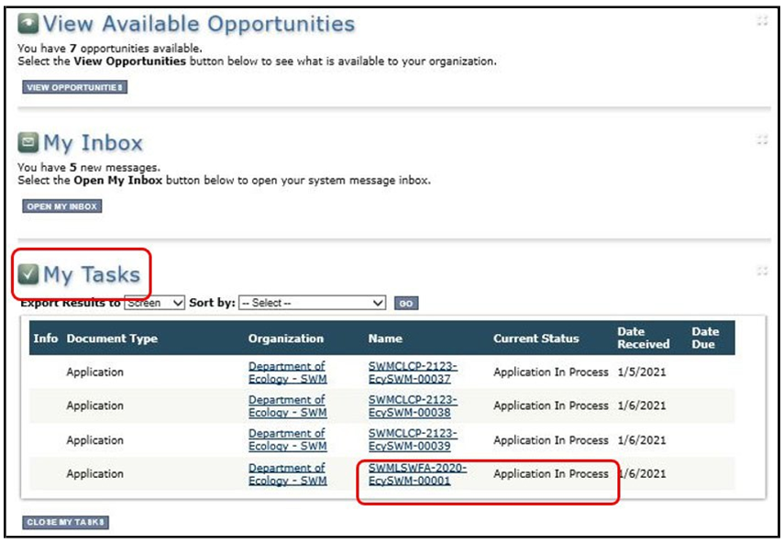
Screenshot 9. Example of a document list under "My Tasks"

Application Forms
This section instructs you on how to complete each of the LSWFA application forms found on the Application Menu - Forms screen. When entering content, remember to type or paste it in plain text and do not use special characters.
If you get lost navigating the various EAGL forms, select your Document Information Number at the top of the screen to get back to the Application Menu screen. Then select View Forms to see the list of Application Forms.

General information form
The General Information form is first in the list of Application Forms. Remember to Save your work frequently and do not use the Back button in EAGL. You can hover your cursor over the tool tip for help in completing that field.
Project Title:
Enter P&I (short for Planning and Implementation) or SWE (short for Solid Waste Enforcement) followed by the short name of your Organization. For example, if Chelan-Douglas Health Department is applying for solid waste enforcement, enter “SWE Chelan-Douglas HD”. Or, if Yakima Public Services Division is applying for planning and implementation, enter “P&I Yakima PSD”.
Project Short Description:
Summarize the work performed with the agreement budget, and the expected outcomes.
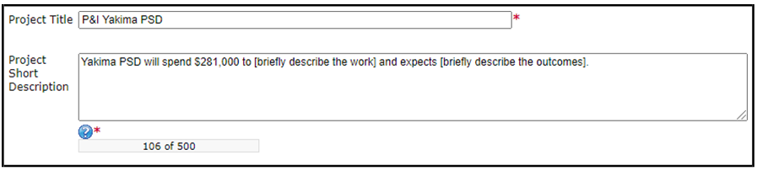
Screenshot 10. Example of LSWFA's naming convention and short description format
Total Cost: This is the entire cost of the project. In some cases, this amount is more than the total eligible cost of the agreement.
Total Eligible Cost: This is the amount the organization and Ecology agree is available to implement all scopes of work. For LSWFA it includes Ecology share plus the required local contribution.
Project Category: This is the type of funding you are applying for. Each category has its own application forms. NOTE: If your organization applies for both types. Pick one for this application. Notify your grant manager for a 2nd application that Ecology creates for you. Your grant manager will let you know the document information number for the 2nd application.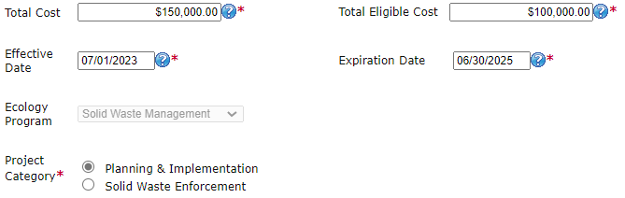
Screenshot 11. Select the correct Project Category related to the funds you are applying for

Navigation links tool
After completing the General Information Form, make sure to save your work. Navigation Links at the bottom of a page are an easy way to toggle through forms.
If you selected the project category of Planning & Implementation, the application forms you complete are shown in Screenshot 14 under Navigation Links.
If you selected the project category of Solid Waste Enforcement, the application forms you complete are the same with one exception. Instead of completing the Category Specific Task(s) – Planning and Implementation form, you will complete the Category Specific Task(s) – Solid Waste Enforcement form.
Regardless of the project category selected, instructions for completing all forms are provided below.
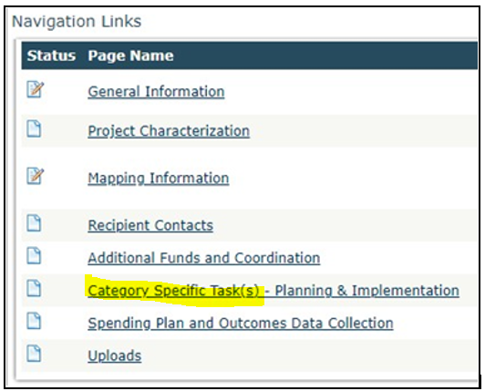
Screenshot 12. Use the navigation links at the bottom of each form to move to the next form on the list

You can also navigate the Application Forms by selecting the Forms Menu link at the top of each form. Selecting this link will refresh the list of application forms.
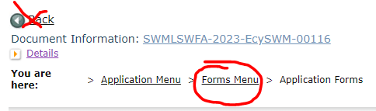
Screenshot 13. Select the Forms Menu link at the top of each form to navigate to other application forms.

Project characterization form
Use the drop-down menu to select primary and secondary themes for the project type. Ecology’s Administration of Grants and Loans (EAGL) Map displays this information for the public. This interactive statewide map shares information on Ecology-funded projects during a grant’s life cycle and after it closes.
- Primary Theme: Solid Waste
After selected, the options for Secondary Theme are available.
- Secondary Theme:
  - If you selected Planning & Implementation as the Project Category on the General Information form, your secondary theme is Solid Waste Management.
  - If you selected Solid Waste Enforcement as the Project Category on the General Information form, your secondary theme is Enforcement.
- Project Website information is not a required field.
- Select Save.

Mapping information form
EAGL only allows one person at a time to check out and edit the map. The person who has the map checked out appears above the Add/Modify Location(s) button as shown in the screenshot below.
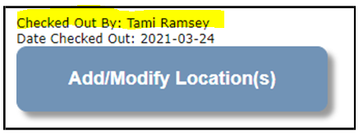
Screenshot 14. Above the Add/Modify Location(s) button will show if the map is checked out and to whom
IMPORTANT: If you need access to the map and someone else has it checked out, please contact that individual to have them check it back in. The person that has the map checked out is the only one that can check it back in.

- Check out the map by clicking Save at the top of the Mapping Information form.
- To complete this form, ignore the instructions on the form and follow these simplified instructions instead:
  - Click on the Add/Modify Location(s) button to go to the map.
  - Look for the Define project area by county drop-down box and select your county.
  - Click Add. This highlights your county on the map. If your project is implemented in more than one county, be sure to Add all counties.
  - Click Next. The system will calculate the statistics. It may take a moment.
  - After the statistics are loaded, click Save. This takes you back to the Mapping Information form and the map is checked out to you.
  - Click Save again to check the map back in.

Recipient contacts form
To appear in the drop-down list in this form, the person must have a Secure Access Washington (SAW) and approved EAGL user account tying them to your organization. Select the appropriate person for each contact from the drop-down list. The same person can be selected more than once.

The person you select as the Authorized Signatory shows up as the first signature block on the agreement. If you have more than one signatory, add them in the table at the bottom of the form. These people do not need an approved EAGL registration because you are not selecting them from a drop-down list. The system adds their signature blocks to the agreement template in the order listed when the agreement is ready for the recipient to sign.
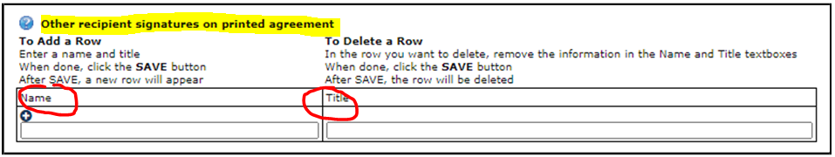
Screenshot 15. Add people who need to sign the agreement beyond the Authorized Signatory to this table.

Additional Funds and Coordination form
This form covers two very important application steps: applying for additional funds and providing proof of required coordination.

Additional Funds
Requesting additional funds is part of the “unrequested process” and should not be confused with the deobligation/reobligation process also known as the “unspent process” conducted in quarter 6 of the biennium. Your only opportunity to request additional funds through the unrequested process is through application and this form.

Local governments listed on the allocation table (also referred to as the Primary), excluding an independent city, can request additional funds should they become available at the start of the biennium. Typically, these funds are the result of a Primary applying for less than what was shown on the allocation table.
If you are a Primary (county government or jurisdictional health department) listed on Ecology’s allocation table, select Yes and answer the two questions under “Additional Funds (“unrequested”)”. In rare circumstances, the Primary is not the county government. If you are unsure, please contact your grant manager for clarification.]
If you are not eligible to request additional funds, select No and move on to the Proof of Coordination section.

Proof of Coordination
This section is only required for applicants that selected Planning & Implementation as the Project Category on the General Information form, excluding independent cities. If you selected Solid Waste Enforcement as the Project Category, or if you are an independent city listed on the allocation table, select No to the first question and save the form. You can move on to the Category Specific Task(s) form.
If you are required to coordinate, the requirements are different for a primary local government than for a partnering local government.
- If you are unsure which best describes your organization, refer to the Coordination section in the LSWFA Guidelines1.
- Upload the required proof of coordination for your organization.
- Checking the boxes indicates you have read and understand the types of documentation required, even if they aren’t applicable to your situation. Both boxes must be checked before the form will save error-free.
- When you are finished, Save the form.

Category specific task(s) form
You’ll complete the Category Specific Task(s) – Planning & Implementation or Category Specific Task(s) – Solid Waste Enforcement form depending on which Project Category you selected on the General Information form. Complete the form and Save when you’re done.

Adding a Task
After you save the form the first time, the “Add” option appears. To add a new task, select the ADD button at the top of the form.
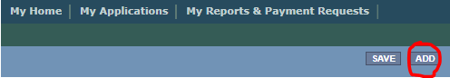
Screenshot 16. To add another task, select the Add button

Planning & Implementation
This form has not changed since last biennium, do your best to answer all the questions. Your grant manager may contact you for clarification after your application is submitted. Instructions for how to complete fields on this form are provided below.

Task Category:
Select the category that best describes the work you plan to perform in this task. Your grant manager will select a standard project title when drafting the agreement. It’s okay if your application includes more than one task with the same Task Category.

Task Total Eligible Cost:
This is the Ecology share plus the 25 percent local contribution requirement. If your application includes more than one task, the sum of all Task Total Eligible Costs should equal the Total Eligible Cost entered on the General Information form.

Task Goal Statement:
State the overall goal for the work. Your grant manager may use stock language for the goal statement when drafting the agreement.

Task Description:
Describe the work, who will perform it, and the costs you expect reimbursed that equal the Task Total Eligible Cost.

Outcomes Recipient Expects to Achieve:
Refer to the Outcomes Guidance in Appendix E of the Guidelines1. List a measure or measures for the work you plan to perform and include the overall expected outcome for each measure. Identify the unit of measure as needed.
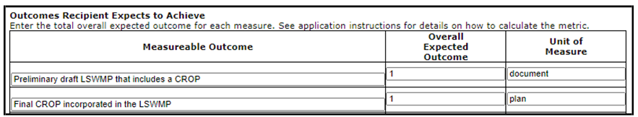
Screenshot 17. List measurable outcome(s), enter the overall expected outcome and unit of measure for each
LSWFA continues to request reported outcomes reflect what was achieved with the Total Eligible Task Cost (TETC). If the TETC is not enough to cover all expenses and you track all outcomes, please use the formula provided by your grant manager to calculate and report the portion achieved with the TETC.
To add a new task, select the ADD button at the top of the form. You will have to save the form first to see the “Add” option below.

Solid Waste Enforcement
This form has not changed since last biennium, do your best to answer all the questions. Your grant manager may contact you for clarification after your application is submitted. Instructions for how to complete fields on this form are provided below.

Task Category:
Select the category “SOLID WASTE ENFORCEMENT” if the work you plan to perform aligns with the two tracks listed below under Task Description. Your grant manager will select a standard project title when drafting the agreement. It’s okay if your application includes more than one task with the same Task Category.
Select the category “ENFORCEMENT SPECIAL TASK” if the work you plan to perform does not fall within the work described for either of the two tracks listed below under Task Description. If you select this category, follow the instructions under “Enforcement Special Task” to complete the form.

Task Total Eligible Cost:
This amount is the Ecology share plus the 25 percent local contribution requirement. If your application includes more than one task, the sum of all Task Total Eligible Costs should equal the Total Eligible Cost entered on the General Information form.

Task Goal Statement:
State the overall goal for the work. Your grant manager may use stock language for the goal statement when drafting the agreement.

Task Description:
There are two tracks of work listed as activities. Your organization may do both or a variation of each. Copy the stock language provided for both tracks and paste it into the Task Description box. Modify as necessary to best describe the work, who will perform it, and the costs you expect reimbursed that equal the Task Total Eligible Cost.
Under the Task Description box, there are additional questions that cover both tracks of work. Answer them as they apply to the task.

Facility / Site Compliance:
If the budget for this task does not include paying the expenses of monitoring solid waste handling facilities, select No, and move on to the next set of questions.
If you are requesting reimbursement for expenses to monitor solid waste handling facilities for compliance, select Yes. Upload a document listing the name of each facility and the status of its permit.

Solid Waste Investigation, Assistance, Enforcement:
Answer the questions as they relate to the costs you expect to charge to the task. Your grant manager will draft the scope the work in the agreement and follow-up with you regarding any other terms.

Enforcement Special Task

Task Category:
You’ve selected ENFORCEMENT SPECIAL TASK as the category. Your grant manager will select a standard project title when drafting the agreement. It’s okay if your application includes more than one task with the same Task Category.

Task Description:
If your special task is Homeless Encampment Response or Syringe Collection Program, briefly describe the work and detail the expected outcomes. Your grant manager will use template language to draft the task.
If your special task is something else, clearly describe the work and expected outcomes. If you need more space, you can use the text box under “List any other outcomes or outputs you would like to track”.

Remainder of form
For this task, it’s unlikely the remainder of the fields in this form are relevant to your task. Answer questions as No. Under “Outcomes Recipient Expects to Achieve”, enter a 0 as the overall expected outcome and leave the unit of measure blank.
Save the form.

Spending plan and outcomes data collection form
This form includes two sections, but you only complete the Spending Plan section for the application. After you complete it, Save the form.

Total Eligible Cost:
The amount you entered as the agreement Total Eligible Cost is reflected in red font on this form. Confirm this is the correct total for your entire agreement. If it is not correct, you can fix it on the General Information form.

Task Title:
Use the drop-down list to select the correct task title. NOTE: Task titles become available after you complete and save the Category Specific Task(s) form.
For each task title, enter an amount you expect to spend each quarter for the work performed in that task. You must at least enter 0. The “Biennial Total” for each task should equal the Task Total Eligible Cost on the Category Specific Task(s) form.
The “Grand Total” should equal the Total Eligible Cost in red font. If it does not, make the necessary corrections.
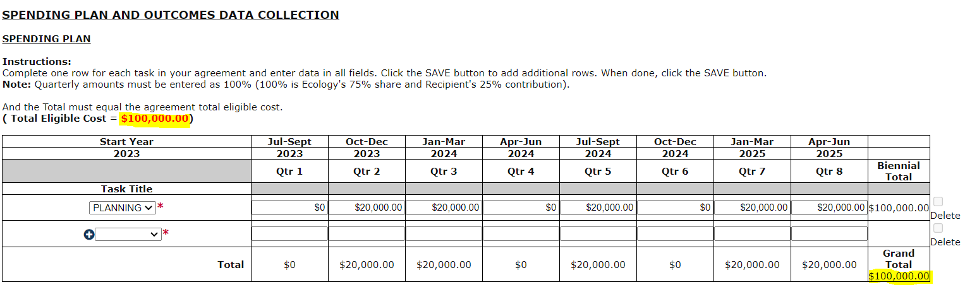
Screenshot 18. Grant Total should equal the Total Eligible Cost in red

Uploads form
Use this form to attach anything you feel is relevant for the application. You can also use this form during the agreement period to upload supporting documentation. Ecology uses it to upload your reporting assessment and other required written communication.

For each attachment, enter the document title and click the Browse button to attach the file. For more information about the file types and sizes accepted by EAGL, see page 17 of the EAGL Users’ Manual³. If you use all three rows, a new row will appear after you Save the form.

Submitting Your Application

Change the status and submit
When you finish all the forms, you’re ready to submit your application.

- Click on the Document Information Number to navigate back to the Application Menu screen.
- Select View Status Options located under the Change the Status heading.
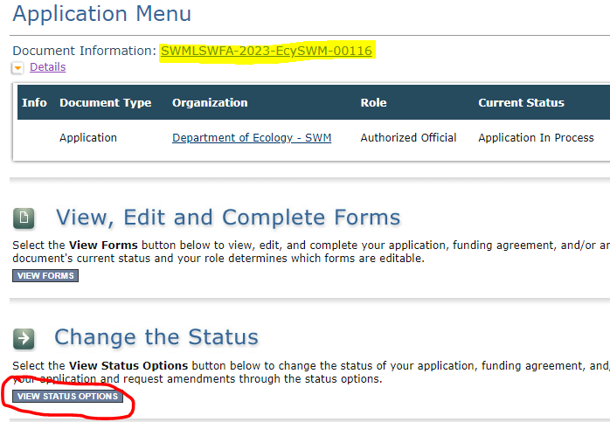
Screenshot 19. The first step in submitting the application is to View Status Options
- On the Application Menu – Status Options screen, select Apply Status under Application Submitted. Warning – DO NOT select Apply Status under Application Cancelled.
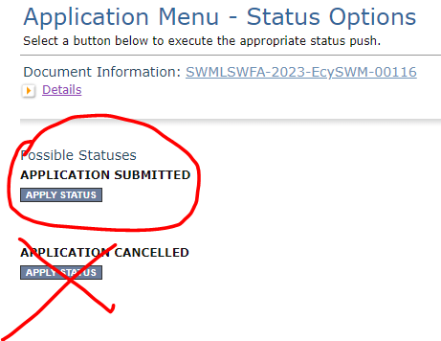
Screenshot 20. Under Application Submitted, select Apply Status
- The last step in submitting your application is to select I Agree on the Agreement screen. If you cannot select I Agree, you cannot submit the application.
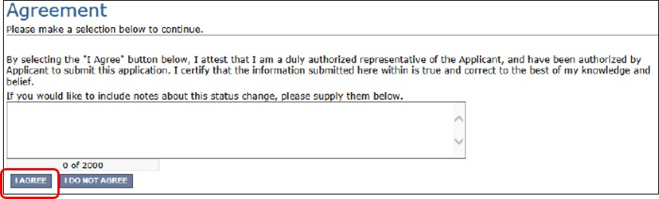
Screenshot 21. Attest to authority to submit the application

Global Errors
If you get a Global Errors message after attempting submission, simply read the error message and correct the problem(s). Sometimes, the error message provides a link to the form with an error. Select the link and make the correction(s). Save the forms you corrected.
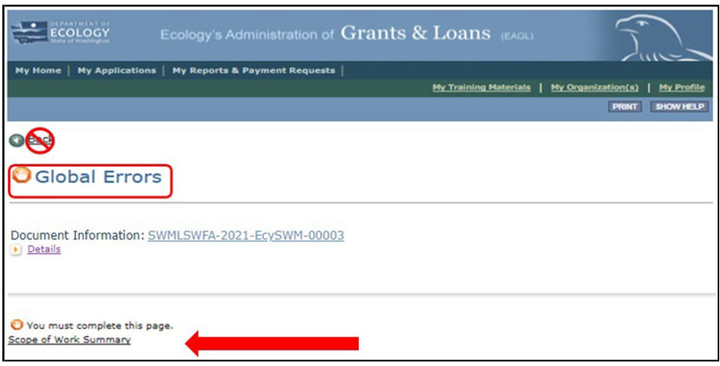
Screenshot 22. The Global Errors message indicates which form the error is located

Try submitting your application again using the steps described above under Submitting your Application. Continue until all Global Errors are cleared, and the status of your application is Application Submitted.

Confirm your submission
To confirm the application was successfully submitted, select the Document Information number to return to the Application Menu screen to check the Current Status. If it isn’t already expanded, select the purple Details link and look under Current Status. If should say, “Application Submitted”. Also, all Authorized Officials for your organization should get an auto-generated email confirming the application was submitted to Ecology.
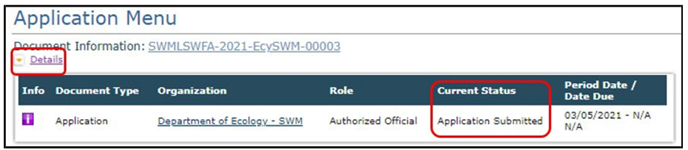
Screenshot 23. Confirm the application is submitted

https://apps.ecology.wa.gov/publications/SummaryPages/2307018.html
www.ecology.wa.gov/contact
https://apps.ecology.wa.gov/publications/SummaryPages/1701015.html
https://apps.ecology.wa.gov/publications/documents/1701004.pdf
https://ecology.wa.gov/About-us/How-we-operate/Grants-loans/Find-a-grant-or-loan/Coordinated-prevention-grants
https://secureaccess.wa.gov/ecy/eagl
https://ecology.wa.gov/About-us/How-we-operate/Grants-loans#Apply
https://ecology.wa.gov/About-us/How-we-operate/Grants-loans/EAGL-map

