EAGL Application Instructions for the
2023-25 Public Participation Grants Program
Solid Waste Management’s guidance for using
Ecology’s Administration of Grants & Loans System (EAGL)
to apply for Public Participation Grants (PPG) funds
For the
Solid Waste Management Program
Washington State Department of Ecology
Olympia, Washington
April 2023 - Publication 23-07-029

Publication Information
This document is available on the Department of Ecology’s website at: https://apps.ecology.wa.gov/publications/summarypages/2307029.html

Related Information
Publication 23-07-002: PPG Funding Guidelines 2023-25

Contact Information
Solid Waste Management Program
Headquarters
P.O. Box 47600
Olympia, WA 98504-7600
Phone: 360-407-6105
Website: Washington State Department of Ecology

ADA Accessibility
The Department of Ecology is committed to providing people with disabilities access to information and services by meeting or exceeding the requirements of the Americans with Disabilities Act (ADA), Section 504 and 508 of the Rehabilitation Act, and Washington State Policy #188.
To request an ADA accommodation, contact Ecology by phone at 360-407-6000- or email at SWMPublications@ecy.wa.gov. For Washington Relay Service or TTY call 711 or 877-833-6341. Visit Ecology's website for more information.

Accesibilidad ADA
Departamento de Ecología se compromete a proporcionar a las personas con discapacidades acceso a información y servicios al cumplir o exceder los requisitos de la Ley para Estadounidenses con Discapacidades (ADA), Secciones 504 y 508 del Acto de Rehabilitación, y la Política del Estado de Washington #188.
Para solicitar acomodación ADA, comuníquese con Ecología por teléfono al 360-407-6195 o por correo electrónico rachael.white @ecy.wa.gov. Para Servicio de Retransmisión de Washington o TTY llame al 711 o 877-833-6341. Visite el sitio web de Ecología (en inglés) para más información

Department of Ecology’s Regional Offices

Map of Counties Served
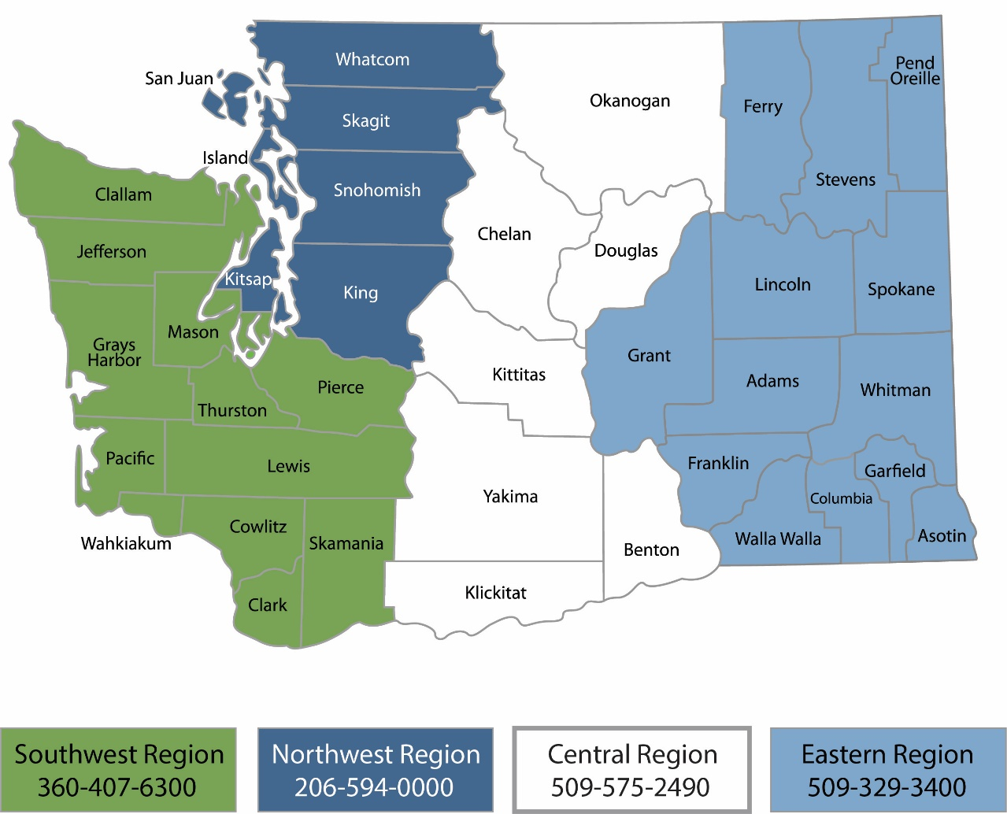
Region | Counties served | Mailing Address | Phone
Southwest | Clallam, Clark, Cowlitz, Grays Harbor, Jefferson, Mason, Lewis, Pacific, Pierce, Skamania, Thurston, Wahkiakum | P.O. Box 47775  Olympia, WA 98504 | 360-407-6300
Northwest | Island, King, Kitsap, San Juan, Skagit, Snohomish, Whatcom | P.O. Box 330316 Shoreline, WA 98133 | 206-594-0000
Central | Benton, Chelan, Douglas, Kittitas, Klickitat, Okanogan, Yakima | 1250 West Alder Street  Union Gap, WA 98903 | 509-575-2490
Eastern | Adams, Asotin, Columbia, Ferry, Franklin, Garfield, Grant, Lincoln, Pend Oreille, Spokane, Stevens, Walla Walla, Whitman | 4601 North Monroe  Spokane, WA 99205 | 509-329-3400
Headquarters | Statewide | P.O. Box 46700  Olympia, WA 98504 | 360-407-6000

EAGL Application Instructions for the
2023-25 Public Participation Grant Program
Solid Waste Management’s guidance for using
Ecology’s Administration of Grants & Loans System (EAGL)
to apply for Public Participation Grant Program (PPG) funds
Solid Waste Management Program
Washington State Department of Ecology
Headquarters
Olympia, WA
April 2023 | Publication 23-07-029

Table of Contents
EAGL Application Instructions for the 2023-25 Public Participation Grants Program
Publication Information 2
Related Information 2
Contact Information 2
ADA Accessibility 2
Accesibilidad ADA 2
Department of Ecology’s Regional Offices 3
Map of Counties Served 3
Table of Contents 5
Table Of Figures 6
Introduction 7
Getting Started in EAGL 3
Accessing EAGL 3
Training materials and guidance documents 4
Important tips for navigating EAGL 4
Beginning an EAGL Application 6
Locating the PPG funding opportunity 6
Applying for PPG funds 7
Application menu 8
How to search for your application 10
Application Forms 12
Navigating the Forms 12
General Information form 12
Project Characterization form 14
Mapping Information form 14
Recipient Contacts Form 14
Community Support form 15
Hazardous Substance Release Sites form 16
Focus Population form 18
Project Narrative form 18
Managing Grant Funds form 18
Project Budget form 19
Uploads form 20
Submitting Your Application 20
Change the status and submit 20

Table Of Figures
Figure 1. Accessing EAGL in SAW. 3
Figure 2. My Training Materials link on the EAGL homepage to access helpful materials like the EAGL User's Manual. 4
Figure 3. Click the Check Global Errors link each time you complete a form. 5
Figure 4. Click on View Opportunities on the My Home page to locate the PPG funding opportunity in EAGL 6
Figure 5. Quickly filter for the PPG application. 7
Figure 6. To initiate an application for PPG, select the apply now button. 7
Figure 7. If you are eligible to apply, select I Agree to proceed. Otherwise select I do not agree to exit the application. 8
Figure 8. Write down your application number and then proceed to the forms by clicking view forms. 8
Figure 9. The Application Menu-Forms page displays a list of guidelines to reference and forms to complete. Use the 2325 Guidelines and Instructions, ignoring older versions. 9
Figure 10. Page error example. 9
Figure 11. Easiest way to search for your application from the My Applications screen 10
Figure 12. Enter the last 3 digits of your document information number to narrow the search results. 10
Figure 13. My Tasks link on the EAGL My Home page is another way an Authorized Official can access an application in process. 11
Figure 14: Use the navigation links at the bottom of a form to quickly move to the next form 12
Figure 15. Form Menu link at the top of each form 12
Figure 16: Organization name as it appears in EAGL 13
Figure 17: Select the correct Project Category related to the total eligible cost 13
Figure 18: Add additional signatures for the final grant agreement 15
Figure 19: Form completed to show site selections 16
Figure 20: Washington Contaminated Site List 16
Figure 21: Site Details Report 17
Figure 22: . Select Washington State from the National Priorities list 17
Figure 23: National Priority Site Name and Score 17
Figure 24: Example description of focus population 18
Figure 25: Budget Form showing cross reference with General Information Form 19
Figure 26: Submitting the application 20
Figure 27Under Application Submitted, select apply status to continue the process 21
Figure 28: Attestation statement with the option to agree or not agree 21
Figure 29: Example of a Global Error with a link to the form that has the error 21
Figure 30: Current status of application should be submitted 22

Introduction
The Public Participation Grants (PPG) program through the Washington State Department of Ecology is a competitive grant program that provides up to $60,000 per year to eligible individuals and nonprofit public interest organizations. The purpose of these grants is to facilitate participation in the investigation and remediation of contaminated sites, and to facilitate implementation of the state’s solid and hazardous waste management priorities.
Ecology designed these grant application instructions for users planning to submit a PPG application for the 2023-25 Biennium in Ecology’s Administration of Grants and Loans (EAGL) system. This document supplements Ecology’s broader guidance in the EAGL External Users’ Manual and the Administrative Requirements for Recipients of Ecology’s Grants and Loans (Yellow Book).
If you have questions about the grant program, see the funding program guidelines for the 2023-25 Public Participation Grants program or visit Ecology’s webpage.
Please contact the grant manager or headquarters staff if you have any questions about the application process.

Grant Manager
Faith Wimberley
(425) 275-7285
faith.wimberley@ecy.wa.gov
Grants Technical Assistance Lead
Alaina Robertson
(360) 706.4048
alaina.robertson@ecy.wa.gov

Getting Started in EAGL

Accessing EAGL

Current EAGL users
Log in to your Secure Access Washington (SAW) account. Access EAGL by selecting the Access Now button.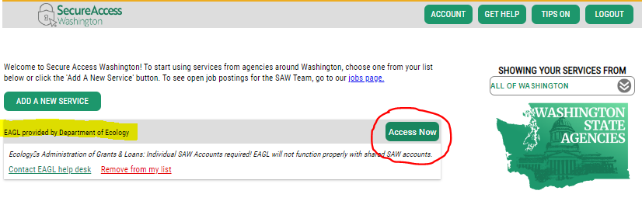
Figure 1. Accessing EAGL in SAW.

New SAW or EAGL users
If you do not already have one, you must create a Secure Access Washington (SAW) account. You may not “share” a SAW account with another person or organization. You also need to complete an EAGL registration form through SAW. Please see detailed instructions on our website -- including a how-to video for registering as a new SAW and/or EAGL user.
After you have a SAW account and your EAGL registration is approved by Ecology EAGL staff, you can access EAGL provided by the Department of Ecology through Secure Access Washington. It may take up to three business days for Ecology EAGL staff to approve your EAGL registration.
The first person to register your organization in EAGL is assigned by EAGL staff the role of “Authorized Official”. For subsequent EAGL registrations under your organization, the system auto-generates an email notifying the Authorized Official(s) that you are a new user. Before you can access Applications/Agreements and subdocuments, an Authorized Official must first activate you and assign your role for each application/agreement and subdocuments you need to access.

Training materials and guidance documents
Training materials, such as the EAGL External User’s Manual, are in EAGL under the My Training Materials link at the top right of the screen on the homepage. You should familiarize yourself with this document. It has step-by-step instructions, important system requirements, and tips for navigating EAGL. Please be sure to read the 2023-25 PPG funding guidelines and the Administrative Requirements for Recipients of Ecology’s Grants and Loans (Yellow Book) before starting the application process.
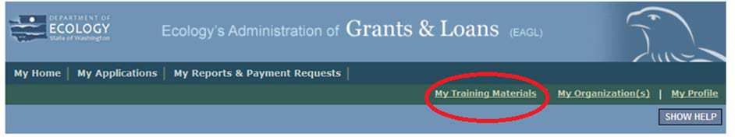
Figure 2. My Training Materials link on the EAGL homepage to access helpful materials like the EAGL User's Manual.

Important tips for navigating EAGL
- Open EAGL using one of these web browsers. We do not recommend using Internet Explorer with EAGL.
  - Google Chrome
  - Edge Chromium
  - Mozilla Firefox
  - Safari
- EAGL is not available from 2:00 p.m. to 3:00 p.m. on Mondays.
  - This is EAGL’s scheduled maintenance time. Make sure to save your work and exit the system prior to this time to avoid losing data.
- Save often!
  - For network security purposes, both SAW and EAGL have timeout features based on inactivity.
    - When SAW times out after inactivity, data entered to that point should not be lost. The system will prompt you to re-enter your Username and Password.
    - When EAGL times out due to inactivity, unsaved data will be lost. Frequently save your work using the SAVE button in EAGL.
- There is no logout feature in EAGL.
  - If you are interrupted or need to leave in the middle of filling out your application, hit the save button located at the top right of the application form and then exit. Exit the system from the Menu bar by selecting the “File” drop-down menu and Exit, or simply click the “X” in the upper right corner of the screen.
- Write down your system generated Document Information number.
  - You can use the last three digits to search for your Application/Agreement later.
- The back button does not work in EAGL.
  - Using the back button in EAGL or your browser may result in losing information. Instead, select your Document Information number to return to the Application Menu screen.
- Remove formatting before copying and pasting text into EAGL.
  - The EAGL system does not easily read formatted text or special characters. For best results, type directly into the textboxes or cut and paste your text from Notepad or a Word document (saved as plain text) into the application’s textboxes. Notepad is a Windows Accessory found in the “Start” button list.
- Check your spelling.
  - EAGL is not a word processing application. You must manually check for typos and grammar. Pay particular attention to email addresses. Web browsers have built-in spell check tools that should work with EAGL.
- Red asterisk (*).
  - This indicates that the field is required. The system will generate an error notice at the top of the page in orange font if you try to submit an application with errors or missing information.
- Question mark icon.
  - A blue circle with a white question mark in the middle indicates more information is available. Hovering over it displays instructions.
- Global errors icon.
  - A red stop sign symbol with a white hand in the middle indicates an error. After you fill out your Application Form, you can run the Check Global Errors command. This button is located at the top right on each application form.
  - If you do get global errors, the message provides links to the forms that you need to fix. Go to the form in the error message, edit it, and re-save the form. Sometimes you simply need to visit a form to clear the error message.
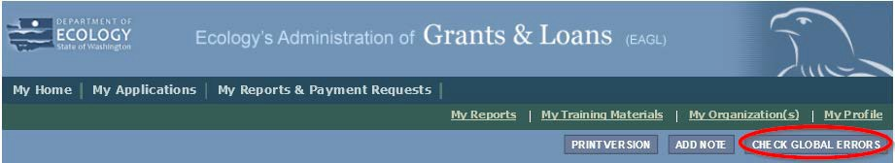
Figure 3. Click the Check Global Errors link each time you complete a form.

Beginning an EAGL Application

Locating the PPG funding opportunity
On the My Home page in EAGL, Authorized Officials can find grant opportunities by clicking on the View Opportunities button.
If you do not see the View Available Opportunities section, you likely have a system role that does not allow you to start or submit applications. An Authorized Official in your organization is responsible for changing the roles for others within the organization. You can also contact the PPG Grant Manager for help modifying your role.
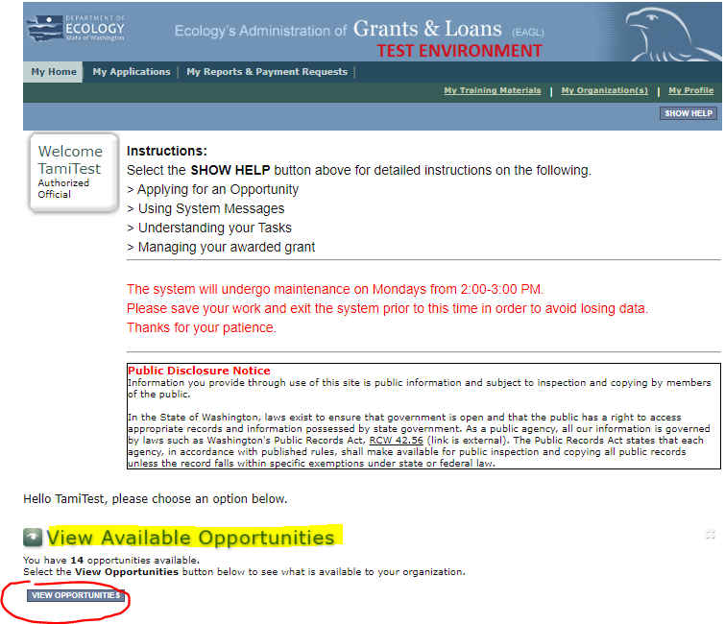
Figure 4. Click on View Opportunities on the My Home page to locate the PPG funding opportunity in EAGL
After selecting the View Opportunities button, the My Opportunities page loads. This is where you can filter for the PPG funding opportunity. Enter litter as the Document Instance and click filter. Remember not to use the back button in EAGL because it does not work.
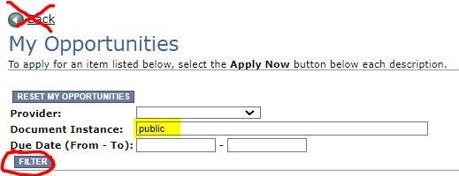
Figure 5. Quickly filter for the PPG application.

Applying for PPG funds
After filtering, you should see information about the Solid Waste Management Public Participation Grant Program.
Select Apply Now at the bottom.
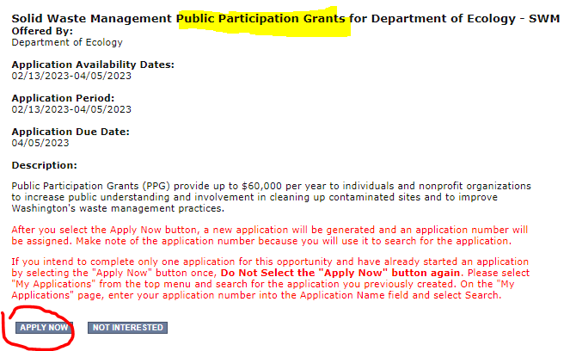
Figure 6. To initiate an application for PPG, select the apply now button.
After selecting Apply Now, you will see Important Eligibility Information. If you are not sure that you are an eligible entity, select I Do Not Agree and contact your Regional Grant Manager at Ecology. If you are sure you are eligible, select I Agree and continue.
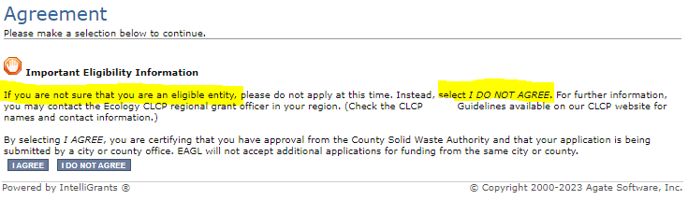
Figure 7. If you are eligible to apply, select I Agree to proceed. Otherwise select I do not agree to exit the application.

Application menu
You have now entered the application process. The system automatically assigned you a Document Information Number. In the screenshot below, you can see the number under Application Menu at the top of the page. This is your application number. It may be helpful to write this number down for later.
From the Application Menu page, you can view your role and the status of your application. If you are funded, this will also be your grant number. In the screenshot below, the person’s role is Authorized Official, and the application status is “in Process”.
To complete your application from the Application Menu, go to the View, Edit, and Complete Forms section. Select the View Forms button.
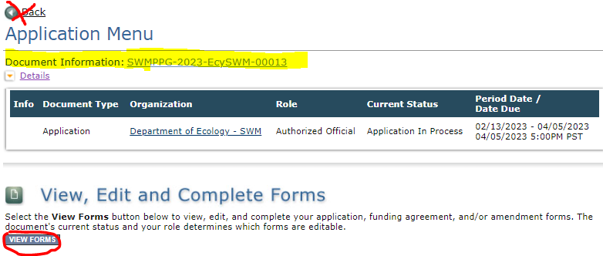
Figure 8. Write down your application number and then proceed to the forms by clicking view forms.
After clicking the View Forms button, you should be on the Application Menu-Forms screen. Starting with General Information, click on each of the Application Forms in the list and fill out the required fields. Save often while working!
You can return to the Application Menu from any screen by selecting your Document Information Number.
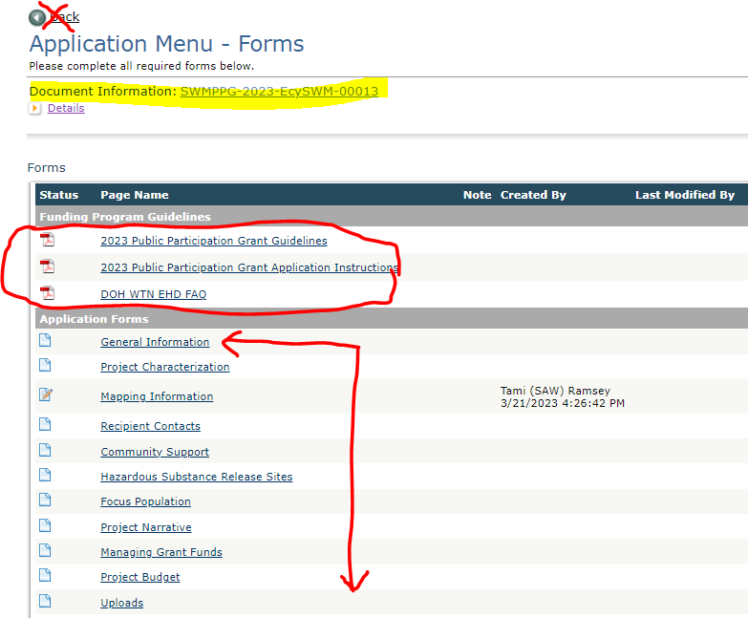
Figure 9. The Application Menu-Forms page displays a list of guidelines to reference and forms to complete. Use the 2325 Guidelines and Instructions, ignoring older versions.
If a form is not complete when you select Save, a page error message will show at the top of the form. Don't worry if you see this error message. EAGL will still save your work and allow you to finish the form later.
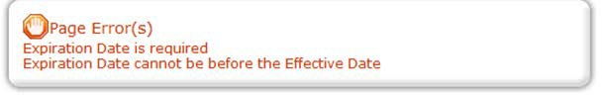
Figure 10. Page error example.

How to search for your application
If you don’t complete the application in one session, you can search for the application when you return to EAGL. You have a couple different options.

“My Applications”
Select My Applications in the top menu to take you to that screen. Simply click on the Search button with no criteria added. This gives you a list of applications associated with your organization.
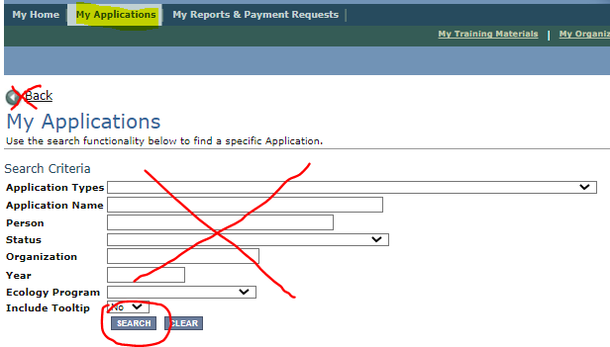
Figure 11. Easiest way to search for your application from the My Applications screen
A list of applications associated with your organization appears on the same page below in the Search Results. From there, find your Document Information Number under the Name column.
If there are too many results, enter the last three digits of your Document Information Number as the Application Name in the Search Criteria above and select Search again.
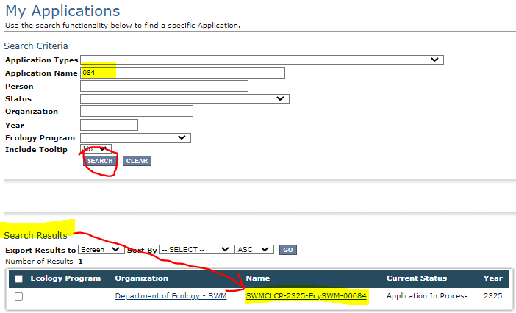
Figure 12. Enter the last 3 digits of your document information number to narrow the search results.

“My Tasks”
If you are the Authorized Official and your application is still in process, you can access your application through My Tasks on your EAGL homepage. Open your tasks list and select your application number under the Name column.
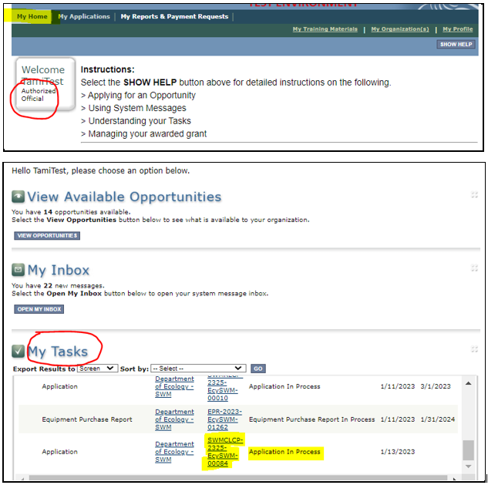
Figure 13. My Tasks link on the EAGL My Home page is another way an Authorized Official can access an application in process.

Application Forms
This section describes the forms found on the Application Menu-Forms page and instructions for filling them out. Remember to type or paste all content in the application forms in plain text and do not use special characters.

Navigating the Forms
If you get lost navigating the various EAGL forms, select your Document Information Number at the top of the page. That will take you back to the Application Menu. Then select View Forms to see the list of Application Forms.
Navigation Links at the bottom of a page are an easy way to access different forms.
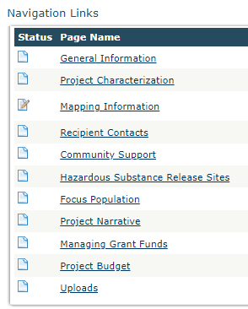
Figure 14: Use the navigation links at the bottom of a form to quickly move to the next form
If the navigation links are not showing on the page, select the Forms Menu link located at the top of each form to refresh the list of application forms.
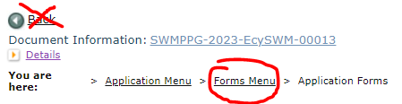
Figure 15. Form Menu link at the top of each form
Remember to Save your work frequently and do not use the back-button in EAGL.

General Information form
The General Information form is first in the list of Application Forms. Complete and save this form first. Note, the Project Long Description and the Overall Goal are already completed.
- Project Title.
  - Enter your organization’s name as it appears in EAGL.
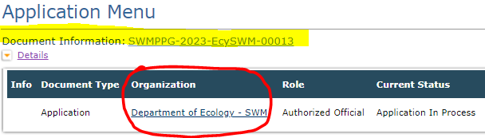
Figure 16: Organization name as it appears in EAGL
Project Short Description
Summarize the work performed with the agreement budget, and the expected results.
Total Cost
This is the entire cost of the project. When the applicant uses alternate revenue to do the project, this amount is more than the total eligible cost of the agreement. This figure should be equal to the Total Project Costs on the Budget Form.
Total Eligible Cost
This is the Public Participation Grant amount the organization is requesting to be awarded for the entire biennium. This figure should be equal to the Total Grant Request on the Budget Form.
Project Category
Pick one for this application.
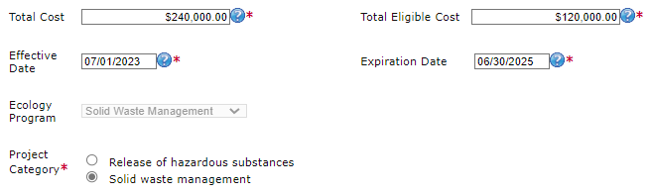
Figure 17: Select the correct Project Category related to the total eligible cost
Save the form and continue to the next form in the list.

Project Characterization form
Use the drop-down menu to select primary and secondary themes for the project type. Ecology's Administration of Grants and Loans (EAGL) Map displays this information for the public. This interactive statewide map shares information on Ecology funded projects during a grant’s life cycle and after it is closed.
- Primary Theme: Solid Waste
- Secondary Theme: Education & Outreach
- Project Website: Optional, enter if available
Save the form and continue to the next form in the list.

Mapping Information form
Ignore the instructions on the Mapping Information form. Instead, follow these simple instructions:
Click on the Add/Modify Location(s) button to go to the map.
- Look for the Define project area by county drop-down box and select your county.
- Click Add. This highlights your county on the map.
- Click Next. It will auto-fill the statistics.
- Click Save. This takes you back to the Mapping Information form and the map is checked out to you.
- Click Save again to check-in the map.
The person that has the map checked out is the only one that can check it back in. To check-in the map, the person who has it checked-out must access the form and click on the “save” button at the top of the Mapping Information form to check it in. Look above the large blue “Add/Modify Location(s)” button to see if the map is checked out.
Save and continue to the next form on the list.

Recipient Contacts Form
Select the appropriate person for each contact from the drop-down lists. If they are not listed, check that they are assigned to the document (application). You will do this in the Application Menu, under Access Management Tools and then clicking Add/Edit People. If they are not listed there, it means they do not have an approved EAGL registration.
- Project Manager
- Authorized Signatory
- Billing Contact
To appear in the drop-down list on this form, your organization’s contacts must have a Secure Access Washington (SAW) account and an Ecology approved EAGL registration.
The project manager and billing contact must be kept current on this form during the life of the grant agreement. List at least two people on this form. Avoid selecting the same name for all three roles if appropriate.
The applicant must have at least one signatory registered in EAGL. This person is the Authorized Signatory contact and shows up as the first signature block on the agreement.
If the applicant is a fiscal sponsor, enter at least one representative of their organization on this form as the Billing Contact and Authorized Signatory. The sponsored organization’s authorized signatory must also sign the agreement. Add their signatory information under “other recipient signatures on printed agreement.”

Other recipient signatures on printed agreement
You can add additional signatories at the bottom of the form. Additional signatories are not required to register in EAGL. The system will populate a signature block under the Authorized Signatory’s block on the final grant document for each additional name/title you enter.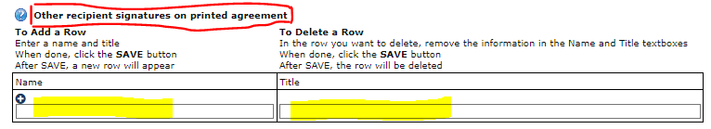
Figure 18: Add additional signatures for the final grant agreement
Save the form and continue to the next form in the list.

Community Support form
This is a new form. The purpose of this form is to capture community support. Follow the instructions on the form.
Save the form and continue to the next form in the list.

Hazardous Substance Release Sites form
This is a new form. The purpose of this form is to capture information about projects that address cleanup of a hazardous substance release site.
- If your project does not address the cleanup of a hazardous substance release site, answer the question No. You can Save and continue to the next form.
- If you answer Yes, include information about your site on this form.
  - Click the list that your site is on and look up your site. Check the box that your site is on.
When you’ve located your site, write the name of the site and the ranking number or score in the text box field. Ranking numbers may not be available for all sites.
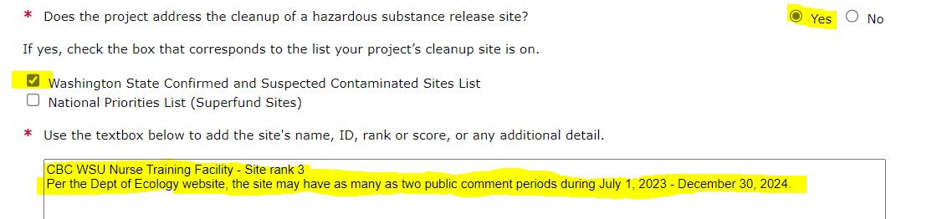
Figure 19: Form completed to show site selections
You can find this information on the lists as shown below.
Washington State Confirmed and Suspected Contaminated Sites List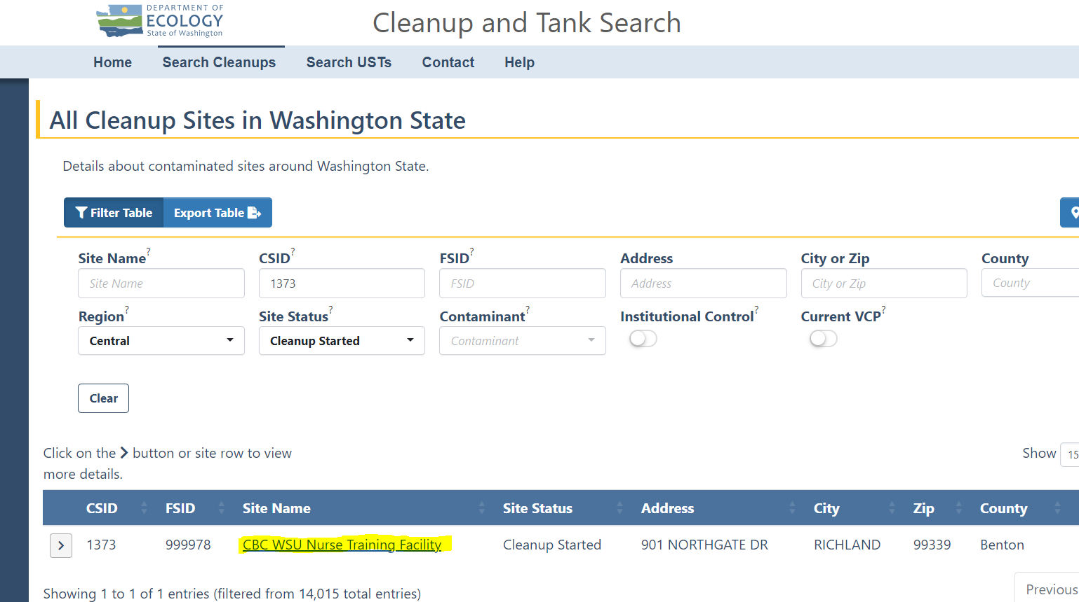
Figure 20: Washington Contaminated Site List
Select your site and locate the Site Rank number as shown: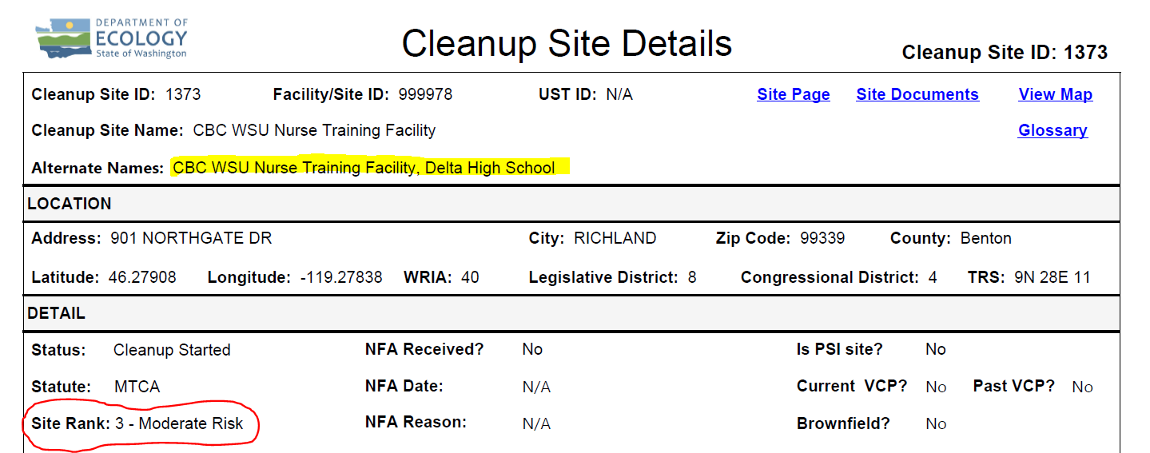
Figure 21: Site Details Report

National Priorities List
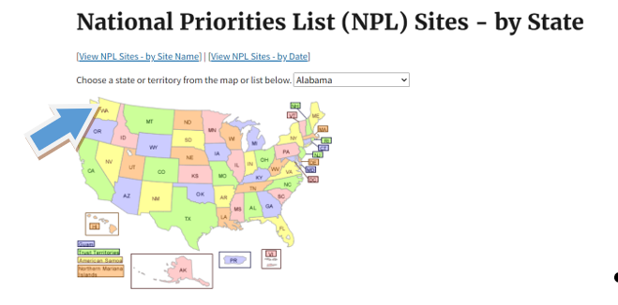
Figure 22: Select Washington State from the National Priorities list
Search for your site from the alphabetical list and locate the Site Score as shown: 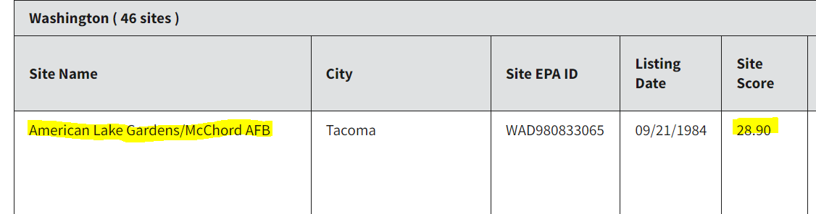
Figure 23: National Priority Site Name and Score
Save the form and continue to the next form in the list.

Focus Population form
This is a new form. The purpose of this form is to capture information about the population(s) being served by the project.
- Answer Yes if the population(s) you’re including in your project are highly impacted communities or vulnerable populations. Definitions for each are provided in the form.
  - If you answer Yes, you must include references to support this designation. Several data sets are listed in the application. Ecology will accept alternative references on a case by case basis. Site the reference data in the text box on this form.
Continue to complete the form.
- Answer No if the population(s) you’re including in your project do not meet the definition of highly impacted communities or vulnerable populations. Continue to complete the form by describing the population this project focuses on.
You must describe the population(s) being served by the project in the text box provided regardless of a ‘yes’ or ‘no’ answer to the question above.
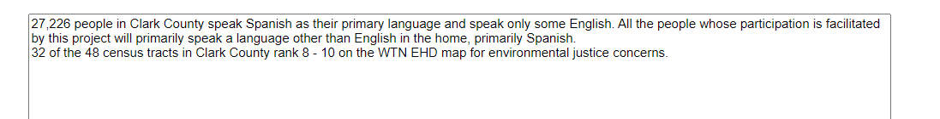
Figure 24: Example description of focus population
Save the form and continue to the next form in the list.

Project Narrative form
This is a new form. The purpose of this form is to capture details of your project. Follow the instructions on the form. Save the form and continue to the next form in the list.

Managing Grant Funds form
This is a new form for PPG. The purpose of this form is to capture details of the applicant’s prior experience managing grant funds.
First, we need to know if you are applying as a nonprofit organization, individual, or a fiscal sponsor. A fiscal sponsor applies on behalf of a nonprofit or individual and must administratively manage the grant while the nonprofit or individual they are sponsoring implements the project.
After you select which applicant type, additional questions will become visible.
- Answer the additional questions.
- Upload requested documents.
  - Nonprofit applicants and fiscal sponsor applicants must upload
    - Organizational chart (showing their reporting hierarchy)
    - Applicants’ bylaws
  - If the fiscal sponsor and the sponsored entity have a Memorandum of Understanding or contract, they should upload it to the application. If they haven’t created an MOU yet, it can be uploaded upon award, but before Ecology will approve reimbursement of costs incurred.
Save the form and continue to the next form in the list.

Project Budget form
This is a new form. The purpose of this form is to capture details of the applicant’s total budget request.
The table in the form is broken out by Task 1 Project Administration and Task 2 Project Costs. For each task, enter the estimated costs by category for each budget year starting with Budget Year 1 being July 1, 2023, through June 30, 2024, followed by Budget Year 2 as July 1, 2024, through June 30, 2025.
Enter salary and benefit expenses for staff employed by the applicant under Salary and Benefit expenses. Under Other Direct Expenses, list all other expenses including service provider fees and contractor expenses. See the Program Guidelines for a list of eligible and ineligible expenses.
The Total, Total Project Cost should be equal to the Total Project Cost from the General Information Form. The Total, Total Grant Request should be equal to the Total Eligible Costs on the General Information Form.
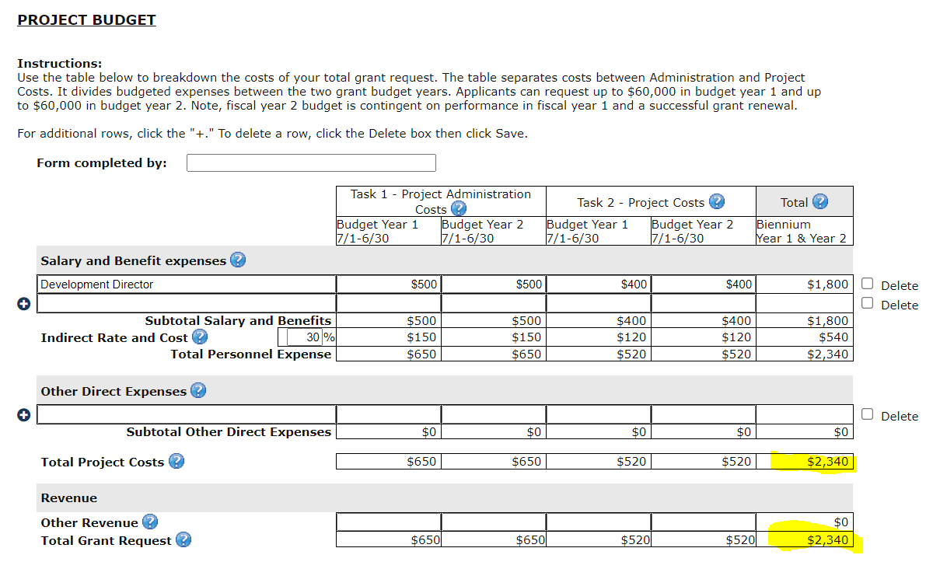
Figure 25: Budget Form showing cross reference with General Information Form

Uploads form
Ecology and grant recipients use this form during the agreement period to upload relevant materials about the grant agreement.
For more information about the file types and sizes accepted by EAGL, see page 17 of the EAGL Users’ Manual. If you use all three rows, a new row will appear after you Save the form.

Submitting Your Application

Change the status and submit
When you finish all the forms, you’re ready to submit your application.
- Click on the Document Information Number to navigate back to the Application Menu screen.
- Under the Change the Status heading, select View Status Options.
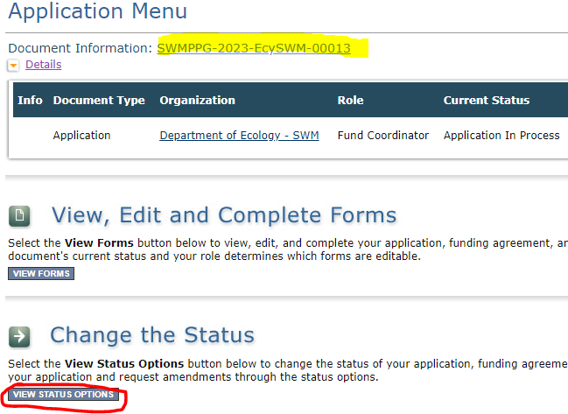
Figure 26: Submitting the application

- On the Application Menu – Status Options screen, under Application Submitted, select Apply Status.
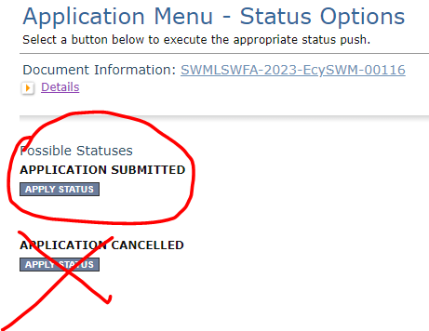
Figure 27: Under Application Submitted, select apply status to continue the process
The last step in submitting your application is to select I Agree on the Agreement screen. If you cannot select I Agree, you cannot submit the application.
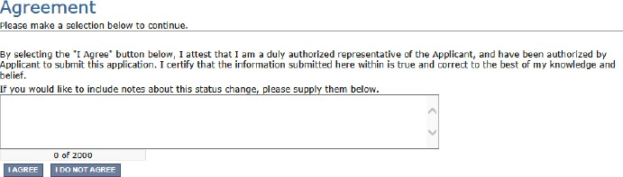
Figure 28: Attestation statement with the option to agree or not agree
- If you get a Global Errors message after attempting submission, simply go back to the form that has the error, make the correction, Save the form, and then try submitting again. Repeat as needed.
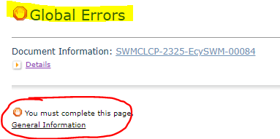
Figure 29: Example of a Global Error with a link to the form that has the error
- Last step! To confirm you successfully submitted your application, go to the Application Menu and check the Current Status.
  - Select your document information number at the top of the page
  - Expand the purple Details button if it isn’t already.
  - Find Current status, it should indicate Application Submitted. If not, contact your grant manager.
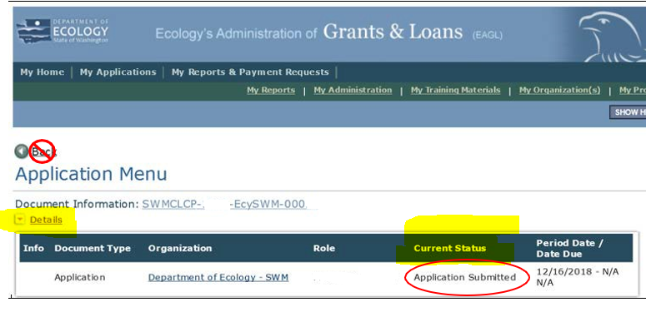
Figure 30: Current status of application should be submitted

https://apps.ecology.wa.gov/publications/summarypages/2307029.html
https://apps.ecology.wa.gov/publications/SummaryPages/2307002.html
www.ecology.wa.gov/contact
https://apps.ecology.wa.gov/publications/SummaryPages/1701015.html
https://apps.ecology.wa.gov/publications/documents/1701004.pdf
https://apps.ecology.wa.gov/publications/SummaryPages/2307002.html
https://ecology.wa.gov/About-us/Payments-contracts-grants/Grants-loans/Find-a-grant-or-loan/Public-participation-grants
https://secureaccess.wa.gov/ecy/eagl
https://youtu.be/XXJh9arfasQ
https://apps.ecology.wa.gov/publications/SummaryPages/1701015.html
https://apps.ecology.wa.gov/publications/SummaryPages/2307005.html
https://apps.ecology.wa.gov/publications/documents/1701004.pdf
https://ecology.wa.gov/About-us/How-we-operate/Grants-loans/EAGL-map

