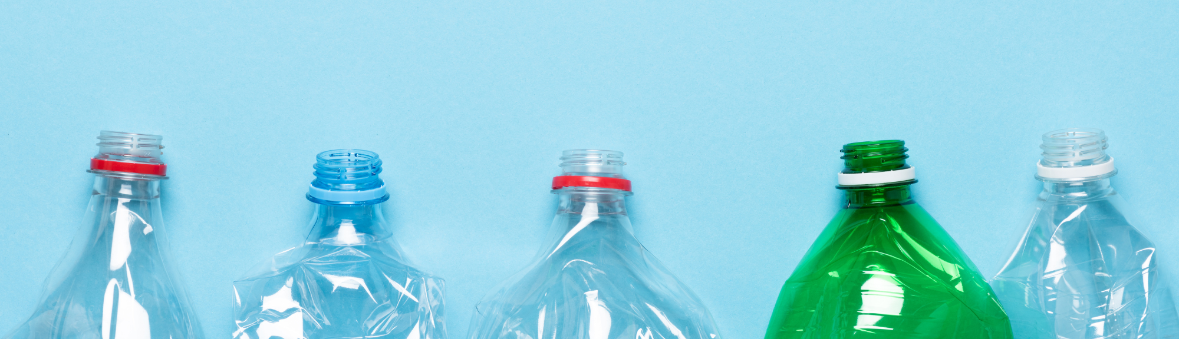
Post-consumer recycled content rulemaking

Chapter 173-925 Washington Administrative Code (WAC)

Post-consumer recycled content (PCRC) law summary
In 2021, Washington passed Chapter 70A.245 RCW. This sets minimum recycled content requirements for plastic in categories of containers and trash bags.

Positive impacts of this law
- Lower virgin plastic production
- Higher value of household recycled plastic
- Incentives to improve the quality of recycled materials for use in plastic containers and trash bags

Rule Proposal
The rulemaking process ensures that Ecology’s regulatory development is consistent and clear. This process offers regulated entities and interested parties time to understand proposed regulations. We welcome input on our interpretations and decisions.
From February to September of 2022, Ecology met with a rule-advisory committee and other interested parties to discuss draft rule language. Comments were accepted until November 2022.

Definitions include in the rule language
- Beverage and plastic beverage containers
- Producer
- Brand
- Entity
- PCRC products and covered products
- Household cleaning and personal care products

Establish in the rule
- Producer registration and reporting processes
- Equitable distribution of yearly fees
- Processes for adjusting requirements or receiving temporary exclusions
Anyone may submit comments. We are chiefly interested in input from the entities that must follow the law. Comments may express support, concerns, or any other relevant issues.
Anyone may give comments on the proposed rule by submitting an online comment form until 11:59 p.m. PST on July 1, 2023.

Important PCRC Rulemaking dates
- May 2, 2023 – Proposed rule is posted and the public comment period opens
- June 8, 2023 – First virtual public hearing
- June 15, 2023 – Second virtual public hearing
- July 1, 2023 – Public comment period closes.
- January 1, 2024 – Chapter 173-925 WAC effective
Visit the rule webpage for more information. Sign up for updates through our plastic packaging email list.

Related Information
- Chapter 173-925 WAC Rulemaking
- Plastic packaging email updates
- Post-consumer recycled content (PCRC) requirements

Shannon Jones
shannon.jones@ecy.wa.gov
360-742-9874

To request an ADA accommodation, contact Ecology by phone at 360-408-6900 or email at SWMpublications@ecy.wa.gov, or visit https://ecology.wa.gov/accessibility. For Relay Service or TTY call 711 or 877-833-6349

