Application for Seasonal Change/Transfer
of a Water Right

Form No. ECY 070-200 (rev. 8/2021)
- We strongly encourage applicants to seek pre-application consultation prior to applying for seasonal change of water source.
- Refer to accompanying guidance to complete this form.
- Incomplete applications will be returned.
- A $50 fee is required to apply.
- All fees are non-refundable (RCW 90.03.470(13)).
- Applications must be received by February 15, or at least 60 days prior to your proposed use.

Where to mail your application:
Submit all applications to Ecology’s Cashiering Section at the address below.

DEPARTMENT OF ECOLOGY
CASHIERING SECTION
PO BOX 47611
OLYMPIA, WA 98504-7611

Check the box for the region where your project is located.
Central Region
Eastern Region
Northwest Region
Office of Columbia River (OCR)*
Southwest Region
*OCR has jurisdiction for designated OCR projects, and new projects located within one mile of the Columbia River.
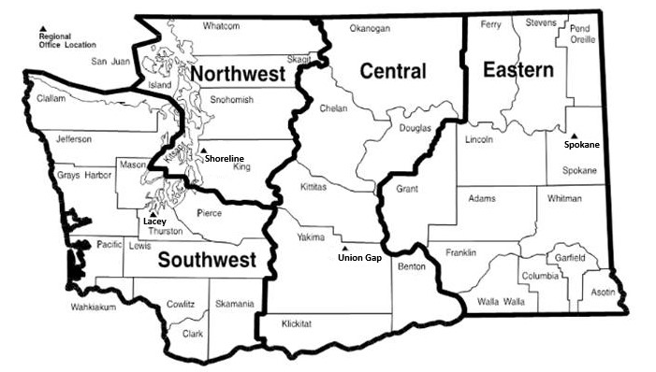
To request ADA accommodation including materials in a format for the visually impaired, call Ecology Water Resources Program at 360-407-6872. People with impaired hearing may call Washington Relay Service at 711. People with speech disability may call TTY at 877-833-6341.
WATER RESOURCES PROGRAM

Application for Seasonal Change/Transfer
of a Water Right
I am applying to (check all that apply):
Change/transfer place of use
Change point(s) of diversion/withdrawal
Add point(s) of diversion/withdrawal

1. Water Right Information
Water right or claim number | Recorded name(s)
Has the water been used as described on your water right document in the last five (5) years? yes no
Water right owner | Phone no. | Alt phone no.

Address

City | State | Zip code

Email address

2. Applicant Information
Applicant/business name | Phone no. | Alt phone no.

Address

City | State | Zip code

Email address

Contact (if different from above) | Phone no. | Alt phone no.

Address

City | State | Zip code

Email address

For Ecology Use
Coding: 001-001-0285-000011
Amount Received: _______

3. Point(s) of Diversion or Withdrawal

A. Existing
Provide the source location information. Attach additional sheets if needed.
Source Name  (Reference by number below) | QTRQTR | QTR | SEC | TWP | RGE | Well Tag | Parcel No.
1.
2.
3.
4.

B. Proposed
Provide the source location information. Attach additional sheets if needed.
Source Name  (Reference by number below) | QTRQTR | QTR | SEC | TWP | RGE | Well Tag | Parcel No.
1.
2.
3.
4.
Do you own the proposed point(s) of diversion/withdrawal? Yes No

4. Place of Use

A. Existing
QTR QTR | QTR | SEC | TWP | RGE | County | Parcel No. | # of Irrigated Acres

Legal description of lands where water is presently used:
Do you own all the lands in the existing place of use? Yes No
If no, provide name & contact information. Attach additional sheets, if necessary.
Legal land owner(s) of existing place(s) of use (if different than applicant) | Phone no. | Alt phone no.

Address

City | State | Zip code

Email address

B. Proposed (if different than 4.A)
QTR QTR | QTR | SEC | TWP | RGE | County | Parcel No. | # of Irrigated Acres

Legal description of lands where new use is proposed:
Do you own all the lands in the proposed place(s) of use? Yes No
If no, provide name & contact information. Attach additional sheets, if necessary.
Legal land owner(s) of proposed place(s) of use  (if different than applicant) | Phone no. | Alt phone no.

Address

City | State | Zip code

Email address

5. Project Description
Provide a brief description of the proposed seasonal change/transfer:

6. Historical Use
If not previously provided to Ecology, include information to support historical water use. Ecology may request additional information from you.
Section | Required information
6.1 | Describe how the water proposed for seasonal change/transfer has been beneficially used since the water right was established.
6.2 | Provide information on historical flow rate and explain how the amount was determined (e.g. meter data or power records).
6.3 | If the requested seasonal change/transfer is for a water right claim, include evidence demonstrating use of water prior to 1917 for surface water, or prior to 1945 for groundwater.

7. Map
Attach a detailed map of your proposed seasonal change/transfer. The map should show existing and proposed point(s) of diversion/withdrawal, place(s) of use, and any other features involved with this application. Also, for irrigation purposes, you must indicate on the map those lands that will not be irrigated within the original place of use.

8. Signatures
By signing below, the applicant certifies that the information provided on this application is true and accurate to the best of their knowledge. If the applicant was assisted in preparing this application, they understand that they are responsible for the accuracy of the information.
The applicant also understands that, in order to process this application, they are granting staff from the Department of Ecology access to the above site(s) for inspection and monitoring purposes.
Applicant Printed Name – Title |  | Applicant Signature |  | (Date: MM/DD/YYYY)
Water Right Holder Printed Name |  | Water Right Holder Signature |  | (Date: MM/DD/YYYY)
Landowner of Existing Place of Use  Printed Name |  | Landowner of Existing Place of Use Signature |  | (Date: MM/DD/YYYY)
Landowner of Proposed Place of Use Printed Name |  | Landowner of Proposed Place of Use Signature |  | (Date: MM/DD/YYYY)
Authorized Representative Printed Name |  | Authorized Representative Signature |  | (Date: MM/DD/YYYY)
If addional signatures are required, attach a supplemental sheet.

Ecology regional offices
For additional information, contact the Ecology regional office where your project is located:
Region/ Office | Counties served | Mailing Address | Phone
Central | Benton, Chelan, Douglas, Kittitas, Klickitat, Okanogan, Yakima | wrCRO@ecy.wa.gov  1250 W Alder St  Union Gap, WA 98903 | 509-575-2490
Eastern | Adams, Asotin, Columbia, Ferry, Franklin, Garfield, Grant, Lincoln, Pend Oreille, Spokane, Stevens, Walla Walla, Whitman | wrERO@ecy.wa.gov  4601 N Monroe  Spokane, WA 99205 | 509-329-3400
Northwest | Island, King, Kitsap, San Juan, Skagit, Snohomish, Whatcom | wrNWRO@ecy.wa.gov  PO Box 330316  Shoreline, WA 98133-9716 | 206-594-0000
Office of Columbia River* | OCR has jurisdiction for designated OCR projects, and new projects located within one mile of the Columbia River. | wrCRO@ecy.wa.gov  1250 W Alder St  Union Gap, WA 98903 | 509-575-2490
Southwest | Clallam, Clark, Cowlitz, Grays Harbor, Jefferson, Lewis, Mason, Pacific, Pierce, Thurston, Skamania, Wahkiakum | wrSWRO@ecy.wa.gov  PO Box 47775  Olympia, WA 98504 | 360-407-6300

Attachment A. Hydrogeological Setting (for groundwater changes only)
If not previously supplied, the following may be required for a change in source. We strongly recommend that applicants contact Ecology prior to conducting any hydrogeological work, to determine the scope of data required for processing this application.
Section | Required information
A.1 | Provide a description of existing authorized point(s) of withdrawal and proposed well(s), their locations, water well report, static water levels, pumping rates and schedules, etc.
A.2 | If known, describe:  - Geographic recharge and discharge areas  - Seasonal variations of groundwater elevations  - Interrelationships between surface water and groundwater, and between aquifers  - Barriers to flow  - Hydrologic boundaries
A.3 | Attach any available well information, including:  - Water well reports (well logs) for existing and proposed wells  - Well diameter and depth  - Motor and pump specifications (i.e., make, horsepower, and type)  - Pump test data  - Well locations (must be identified as outlined in Section 7 (Map))
A.4 | If known, describe the following charicteristics of the aquifer, and cite the source of that information:  - Aquifer transmissivity  - Aquifer storage coefficient and specific yield  - Saturated thickness  - Aquitard leakage  - A detailed description of groundwater-flow boundaries  - Water-level hydrographs for wells  - Associated waterquality information
A.5 | Additional hydrogeological work may be required to process your application.

