|  |  |  |  |  |  |  |  |  |  |  |  |  |  |  |  |  |  |  |
| --- | --- | --- | --- | --- | --- | --- | --- | --- | --- | --- | --- | --- | --- | --- | --- | --- | --- | --- |
|  | **Sand and Gravel General Permit**  **Portable Beginning of Operation Notice Form**  Ecology must **receive** this notification form at least 10 days before you begin operating at a new location. | | | | | | | | | | | | | | | | | |
| Submitting this notification does not guarantee that you may begin operations on the proposed start date. Ecology reserves the right to require additional information or the placement of best management practices before you begin operations if this form is incomplete or environmental sensitivity is not sufficiently addressed.  Please print in ink or type all sections of this application. All fields are required unless otherwise marked. | | | | | | | | | | | | | | | | | | |
| **1. Permit Number** – Provide your permit number. | | | | | | | | | | | | | | | | | | |
| **Permit Number:** | | | | | | | | | | | | | | | | | | |
|  | | | | | | | | | | | | | | | | | | |
| **2. Permittee Contact Information** | | | | | | | | **3. Site Contact** –Ecology may contact this person regarding site inspections | | | | | | | | | | |
| **Organization Name** – Provide the legal name of the business or company (Permittee) that is applying for permit coverage**:** | | | | | | | | **Site Contact First & Last Name:** | | | | | | | | | | |
| **Legal Responsible Party** – Provide the first and last name of the person who has the legal authority to represent the permittee and commit to the terms and conditions of the permit**:** | | | | | | | | **Organization Name:** | | | | | | | | | | |
| **E-mail:** | | | | **Business Phone:** | | | | E-mail (Optional): | | | | | | **Business Phone:** | | | | |
| **Mailing Address:** | | | | | | | | **Mailing Address:** | | | | | | | | | | |
| **City:** | | **State:** | | | **Zip + 4:** | | | **City:** | | | | **State:** | | | | | **Zip + 4:** | |
| Cell Phone (Optional): | | | | Fax (Optional): | | | | Cell Phone (Optional): | | | | | | Fax (Optional): | | | | |
| **4. Site Owner** | | | | | | | | | | | | | | | | | | |
| **Site Owner First & Last Name:** | | | | | | | | Organization Name (Optional): | | | | | | | | | | |
| **Mailing Address:** | | | | | **City:** | | | | | | **State:** | | **Zip + 4:** | | | | | |
| **Business Phone:** | | | Cell Phone (Optional): | | | | E-mail (Optional): | | | | | | | | | | | |
| **5. Site Management Plan**  **Is your Site Management Plan** (including the Site Map, Stormwater Pollution Prevention Plan, Monitoring Plan, Spill Control Plan, and Erosion and Sediment Control Plan) **created, up to date, and complete for this specific site?**  Yes  No | | | | | | | | | | | | | | | | | | |
| **7. Site Information**  **Site Name:** | | | | | | | | | | | | | | | | | | |
| **Street Address:** | | | | | | | **City:** | | | | | | | | | | **Zip + 4:** | |
| **Record Site Location at front door or site entrance –** Provide latitude and longitude, expressed in decimal degrees to six decimal places, at front door or site entrance.  **Latitude:**       ° N **Longitude:**       ° W | | | | | | | | | | | | | | | | | | |
| **Acreage that will be occupied by the portable operation include materials and stockpiles:** | | | | | | | | | | | | | | | | | | |
| **Proposed Begin Date for Portable Operations at the Site:**  **Proposed End Date for Portable Operation, or Date for Site Restoration (whichever is later):** | | | | | | | | | | | | | | | | | | |
| 8. Site Map - Attach a copy of the site map from your Site Management Plan. See Attachment 2 for an example site map. Your site map should be to scale and preferably 11” x 17” in size. | | | | | | | | | | | | | | | | | | |
| 9. Site Restoration  Describe the site condition before setting up the portable operation (e.g. vegetated, unimproved, cleared and leveled, paved):      _______________________________________________________________________________________  _______________________________________________________________________________________________  _______________________________________________________________________________________________  Describe how the site will be changed to set up the portable operation (e.g. cleared and leveled, access road developed, concrete footings added):      _______________________________________________________________________________________  _______________________________________________________________________________________________  _______________________________________________________________________________________________  Describe what actions will be taken to restore the site when the portable operation is moved out (e.g. area seeded, concrete footings removed):      _______________________________________________________________________________________  _______________________________________________________________________________________________  _______________________________________________________________________________________________ | | | | | | | | | | | | | | | | | | |
| Will the portable operate at an active construction site?  No  Yes  **Who will be responsible for site restoration?**  We will (portable owner / operator)  Construction Contractor  Site Owner  Other (provide explanation):      _____________________________________________________________ | | | | | | | | | | | | | | | | | | |
| 10. Ground Water Protection Designations | | | | | | | | | | | | | | | | | |
| **Is the site within a Critical Aquifer Recharge Area?** | | | | | | | | | Yes | | | | | | No | | |
| **Is the site within a designated Wellhead Protection Area?** | | | | | | | | | Yes | | | | | | No | | |
| **Is the site within a Sole Source Aquifer?** | | | | | | | | | Yes | | | | | | No | | |
| 11. NAICS / Ecology Code Information – Indicate what activities take place at the site by checking the appropriate boxes. (See Appendix A of the Sand & Gravel General Permit for code descriptions.) | | | | | | | | | | | | | | | | | |
| Rock Crusher for crushing:  Gravel (NAICS 212321)  Limestone (NAICS 212312)  Other Stone (NAICS 212319)  Granite (NAICS 212313)  Concrete Recycle (ECY 002)  Asphalt Recycle (ECY 001)  **Is rock washing part of the operation?**  Yes  No | | | | | | | | | | Asphalt Batch Plant (NAICS 324121)  Bag House  Wet Scrubber | | | | | | | |
| Concrete Batch Plant (NAICS 327320)  Dry Batch  Wet Batch | | | | | | | |
| **Will Mining or Excavating Occur?**  No  Yes. **Does the site have a Sand and Gravel Permit Number (e.g. WAG50-0000)?**  Yes, provide permit number:      _____  No | | | | | | | | | | 12. Amount of Recycled Concrete (Optional) | | | | | | | |
| Approximately, how much concrete will be recycled at the site in cubic yards per year?        yd3 / year | | | | | | | |
| **13. Estimated quantity – provide the estimated amount of product that will be produced by your portable at the site, include units (e.g., yd3 / year):**       _____ | | | | | | | | | | How much cubic yards of fragmented concrete will be stored onsite at any one time for recycling purposes?        yd3 / year | | | | | | | |

|  |  |  |  |  |  |  |  |  |
| --- | --- | --- | --- | --- | --- | --- | --- | --- |
| **14. Storm Sewer Conveyance System** - If your stormwater, process water, and/or mine dewatering water will flow through a storm drain system or roadside ditch, provide the name of the operator of the storm sewer system and conveyance system (typically, the operator is the city or county you are located in, e.g., Kent stormwater drainage system, 145th street ditch). Otherwise leave this blank. **Storm Sewer Operator:** | | | | | | | | |
| 15. Discharge to Surface Waterbody - Skip this section if you discharge to groundwater only.  Fill out the table below for all surface water outfalls related to your site. (Please use an extra sheet of paper if necessary.) Provide the information below for all the point(s) where your stormwater, process water, and/or mine dewatering water enters (or has the potential to enter) into a surface waterbody. Surface waters include but are not limited to lakes, rivers, ponds, streams, wetlands, inland waters, salt waters, and all other surface waters and water courses within the jurisdiction of the state of Washington. See Attachment 3 for an example of how to fill out this section. | | | | | | | | |
| **Surface Water Outfall Point Identifier:** assign a name (up to 4 characters) to identify the outfall point (e.g., S001).  **Surface Water Outfall Name:** assign a name to identify the outfall point (e.g., Outfall to Duck Creek).  **Surface Water Outfall Point** **Latitude and Longitude:** Provide the latitude and longitude, expressed in decimal degrees to six decimal places, of the point where your stormwater, process water, and/or mine dewatering water enters (or has the potential to enter) into a surface waterbody.  **Name of Surface Waterbody:** Enter the waterbody name where your stormwater, process water, and/or mine dewatering water enters (or has the potential to enter) into a surface waterbody; even if the risk of discharge is low or limited to periods of extreme weather.   * If the creek or tributary is unnamed, use a format such as “unnamed tributary to Deschutes River.” * If your discharge is to a storm sewer system, enter the name of surface water body that the storm sewer system discharges to. * If the outfall flows into a wetland (which is not a constructed wetland), mark “**Wetland**”.   **Is the Outfall Point a Monitoring Point:** Indicate which outfall point(s) from your facility will be sampled to comply with Sections S4.B.1 and S4.B.2 of the permit monitoring requirements. If it is a monitoring point, mark ***“Yes”***; if it is not, mark ***“No”***.  **Type of Discharge:** List the discharge type (either process water, mine dewatering water, or stormwater) that apply to the outfall point. Stormwater that mixes with process water is considered process water.  **NAICS Code(s):** List **all** NAICS and Ecology (ECY) codes that apply to the outfall point, see Section 6 for a list of codes. | | | | | | | | |
| **Surface Water Outfall Point Identifier**  **(4 characters max)** | **Surface Water Outfall Name** | **Surface Water Outfall Point Latitude**  **(Decimal Degrees)** | **Surface Water Outfall Point Longitude**  **(Decimal Degrees)** | **Name of Surface Waterbody** | **Is the Outfall Point a Monitoring Point?** | **Type of Discharge (Process Water, Mine Dewatering Water, or Stormwater)** | | **NAICS / ECY Code(s)** |
|  |  |  |  |  |  |  | |  |
|  |  |  |  |  |  |  | |  |
|  |  |  |  |  |  |  | |  |
|  |  |  |  |  |  |  | |  |
| 16. Monitoring Point Locations  Fill out the table below for all of the monitoring points (both to surface water and groundwater) on your site. (Please use an extra sheet of paper if necessary.) Provide the information below for all of the point(s) that you sample to comply with Sections S4.B and S4.C of the permit monitoring requirements. See Attachment 3 for an example of how to fill out this section. | | | | | | | | |
| **Monitoring Point Identifier:** assign a name (up to 4 characters) to identify the monitoring point (e.g., MP01).  **Monitoring Point Name:** assign a name to identify the monitoring point (e.g., Stormwater Pond 1).  **Monitoring Point** **Latitude and Longitude:** Provide the latitude and longitude, expressed in decimal degrees to six decimal places, of the point where you sample to comply with Sections S4.B and S4.C of the permit monitoring requirements.  **Discharge to Groundwater or Surface Water:** Identify if the monitoring point relates to a groundwater or surface water discharge from your site.  **Corresponding Surface Water Outfall Identifier:** Each monitoring point that discharges to surface water must correspond with a surface water outfall listed in Section 14. Enter the surface water outfall identifier from Section 14. You can have more than one monitoring point associated with each surface water outfall. If the monitoring point is related to a groundwater discharge, leave this column blank or enter “**N/A**”.  **Type of Discharge:** List the discharge type (either process water, mine dewatering water, or stormwater) that apply to the monitoring point. Stormwater that mixes with process water is considered process water.  **NAICS Code(s):** List **all** NAICS and Ecology (ECY) codes that apply to the outfall point, see Section 6 for a list of codes. | | | | | | | | |
| **Monitoring Point Identifier**  **(4 characters max)** | **Monitoring Point Name** | **Monitoring Point Latitude**  **(Decimal Degrees)** | **Monitoring Point Longitude**  **(Decimal Degrees)** | **Discharge to Groundwater or Surface Water?** | **Corresponding Surface Water Outfall Identifier** | | **Type of Discharge (Process Water, Mine Dewatering Water, or Stormwater)** | **NAICS / ECY Code(s)** |
|  |  |  |  |  |  | |  |  |
|  |  |  |  |  |  | |  |  |
|  |  |  |  |  |  | |  |  |
|  |  |  |  |  |  | |  |  |
|  |  |  |  |  |  | |  |  |
|  |  |  |  |  |  | |  |  |
|  |  |  |  |  |  | |  |  |
|  |  |  |  |  |  | |  |  |
|  |  |  |  |  |  | |  |  |

|  |  |  |
| --- | --- | --- |
| **17. State Environmental Policy Act (SEPA)**  A SEPA review must be completed for all site wastewater discharges. SEPA requirements are under Chapter 197-11 WAC. More SEPA information is available at: <http://www.ecy.wa.gov/programs/sea/sepa/e-review.html>. | | |
| **Will the portable operate at an active construction site or at an existing site for which a SEPA determination has already been made?**  Yes. **Please provide a contact that could provide the SEPA determination, or attach a copy of the SEPA determination to this form.** | | |
| **SEPA Contact First & Last Name:** | **Business Phone:** | E-mail (Optional): |
| No. **Please provide the information below.** | | |
| **Date operations began or will begin at the facility:**  **Lead agency issuing SEPA Determination?**  **Has SEPA review been completed for all site activities?**  No  Yes  Exempt  **Date of final SEPA decision:**       **or**   Exempt, **check type of exemption below and attach written exemption information documentation.**  Watershed Restoration & Fish Habitat Enhancement Exemption (RCW 43.21C.0382)  Infill Development Exemption (RCW 43.21C.229)  Planned Action Exemption (RCW 43.21C.031)  Categorical Exemption. **Under what section of the SEPA Rule (WAC 197-11-800) is it exempt?** For example, WAC 197-11-800(1) *Minor New Construction*. **SEPA Rule section:**  **Date when all SEPA-related comment & appeal periods are exhausted:**  **Type of SEPA decision issued:**  Determination of Non-Significance (DNS)  Mitigated DNS (MDNS)  Determination of Significance (DS)  Final Environmental Impact Statement (EIS)  Other:  **If a supplemental EIS, SEPA addendum, or some other type of additional SEPA review was required, please attach and submit with this application.** | | |
|  | | |
| **18. Public Notice** | | |
| Unless you have previously provided public notice for portable operations at the specific site, you must publish a public notice at least **once** a week for **two** consecutive weeks with **seven days** between publications, in at least a **single** newspaper of general circulation in the county in which the facility is located.  Either use the Public Notice Template in Attachment 1 or **attach your notice on a separate sheet of paper, if necessary.** The **bold** language in the Public Notice Template is required by WAC 173-226-130 and must be included in its entirety in your public notice. | | |
| Provide the **exact** dates (mm/dd/yy) that the first and second public notices will appear in the newspaper(s):  First notice:      /      /  Second notice:      /      /      (Begins 30-day public comment period.)  Name of the newspaper(s) publishing the notices: | | |

|  |
| --- |
| **19. Certification of Permittees** |
| “I certify under penalty of law that this document and all attachments were prepared under my direction or supervision in accordance with a system designed to assure that qualified personnel properly gather and evaluate the information submitted. Based on my inquiry of the person or persons who manage the system or those directly responsible for gathering the information, the information submitted is, to the best of my knowledge and belief, true, accurate, and complete. I am aware that there are significant penalties for submitting false information, including the possibility of fine and imprisonment for knowing violations.”        /             .  Printed Name/ Company (Permittee) Title        .  Signature of Responsible Person* Date  **\* Federal regulations require this application is signed by one of the following:**   1. For a corporation: By a principal executive officer of at least the level of vice president. 2. For a partnership or sole proprietorship: By a general partner or the proprietor, respectively. 3. For a municipality, state, federal, or other public facility: By either a principal executive officer or ranking elected official. |

|  |  |
| --- | --- |
| **20. Mailing Address** -Mail your completed application to the appropriate Ecology Regional Office listed below, based on the county in which the site is located: | |
| **Regional Office Address** | **Counties** |
| Attn: WQ Sand & Gravel Permit Coordinator  Washington State Department of Ecology  Central Regional Office  1250 West Alder Street  Union Gap, WA 98903-0009 | Benton, Chelan, Douglas, Kittitas, Klickitat, Okanogan, or Yakima Counties |
| Attn: WQ Sand & Gravel Permit Manager  Washington State Department of Ecology  Eastern Regional Office  4601 North Monroe Street Suite 202  Spokane, WA 99205-1295 | Adams, Asotin, Columbia, Ferry, Franklin, Garfield, Grant, Lincoln, Pend Oreille, Spokane, Stevens, Walla Walla, or Whitman Counties |
| Attn: WQ Sand & Gravel Permit Coordinator  Washington State Department of Ecology  Northwest Regional Office  3190 160th Avenue S.E.  Bellevue, WA 98008-5452 | Island, King, Kitsap, San Juan, Skagit, Snohomish, or  Whatcom Counties |
| Attn: WQ Sand & Gravel Permit Coordinator  Washington State Department of Ecology  Southwest Regional Office  300 Desmond Drive  PO Box 47775  Olympia, WA 98504-7775 | Clallam, Clark, Cowlitz, Grays Harbor, Lewis, Mason,  Pacific, Pierce, Skamania, or Wahkiakum Counties |

**Accommodation Requests:**

To request ADA accommodation including materials in a format for the visually impaired, call Water Quality Reception at Ecology, 360-407-6600. Persons with impaired hearing may call Washington Relay Service at 711. Persons with speech disability may call TTY at 877-833-6341.

|  |
| --- |
| **Attachment 1 - Public Notice Template** |
| Complete this template using site-specific information. The **bold** language is required by WAC 173-226-130 and must be included in its entirety. (Either use the fill-in template below or **attach on a separate sheet of paper, if necessary.**) |

|  |
| --- |
| *(Name of operator/permittee),*       *(address of operator/permittee),* **is seeking coverage under the Washington State Department of Ecology’s Sand and Gravel General Permit.**  **The portable facility, known as**       *(facility name),* **is or will be, located at** (*street address, or other descriptive site location)***in** *(name of nearest city)***, in** *(County)****.* Activities at the portable facility will include** (*list all sand and gravel activities that will be conducted at the facility)* **and are due to start up on**       *(enter date when activities will begin)*. **This facility will discharge process water and / or stormwater to**       *(List all named and un-named surface water bodies listed in section XII, and / or ground water if applicable)*.  **Ecology developed the Sand and Gravel General Permit with the expectation that sites covered under this permit will meet water quality standards including antidegradation requirements under WAC 173-201A-320. Any person desiring to present their views to the Department of Ecology regarding this application may do so in writing within thirty days of the last date of publication of this notice. Comments shall be submitted to the Department of Ecology. Any person interested in the department's action on this application may notify the department of their interest within thirty days of the last date of publication of this notice.**  **Comments can be submitted to:**  **(*Mailing Address for the appropriate Ecology regional office from Section 20.)*** |

Attachment 2 - Example Facility Site Map



|  |
| --- |
| Attachment 3 – Example of how to fill out Sections 14 & 15. Below is a figure that shows example situations of groundwater and surface water discharges from a Sand & Gravel Site. The site below has a NAICS code of 212321. The information from the figure has been used to fill out the section 14 and 15 tables below. |

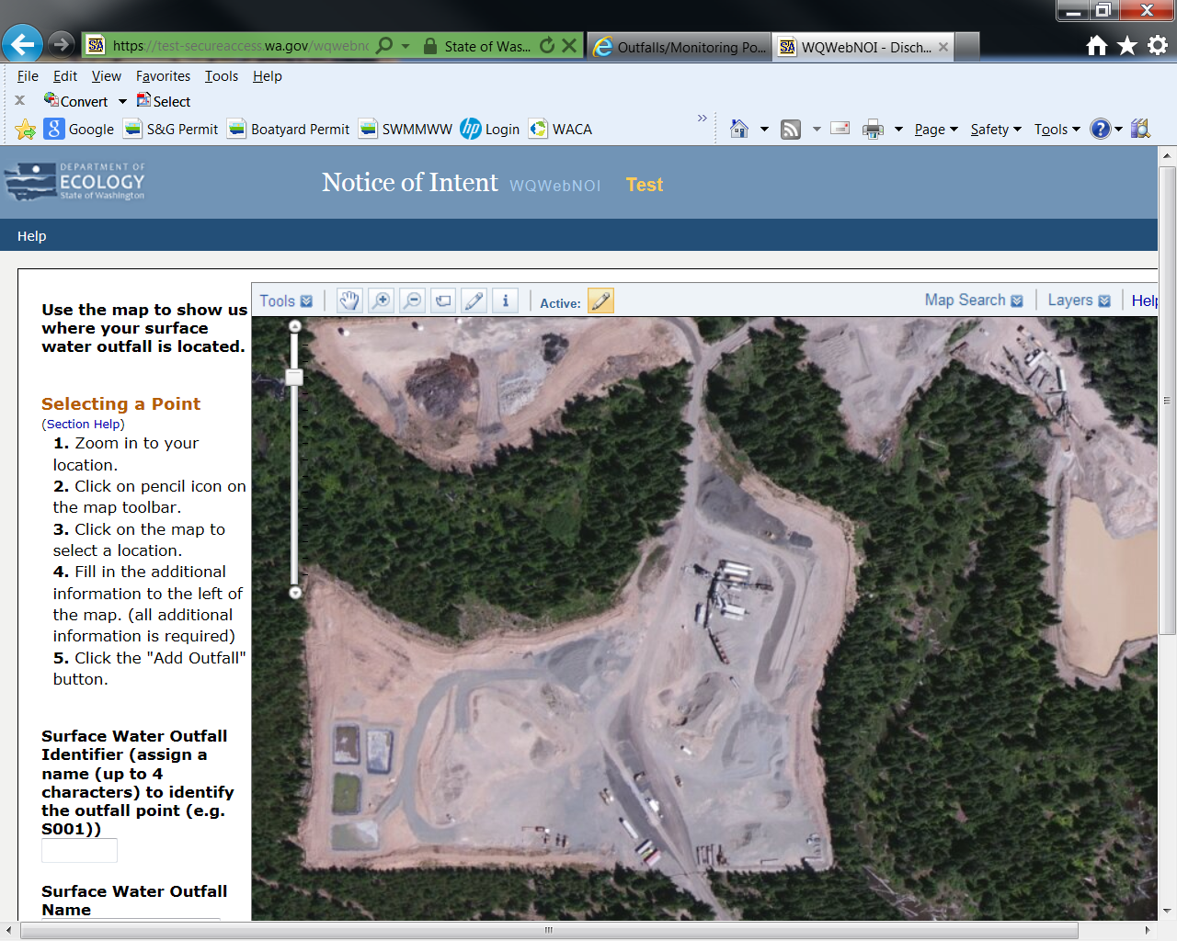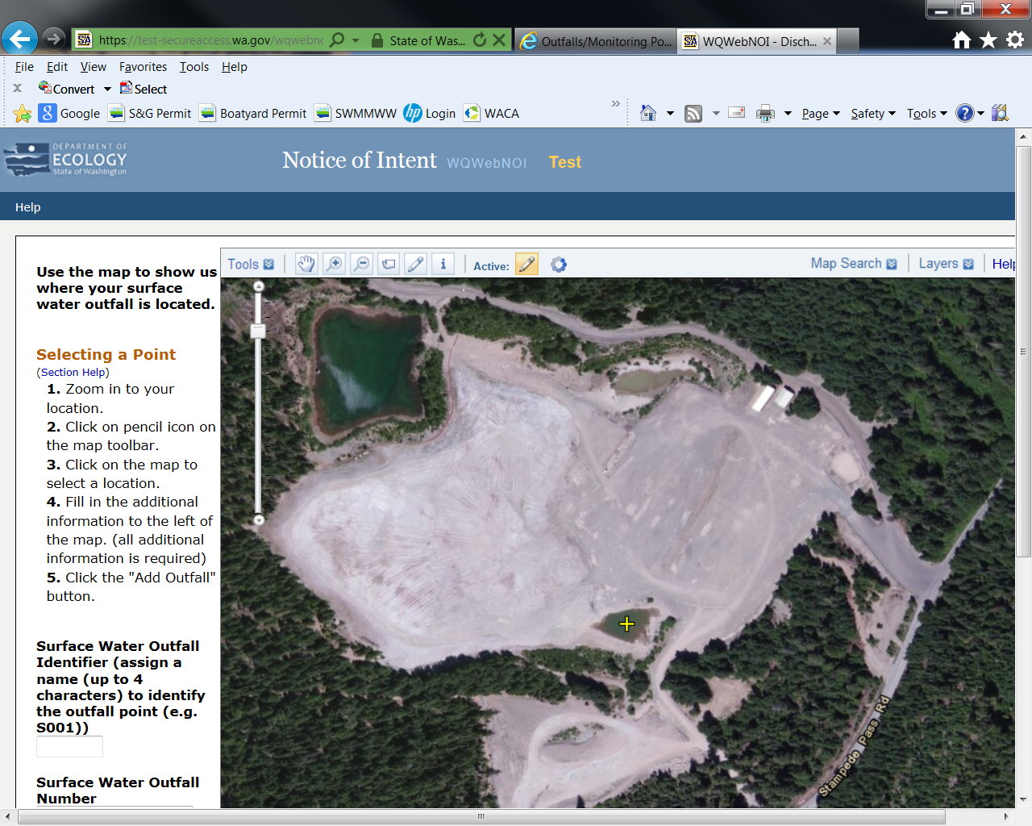

**G004**

**Pond 4 Stormwater Infiltration**

Stockpile

Stormwater Runoff

Stockpile

Stockpile

Stormwater Runoff

Nice Road Ditch (Pierce County)

Culvert, ditch to Duck Creek

**S001**

**Ditch Outfall**

**Surface water body**

**(Duck Creek)**

**Pond 3 (Impervious)**

**Process Water**

Pipe from Pond 3 to Duck Creek

**Pond 1 Stormwater**

Overflow to ditch

**G001**

**MP01**

**S002**

**Duck Creek Outfall**

**Pond 2**

**Process Water Infiltration**

**G002**

**Sand & Gravel Site**

Crusher / Wash Plant

Process Water

Process Water

Coordinates for G001:

**Latitude:** 47.04746

**Longitude:** -122.81579

Coordinates for G002:

**Latitude:** 47.04852

**Longitude:** -122.81480

Coordinates for MP01:

**Latitude:** 47.04840

**Longitude:** -122.81311

Coordinates for S002: **Latitude:** 47.04850 **Longitude:** -122.81579

Coordinates for S001: **Latitude:** 47. 04840 **Longitude:** -122. 81311

Coordinates for G004:

**Latitude:** 47.04746

**Longitude:** -122.81597

|  |  |  |  |  |  |  |  |
| --- | --- | --- | --- | --- | --- | --- | --- |
| Example of how to fill out section 14 - Discharge to Surface Waterbody (refer to figure above) | | | | | | | |
| Stormwater from the Pond 1 discharges from the facility into a Nice Road ditch. The ditch is owned and operated by the city or county that the ditch is located in; in this example, Pierce County – you would enter “Pierce County, Nice Road ditch” in Section 13 of this application. The water in the Nice Road ditch enters the surface waterbody (Duck Creek) at S001 – enter “S001” in the “Surface Water Outfall Point Identifier” column in the table below; enter “Duck Creek” in the “Name of Surface Waterbody” column for S001. In the figure, S001 has the name Ditch Outfall – Enter “Ditch Outfall” in the Surface Water Outfall Name” column. Enter the latitude and longitude corresponding to S001 in the table below. S001 is not a monitoring point, the permittee monitors this discharge at MP01 – enter “No” in the Is the “Outfall Point a Monitoring Point” column. The discharge type associated with S001 for this facility is stormwater – enter “Stormwater” into the Type of Discharge Column. In the text above the figure, it says to assume a NAICS code of 212321 – enter this information in the table below in the “NAICS Code(s)” column for S001.  In the figure, Pond 3 discharges to Duck Creek at S002 – enter “S002” in the “Surface Water Outfall Point Identifier” column in the second row of the table below. This outfall has the name of “Duck Creek Outfall” – enter this name in the “Surface Water Outfall Name” column. Enter the latitude and longitude corresponding to S002 in the table below. S002 discharges to Duck Creek – enter “Duck Creek” in the “Name of Surface Waterbody” column below. S002 is a monitoring point – enter “Yes” into the “Is the Outfall Point a Monitoring Point?” column below. Pond 3 discharges process water – enter “Process Water” into the “Type of Discharge” column. In the text above the figure, it says to assume a NAICS code of 212321 – enter this information in the table below in the “NAICS Code(s)” column for S001. | | | | | | | |
| **Surface Water Outfall Point Identifier**  **(4 characters max)** | **Surface Water Outfall Name** | **Surface Water Outfall Point Latitude**  **(Decimal Degrees)** | **Surface Water Outfall Point Longitude**  **(Decimal Degrees)** | **Name of Surface Waterbody** | **Is the Outfall Point a Monitoring Point?** | **Type of Discharge (Process Water, Mine Dewatering Water, or Stormwater)** | **NAICS Code(s)** |
| S001 | Ditch Outfall | 47. 04840 | -122. 81311 | Duck Creek | No | Stormwater | 212321 |
| S002 | Duck Creek Outfall | 47.04850 | -122.81579 | Duck Creek | Yes | Process Water | 212321 |

|  |  |  |  |  |  |  |  |
| --- | --- | --- | --- | --- | --- | --- | --- |
| Example of how to fill out section 15 - Monitoring Point Locations (refer to figure above) | | | | | | | |
| In the figure, Pond 1 infiltrates to groundwater and also has a surface water discharge through the overflow to the ditch, which then flows into Duck Creek. There are two monitoring points associated with Pond 1 – G001 and MP01. Enter “G001” into the “Monitoring Point Identifier” into the first row in the table below. Assign a monitoring point name of “Pond 1” and enter this into the “Monitoring Point Name” column corresponding to G001. Enter the latitude and longitude coordinates corresponding to G001. For Pond 1, G001 is the groundwater monitoring point – enter “Groundwater” into the “Discharge to Groundwater or Surface Water?” column. There is no corresponding surface water outfall identifier for G001 – enter “N/A” into the “Corresponding Surface Water Outfall Identifier” column. In the figure Pond 1 receives only stormwater – enter “Stormwater” into the “Type of Discharge” column. In the text above the figures, it says to assume a NAICS code of 212321 – enter this information in the table below in the “NAICS Code(s)” column for G001.  Pond 1 also has an overflow to surface water and an associated surface water monitoring point – enter “MP01” into the second row in the “Monitoring Point Identifier” column. Assign the name “Pond 1 Overflow” to MP01 and enter this name into the “Monitoring Point Name” column. Enter the latitude and longitude coordinates corresponding to MP01. For Pond 1, MP01 is a surface water monitoring point – enter “Surface Water” into the “Discharge to Groundwater or Surface Water?” column. MP01 corresponds to surface water outfall S001 – enter “S001” into the “Corresponding Surface Water Outfall Identifier” column. In the figure Pond 1 receives only stormwater – enter “Stormwater” into the “Type of Discharge” column. In the text above the figures, it says to assume a NAICS code of 212321 – enter this information in the table below in the “NAICS Code(s)” column for MP01.  In the figure, Pond 2 infiltrates process water. G002 is a groundwater monitoring point for Pond 2 – enter G002 into the “Monitoring Point Identifier” column in the third row in the table below; assign “Pond 2” as the name for G002 and enter it into the “Monitoring Point Name” column. Enter the latitude and longitude coordinates corresponding to G002. Pond 2 infiltrates the process water – enter “Groundwater” into the “Discharge to Groundwater or Surface Water?” column. There is no corresponding surface water outfall identifier for G002 – enter “N/A” into the “Corresponding Surface Water Outfall Identifier” column. In the figure Pond 2 receives process water – enter “Process Water” into the “Type of Discharge” column. In the text above the figures, it says to assume a NAICS code of 212321 – enter this information in the table below in the “NAICS Code(s)” column for G002. Follow these same steps for G004, associated with stormwater Pond 4.  Pond 3 directly discharges to Duck Creek at S002 (note Pond 3 is impervious and therefore does not have an associated groundwater discharge). Since S002 is both a surface water outfall and a monitoring point, enter the same information for S002 from the table above in Section 14 into the fifth row of the table below and enter “S002” into the “Corresponding Surface Water Outfall Identifier” column. Note the Monitoring Point Name for S002 is the same as the Surface Water Outfall Name. | | | | | | | |
| **Monitoring Point Identifier**  **(4 characters max)** | **Monitoring Point Name** | **Monitoring Point Latitude**  **(Decimal Degrees)** | **Monitoring Point Longitude**  **(Decimal Degrees)** | **Discharge to Groundwater or Surface Water?** | **Corresponding Surface Water Outfall Identifier** | **Type of Discharge (Process Water, Mine Dewatering Water, or Stormwater)** | **NAICS Code(s)** |
| G001 | Pond 1 | 47.04746 | -122.81579 | Groundwater | N/A | Stormwater | 212321 |
| MP01 | Pond 1 Overflow | 47.04840 | -122.81311 | Surface Water | S001 | Stormwater | 212321 |
| G002 | Pond 2 | 47.04852 | -122.81480 | Groundwater | N/A | Process Water | 212321 |
| G004 | Pond 4 | 47.04746 | -122.81597 | Groundwater | N/A | Stormwater | 212321 |
| S002 | Duck Creek Outfall | 47.04850 | -122.81579 | Surface Water | S002 | Process Water | 212321 |