**WATER RESOURCES PROGRAM  
Application to Enter a Water Right into the  
Trust Water Rights Program**

For Ecology use. Space for Date Stamp.**Note:** This application is used to request transfer of a water right into the state Trust Water Rights Program through the types of conveyance listed below. No modifications to the water right is being proposed. If other modifications to the water right are needed, contact the appropriate region office to discuss submitting an Application to Change/Transfer a Water Right, Ecology form number 040-1-97.

**No fee is required to submit this application.**

The water right will be conveyed to Ecology to be held in trust through:

Lease

Purchase

Water Banking Agreement

Other:__________________________________________

Transfer of:

All of the water right

A portion of the water right

For lease or other temporary arrangement:

Start Date _____/_____/_____

End Date _____/_____/_____

### 1. Applicant Information

|  |  |  |
| --- | --- | --- |
| Applicant/business name: | Phone no: | Other no: |
| Address: | | |
| City: | State: | Zip: |
| Email address (if available): | | |

|  |  |  |
| --- | --- | --- |
| Contact name (if different from above): | Phone no: | Other no: |
| Relationship to applicant: | | |
| Address: | | |
| City: | State: | Zip: |
| Email address (if available): | | |

### 2. Water Right Information

|  |  |  |
| --- | --- | --- |
| Water right or claim number | Recorded name(s) | |
| Water right owner (if different from above): | Phone no. | Other no. |
| Address | | |
| City | State | Zip code |
| Email address (if available) | | |

### 3. Describe how water will be made available for Trust

Indicate what alteration to the existing water use under the water right is planned to make water right available for the Trust Water Right Program. Check all boxes that may apply.

Alteration in method of diversion

Alteration in method of delivery/conveyance

Alteration in water use/ irrigated acreage

Alteration in type of crop

Nonuse of one or more points of diversion

Nonuse of all or a portion of the named water right

Other:___________________________________________________________________________

Explain how water will be made available for trust. Also describe any agreements, grants, or larger projects that this related to. Include any future permitting or reporting that may be requested of Ecology’s Water Resources Program.

|  |
| --- |
|  |

### 4. Proof of water use

* Has the water right or portion of the right proposed for transfer to trust been used as described on your water right document in the last five (5) years?  
   yes  no
* Are water withdrawals of this water right metered or measured?   
   yes  no
* Has the water right been a part of a water right change?   
   yes  no. If yes, provide the date the change was approved
* Attach any information, such as records of measurement, pump electrical consumption records or other information that indicates the extent of water use during the past five-years and general information of the extent of historic water use. If you have a water system plan or conservation plan, include a copy with your application.

**5. Point(s) of Diversion or Withdrawal**

Describe the point of diversion or withdrawal from which the water right has historically been diverted, such as a stream or from a well. If water is withdrawn from a well, attach all existing records of the well.

|  |  |  |  |  |  |  |  |
| --- | --- | --- | --- | --- | --- | --- | --- |
| Source name | QTR  QTR | QTR | SEC | TWP | RGE | Parcel No. | Well Tag No. |
| 1. |  |  |  |  |  |  |  |
| 2. |  |  |  |  |  |  |  |
| 3. |  |  |  |  |  |  |  |
| 4. |  |  |  |  |  |  |  |

Do you own the point(s) of diversion or withdrawal?  yes  no

**5. Purpose(s) and Period of Use**

Describe the existing purpose of use and the proposed purpose of use during the period the water right will be in trust.

| Existing Purpose of use | GPM or CFS | Acre-Feet/Year | Period of use |
| --- | --- | --- | --- |
|  |  |  |  |
|  |  |  |  |
|  |  |  |  |
|  |  |  |  |

| Purpose of the Trust Water Right | GPM or CFS | Acre-Feet/Year |
| --- | --- | --- |
|  |  |  |

**6. Place of Use**

**A. Existing Place of Use**

| QTR QTR | QTR | SEC | TWP | RGE | County | Parcel # | # of irrigated acres |
| --- | --- | --- | --- | --- | --- | --- | --- |
|  |  |  |  |  |  |  |  |

Legal description of lands where water is presently used:

|  |  |  |
| --- | --- | --- |
| Legal landowner of existing place of use  (if different than applicant) | Phone no. | Alt phone no. |
| Address | | |
| City | State | Zip code |
| Email address (if available) | | |

**B. Proposed Use of the Trust Water Right**

Describe the water body or other location(s) that will benefit from the trust water right. If the trust water right will be instream, describe the stream reaches that will contain the right.

|  |
| --- |
|  |

### 7. Remarks and other relevant information:

|  |
| --- |
|  |

Certain applications may incur a Real Estate Excise Tax liability for the seller of the water rights. The Department of Revenue has requested notification of potential taxable water right related actions and therefore may be provided with a copy of this request.

Please contact the State Department of Revenue for further information. The website is <https://dor.wa.gov>. The phone number is (360) 570-3265. The address is: Department of Revenue, Real Estate Excise Tax, PO Box 47477, Olympia, WA 98504-7477.

### 8. Signatures

I certify that the information above is true and accurate to the best of my knowledge. I hereby grant staff from the Department of Ecology access to the above site(s) for inspection and monitoring purposes. If assisted in the preparation of the above application, I understand that all responsibility for the accuracy of the information rests with me.

|  |  |  |  |  |
| --- | --- | --- | --- | --- |
|  |  |  |  |  |
| **Applicant Printed Name** |  | **Applicant Signature** |  | **(Date: MM/DD/YYYY)** |
|  |  |  |  |  |
| **Water Right Holder Printed Name** |  | **Water Right Holder Signature** |  | **(Date: MM/DD/YYYY)** |
|  |  |  |  |  |
| **Landowner of Existing Place of Use, Printed Name** |  | **Landowner of Existing Place of Use Signature** |  | **(Date: MM/DD/YYYY)** |

**Send your completed form to Ecology**

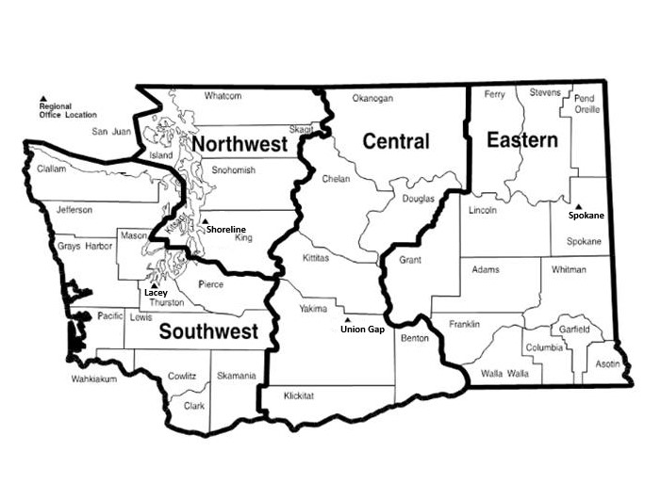Attach a scanned copy of the completed and signed agreement form in an email and send it to the regional office where your water right is located (see email addresses below). We strongly encourage paperless processing, but if you do not have access to email, mail the form to the office where your project is located:

| **Region/ Office** | **Counties served** | **Mailing Address** | **Phone** |
| --- | --- | --- | --- |
| **Central** | Benton, Chelan, Douglas, Kittitas, Klickitat, Okanogan, Yakima | 1250 W Alder St Union Gap, WA 98903 | 509-575-2490  [wrCRO@ecy.wa.gov](mailto:wrCRO@ecy.wa.gov) |
| **Eastern** | Adams, Asotin, Columbia, Ferry, Franklin, Garfield, Grant, Lincoln, Pend Oreille, Spokane, Stevens, Walla Walla, Whitman | 4601 N Monroe Spokane, WA 99205 | 509-329-3400  [wrERO@ecy.wa.gov](mailto:wrERO@ecy.wa.gov) |
| **Northwest** | Island, King, Kitsap, San Juan, Skagit, Snohomish, Whatcom | 15700 Dayton Ave N Shoreline, WA 98133 | 206-594-0000  [wrNWRO@ecy.wa.gov](mailto:wrNWRO@ecy.wa.gov) |
| **Office of Columbia River** | OCR has jurisdiction for designated OCR projects, and new projects located within one mile of the Columbia River. | 1250 W Alder St Union Gap, WA 98903 | 509-457-7141  [wrCRO@ecy.wa.gov](mailto:wrCRO@ecy.wa.gov) |
| **Southwest** | Clallam, Clark, Cowlitz, Grays Harbor, Jefferson, Lewis, Mason, Pacific, Pierce, Thurston, Skamania, Wahkiakum | PO Box 47775Olympia, WA 98504 | 360-407-6300  [wrSWRO@ecy.wa.gov](mailto:wrSWRO@ecy.wa.gov) |