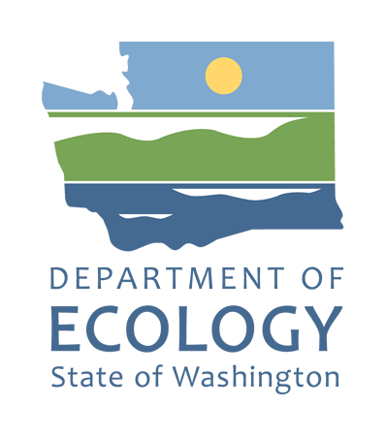 | Clean Water State Revolving Fund  State Environmental Review Process (SERP)  State Environmental Policy Act (SEPA) Certification:  Finding of SEPA Exemption  To be completed and signed by Agency SEPA Responsible Official and sent for review and approval to the Ecology Environmental Review Coordinator
Local Government Name: |  | Ecology Agreement No.:
Address:
Project Location:
Description of Activities and Connected Projects:
Reason for Exemption under SEPA:

CERTIFICATION

The recipient certifies the proposed Ecology-funded project complies with the provisions of the State Environmental Policy Act (SEPA) under RCW 43.21C and WAC 197.11.800.

Agency SEPA Responsible Official:
Signature: | Date:

Ecology Environmental Review Coordinator:
Signature: | Date:
To request an ADA accommodation, contact Ecology by phone at 360-407-6600 or email at liz.ellis@ecy.wa.gov, or visit https://ecology.wa.gov/accessibility. For Relay Service or TTY call 711 or 877-833-6341. To request this document in another language, please contact Liz Ellis at 360-628-4410 and ask for an interpreter, or email liz.ellis@ecy.wa.gov

