Application for Coverage Under the Statewide General Permit for Biosolids Management
Active Biosolids Management Facilities
Solid Waste Management Program
Washington State Department of Ecology
Olympia, WA
Revised June 2022 | ECY 070-652

Form Information
This document is available on the Department of Ecology’s website.

Department of Ecology’s Regional Offices
Map of Counties Served
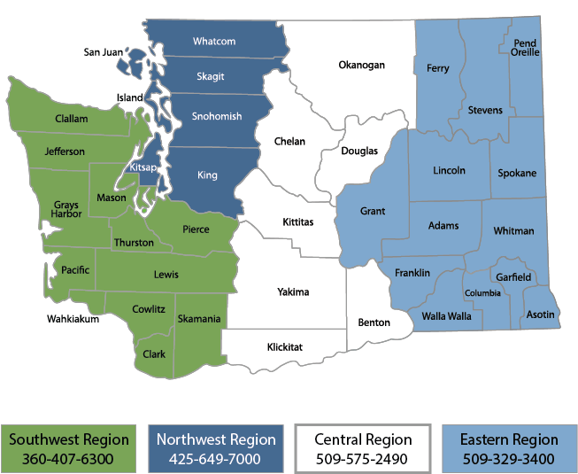

Contact Information
Contact information for biosolids staff is located on Ecology’s biosolids webpage.

ADA Accessibility
The Department of Ecology is committed to providing people with disabilities access to information and services by meeting or exceeding the requirements of the Americans with Disabilities Act (ADA), Section 504 and 508 of the Rehabilitation Act, and Washington State Policy #188.
To request an ADA accommodation, contact Ecology by phone at 360-407-6900 or email at SWMpublications@ecy.wa.gov. For Washington Relay Service or TTY call 711 or 877-833-6341. Visit Ecology's website for more information.

Table of Contents
Instructions for Completing Application for Coverage Under the General Permit for Biosolids Management iv
Who is subject to the general permit iv
Who must submit a permit application iv
General instructions iv
Application for coverage under the statewide general permit for Biosolids Management 1
Active Biosolids Management 1
Other Permits 4
Process, Production and Storage 5
Treatment Process Components 2
Material end use 2
Attachments 12
Certification Statement 13

Instructions for Completing Application for Coverage Under the General Permit for Biosolids Management
Active Biosolids Management

Who is subject to the general permit
Public and private facilities within the jurisdiction of the State of Washington that meet the definition of Treatment Works Treating Domestic Sewage (TWTDS) are subject to the Statewide General Permit for Biosolids Management. This includes:
All publicly owned treatment works,
- Privately owned treatment works that treat only domestic sewage,
- Beneficial Use Facilities (provide land application services to biosolids generators,
- Septage management facilities (treat and/or land apply septage), and
- Other facilities that treat biosolids and septage like Compost facilities.
Covered activities include treating, storing, land applying, selling, giving away, transferring from one facility to another, and disposing of biosolids in a municipal solid waste landfill or incinerator.

Important note
Existing facilities without Active Biosolids or Septage Management programs, operating under the previous permit as of September 4, 2020, are not required to submit a permit application unless directed to do so by Ecology.

Who must submit a permit application
All facilities with active management programs, and all new facilities, regardless of their practices, that begin operations after September 4, 2020, are required to submit a permit application, and are subject to additional public notice and SEPA review.

General instructions
When completing the general permit application, read all questions carefully, do not leave any applicable sections blank, and be sure to submit all necessary supporting documents.
Facilities applying for coverage under the general permit should start by reviewing the required content for a complete application. Ecology provides some templates and guidance materials, and regional biosolids coordinators can help with questions.

Common application errors that will delay permit issuance
Incomplete or poorly prepared applications are the most common cause of delays in permit processing. We encourage responsible officials to take time to prepare an accurate, thorough, and professional permit application. Applications must be suitable for review by both Ecology staff and interested parties. To ensure a smooth review process, facilities must:
- Prepare and write their application in a way that a reasonably knowledgeable person can understand.
- Use the application form provided by Ecology for their facility type.
- Adhere to proper format and organization.
Ecology will advise each facility when their application is ready for public notice. Ecology may post the applications to our web site, and/or release it directly to interested parties on request.

Confirming what sections of the permit your facility is subject to
Use the flowchart below provided by Ecology to confirm what sections of the permit your facility is subject too. Consult your biosolids coordinator with any questions.
Figure 1 – Permit sections flow chart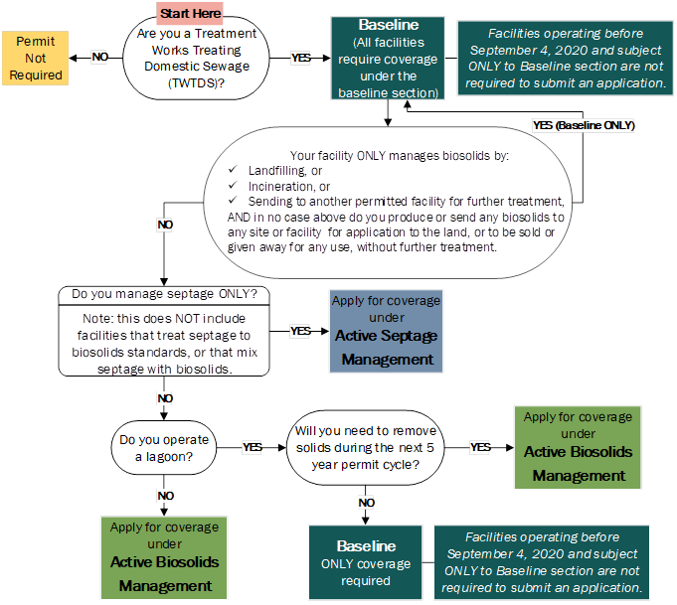

Submitting the application
Electronic copies are preferred. Hard copies can be submitted via mail, in person, or by parcel delivery service.All facilities must submit their permit application as follows:
- One copy to the Regional Biosolids Coordinator (regional contact and address information provided above and online),
- One copy to all Local Health Jurisdictions where you will treat, store, dispose, or land apply biosolids, sewage sludge, or septage, unless the health jurisdiction has declined to receive a copy.
Exisiting facilities operating under the previous general permit as of September 4, 2020, must submit their applications by the following deadlines. Please note deadlines vary depending on submission format as outlined below:
- By Email: Received no later than 11:59 PM, 90 days after permit issuance.
- By Mail: Postmarked no later than 11:59 PM, 90 days after permit issuance.
- In Person or Parcel Delivery Service: Delivered to office no later than 5:00 PM, 90 days after permit issuance.
New facilities must submit their applications 180 days before beginning operations.

Active Biosolids Management Application for coverage under the statewide general permit for Biosolids Management

Permit sections applicable to your facility
This application is for facilities that require coverage under the General Permit for Biosolids Management and have Active Biosolids Management programs. Use the Figure 1 flowchart above and list of facilities provided by Ecology to confirm whether the sections listed below are applicable to your facility
- baseline, and
- Active Biosolids Management
Consult your biosolids coordinator with any questions. Next, follow the instructions to complete the application.

Basic facility information
Please provide complete and accurate information.
Name of facility
List all business names associated with your facility.

Owner(s)

Ownership status

State
Local
Private
Federal
WA Tribe
Other

Physical address of facility
Address used to locate facility for visits/inspections.

Mailing address
Where notifications should be delivered.

Permit number
Biosolids permit numbers begin with BA or BT. Consult your regional biosolids coordinator if you don’t know yours.

Facility Contacts
Consult section 2.1.3 of the general permit for an explanation of Responsible Official vs. Primary Contact

Primary Contact
Typically an individual who works at the facility and is first point of contact for Ecology

Name

Title

Mailing address

Phone

Email

Responsible official
See link below. Responsible official depends on facility ownership and size.
Name

Title

Mailing address

Phone

Email

Billing contact

Name

Title

Mailing address

Phone

Email

Other contact (if applicable)

Specify Contact Type

Name

Title

Mailing Address

Phone

Email

Facility Type
Check all boxes that apply to your facility.
Example: Minor WWTPs with lagoons will check the 2nd AND 7th boxes below.
Major sewage treatment facility (design flow of ≥ 1 mgd or serving a population of ≥ 10,000)
Minor sewage treatment facility (design flow of < 1 mgd and serving a population of <10,000)
Have a pretreatment program or designated as a Class I facility as defined in WAC 173-308-080
Composting facility (using biosolids as a feedstock)
Mixing facility (mixes both biosolids and septage and treats to biosolids standards)
Septage Management Facility treating only septage to biosolids standards
Have a lagoon
Other – describe

Other Permits
Check all that apply to your facility and provide associated permit number(s):
National Pollutant Discharge Elimination System (NPDES)
Permit number

State Waste Discharge
Permit number

Solid Waste
Permit number

Air
Permit number

Local special or conditional use
Permit number

Issuing Authority

Additional or More Stringent Requirements
Facilities must comply with additional or more stringent requirements imposed by Ecology under the previous expired permit.
Do you have any additional or more stringent requirements imposed on your facility under the previous expired permit coverage? Yes, No

If yes:
If you wish to have provisional approval to engage in the biosolids management activities proposed in this application prior to Ecology reviewing it and issuing final approval of coverage, you must state that you agree to be bound by any additional, more stringent conditions that Ecology imposed on your previous, expired permit coverage until such time as Ecology makes a decision on your new permit coverage.
I have read and understand the statement above and agree to the conditions.

Process, Production and Storage
Describe your facility’s operations, touching on each phase of solids production and management:
For example, “Our biosolids are stabilized in two aerobic digesters that operate on alternating cycles. We pump the stabilized biosolids to our drying beds. When a drying bed reaches 75% or more solids content, we move the solids to a covered storage bay. We test the material in our storage bay in mid to late summer. When we have confirmation of Class B pathogen reduction and pollutant concentration limits, we notify our contract land applier and they come and remove the solids for land application.”

Do you plan to make any changes to your operations during this 5-year permit cycle? Yes, No
If yes, explain
You must notify your coordinator about any changes you plan to make.

Do you operate a lagoon? Yes No
If no, continue on to the question after the indentations.
If yes, provide answers to the remaining questions below.
When was the last time you sampled for pollutants in lagoon solids?

On average, how often do you remove solids from the lagoon?

When was the last time you removed any solids?

Do you plan to remove solids within the 5-year permit cycle? Yes No
If no, continue on to the next page.
If yes, provide answers to the remaining questions on this page.
When do you plan to start the removal process?

How long do you anticipate the project taking?

What do you plan to do with the materials removed?
Check all boxes that apply.
Send to another facility for further treatment
Send to another facility for land application
Directly land apply the materials on land permitted for your facility
Other – Please explain

Pathogen Reduction
Please identify the alternative(s) used at your facility to meet pathogen reduction standards.

Class A:
Alternative 1 (time/temperature)
Alternative 2 (pH/time/temperature/% solids)
Alternative 3 (process to further reduce pathogens [PFRP])

Composting
Heat drying
Heat treatment
Pasteurization
Thermophilic aerobic digestion

Alternative 4 (PFRP equivalent)

Class B:
Alternative 1 (7 samples)
Alternative 2 (process to significantly reduce pathogens)

Aerobic digestion
Air drying
Anaerobic digestion
Composting
Lime stabilization

Alternative 3 (PSRP equivalent)
Be sure all checked processes are included in the process, production, and storage section, above.

Vector Attraction Reduction
Please identify the alternative(s) used at your facility to meet Vector Attraction Reduction standards.
Be sure all checked processes are included in the process, production, and storage section, above.
Alternative 1 (38% volatile solids reduction)
Alternative 1a (bench test-anaerobic)
Alternative 1b (bench test-aerobic)
Alternative 2 (SOUR)
Alternative 3 (aerobic process)
Alternative 4 (pH stabilization)
Alternative 5 (≥ 75% solids)
Alternative 6 (≥ 90% solids)
Alternative 7 (injection)
Alternative 8 (incorporation)

Pollutants
Please answer all applicable questions below about analysis of pollutants. Pollutant concentration limits are described in WAC 173-308-160
How often do you test your biosolids?:

Annually - Once per year
Quarterly – Four times per year
Bimonthly – Six times per year
Monthly – Twelve times per year

Other (Describe)

Did any of the sampling events from the last 5 years find pollutants in quantities exceeding Table 1 or Table 3 values?
Be sure all processes outlined in the pollutants section are included in the process, production, and storage section, above.

Products required to meet recycled content minimums

Treatment Process Components
Be sure all checked processes are included in the process, production, and storage.
Check all that apply

Aerobic digester
Anaerobic digester
Autothermal Thermophilic Anaerobic Digestion
Screening (trash removal)
Mechanical Dewatering
Heat Drying
Air drying / drying beds
Lime Stabilization
Composting
Gravity Thickener
Flocculation

Other, please describe

Tank Info
Check all boxes that apply to your facility, and answer associated questions as directed.
Do you operate under an NPDES or State Waste Discharge Permit? Yes, No
Do you have tanks on site used for storage or treatment of biosolids? Yes, No
If yes, please provide the number of tanks, their capacity, and whether they are above or below ground.

Material end use
Check all boxes that apply to your facility, and answer associated questions as directed. However ONLY check the boxes associated with an end use your facility is designed, and intends to produce.
For example if you have experienced isolated issues meeting standards, you do not need to identify that here. But, if you regularly land apply material on land specifically permitted for this purpose AND depend on other permitted facilities for further treatment, land application, or disposal, please check the applicable boxes, and answer the questions that follow.

Beneficial use
Exceptional quality biosolids
Do you land apply or sell/give away second-generation EQ biosolids? Yes, No
Do you land apply or sell/give away first-generation EQ biosolids? Yes, No
If yes, please explain what you do with your EQ biosolids

Land apply non-exceptional quality biosolids
Do you apply non-exceptional quality biosolids to land that you own, or control by lease or other arrangement, that is specifically approved as part of your permit coverage? Yes, No
If yes, please explain what you do with your biosolids

Rely on other facilities
Do you send any biosolids to a BUF for land application? Yes, No
Do you send any biosolids to another permitted facility for further treatment? Yes, No
Where do you send the biosolids?
If you send to multiple facilities, list all.

Who is responsible for completing the spill prevention and response plan for transportation of your biosolids?

Disposal
Send materials to an incinerator
State law emphasizes the maximum beneficial use of biosolids. Please provide justification for disposing of your materials.

Provide the name of the incinerator which you send biosolids.

Who is responsible for completing the spill prevention and response plan for transportation of your biosolids?

Send materials to a municipal landfill
State law emphasizes the maximum beneficial use of biosolids. Please provide justification for disposing of your materials.

Provide the name of the landfill to which you send biosolids.

Who is responsible for completing the spill prevention and response plan for transportation of your biosolids?

Attachments
Check all applicable boxes and include all attachments with your application. If previously submitted (historical) documents are still accurate, you may submit copies if they meet criteria as to form and content for this permit process.
Confirm required attachments for your facility with your biosolids coordinator, and please note your region coordinator may require updated documents.
Attachments: | Applicable to: | Included:
Vicinity map | All facilities
Facility schematic | All facilities
Contingency plan | EQ Producers, Land appliers and facilities that send materials for land application.
Spill Prevention and Response Plan | Facilities that haul biosolids
Biosolids Sampling and Analysis Plan | EQ Producers, Land appliers, and facilities that send to BUFs
Soil Sampling and Analysis Plan | Land appliers
Analytical data | All Facilities
Site Specific Land Application Plan | Land appliers of non-EQ biosolids
General Land Application Plan | Land appliers where applicable
State Environmental Policy Act (SEPA) | All facilities
Public Notice | All facilities
Temporary Disposal Plan | All facilities
Lagoon Cleanout Plan | Lagoons cleaning out within 5-year permit cycle
Second-Generation Products Plan | Facilities producing second-generation EQ products

Certification Statement
“I certify under penalty of law that this document and all attachments were prepared under my direction or supervision in accordance with a system designed to assure that qualified personnel properly gather and evaluate the information submitted. Based on my inquiry of the person or persons who manage the system, or those persons directly responsible for gathering the information, the information submitted is, to the best of my knowledge and belief, true, accurate, and complete. I am aware that there are significant penalties for submitting false information, including the possibility of fine and imprisonment for knowing violations.”

Signature of Responsible Official

Title

Date

Must be signed by the Responsible Official; see WAC 173-308-310(10)(a).

https://apps.ecology.wa.gov/publications/summarypages/070654.html
https://ecology.wa.gov/Waste-Toxics/Reducing-recycling-waste/Biosolids/Program-contacts
https://apps.leg.wa.gov/WAC/default.aspx?cite=173-308-080
https://apps.leg.wa.gov/WAC/default.aspx?cite=173-308-170
https://apps.leg.wa.gov/WAC/default.aspx?cite=173-308-170
https://apps.leg.wa.gov/WAC/default.aspx?cite=173-308-180
https://apps.leg.wa.gov/WAC/default.aspx?cite=173-308-160

