Application for Coverage under the Statewide General Permit for Biosolids Management
Active Septage Management Facilities
Solid Waste Management Program
Washington State Department of Ecology
Olympia, WA
Revised June 2022 |ECY 070-653

Form Information
This document is available on the Department of Ecology’s website.

Department of Ecology’s Regional Offices

Map of Counties Served
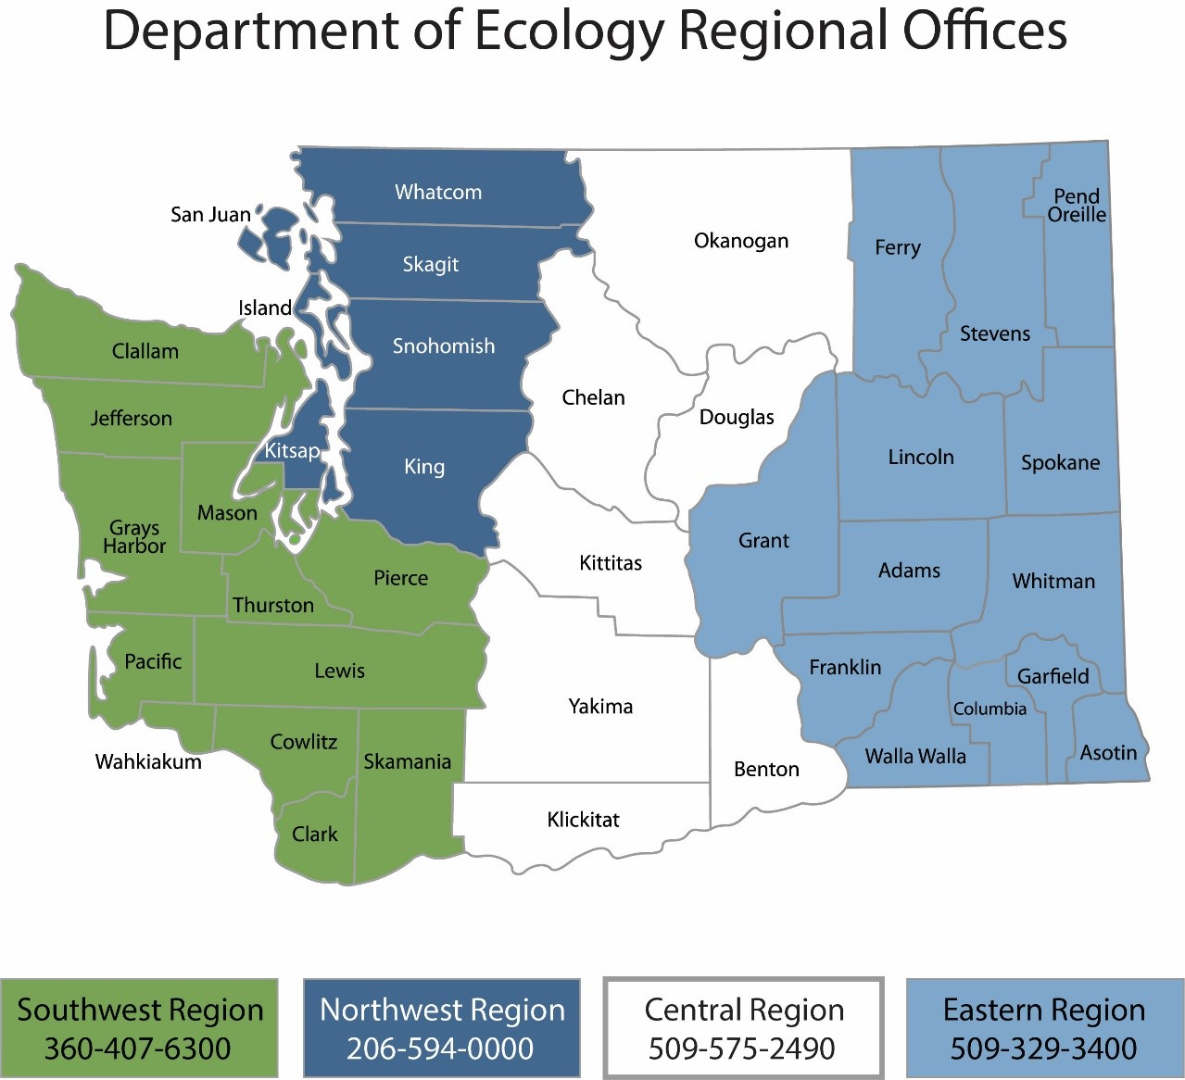

Contact Information
Contact information for biosolids staff is located on Ecology’s biosolids webpage.

ADA Accessibility
The Department of Ecology is committed to providing people with disabilities access to information and services by meeting or exceeding the requirements of the Americans with Disabilities Act (ADA), Section 504 and 508 of the Rehabilitation Act, and Washington State Policy #188.
To request an ADA accommodation, contact Ecology by phone at 360-407-6831 or email at swmpublications@ecy.wa.gov. For Washington Relay Service or TTY call 711 or 877-833-6341. Visit Ecology's website for more information.

Table of Contents
Instructions for Completing Application for Coverage under the General Permit for Biosolids Management v
Who is subject to the general permit v
Who must submit a permit application v
General instructions v
Application for coverage under the statewide general permit for Biosolids Management 1
Permit Sections Applicable to your Facility 1
Basic Facility Information 1
Facility contacts 2
Facility type 4
Other permits 4
Additional or More Stringent Requirements 5
Process, production and storage 5
Treatment 6
Septage End Use 7
Attachments 8
Certification Statement 9

Instructions for Completing Application for Coverage under the General Permit for Biosolids Management

Who is subject to the general permit
Public and private facilities within the jurisdiction of the State of Washington that meet the definition of Treatment Works Treating Domestic Sewage (TWTDS) are subject to the Statewide General Permit for Biosolids Management. This includes:
- All publicly owned treatment works,
- Privately owned treatment works that treat only domestic sewage,
- Beneficial Use Facilities (provide land application services to biosolids generators,
- Septage management facilities (treat and/or land apply septage), and
- Other facilities that treat biosolids and septage like compost facilities.
Covered activities include treating, storing, land applying, selling, giving away, transferring from one facility to another, and disposing of biosolids in a municipal solid waste landfill or incinerator.

Important Note
Existing facilities without Active Biosolids or Septage Management programs, operating under the previous permit as of September 4, 2020, are not required to submit a permit application unless directed to do so by Ecology.

Who must submit a permit application
All facilities with active management programs, and all new facilities, regardless of their practices, that begin operations after September 4, 2020, are required to submit a permit application, and are subject to additional public notice and SEPA review.

General instructions
When completing the general permit application, read all questions carefully, do not leave any applicable sections blank, and be sure to submit all necessary supporting documents.
Facilities applying for coverage under the general permit should start by reviewing the required content for a complete application. Ecology provides some templates and guidance materials, and regional biosolids coordinators can help with questions.

Common application errors that will delay permit issuance
Incomplete or poorly prepared applications are the most common cause of delays in permit processing. We encourage responsible officials to take time to prepare an accurate, thorough, and professional permit application. Applications must be suitable for review by both Ecology staff and interested parties. To ensure a smooth review process, facilities must:
- Prepare and write their application in a way that a reasonably knowledgeable person can understand.
- Use the application form provided by Ecology for their facility type.
- Adhere to proper format and organization.
Ecology will advise each facility when their application is ready for public notice. Ecology may post the applications to our web site, and/or release it directly to interested parties on request.

Confirming what sections of the permit your facility is subject to
Use the flowchart below provided by Ecology to confirm what sections of the permit your facility is subject too. Consult your biosolids coordinator with any questions.
Figure 1 – Permit Sections Flow Chart
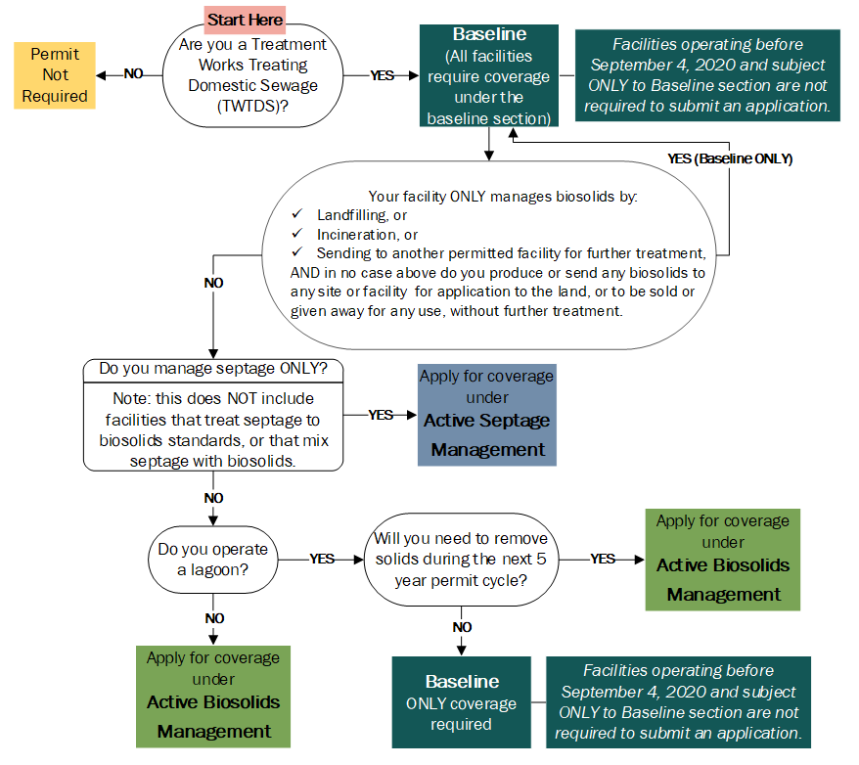

Submitting the application
Electronic copies are preferred. Hard copies can be submitted via mail, in person, or by parcel delivery service. All facilities must submit their permit application as follows:
- One copy to the Regional Biosolids Coordinator (regional contact and address information provided above and online),
- One copy to all Local Health Jurisdictions where you will treat, store, dispose, or land apply biosolids, sewage sludge, or septage, unless the health jurisdiction has declined to receive a copy.
Existing facilities operating under the previous general permit as of September 4, 2020, must submit their applications by the following deadlines. Please note deadlines vary depending on submission format as outlined below:
- By Email: Received no later than 11:59 PM, 90 days after permit issuance.
- By Mail: Postmarked no later than 11:59 PM, 90 days after permit issuance.
- In Person or Parcel Delivery Service: Delivered to office no later than 5:00 PM, 90 days after permit issuance.
New facilities must submit their applications 180 days before beginning operations.

Application for coverage under the statewide general permit for Biosolids Management
Active Septage Management

Permit Sections Applicable to your Facility
This application is for facilities that require coverage under the General Permit for Biosolids Management and have Active Septage Management programs. Use the flowchart above and list of facilities provided by Ecology to confirm whether the sections listed below are applicable to your facility:
- Baseline, and
- Active Septage Management
Consult your biosolids coordinator with any questions. Next, follow the instructions to complete the application.

Basic Facility Information
Please provide complete and accurate information.
Name of facility
List all business names associated with your facility.

Owner(s)

Ownership status

State
Local
Private
Federal
WA Tribe
Other:

Physical address of facility
Address used to locate facility for visits/inspections.

Mailing address
Where notifications should be delivered.

Permit number
Biosolids permit numbers begin with BA or BT. Consult your regional biosolids coordinator if you don’t know yours.

Facility contacts
Consult section 2.1.3 of the general permit for an explanation of Responsible Official vs. Primary Contact.
Primary Contact
Typically an individual who works at the facility and is first point of contact for Ecology.

Name
Title
Email
Mailing Address
Phone

Responsible Official
Responsible official depends on facility ownership and size.

Name
Title
Email
Mailing Address
Phone

Billing Contact

Name
Title
Email
Mailing Address
Phone

Other Contact (if applicable)

Specify Contact Type
Name
Title
Mailing Address
Phone
Email

Facility type
Check the additional boxes below if applicable.
Septage management facility (land apply or prepare septage for land application)
Check this box if you store septage in a lagoon.
Have a lagoon
If you have a lagoon, do you plan to remove sediment from the bottom of your lagoon during the 5-year permit cycle? Yes No

Other permits
Check all that apply to your facility and provide associated permit number(s):
National Pollutant Discharge Elimination System (NPDES)
Permit number
State Waste Discharge
Permit number
Solid Waste
Permit number
Air
Permit number
Local special or conditional use
Permit number
Issuing Authority

Additional or More Stringent Requirements
Facilities must comply with additional or more stringent requirements imposed by Ecology under the previous expired permit.
Do you have any additional or more stringent requirements imposed on your facility under the previous expired permit coverage? Yes No
If yes:
If you wish to have provisional approval to engage in the biosolids management activities proposed in this application prior to Ecology reviewing it and issuing final approval of coverage, you must state that you agree to be bound by any additional, more stringent conditions that Ecology imposed on your previous, expired permit coverage until such time as Ecology makes a decision on your new permit coverage.
I have read and understand the statement above and agree to the conditions.

Process, production and storage
Describe your facility’s operations, touching on each phase of solids production and management:
Example: When septage is received at our site, we screen to remove inert materials 3/8 inch or larger and haul to landfill. Septage is transferred to an above ground tank for lime stabilization. After we test a batch to ensure it is stabilized, we transfer it to a tractor-hauled application trailer and, apply at agronomic rates to a field. We plant triticale and harvest in fall. If we can’t stabilize with lime, we incorporate with a tractor disc within 6 hours of application.

Do you plan to make any changes to your operations during this 5-year permit cycle? Yes No
If yes, explain:
You must notify your coordinator about any changes you plan to make.

Treatment
Identify the Pathogen Reduction and Vector Attraction Reduction methods used at your facility.
Injection under soil surface (no significant amount visible one hour after application)
Incorporation into soil (within six hours of application)
pH adjustment (document two representative samples showing pH ≥ 12 for at least 30 minutes)

Treatment process components
Check all that apply:
All processes checked must be included in the description (narrative) above, located after the Process, production, and storage section on the previous page
Screening (required)
Describe the type of screen and size of openings in your screening system.

Describe how wastes from screening are managed.

Lime Stabilization
Mechanical Dewatering
Solar drying or drying beds
Other, please describe

Tank Info
Do you have tank(s) on site used for storage and/or treatment of septage? Yes No
If yes, provide the number of tanks ,
their capacity ,
and whether they are above or below ground. Above ground Below ground

Septage End Use
Check all boxes that apply to your facility, and answer associated questions as directed. ONLY check the boxes associated with an end use for which your facility is designed and intends to operate.
For example, if you have experienced isolated issues meeting standards, you do not need to identify that here. But, if you regularly apply septage on land specifically permitted for this purpose AND also depend on other permitted facilities to provide further treatment, land application, or disposal, for some portion of septage you receive, check the applicable boxes, and answer the questions that follow.
Beneficial Use
Do you apply septage to land that you own, or control by lease (or other arrangement) that is or will be specifically approved as part of your permit coverage? Yes No
Do you send septage to another permitted facility? Yes No
If yes, where do you send the septage?
If you send to multiple facilities, list all.

Who is responsible for completing the spill prevention and response plan for transportation of your septage?

Send septage or septage sediment from the bottom of a lagoon to a municipal landfill
This section is asking for information about the disposal of septage, NOT inert materials screened from your septage.
State law emphasizes the maximum beneficial use of biosolids. Please provide justification for disposal.

Provide the name of the landfill where you send septage

Who is responsible for completing the spill prevention and response plan for transportation of your septage?

Attachments
Check all applicable boxes and include all documents and required attachments with your application. If previously submitted (historical) documents are still accurate, you may re-submit copies if they meet criteria as to form and content for this permit process. If you are unsure about required attachments for your facility, confirm with your region coordinator, and please note your region coordinator may require updated documents.
Vicinity Map
Facility Schematic
Contingency Plan
Spill Prevention and Response Plan
Soil Sampling and Analysis Plan
Analytical Data
First time pre-application soil pollutant analysis
Complete Site Specific Land Application Plan (SSLAP)
Complete General Land Application Plan (GLAP)
State Environmental Policy Act (SEPA) Checklist
State Environmental Policy Act (SEPA) Threshold Determination
Public Notice
Temporary Disposal Plan
Lagoon Sediment Cleanout Plan (material that settles on the bottom)

Certification Statement
“I certify under penalty of law that this document and all attachments were prepared under my direction or supervision in accordance with a system designed to assure that qualified personnel properly gather and evaluate the information submitted. Based on my inquiry of the person or persons who manage the system, or those persons directly responsible for gathering the information, the information submitted is, to the best of my knowledge and belief, true, accurate, and complete. I am aware that there are significant penalties for submitting false information, including the possibility of fine and imprisonment for knowing violations.”

Signature of Responsible Official

Title

Date

Must be signed by the Responsible Official; see WAC 173-308-310(10)(a).

https://apps.ecology.wa.gov/publications/summarypages/070654.html
https://ecology.wa.gov/Waste-Toxics/Reducing-recycling-waste/Biosolids/Program-contacts

