Application for Coverage under the Statewide General Permit for Biosolids Management
Baseline Facilities
Solid Waste Management Program
Washington State Department of Ecology
Olympia, WA
Revised June 2022 | ECY 070-654

Form Information
This document is available on the Department of Ecology’s website.

Department of Ecology’s Regional Offices

Map of Counties Served
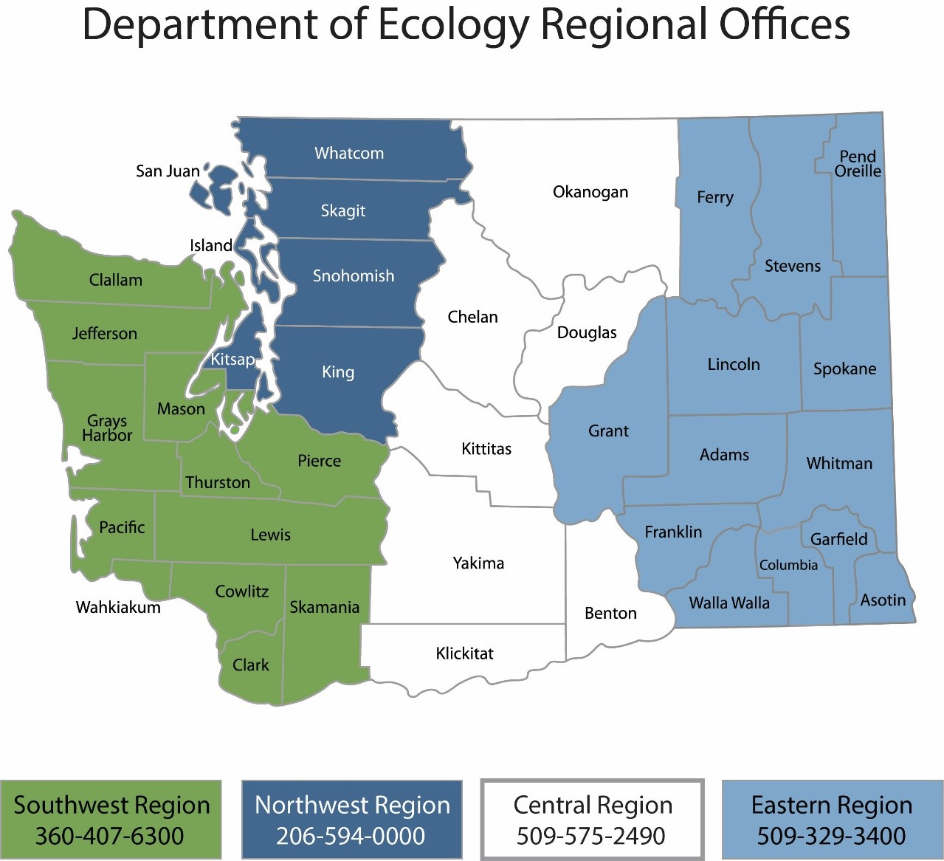

Contact Information
Contact information for Biosolids staff is located on Ecology’s Biosolids webpage.

ADA Accessibility
The Department of Ecology is committed to providing people with disabilities access to information and services by meeting or exceeding the requirements of the Americans with Disabilities Act (ADA), Section 504 and 508 of the Rehabilitation Act, and Washington State Policy #188.
To request an ADA accommodation, contact Ecology by phone at 360-407-6831 or email at swmpublications@ecy.wa.gov. For Washington Relay Service or TTY call 711 or 877-833-6341. Visit Ecology's website for more information.

Table of Contents
Instructions for Completing Application for Coverage under the General Permit for Biosolids Management iv
Who is subject to the general permit? iv
Who must submit a permit application iv
General instructions iv
Permit Sections Applicable to your Facility 2
Basic Facility Information 2
Facility type 2
Other permits 2
Process, production and storage 2
Biosolids End Use 3
Attachments 4
Certification Statement 5

Instructions for Completing Application for Coverage under the General Permit for Biosolids Management

Who is subject to the general permit?
Public and private facilities within the jurisdiction of the State of Washington that meet the definition of Treatment Works Treating Domestic Sewage (TWTDS) are subject to the Statewide General Permit for Biosolids Management. This includes:
- All publicly owned treatment works,
- Privately owned treatment works that treat only domestic sewage,
- Beneficial Use Facilities (provide land application services to biosolids generators,
- Septage management facilities (treat and/or land apply septage), and
- Other facilities that treat biosolids and septage like Compost facilities.
Covered activities include treating, storing, land applying, selling, giving away, transferring from one facility to another, and disposing of biosolids in a municipal solid waste landfill or incinerator.

Important Note
Existing facilities without Active Biosolids or Septage Management programs, operating under the previous permit as of September 4, 2020, are not required to submit a permit application unless directed to do so by Ecology.

Who must submit a permit application
All facilities with active management programs, and all new facilities, regardless of their practices, that begin operations after September 4, 2020, are required to submit a permit application, and are subject to additional public notice and SEPA review.

General instructions
When completing the general permit application, read all questions carefully, do not leave any applicable sections blank and be sure to submit all necessary supporting documents.
Facilities applying for coverage under the general permit should start by reviewing the required content for a complete application. Ecology provides some templates and guidance materials, and regional Biosolids Coordinators can help with questions.

Common application errors that will delay permit issuance
Incomplete or poorly prepared applications are the most common cause of delays in permit processing. We encourage responsible officials to take time to prepare an accurate, thorough, and professional permit application. Applications must be suitable for review by both Ecology staff and interested parties. To ensure a smooth review process, facilities must:
- Prepare and write their application in a way that a reasonably knowledgeable person can understand.
- Use the application form provided by Ecology for their facility type.
- Adhere to proper format and organization.
Ecology will advise each facility when their application is ready for public notice. Ecology may post the applications to our web site, and/or release it directly to interested parties on request.

Confirming what sections of the permit your facility is subject to
Use the flowchart below provided by Ecology to confirm what sections of the permit your facility is subject too. Consult your Biosolids Coordinator with any questions.
Figure 1 – Permit Sections Flow Chart
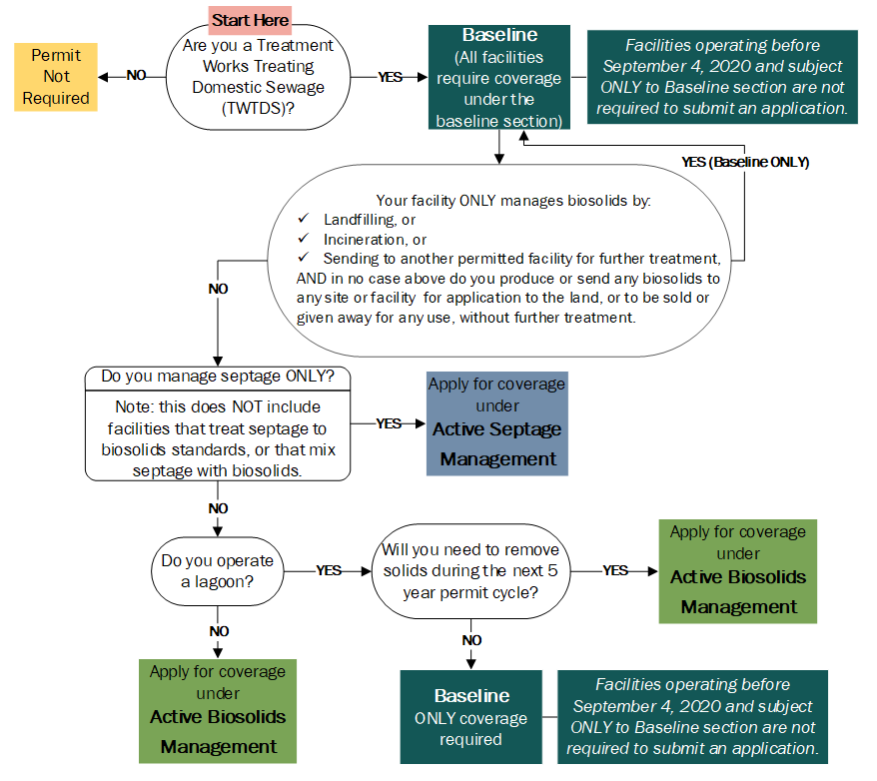

Submitting the application
Electronic copies are preferred. Hard copies can be submitted via mail, in person, or by parcel delivery service. Facilities must submit their permit application as follows:
- One copy to the Regional Biosolids Coordinator (regional contact and address information provided above and online),
Please note deadlines vary depending on submission format as outlined below:
- By Email: Received no later than 11:59 PM, 90 days after permit issuance.
- By Mail: Postmarked no later than 11:59 PM, 90 days after permit issuance.
- In Person or Parcel Delivery Service: Delivered to office no later than 5:00 PM, 90 days after permit issuance.

Application for Coverage under the Statewide General Permit for Biosolids Management

Baseline

Permit Sections Applicable to your Facility
This application is for facilities that require coverage under the Statewide General Permit for Biosolids Management and do NOT have an Active Biosolids or Septage Management program. Use the flowchart provided by Ecology on the previous page to confirm that your facility is subject ONLY to the Baseline section of the permit.
Consult your Biosolids Coordinator with any questions. Next, follow the instructions to complete the application.

Basic Facility Information
This application is for new facilities that that began operation after September 4, 2020, and require coverage only under the Baseline section of the General Permit for Biosolids Management, and for facilities under permit as of September 4, 2020 that wish to modify their permit, but will not have an Active Biosolids or Septage Management program.
Please provide complete and accurate information.
Name of facility
List all business names associated with your facility.

Owner(s)

Ownership status

State
Local
Private
Federal
WA Tribe
Other:

Physical address of facility
Address used to locate facility for visits/inspections

Mailing address
Where notifications should be delivered

Permit number:
Biosolids permit numbers begin with BA or BT. Consult your regional biosolids coordinator if you don’t know yours.

Facility contacts
Consult section 2.1.3 of the general permit for an explanation of Responsible Official vs. Primary Contact.
Primary Contact
Typically an individual who works at the facility and is first point of contact for Ecology.

Name
Title
Email
Mailing Address
Phone

Responsible Official
See link below. Responsible official depends on facility ownership and size.

Name
Title
Email
Mailing Address
Phone

Billing Contact

Name
Title
Email
Mailing Address
Phone

Other Contact (If Applicable)

Specify Contact Type
Name
Title
Mailing Address
Phone
Email

Facility type
Check all boxes that apply to your facility.
Major sewage treatment facility (design flow of ≥ 1 mgd or serving a population of ≥ 10,000)
Minor sewage treatment facility (design flow of < 1 mgd and serving a population of <10,000)
Have a pretreatment program or designated as a Class I facility as defined in WAC 173-308-080
WWTP with a Lagoon (WWTP only)
Other – Describe

Other permits
Check all boxes that apply to your facility and provide associated permit number(s)
National Pollutant Discharge Elimination System (NPDES)
Permit number
State Waste Discharge
Permit number
Solid Waste
Permit number
Air
Permit number
Local special or conditional use
Permit number
Issuing Authority

Process, production and storage
Describe your facility’s operations, touching on each phase of solids production and management.
For example, “Our facility is a small package plant serving a community of 500 homes. We have a state waste discharge permit that allows land application of our effluent. Our biosolids are stored in a tank on site and periodically removed to the regional wastewater treatment facility.

Do you plan to make any changes to your operations during this 5-year permit cycle? Yes No
If yes, explain:
Do you have a lagoon? Yes No
If yes, do you plan to remove biosolids from the lagoon during this 5-year permit cycle? Yes No
If yes or if you are unsure, please contact your regional biosolids coordinator to discuss whether you are completing the correct permit application.

Biosolids End Use
Check all boxes that apply to your facility and answer associated questions as directed. Check ONLY the boxes associated with an end use for which your facility is designed and intends to produce.
Send biosolids to another facility for further treatment
Where do you send your solids?
Please provide the name of the facility and their biosolids permit number if applicable
Who is responsible for completing the spill prevention and response plan for transportation of your biosolids?
On average, about how many dry tons do you send for further treatment annually?
Dry tons
Leave solids in your lagoon for the entire 5-year permit cycle
When do you estimate you will remove solids from the lagoon next? (Please provide a year)
Send to an incinerator
State law emphasizes the maximum beneficial use of biosolids. Please provide justification for disposing of your solids.

On average, how many dry tons do you dispose of via incineration annually? Dry tons
Provide the name of the incinerator to which you send solids.
Who is responsible for completing the spill prevention and response plan for transportation of your biosolids?
Send solids to a municipal solid waste landfill
State law emphasizes the maximum beneficial use of biosolids. Please provide justification for disposing of your solids.

On average, how many dry tons do you dispose of in a municipal solid waste landfill annually?
Dry tons
Provide the name of the landfill to which you send your solids:
Who is responsible for completing the spill prevention and response plan for transportation of your biosolids?

Attachments
Check all applicable boxes and include all attachments with your application. Consult the biosolids coordinator for your region if you are unsure which attachments are required.
Vicinity Map
Facility Schematic
Spill Prevention and Response Plan (if applicable)
State Environmental Policy Act (SEPA)
Public Notice
Temporary Disposal Plan

Certification Statement
“I certify under penalty of law that this document and all attachments were prepared under my direction or supervision in accordance with a system designed to assure that qualified personnel properly gather and evaluate the information submitted. Based on my inquiry of the person or persons who manage the system, or those persons directly responsible for gathering the information, the information submitted is, to the best of my knowledge and belief, true, accurate, and complete. I am aware that there are significant penalties for submitting false information, including the possibility of fine and imprisonment for knowing violations.”

Signature of Responsible Official

Title

Date

Must be signed by the Responsible Official; see WAC 173-308-310(10)(a).

https://apps.ecology.wa.gov/publications/summarypages/070654.html
https://ecology.wa.gov/Waste-Toxics/Reducing-recycling-waste/Biosolids/Program-contacts
https://apps.leg.wa.gov/WAC/default.aspx?cite=173-308-080

