Puget Sound No Discharge Zone
Free Signs Available!

The signs listed below are provided at no cost to marinas and agencies that manage boat launch areas in the Puget Sound region. Once we get your request, we will coordinate delivery options with you. These signs are available for free on a first come, first served basis while supplies last.

Ordering Instructions:
Email your completed order request form to Justine Asohmbom at: Justine.Asohmbom@ecy.wa.gov . Your email should include:
- Name and affiliation of person ordering
- Contact phone & email
- Locations where the signs will be installed.
If you have any questions, please, call 425-495-1569.

NOTE: We have indicated that some of the signs are for locations in the South Sound or the North Sound because they include the phone number and email address of that region for reporting illegal sewage discharges. If you are unsure of which version is appropriate for your location, please contact Justine.Asohmbom@ecy.wa.gov for guidance.

Item # | Sign Options | Item Size | Material | # Requested
1 | 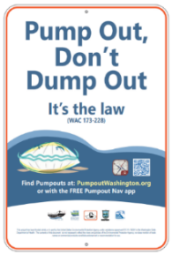 | Small sign – 12 x 18 inches | Aluminum/Vinyl Reflective ink-print anti-UV laminate, round corners with punch holes
2 | 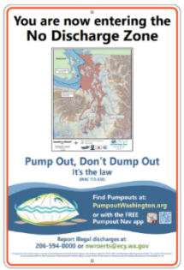 | Large sign – 24 x 36 inches  Note: Use in the Central & North Sound locations | Aluminum/Vinyl - Reflective ink-print anti-UV laminate, round corners with punch holes
3 | 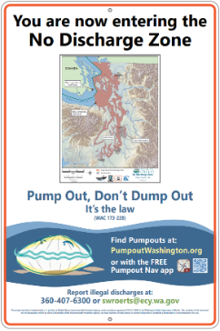 | Large sign – 24 x 36 inches  Note: Use in South Sound & Strait locations. | Aluminum/Vinyl - Reflective ink-print anti-UV laminate, round corners with punch holes

Item # | Sign Options | Item Size | Material | # Requested
4 | 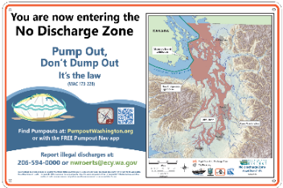 | Large sign – 36 x 24 inches  Note: Use in Central & North Sound locations | Aluminum/Vinyl Reflective ink-print anti-UV laminate, round corners with punch holes
5 | 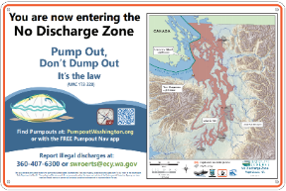 | Large sign – 36 x 24 inches  NOTE: Use in South Sound & Strait locations | Aluminum/Vinyl - Reflective ink-print anti-UV laminate, round corners with punch holes
6 |  | Large sign – 36 x 36 inches  Note: Use in Central & North Sound locations | Aluminum/Vinyl - Reflective ink-print anti-UV laminate, round corners with punch holes
7 | 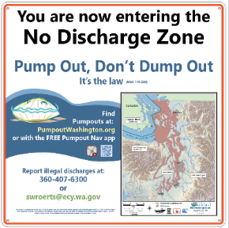 | Large sign – 36 x 36 inches  Note: Use in South Sound & Strait locations | Aluminum/Vinyl - Reflective ink-print anti-UV laminate, round corners with punch holes

Item # | Sign Options | Item Size | Material | # Requested
8 | 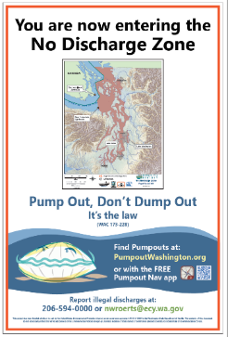 | A-Frame Sign – 24 x 36 inches  Note: Use in Central & North Sound locations | Anti-UV laminate on Di-Bond backing and mount to A-Frame
9 |  | A-Frame Sign – 24 x 36 inches  Note: Use in South Sound & Strait locations | Anti-UV laminate on Di-Bond backing and mount to A-Frame
10 |  | 18" x 24" inches | Magnetic/Vinyl Decal reflective material, anti-UV laminate
11 |  | 18" x 24" inches | Magnetic/Vinyl Decal - reflective material, anti-UV laminate
12 |  | 18" x 24" inches | Vinyl Decals, reflective material, anti-UV laminate.

Installation Tips:
- Signs should be installed in high visibility locations near water access, such as on posts, fences, and bulletin boards near boat ramps and docks.
- Sign installation will be the responsibility of the recipient and will require screws, rings, or other fasteners depending on the install location/substrate.
To request an ADA accommodation, contact Ecology by phone at 360-407-6600 or email at Justine.Asohmbom@ecy.wa.gov. For Washington Relay Service or TTY call 711 or 877-833-6341. Visit Ecology's website for more information.

