# Washington state Department of Ecology logo.Request to Establish or Modify a Water Bank

**Form No. ECY 070-679**

* We strongly encourage consultation with our regional staff prior to submitting this form.
* There is no fee for filing this form.

## Submit your completed form:

Attach a scanned copy of the completed form and associated report in an email, and send it to the regional office where your proposed water bank intends to operate (see email addresses below). We encourage paperless processing, but if you do not have access to email, mail the form to the appropriate regional office below.

| **Region/ Office** | **Counties served** | **Mailing Address** | **Phone** |
| --- | --- | --- | --- |
| **Central** | Benton, Chelan, Douglas, Kittitas, Klickitat, Okanogan, Yakima | [wrCRO@ecy.wa.gov](mailto:wrcro@ECY.WA.GOV?subject=Request%20to%20Establish%20or%20Modify%20a%20Water%20Bank%20-%20ECY%20070-679)  1250 W Alder St Union Gap, WA 98903-0009 | 509-575-2490 |
| **Eastern** | Adams, Asotin, Columbia, Ferry, Franklin, Garfield, Grant, Lincoln, Pend Oreille, Spokane, Stevens, Walla Walla, Whitman | [wrERO@ecy.wa.gov](mailto:wrero@ECY.WA.GOV?subject=Request%20to%20Establish%20or%20Modify%20a%20Water%20Bank%20-%20ECY%20070-679)  4601 N Monroe Spokane, WA 99205-1265 | 509-329-3400 |
| **Northwest** | Island, King, Kitsap, San Juan, Skagit, Snohomish, Whatcom | [wrNWRO@ecy.wa.gov](mailto:wrNWRO@ecy.wa.gov?subject=Request%20to%20Establish%20or%20Modify%20a%20Water%20Bank%20-%20ECY%20070-679)  PO Box 330316 Shoreline, WA 98133-9716 | 206-594-0000 |
| **Office of Columbia River** | OCR has jurisdiction for designated OCR projects, and new projects located within one mile of the Columbia River. | [wrCRO@ecy.wa.gov](mailto:wrcro@ECY.WA.GOV?subject=Request%20to%20Establish%20or%20Modify%20a%20Water%20Bank%20-%20ECY%20070-679)  1250 W Alder St Union Gap, WA 98903-0009 | 509-457-7141 |
| **Southwest** | Clallam, Clark, Cowlitz, Grays Harbor, Jefferson, Lewis, Mason, Pacific, Pierce, Thurston, Skamania, Wahkiakum | [wrSWRO@ecy.wa.gov](mailto:wrSWRO@ecy.wa.gov?subject=Request%20to%20Establish%20or%20Modify%20a%20Water%20Bank%20-%20ECY%20070-679)  PO Box 47775Olympia, WA 98504-7775 | 360-407-6300 |

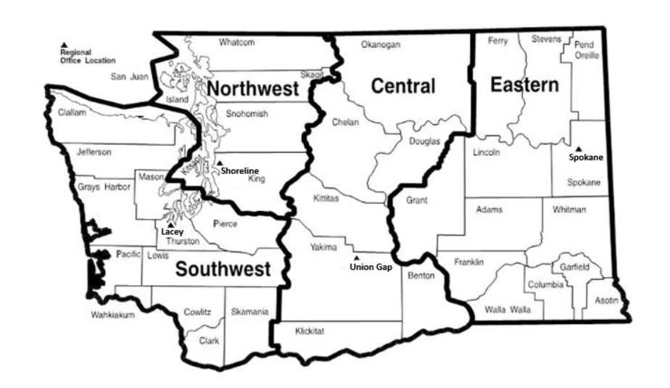To request ADA accommodation including materials in a format for the visually impaired, call Ecology Water Resources Program at 360-407-6872. People with impaired hearing may call Washington Relay Service at 711. People with speech disability may call TTY at 877-833-6341.

For Ecology use. Space for Date Stamp.**WATER RESOURCES PROGRAM**Request to Establish or Modify a Water Bank

## Requester/Water Banker

|  |  |  |
| --- | --- | --- |
| Name or Entity | Phone No. | Alt Phone No. |
| Address | | |
| City | State | Zip Code |
| Email Address (if available) | | |

|  |  |  |
| --- | --- | --- |
| Contact Name (If different from above): | Phone No: | Other No: |
| Relationship to Banker: | | |
| Address: | | |
| City: | State: | Zip: |
| Email Address (if available): | | |

## 2. Proposal to Establish or Modify a Water Bank

Provide your responses in a **separate report**, and include the corresponding section numbers.

| **Section** | **Requested Information** |
| --- | --- |
| 2.1: Summary | Provide a summary of the proposed water bank (or summary of the proposed changes to an existing bank), including bank purpose and objectives, timelines, and operations. |
| 2.2:  Mitigating Rights | Provide the water right number or claim number for the water right(s) you intend to serve as mitigation for new uses (mitigating rights).   * If you have already applied to change the water right’s purpose of use to instream flow for mitigation in anticipation of establishing a water bank, include the Change Application File Number. * Provide information to support a determination that the proposed mitigating right(s) is suitable to mitigate the proposed new uses.   If you are requesting to modify an existing water bank, describe the water rights you intend to add or remove from the water bank. |
| 2.3: Demand | Describe the anticipated demand to be served by the bank including:   * The specific geographic area where the proposed new uses are located. Include a detailed map clearly indicating the new uses, and/or the proposed service area where the water bank intends to offer mitigation. * The types or purposes of the new uses to be mitigated. * The quantities of water needed to serve the new uses. * The timing of when water is needed to serve the new uses. * Other information Ecology will need to evaluate the impacts from the new uses.   If you are requesting to modify the new uses currently being served by an existing water bank, provide the information requested here regarding those new uses. |
| 2.4: Impairment | Provide any information that will assist Ecology in determining whether operating the proposed water bank, or modification of an existing bank would impair existing water rights or the public interest. |
| 2.6: Other | Provide any other information that may be relevant for Ecology’s review and planning. For example, describe any other agreements, permits, or processes that may be part of establishing the water bank. |

## 3. Signatures:

I certify that the information above, and in the attached report is true and accurate to the best of my knowledge. If assisted in preparing this request, I understand that all responsibility for the accuracy of the information rests with me.

|  |  |  |  |  |
| --- | --- | --- | --- | --- |
| **Requester/Water Banker - Printed Name –** |  | **Signature** |  | **(Date: MM/DD/YYYY)** |