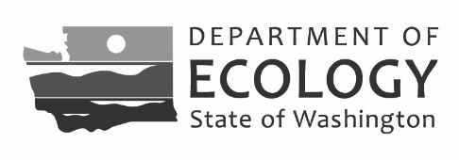
Landowner Signature Form

Water Resources Program
The Landowner Signature Form is used to collect the required signature(s) and contact information for each legal owner or part owner of land where water is and/or will be used as described on a water right application. Water right applicants must upload this Form (as appliable) for their application to be considered complete. The requirement to include all legal landowner signatures is described in WAC 508-12-130.
By signing this form, you attest to the following:
- I am the legal owner or authorized representative of the property where water is and/or will be used as described on the subject water right application described below.
- I am aware that the proposed project, as described on the subject water right application, includes my property.
- I grant staff from the Department of Ecology access to my property for the purpose of inspection and monitoring.
- My signature does not represent water right application approval.

1. Provide water right application information
Applicant name:
Project name:
Application type:
Water right or claim no. proposed for change (if applicable):
Source type (surface water or groundwater):
Ecology region where the project is located:

2. Include all landowner signature(s) and contact information
Landowner name:
Property address(es):
Parcel number(s):
Email:
Phone:
Address:
Landowner signature: Signature date:

Landowner name:
Property address(es):
Parcel number(s):
Email:
Phone:
Address:
Landowner signature: Signature date:
Landowner name:
Property address(es):
Parcel number(s):
Email:
Phone:
Address:
Landowner signature: Signature date:
Landowner name:
Property address(es):
Parcel number(s):
Email:
Phone:
Address:
Landowner signature: Signature date:

3. Attach additional sheets if needed

4. Upload this form to your online application
If you have questions about this form or your water right application, please contact the Ecology office where your project is located.
ECY 040-1-26 (Rev 10-2023) To request ADA accommodation including materials in a format for the visually impaired, call Ecology Water Resources Program at 360-407-6872. Persons with impaired hearing may call Washington Relay Service at 711. Persons with speech disability may call TTY at 877-833-6341.

